Striatal brain volume linked to severity of substance use in high-risk incarcerated youth: Supplementary Material

Nathaniel Anderson, Michael Maurer, David Stephenson, Keith Harenski,
Michael Caldwell, Greg Van Rybroek, Kent Kiehl

As noted in the main text, two structural networks (derived by ICA), which included a priori regions of interest, were significantly associated with substance use severity. These two components are represented in the main text. Three additional components (out of 30), which did not include a priori regions of interest, were also significantly related to substance use severity. These components included structural networks comprising 1) posterior cingulate, precuneus, and cuneus; 2) precuneus, occipito-temporal gyrus, inferior temporal gyrus. Both of these structural networks were positively correlated with substance use severity. 3) A network including posterior cerebellum (semilunar lobule) was significantly negatively correlated with substance use severity. Relevant statistics for bivariate and partial correlations (controlling for age, race, IQ, PCL:YV, GM+WM) are provided for each component. Since these components did not include a priori ROIs, they are presented here for completeness, but do not survive corrections for multiple comparisons considering the 30 independent components evaluated in the SBM analysis.

1)
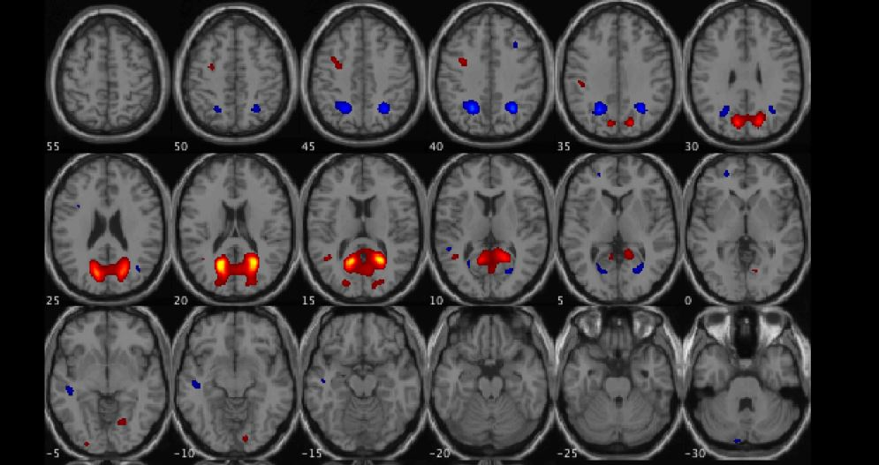
Correlations with substance use severity: r = .165, p = .042; partial r = .149, p = .071 (NS)

2)
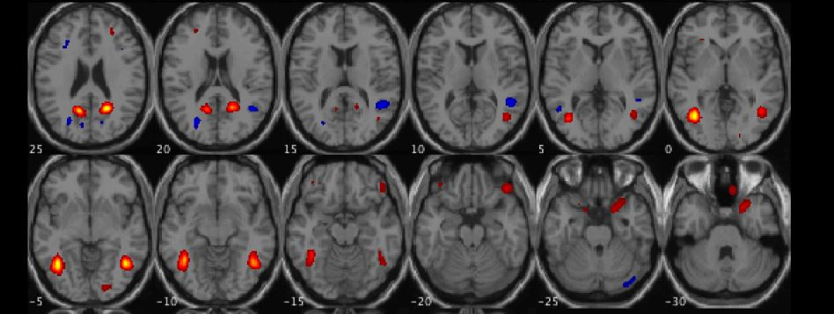
Correlations with substance use severity: r = .208, p = .010; partial r = .213, p = .009

3)
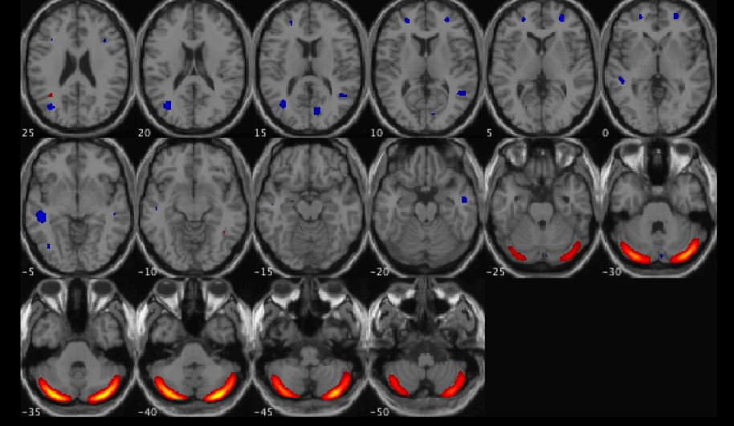
Correlations with substance use severity: r = -.169, p = .038; partial r = .178, p = .031

