Supplementary Information for
Childhood maltreatment and resting-state network connectivity: The risk-buffering role of positive parenting

This file include:
eMethods. Participant’s recruitment
eMethods. Image Preprocessing
Fig S1. Schematic figure depicting the timeline of our assessments.
Fig S2. Spaghetti plots showing the time points of observations for childhood maltreatment for each participant.
Table S1. Longitudinal effects of childhood neglect on network connectivity

eMethods. Participant’s recruitment
Participants in this study were part of the NSPN cohort. The NSPN is a multi-center, accelerated longitudinal study aimed at measuring developmental changes in a demographically representative sample of 2,406 young people aged 14-24 years from North London and Cambridgeshire, UK (Kiddle et al., 2018). Participants were stratified by age and sex, with an equal number of males and females in each of the following age groups: 14-15, 16-17, 18-19, 20-21, and 22-25 years. The cohort's objective is to support an accelerated longitudinal design to measure developmental changes, which involves recruiting multiple, age-adjacent cohorts and following them longitudinally for a limited time period. This approach allows for a faster estimation of development across a wider range of ages than a single-cohort longitudinal follow-up.
Participants received a Home Questionnaire Pack (HQP) and a Sociodemographic Questionnaire to assess their mood, behavior, wellbeing, and demographic characteristics at three time-points (HQP1, HQP2, HQP3). Two in-unit assessments (IUA1, IUA2) comprised questionnaires, cognitive assessments, and MRI scanning. IUA1 and IUA2 interleaved with HQP1, HQP2 and HQP3 (see Fig S1 in supplementary file). Detailed descriptions of the recruitment methods and sample are available in recent publications (Dorfschmidt et al., 2022; Vaghi et al., 2020; Váša et al., 2020).
A subsample of 318 healthy youth participated in an MRI study, with approximately 60 participants in each of five age bins (14 to 15 years, 16 to 17 years, 18 to 19 years, 20 to 21 years and 22 to 24 years). Participants were excluded if they reported a history of psychiatric treatment or neurological disorder, head injury, or intellectual disability. After rigorous visual quality control and excluding 10% of scans with highest during-scan motion, the final evaluable dataset included 298 participants. Of these, 281 subjects were scanned at baseline (IUA1) and 211 were scanned approximately 18 months later at follow-up (IUA2). For the present study, the final sample included 183 participants (age range 14-25 years; mean [SD] age, 18.84 [2.85] years; 46.99% female) who were scanned at both time points. Further demographic information can be found in Table 1. When we employed a cut-off score of 17 or higher on the Mood and Feelings Questionnaire (MFQ) (Costello & Angold, 1988), as recommended by Yates et al. (2004), to identify mild-to-moderate depressive disorder in participants, we found that approximately 28% of participants at HPQ3 and approximately 30% of participants at HPQ2 who provided information on depression scored above this cut-off. This indicates a significant proportion of our sample experiencing depression. Participants aged 16-25 gave written informed consent for each aspect of the study; a legal guardian’s written informed consent was obtained for those aged 14–15 years, and those youth gave assent to participate. The NSPN study was approved by the Cambridge Central Research Ethics Committee (12/EE/0250). This study was approved as a secondary data analysis protocol by the Institutional Review Board of our university.

eMethods. Image Preprocessing
Using Freesurfer v5.3.0, individual structural scans were processed with a pipeline including skull-stripping, segmentation of cortical grey and white matter, and reconstruction of the cortical surface and grey-white matter boundary (Fischl, Sereno & Dale, 1999). Then all scans were precisely quality controlled by re-running the reconstruction algorithm after the addition of control points and white matter edits as previously described (Váša et al., 2020; Whitaker et al., 2016). The pre-processing of resting-state data for multiecho independent component analysis (ME-ICA) analysis was conducted in AFNI. Volumes obtained during steady-state equilibration (15 s) were disregarded. Matrices for deobliquing, motion correction, and anatomical-functional coregistration were computed, and subsequently combined into a single alignment matrix using the concatenation approach from the AFNI tool align_epi_anat.py. Slice timing correction, spatially aligned through application of the alignment matrix, and visual assessment for anatomical-functional coregistration were performed.
Furthermore, we employed ME-ICA during the pre-processing of functional scans to identify sources of variance in the fMRI time series that were BOLD-related and scaled linearly with TE, while discarding other sources of fMRI variance, such as head movement, which were not BOLD-related and did not scale with TE. In addition, we utilized realignment of scans to estimate six motion parameters (3 translation parameters and 3 rotation parameters) for each participant during pre-processing. These parameters were then used to calculate an overall estimate of motion, known as the framewise displacement (FD), which represents the sum of the absolute derivatives of the six motion parameters. To correct for head movement in each scan session, we used mean FD as a measure of head movement, and subsequently regressed functional connectivity on mean FD. This movement correction pipeline of ME-ICA followed by FD regression formed the basis for our analysis of functional connectivity. A broadband denoised fMRI time series at each voxel was generated by the retained independent components of the BOLD contrast. Finally, the BOLD signal oscillating in the frequency range 0.025-0.111 Hz was acquired after bandpass filtering using the discrete wavelet transform (Daubechies 4 wavelet). Detailed information about the pre-processing steps and ME- ICA can be found in published studies (Dorfschmidt et al., 2022; Vaghi et al., 2020; Váša et al., 2020).

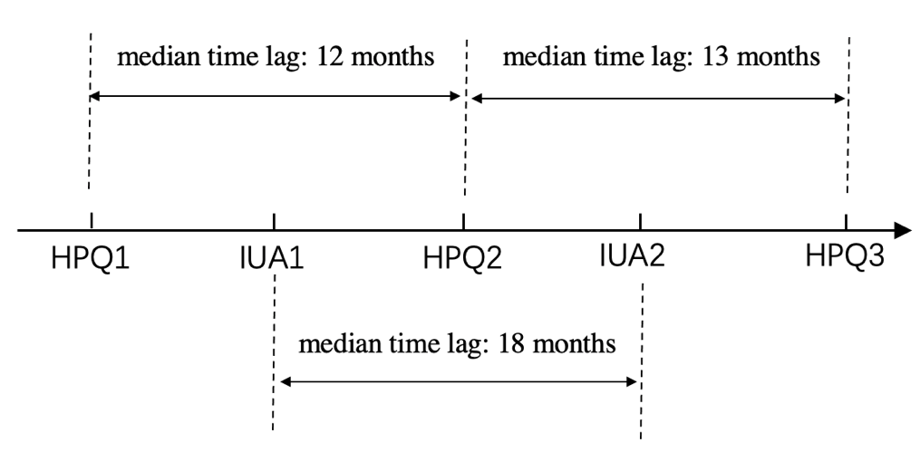
Fig S1. Schematic figure depicting the timeline of our assessments.

Fig S2. Spaghetti plots showing the timepoints of observations for childhood maltreatment for each participant.
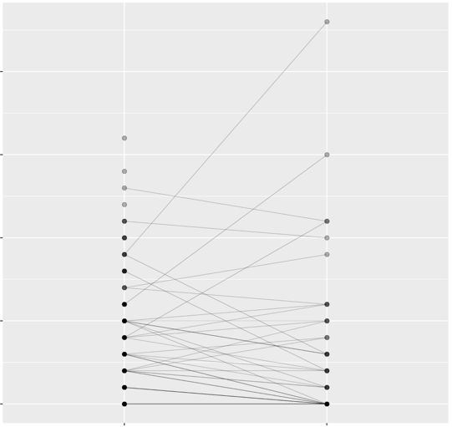
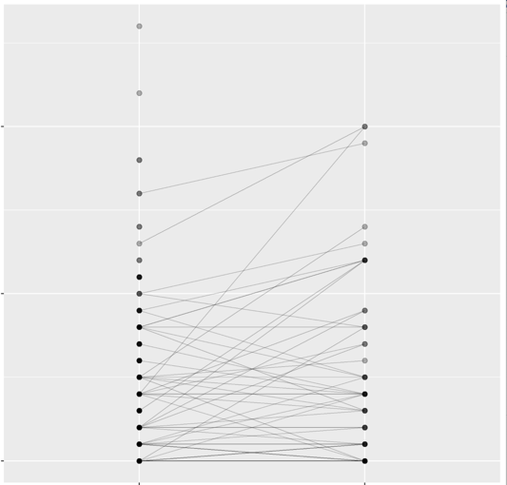
IUA1
IUA2
10
20
30
Childhood Abuse
IUA1
IUA2
10
20
30
Childhood Neglect

Table S1. Longitudinal effects of childhood neglect on network connectivity
network connectivity at IUA2 | β (95% CI) | p | p_{FDR} | η2 (95% CI)
Within-VAN | 0.094(-0.051 to 0.239) | 0.201 | 0.609 | 0.034(0.004 to 1)
Within-DAN | 0.043(-0.105 to 0.191) | 0.57 | 0.712 | 0.010(0.000 to 1)
Within-SAN | 0.068(-0.080 to 0.216) | 0.366 | 0.609 | 0.030(0.002 to 1)
Within-FPN | 0.084(-0.062 to 0.230) | 0.258 | 0.609 | 0.022(0.000 to 1)
Within-DMN | 0.021(-0.111 to 0.152) | 0.756 | 0.756 | 0.057(0.014 to 1)
DMN-VAN | 0.094(-0.039 to 0.227) | 0.164 | 0.254 | 0.058(0.015 to 1)
DMN-FPN | 0.069(-0.068 to 0.207) | 0.321 | 0.357 | 0.052(0.012 to 1)
DMN-SAN | 0.051(-0.087 to 0.190) | 0.464 | 0.464 | 0.057(0.014 to 1)
DMN-DAN | 0.110(-0.030 to 0.250) | 0.123 | 0.254 | 0.035(0.004 to 1)
FPN-SAN | 0.100(-0.045 to 0.244) | 0.176 | 0.254 | 0.049(0.010 to 1)
FPN-VAN | 0.094(-0.043 to 0.231) | 0.178 | 0.254 | 0.080(0.028 to 1)
FPN-DAN | 0.119(-0.028 to 0.265) | 0.111 | 0.254 | 0.012(0.000 to 1)
SAN-VAN | 0.109(-0.032 to 0.249) | 0.128 | 0.254 | 0.071(0.022 to 1)
SAN-DAN | 0.120(-0.027 to 0.268) | 0.109 | 0.254 | 0.025(0.001 to 1)
VAN-DAN | 0.091(-0.055 to 0.238) | 0.221 | 0.276 | 0.030(0.002 to 1)
Note. ª Gender, age, IQ, FD and network connectivity at IUA1 were included as covariates across the analyses.

References
Costello, E. J. & Angold, A. (1988). Scales to assess child and adolescent depression: checklists, screens, and nets. Journal of the American Academy of Child and Adolescent Psychiatry 27(6), 726-37.
Dorfschmidt, L., Bethlehem, R. A., Seidlitz, J., Váša, F., White, S. R., Romero-García, R., Kitzbichler, M. G., Aruldass, A. R., Morgan, S. E. & Goodyer, I. M. (2022). Sexually divergent development of depression-related brain networks during healthy human adolescence. Science Advances 8(21), eabm7825.
Fischl, B., Sereno, M. I. & Dale, A. M. (1999). Cortical surface-based analysis: II: inflation, flattening, and a surface-based coordinate system. Neuroimage 9(2), 195-207.
Kiddle, B., Inkster, B., Prabhu, G., Moutoussis, M., Whitaker, K. J., Bullmore, E. T., Dolan, R. J., Fonagy, P., Goodyer, I. M. & Jones, P. B. (2018). Cohort profile: the NSPN 2400 Cohort: a developmental sample supporting the Wellcome Trust NeuroScience in Psychiatry Network. International journal of epidemiology 47(1), 18-9g.
Vaghi, M. M., Moutoussis, M., Váša, F., Kievit, R. A., Hauser, T. U., Vértes, P. E., Shahar, N., Romero-Garcia, R., Kitzbichler, M. G. & Bullmore, E. T. (2020). Compulsivity is linked to reduced adolescent development of goal-directed control and frontostriatal functional connectivity. Proceedings of the National Academy of Sciences 117(41), 25911-22.
Váša, F., Romero-Garcia, R., Kitzbichler, M. G., Seidlitz, J., Whitaker, K. J., Vaghi, M. M., Kundu, P., Patel, A. X., Fonagy, P. & Dolan, R. J. (2020). Conservative and disruptive modes of adolescent change in human brain functional connectivity. Proceedings of the National Academy of Sciences 117(6), 3248-53.
Whitaker, K. J., Vértes, P. E., Romero-Garcia, R., Váša, F., Moutoussis, M., Prabhu, G., Weiskopf, N., Callaghan, M. F., Wagstyl, K. & Rittman, T. (2016). Adolescence is associated with genomically patterned consolidation of the hubs of the human brain connectome. Proceedings of the National Academy of Sciences 113(32), 9105-10.

