Supplemental Figures

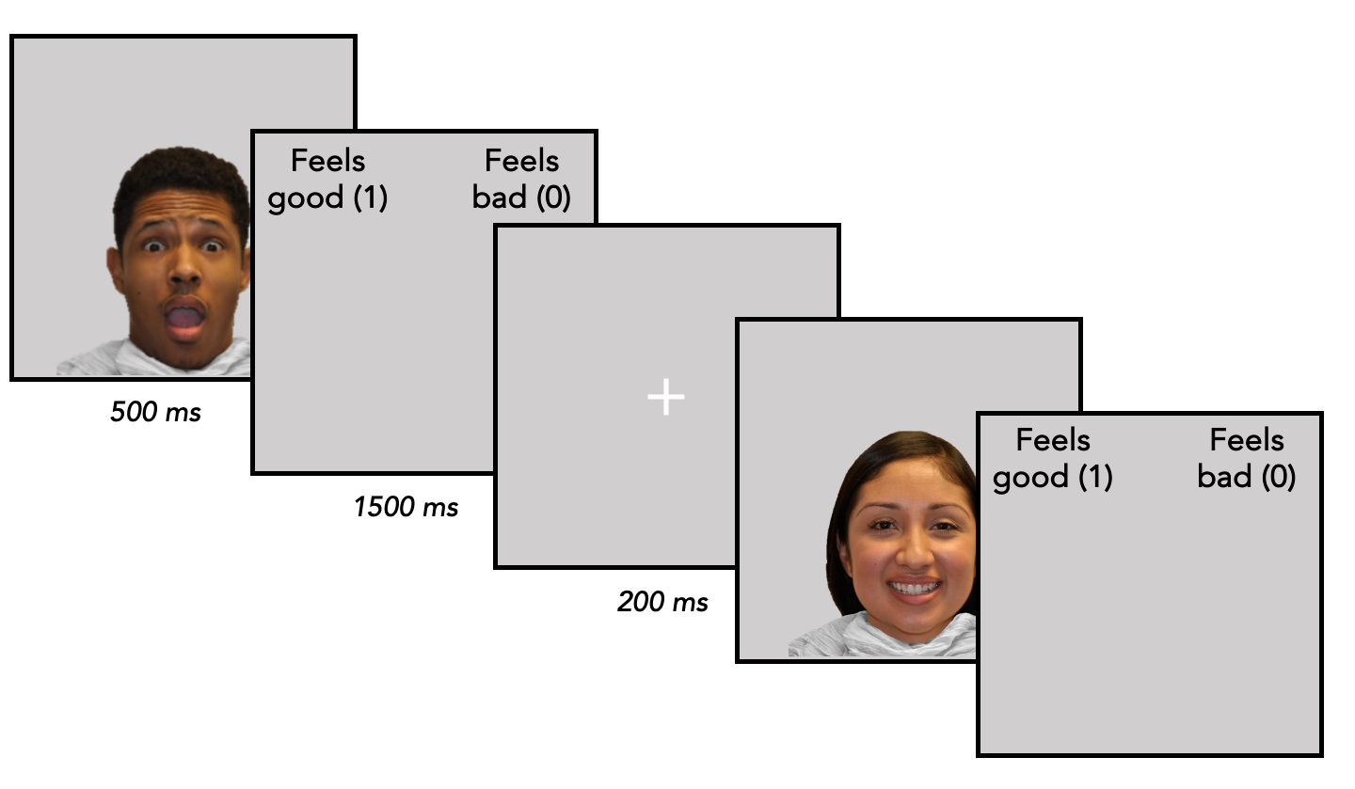
Supplemental Figure 1. During the post-scan behavioral categorization task, participants categorized a subset of the previously seen threatening (angry), nonthreatening (happy), and ambiguous (surprised) faces as “feels good” or “feels bad” (0 or 1, counterbalanced across participants) outside of the scanner. The stimulus was presented for 500 ms, followed by a screen with text requesting their response, which lasted for 1500 ms regardless of when they responded.

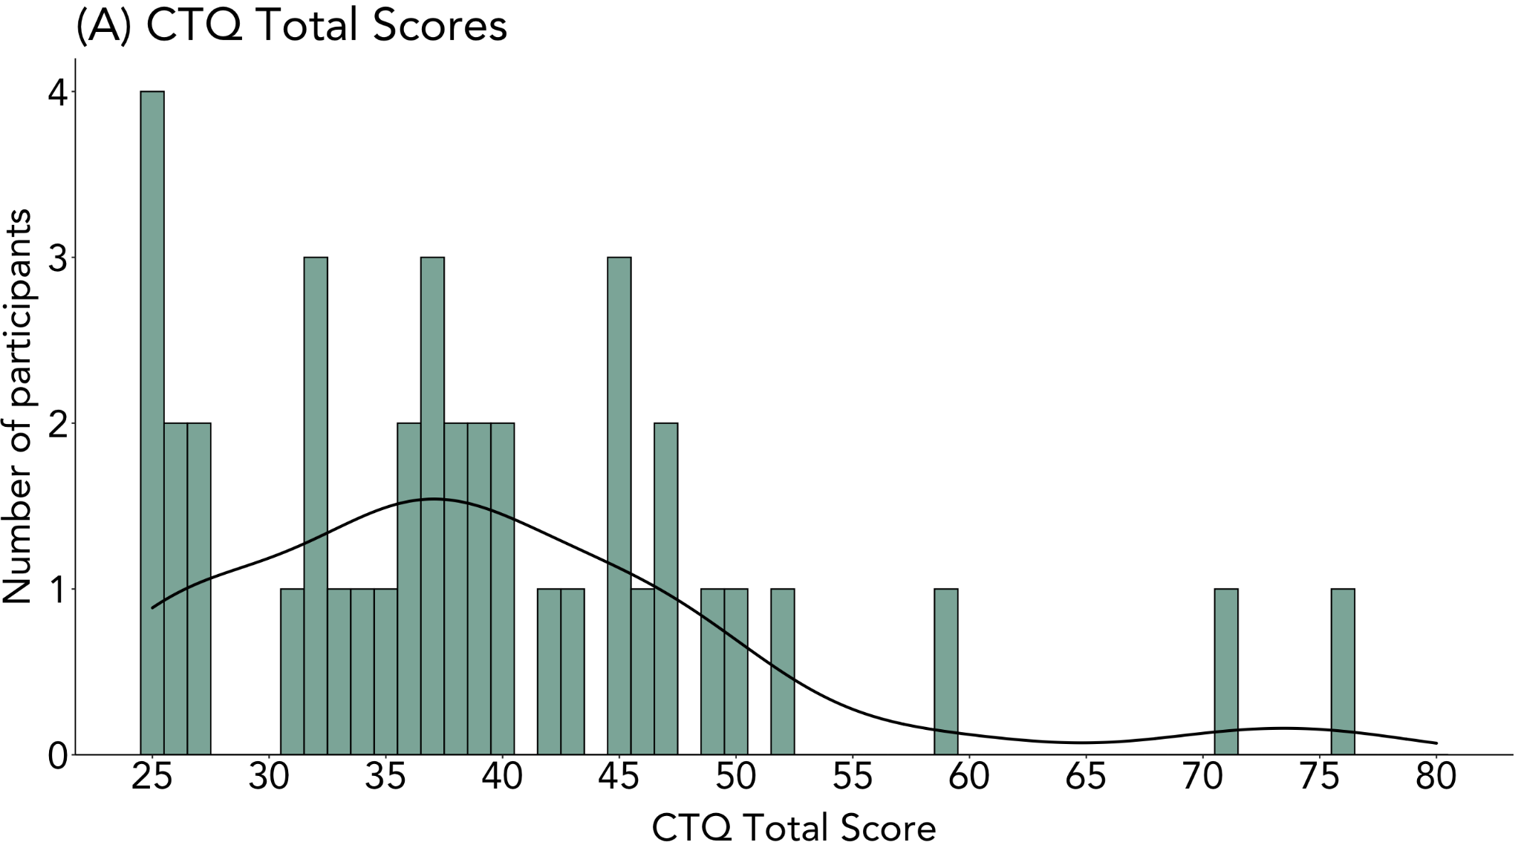
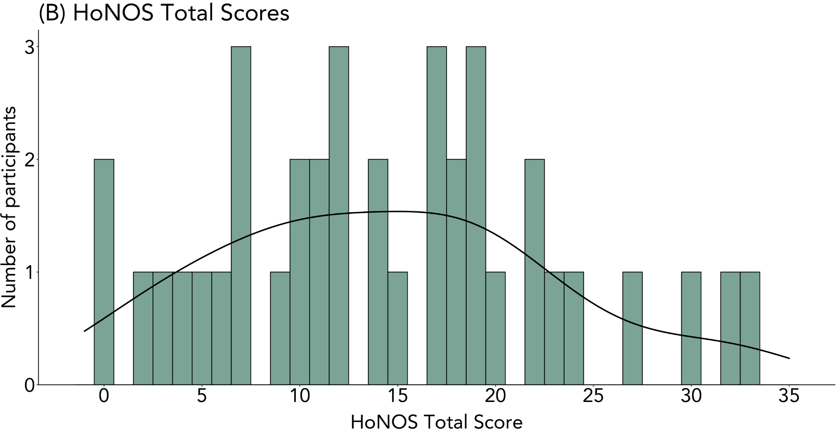
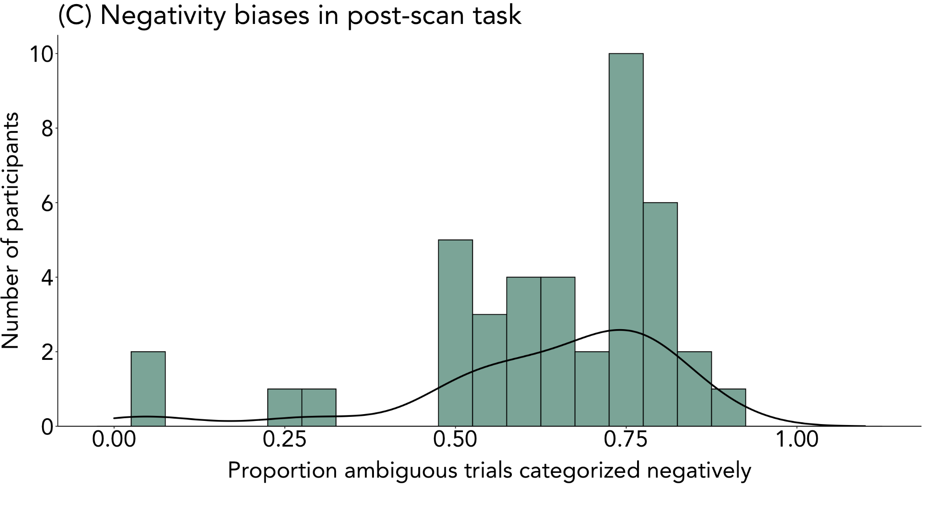

Supplemental Figure 2. Distributions of questionnaire scores and behavioral data. (A) Distribution of Childhood Trauma Questionnaire (CTQ) total scores. (B) Distribution of Health of the Nation Outcomes Scale (HoNOS) total scores. Note that greater scores indicate greater impairment in global functioning.(C) Distribution of negativity biases, or percent of surprised trials (N = 100 total) interpreted negatively in the behavioral task.

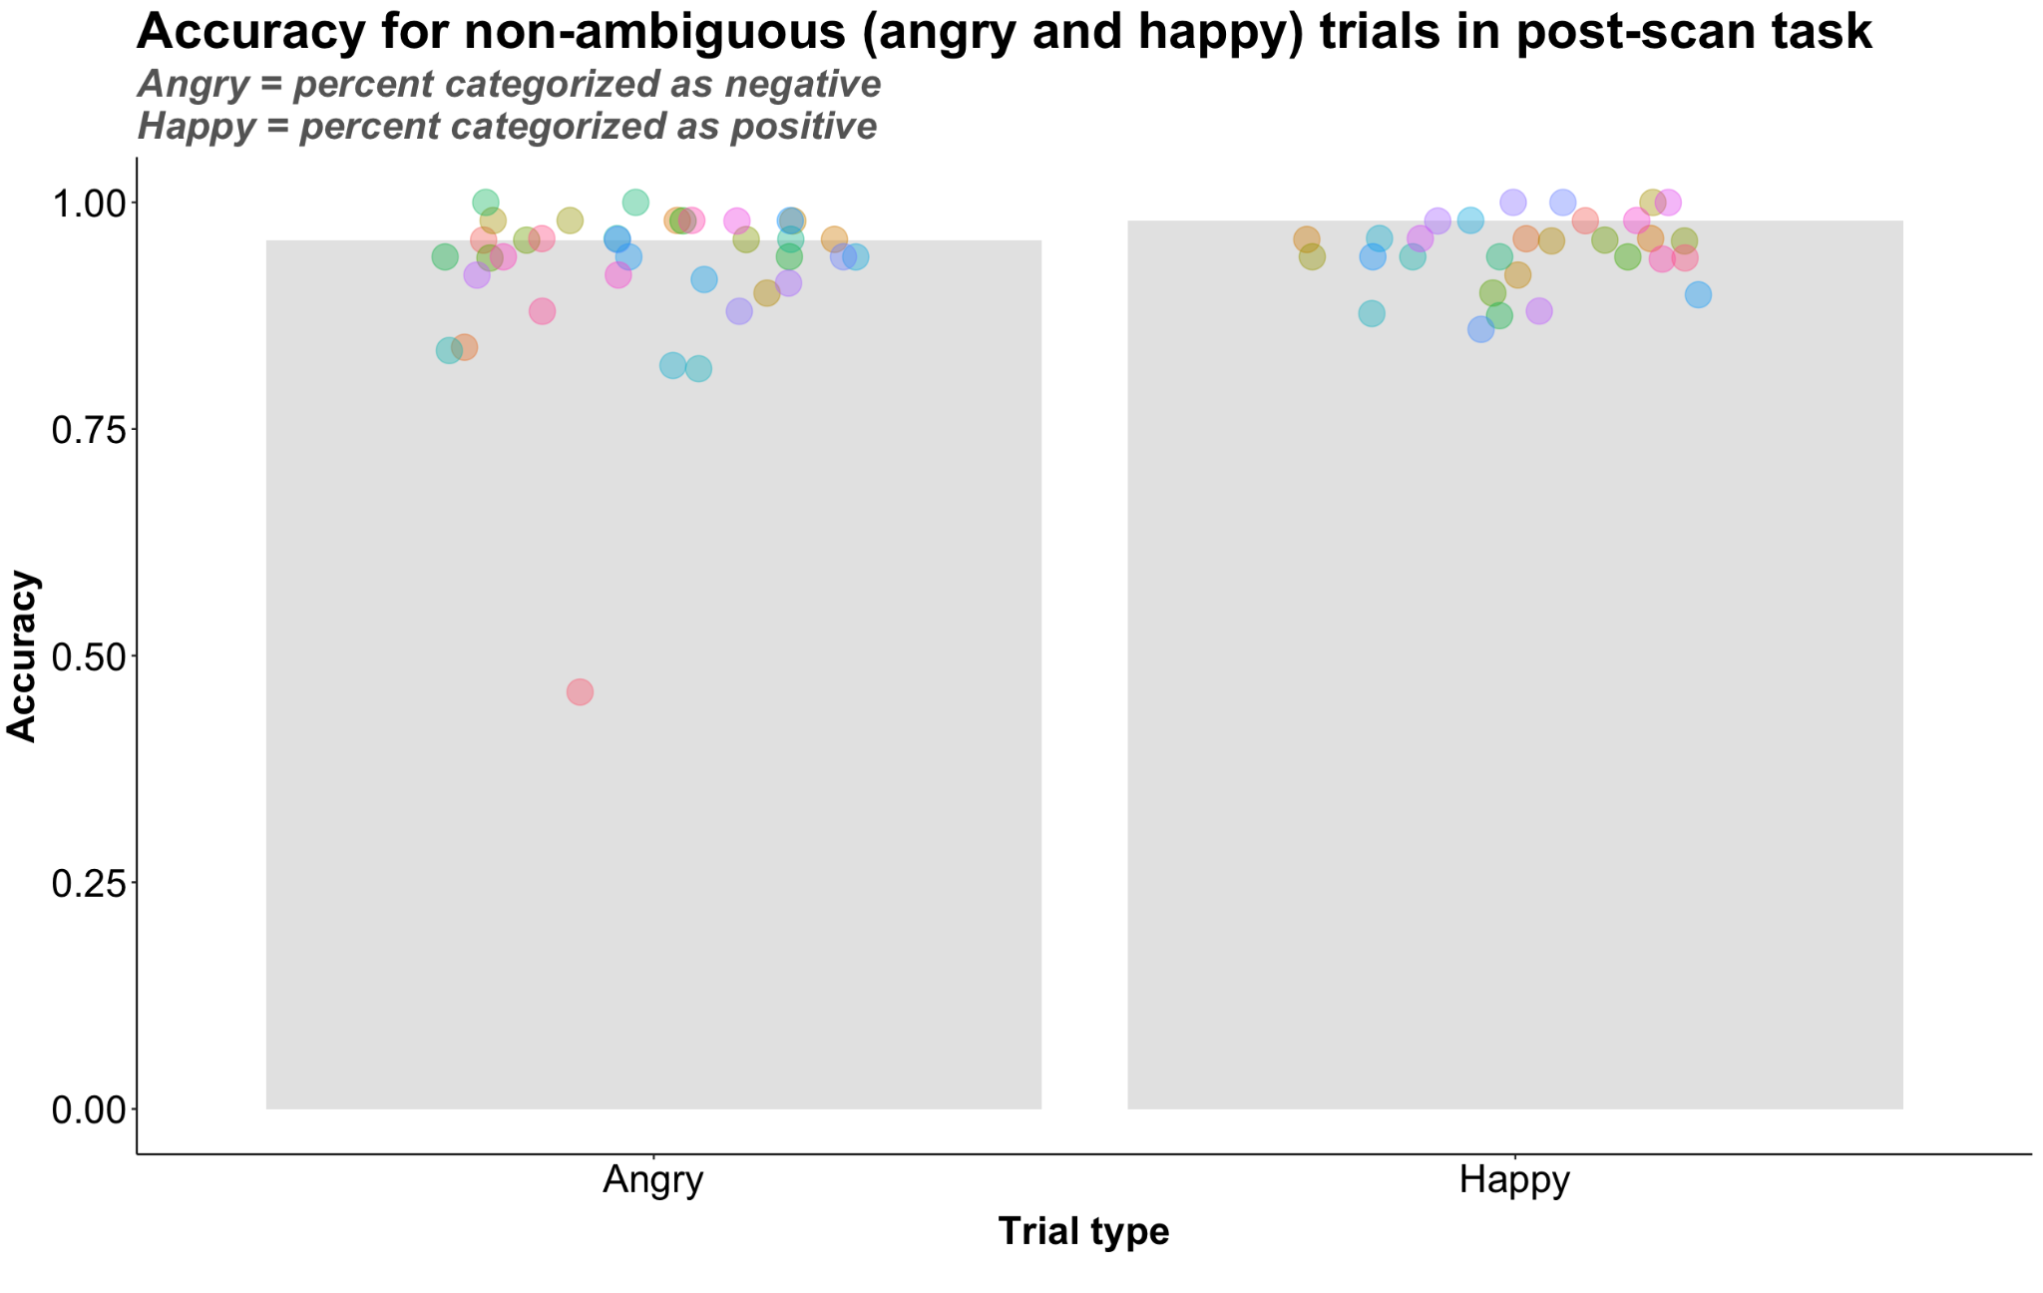
Supplemental Figure 3. Accuracy for threatening (angry) and nonthreatening (happy) trials in post-scan task.

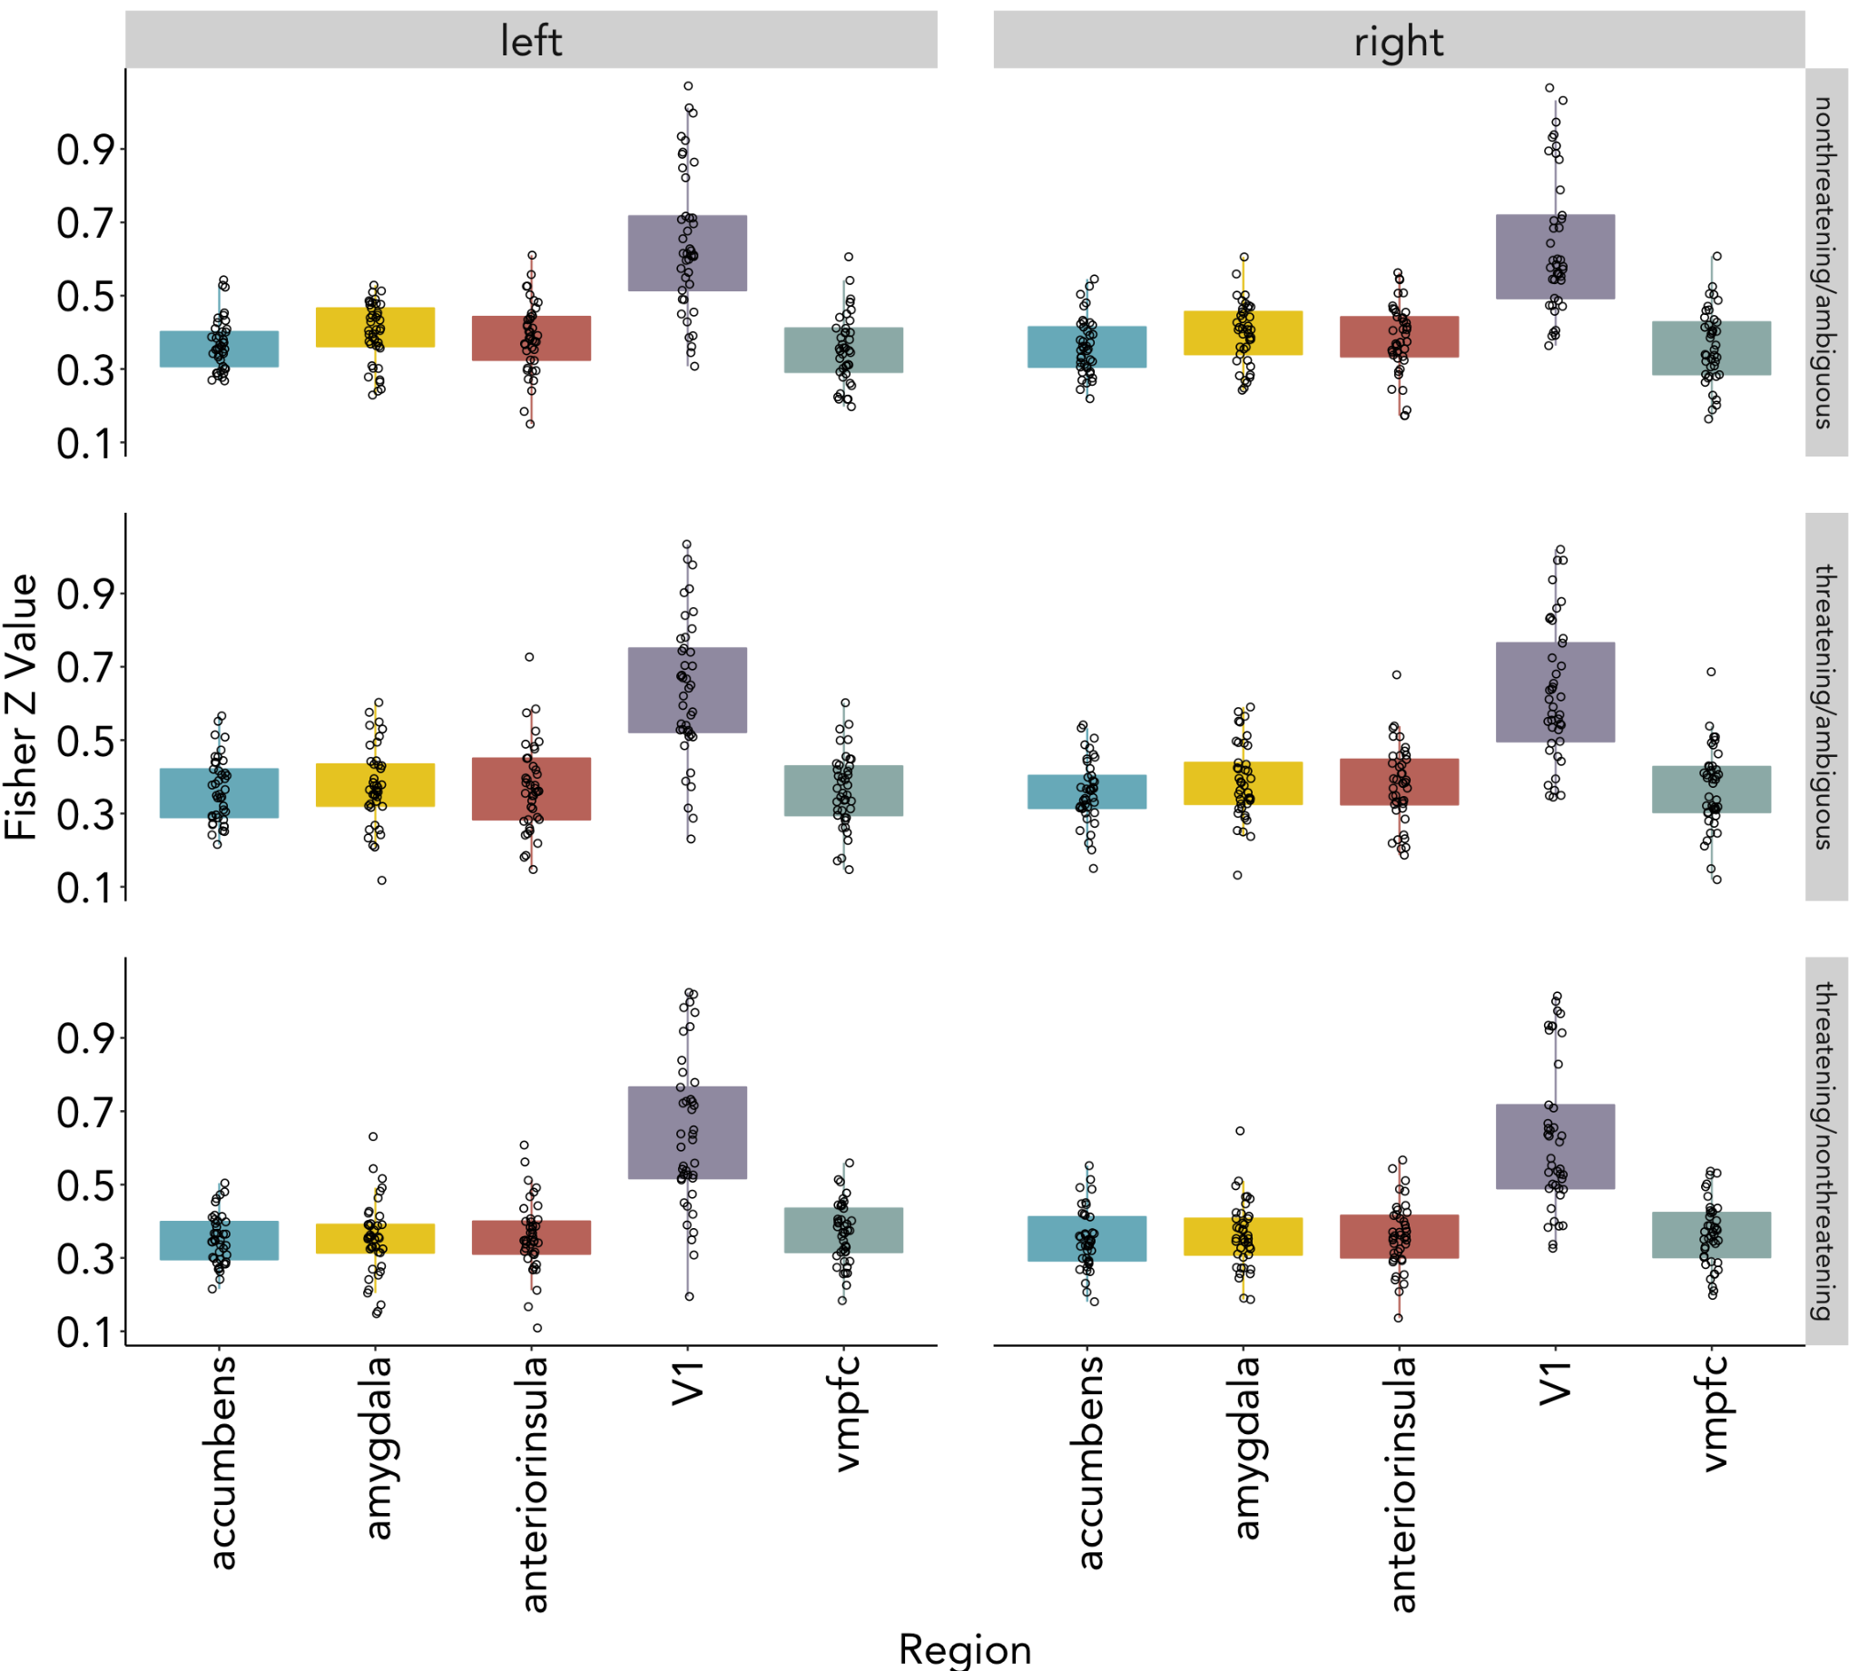
Supplemental Figure 4. Fisher-z correlation values from RSA by condition pair within each region of interest.

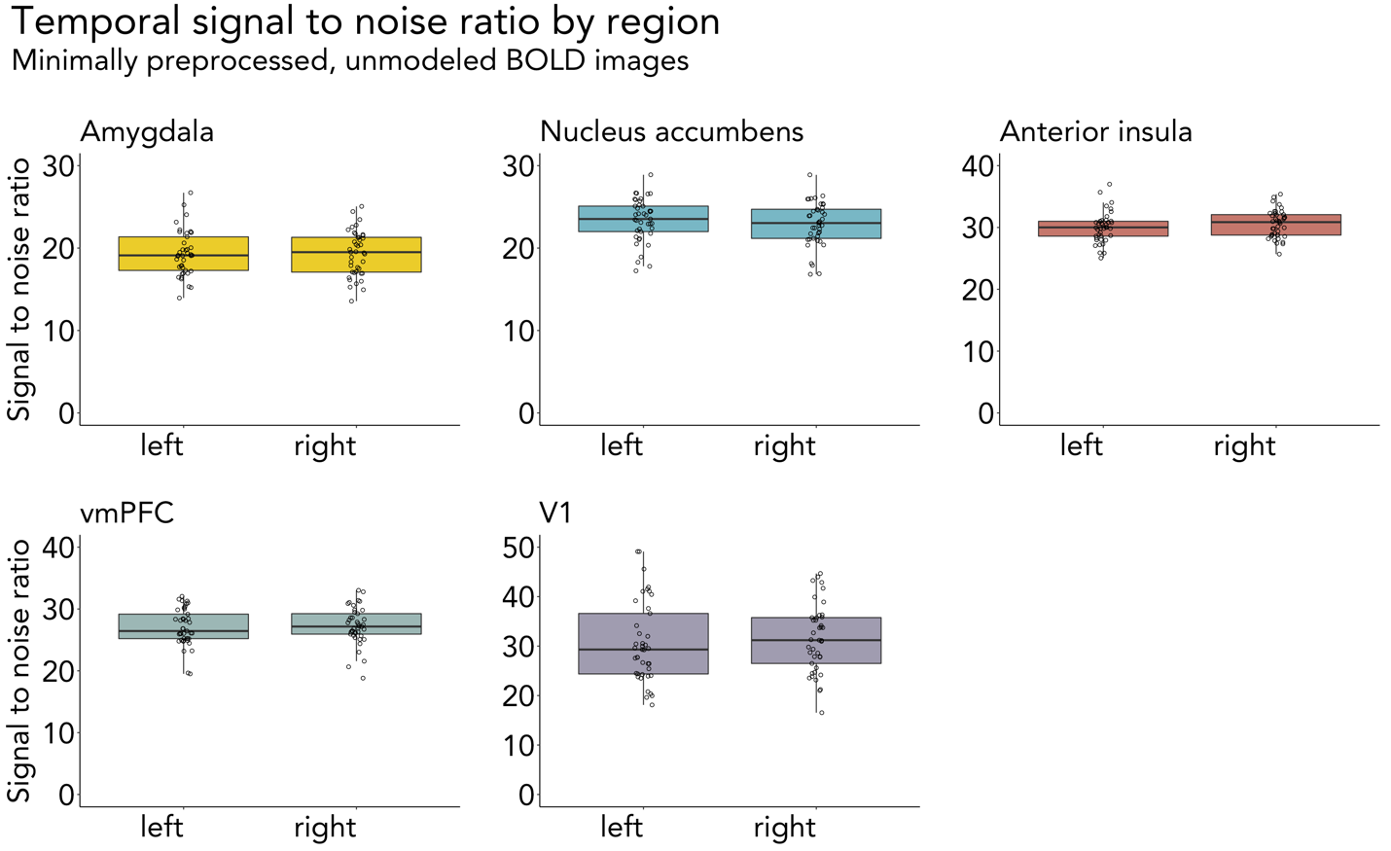
Supplemental Figure 5. Temporal signal-to-noise ratio in regions of interest. Calculated in minimally preprocessed BOLD images that had motion correction, but no spatial smoothing.

