Supplementary Material
“The Double Jeopardy of Low Family Income and Negative Emotionality:
The Family-Stress Model Revisited”

Content:

- Table 1S. Indirect effects from family income to children’s behavior problems for girls and boys
- Table 2S. ANOVA of gender differences for each study variable
- Table 3S. Bivariate correlations among study variables
- Table 4S. Moderated multiple regression analysis in predicting family stressors, externalizing and internalizing problem behaviors
- Table 5S. Indirect effects from family income to children’s behavior problems for low, moderate, high and very high negative emotionality groups
- Table 6S. Regression analysis results for family income predicting negative emotionality measures
- Table 7S. Indirect effects from family income to children’s behavior problems for low vs. moderate vs. high negative emotionality groups (18-month only)
- Table 8S. Supplementary Multigroup Family Stress Model; Indirect effects from family income to children’s behavior problems for low, moderate, and high negative emotionality groups

- Figure 1S. Measurement model for second-order family stressors variable
- Figure 2S. Measurement model for child behavior problems
- Figure 3S. Supplementary Multigroup Family Stress Model outlining the proposed Compounding Stress, Diathesis-Stress, and Double Jeopardy hypothesis
- Figure 4S. Supplementary structural Family Stress Model; family income in the first three years of life impacts on child externalizing and internalizing problems at age 5 mediated through external locus of control, maternal distress, and relationship dissatisfaction age 3

Table 1S. Indirect effects from family income to children’s behavior problems for girls and boys
 | Girls | Boys | Group difference
 | β (SE) | β (SE) | p
Direct paths
Family income family stressors | -.163 (.013)*** | -.192 (.012)*** | .079
Family income externalizing problems | -.028 (.011)** | -.002 (.011) | .097
Family income internalizing problems | -.027 (.011)** | -.008 (.011) | .031
Family stressors externalizing problems | .323 (.013)*** | .426 (.015)*** | .000
Family stressors internalizing problems | .313 (.015)*** | .379 (.016)*** | .005
Indirect paths
Family income family stressors externalizing problems | -.053 (.005)*** | -.082 (.006)*** | .000
Family income family stressors internalizing problems | -.082 (.006)*** | -.073 (.006)*** | .002
Total effects (indirect + direct)
Family income externalizing problems | -.081 (.011)*** | -.084 (.010)***
Family income internalizing problems | -.051 (.005)*** | -.065 (.011)***
Note. N_{girls} = 38907; N_{boys} = 40982.
** .001 ≤ p < .01
*** p < .001

Table 2S. ANOVA of gender differences for each study variable
 | Mean Values |  | F | df | p
 | Boys | Girls
Log of family incomeª | 1.934 | 1.936 | 1.09 | 1 | .295
Child negative emotionalityª | 2.753 | 2.774 | 16.08 | 1 | .000
Maternal distress^{b} | 1.284 | 1.277 | 3.91 | 1 | .048
Relationship dissatisfaction^{b} | 1.997 | 1.983 | 3.26 | 1 | .070
External locus of control^{b} | 1.949 | 1.938 | 5.11 | 1 | .023
Child externalizing problems^{c} | 1.358 | 1.323 | 160.46 | 1 | .000
Child internalizing problems^{c} | 1.248 | 1.250 | 1.10 | 1 | .293
Note. ª Average across the first three years. ^{b} Measured at age three. ^{c} Measured at age five. Gender differences are calculated based on mean values.

Table 3S. Bivariate correlations among study variables
 | 1 | 2 | 3 | 4 | 5 | 6 | 7
- Log of family incomeª | -
- Negative emotionalityª | -.035** | -
- Maternal distress^{b} | -.120** | .015** | -
- Relationship dissatisfaction^{b} | -.059** | .129** | .372** | -
- External locus of control^{b} | -.009** | .243** | .219** | .193** | -
- Externalizing problems^{c} | -.084** | .296** | .182** | .160** | .251** | -
- Internalizing problems^{c} | -.067** | .229** | .177** | .107** | .186** | .375** | -
Note. ª Average across the first three years. ^{b} Measured at age three. ^{c} Measured at age five. Correlations are calculated based on mean values.
* p < .05; ** p < .001.

Table 4S. Moderated multiple regression analysis in predicting family stressors, externalizing and internalizing problem behaviors
 | Child Externalizing problemsª |  |  |  | Child Internalizing problemsª |  |  |  | Family Stressorsª
Predictor Variables | β | SE | p | [95% CI] | β | SE | p | [95% CI] | β | SE | p | [95% CI]
Family income (log of) | .138 | .083 | .097 | [-.024; .302] | .106 | .086 | .216 | [-.062; .275] | -.025 | .042 | .550 | [-.108; .057]
Child negative emotionality | .580 | .059 | .000 | [.463; .697] | .450 | .061 | .000 | [.329; .570] | .418 | .029 | .000 | [.361; .475]
Family stressors | .130 | .031 | .000 | [.069; .191] | .001 | .032 | .953 | [-.060; .064] | –
Negative emotionality X family income | -.099 | .031 | .001 | [-.156; -.042] | -.080 | .029 | .007 | [-.139; -.021] | -.077 | .014 | .000 | [-.106; -.048]
Negative emotionality X family stressors | .054 | .010 | .000 | [.033; .075] | .081 | .010 | .000 | [.060; .103] | –
Note. ª Standardized scores. Adjusted for birth weight, year of birth, number of children and adults in the family, child’s gender, western and non-western immigrant background, maternal education, and mothers’ age at birth.

Table 5S. Indirect effects from family income to children’s behavior problems for low, moderate, high and very high negative emotionality groups
 |  |  |  | Group differences (p)
 |  |  |  | Low (1) | Moderate (2) | High (3) | Very High (4)
 |  | β (SE)
H1₁: Family income family stressors |  | -.117 (.017)*** | 1 | -
 |  | -.139 (.015)*** | 2 | .368 | -
 |  | -.168 (.013)*** | 3 | .025 | .174 | -
 |  | -.166 (.013)*** | 4 | .030 | .200 | .942 | -
H2₁: Family stressors externalizing problems |  | .199 (.017)*** | 1 | -
 |  | 240 (.019)*** | 2 | .108 | -
 |  | .282 (.020)*** | 3 | .002 | .109 | -
 |  | .423 (.023)*** | 4 | .000 | .000 | .000 | -
H2₂: Family stressors internalizing problems |  | .163 (.018)*** | 1 | -
 |  | 209 (.019)*** | 2 | .104 | -
 |  | .285 (.023)*** | 3 | .000 | .012 | -
 |  | .499 (.026)*** | 4 | .000 | .000 | .000 | -
H3₁: Family income family stressors externalizing problems |  | -.023 (.004)*** | 1 | -
 |  | -.033 (.005)*** | 2 | .098 | -
 |  | -.047 (.005)*** | 3 | .000 | .036 | -
 |  | -.070 (.007)*** | 4 | .000 | .000 | .002 | -
H3₂: Family income family stressors internalizing problems |  | -.019 (.003)*** | 1 | -
 |  | -.029 (.004)*** | 2 | .081 | -
 |  | -.048 (.005)*** | 3 | .000 | .006 | -
 |  | -.083 (.008)*** | 4 | .000 | .000 | .000 | -
Total Effect
Family income externalizing problems |  | β (SE) |  | -.038 (.013)** | -.033 (.015)* | -.096 (.014)*** | -.111 (.016)***
Family income internalizing problems |  | β (SE) |  | -.027 (.014)* | -.049 (.015)** | -.076 (.014)*** | -.085 (.017)***
Note. Adjusted for birth weight, year of birth, number of children and adults in the family, child’s gender, western and non-western immigrant background, maternal education, and mothers’ age at birth. * .01 ≤ p < .05; ** .001 ≤ p < .01; *** p < .001

Table 6S. Regression analysis results for family income predicting negative emotionality measures
 |  | Log of Family Income
Outcome Variablesª | β | SE | t | p | [95% CI]
18-month measure of negative emotionality | -.009 | .016 | -0.56 | .575 | [-.042; .023]
36-month measure of negative emotionality | -.066 | .018 | -3.56 | .000 | [-.102; -.029]
Average measure of negative emotionality | -.033 | .016 | -2.10 | .036 | [-.065; -.002]
Note. ª Standardized scores. Adjusted for birth weight, year of birth, number of children and adults in the family, child’s gender, western and non-western immigrant background, maternal education, and mothers’ age at birth.

Table 7S. Indirect effects from family income to children’s behavior problems for low vs. moderate vs. high negative emotionality groups (18-month only)
 | Levels of Negative Emotionality |  |  | Group difference
 | Low (L) | Moderate (M) | High (H) | L – M | M – H | L – H
 | β (SE) | β (SE) | β (SE) | p | p | p
Direct paths
H1₁: Family income family stressors | -.149 (.019)*** | -.159 (.017)*** | -.192 (.012)*** | .627 | .054 | .024
H2₁: Family stressors externalizing problems | .258 (.018)*** | .286 (.018)*** | .412 (.017)*** | .269 | .000 | .000
H2₂: Family stressors internalizing problems | .205 (.019)*** | .248 (.019)*** | .451 (.021)*** | .151 | .000 | .000
Indirect paths
H3₁: Family income family stressors externalizing problems | -.038 (.006)*** | -.045 (.006)*** | -.070 (.006)*** | .322 | .000 | .000
H3₂: Family income family stressors internalizing problems | -.031 (.005)*** | -.039 (.005)*** | -.077 (.006)*** | .211 | .000 | .000
Total effects (indirect + direct)
Family income externalizing problems | -.034 (.014)** | -.067 (.013)*** | -.098 (.012)***
Family income internalizing problems | -.035 (.014)* | -.055 (.013)*** | -.082 (.012)***
Note. Adjusted for birth weight, year of birth, number of children and adults in the family, child’s gender, western and non-western immigrant background, maternal education, and mothers’ age at birth. N_{Low} = 12198; N_{Moderate} = 16652; N_{High} = 23947.
*** p ≤ .001; ** p < .01; * p < .05

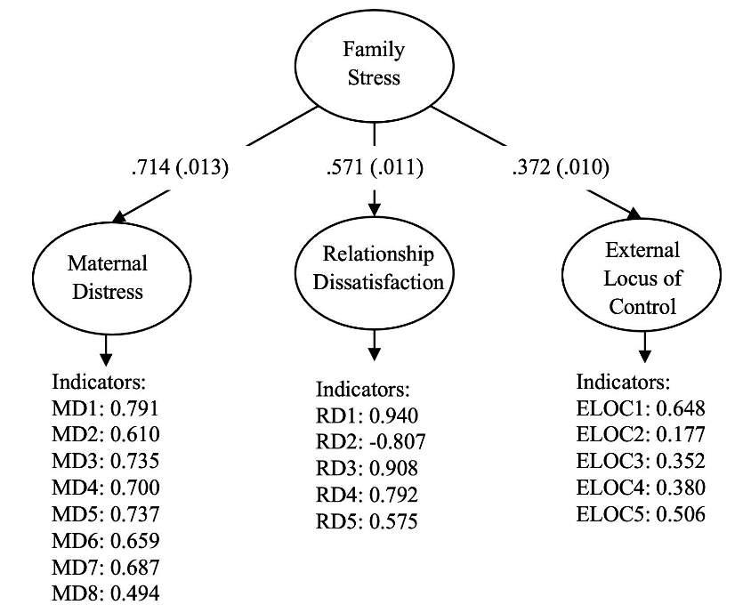
Figure 1S. Measurement model for second-order family stressors variable

Note. Standardized estimates are displayed, all significant at p<.001. Model fit: χ² (129) = 11567.736, p < .001, RMSEA = .046, SRMR = .043, CFI/TLI = .945/.935

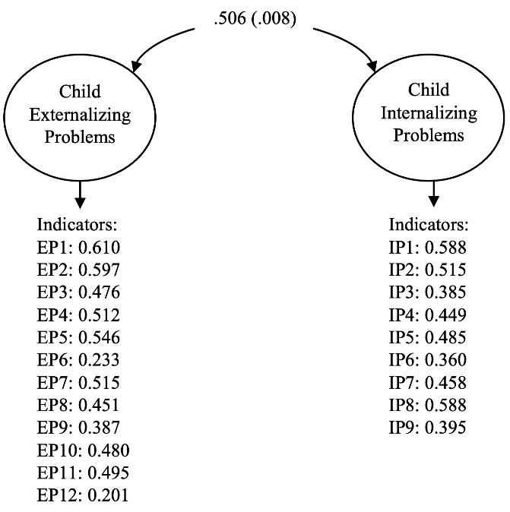
Figure 2S. Measurement model for child behavior problems

Note. Standardized estimates are displayed, all significant at p<.001. Model fit: χ² (185) = 14289.088, p < .001, RMSEA = .044, SRMR = .044, CFI/TLI = .867/.84
A Test of Alternative Model
Purpose
Our objective in this additional analysis is to test our three hypothesized models on the moderating role of negative emotionality on specific FSM paths. Specifically, the compounding stress hypothesis is supported if the associations between family income and parenting measures (locus of control [H1_{1S}], maternal distress [H1_{2S}], relationship satisfaction [H1_{3S}]), and the association of maternal distress with other stressors (locus of control [H1_{4S}] and relationship satisfaction [H1_{5S}]) are stronger for children with higher negative emotionality than those with lower negative emotionality (see a paths in Figure 3S). The diathesis-stress hypothesis is supported if we find evidence that the association between measures of the family environment (locus of control [H2_{1S}], maternal distress [H2_{2S}], relationship satisfaction [H2_{3S}]) and behavior problems is stronger for children rated higher on negative emotionality (see b paths in Figure 3S). Finally, the double jeopardy hypothesis is supported if we find that children’s negative emotionality moderates the effects of both low family income on parenting measures and moderates adverse family context in predicting more externalizing and internalizing behaviors (see a and b paths in Figure 3S). Moreover, we find support for specific double jeopardy if we find moderated paths involving specific family environment measures (locus of control [H3_{1S}], maternal distress [H3_{2S}], relationship satisfaction [H3_{3S}], and combined effect of maternal distress and parental locus of control [H3_{4S}], and maternal distress and relationship satisfaction [H3_{5S}]) are moderated by negative emotionality, both for associations between family income and family measures (i.e., a paths) and family measures with behavioral problems (i.e., b paths). A general double jeopardy hypothesis is supported if both a and b paths are moderated, but not involving the same specific measure of the family environment.

Results
Direct and Indirect Effects
In Figure 4S, we show a path model with standardized coefficients for model direct effects (e.g., family income to family stressors, family stressors to child problem behaviors), omitting paths for the measurement models. The structural model yielded acceptable model fit [χ² (1164) = 49114.916, p < .001, RMSEA = .023, SRMR = .031, CFI/ TLI = .881/.872]. Overall, the model was partly consistent with the FSM—the indirect effects through family variables explained 30% and 44% of the association between the log of family income and externalizing and internalizing problems, respectively. In total, one standard deviation higher log of family income (e.g., the difference between the 5th and the 15th percentile) was associated with 8.1% and 7.1% of standard deviation lower scores on externalizing and internalizing problems, respectively. Of these effects, the family mediators explained 2.5% (externalizing) and 3% (internalizing) standard deviations. The total indirect of maternal distress, including the portion explained jointly by the other mediators, was larger compared to other mechanisms. Relationship satisfaction was the weakest mediator in terms of its indirect effect on behavioral problems.
A closer look at the specific paths of the model adds nuance to this. First, consider the paths from family income to the three mediators (external locus of control, maternal distress, and relationship dissatisfaction). One standard deviation higher log of family income was associated with 3% of a standard deviation higher lack of control, 15% of a standard deviation lower on maternal distress, and 3% of a standard deviation higher relationship dissatisfaction. While the two latter of these are consistent with our predictions, the positive association between income and lack of locus of control is the opposite of what we expected. However, to get the full picture of the association between family income and external locus of control (and relationship dissatisfaction), we must take into account that we also estimated an indirect effect through maternal distress (consistent with the theoretical model of Conger et al. 2010; Conger & Conger, 2002), and the shared variance accounted for by the correlation between the two mediators. When multiplying all paths (and the correlation), the association between family income and lack of parental control is close to zero. This is still not consistent with our prediction but is no evidence of a positive association between family income and lack of locus of control.
The second part of the model concerns associations between family environment at age three and behavior problems at age 5. Specifically, one standard deviation higher score on external locus of control and maternal distress was associated with 33% and 10% of a standard deviation higher scores on externalizing, and 21% and 18% of a standard deviation higher scores on internalizing problems at age 5. One standard deviation higher score on relationship dissatisfaction was associated with 6% of a standard deviation higher score on externalizing problems, but only 1% of a standard deviation (and not statistically significant) with internalizing problems.
Overall, in this model, where we refined the FSM to assess the influence of each individual stressor (aka maternal distress, relationship dissatisfaction, and external locus of control) on the relationship between family income and externalizing and internalizing behavior problems, we found maternal distress to be the most critical aspect of negative family environment in the Norwegian family context as it was found on previous studies (NICHD Early Child Care Research Network, 1999; McLoyd, 1990). When we compared the effect sizes, the Norwegian sample showed a slightly weaker association between family income and maternal distress compared to findings in prior studies (Gershoff et al., 2007; Linver et al., 2002). When economic pressure, as a proxy for low family income, was linked to maternal stress, effect sizes were almost two times stronger in the USA samples (e.g., Gard et al., 2020; Landers et al., 2015; Neppl et al., 2016).
Moderating Effects of Negative Emotionality: Test of Risk Hypotheses
We performed a multigroup analysis to examine whether the mediation paths varied across groups of children with higher, moderate, and lower levels of emotional reactivity. The direct and indirect parameter estimates across the groups are summarized in Table 8S.
The total association between the log of family income and externalizing problems was twice as large among children with higher- compared to moderate negative emotionality. One standard deviation higher log of family income (e.g., the difference between the 5th and the 15th percentile) was associated with 11% of a standard deviation lower score on externalizing problems among children with higher negative emotionality, compared to 4% of a standard deviation among children with lower, and 6% among children with moderate level. For internalizing problems, the difference in the association was slightly smaller, 8% of a standard deviation for the group with higher emotional reactivity compared to 4% for the group with low, and 6% for the group with moderate. Notably, for externalizing problems, the total indirect association was only 27% of the total association for children with higher emotional reactivity, and 15% and 13% for children with moderate and lower levels, respectively. For internalizing problems, the corresponding indirect associations were 40%, 18% and 14%. Although the FSM did not explain a greater share of the total association, family income showed a considerably stronger association with behavior problems among children with higher negative emotionality than those in lower groups. Yet again, a closer look at the specific parts of the models adds nuance to this initial interpretation.
In the first part of the model, family stressors are regressed on family income, including the paths from maternal distress to external locus of control and relationship dissatisfaction. The moderated model was partly consistent with the compounding stress hypothesis. Specifically, a one standard deviation increase in family income was associated with nearly 18% of a standard deviation lower level of maternal distress in the group of children with higher emotional reactivity, and around 11% in the group with lower levels, and 12% for moderate level group (H1_{2S}). However, none of the other paths in this first part of the model were moderated by negative emotionality.
In the second part of the model, externalizing and internalizing problems are regressed on the family mediators. The results yielded three paths being statistically different across groups, thus aligning with the diathesis-stress hypothesis. One standard deviation higher scores on external control were associated with 39% and 31% of standard deviation higher scores externalizing and internalizing problems, respectively, in the group with higher emotional reactivity (H2_{1S}). Similarly, one standard deviation higher score on maternal distress was associated with 20% of a standard deviation higher score on internalizing problems in the group with higher emotional reactivity (H2_{2S}). The group differences were significant at a 1% level when comparing the higher and lower groups as well as the moderate and higher groups.
The double jeopardy hypothesis predicts that negative emotionality moderates both sides of the model. The fact that we found some evidence for both the compounding stress hypothesis and the diathesis-stress hypothesis is consistent with the general double jeopardy hypothesis, although only some of the associations related to both of these models were not moderated. We also found some support for the specific double jeopardy model concerning maternal distress. The paths from family income via maternal distress to internalizing problems differed significantly at a significance level of 1% between children rated as having higher (products of path coefficient -.035), moderate (products of path coefficient being -.017) and lower (products of path coefficient being -.013) emotional reactivity (H3_{2S}). Moreover, the path from family income through maternal distress and low levels of locus of control to problem behaviors were also different across groups, -.004 and -.001 from higher- and lower emotional reactivity for externalizing and -.014 and -.003 from higher- and lower emotional reactivity for internalizing (H3_{4S}). Albeit statistically not strong, children in lower and higher emotionality groups also differ in their scores in externalizing problems depending on how family income is indirectly associated with maternal distress and relationship satisfaction. None of the other indirect effects were statistically significant.

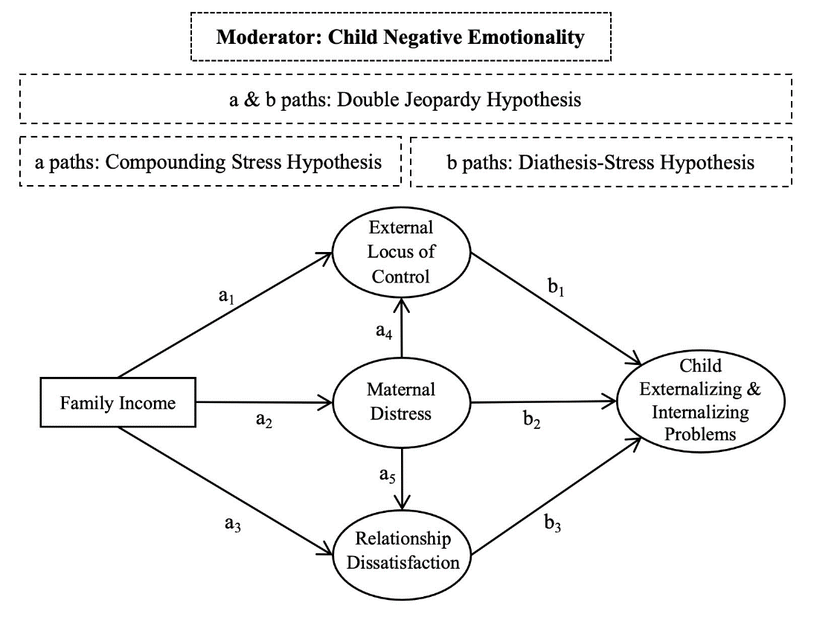
Figure 3S. Supplementary Multigroup Family Stress Model outlining the proposed Compounding Stress, Diathesis-Stress, and Double Jeopardy Hypothesis
Note. If the A paths (a₁ a₂ a₃ a₄ a₅), B paths (b₁ b₂ b₃), or both (a₁ a₂ a₃ a₄ a₅ & b₁ b₂ b₃) are stronger for children with higher negative emotionality, it supports the compounding stress hypothesis, the diathesis-stress hypothesis, and the double jeopardy hypothesis, respectively.

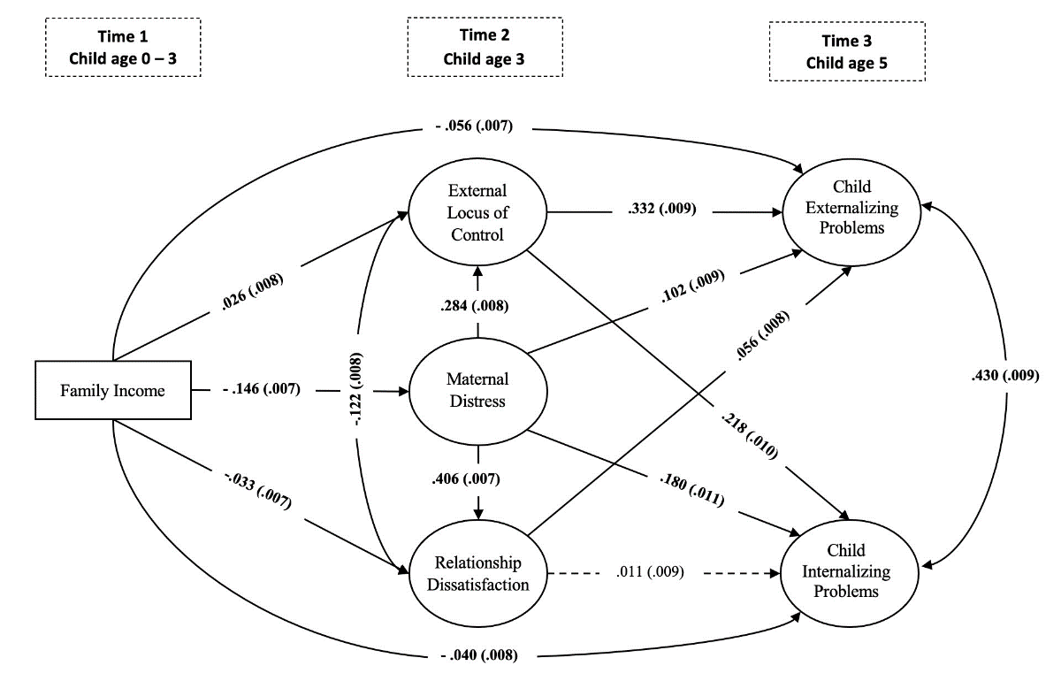
Figure 4S. Supplementary structural Family Stress Model; family income in the first three years of life impacts on child externalizing and internalizing problems at age 5 mediated through external locus of control, maternal distress, and relationship dissatisfaction age 3

Note. Adjusted for birth weight, year of birth, number of children and adults in the family, child’s gender, western and non-western immigrant background, maternal education, and mothers’ age at birth. Measurement models were not included in the model for reasons of brevity. Standardized coefficients (standard errors in parentheses) are presented in the figure. Solid lines indicate statistically significant path coefficients at p < .001. A dashed line indicates nonsignificant association.

Table 8S. Supplementary Multigroup Family Stress Model; Indirect effects from family income to children’s behavior problems for low, moderate, and high negative emotionality groups
 | Low  Negative Emotionality | Moderate Negative Emotionality | High  Negative Emotionality | Group Difference
 |  |  |  | L – M | M – H | L – H
 | β (SE) | β (SE) | β (SE) | p | p | p
Direct effects
H1_{1s}: Family income parental control | .026 (.014) | .028 (.015) | .028 (.014)* | .948 | .987 | .932
H1_{2s}: Family income maternal distress | -.107 (.011)*** | -.120 (.012)*** | -.175 (.012)*** | .415 | .002 | .000
H1_{3s}: Family income relationship dissatisfaction | -.033 (.011)** | -.034 (.012)** | -.030 (.010)** | .945 | .793 | .845
H1_{4s}: Maternal distress external control | .251 (.015)*** | .233 (.014)*** | .265 (.012)*** | .345 | .105 | .613
H1_{5s}: Maternal distress relationship dissatisfaction | .404 (.013)*** | .391 (.012)*** | .397 (.010)*** | .401 | .892 | .429
H2_{1s}: External control externalizing problems | .123 (.017)*** | .229 (.016)*** | .386 (.019)*** | .062 | .000 | .000
H2_{1s}: External control internalizing problems | .193 (.014)*** | .141 (.016)*** | .305 (.027)*** | .254 | .000 | .000
H2_{2s}: Maternal distress externalizing problems | .098 (.015)*** | .074 (.017)*** | .080 (.016)*** | .306 | .664 | .573
H2_{2s}: Maternal distress internalizing problems | .123 (.017)*** | .142 (.017)*** | .203 (.020)*** | .437 | .009 | .001
H2_{3s}: Relationship dissatisfaction externalizing problems | .033 (.013)** | .069 (.015)*** | .060 (.014)*** | .065 | .805 | .111
H2_{3s}: Relationship dissatisfaction internalizing problems | .010 (.013)** | .016 (.015) | -.005 (.016) | .760 | .359 | .474
Indirect effects
H3_{1s}: Family income parental control externalizing problems | .005 (.003) | .006 (.003) | .011 (.005)* | .754 | .430 | .288
H3_{2s}: Family income maternal distress externalizing problems | -.010 (.002)*** | -.009 (.002)*** | -.014 (.003)*** | .611 | .128 | .238
H3_{3s}: Family income relationship dissatisfaction externalizing problems | -.001 (.001)* | -.002 (.001)* | -.002 (.001)* | .251 | .724 | .379
H3_{4s}: Family income maternal distress external control externalizing problems | -.005 (.001)*** | -.006 (.001)*** | -.018 (.002)*** | .246 | .000 | .000
H3_{5s}: Family income maternal distress relationship dissatisfaction externalizing problems | -.001 (.001)** | -.003 (.001)*** | -.004 (.001)*** | .061 | .406 | .015
H3_{1s}: Family income external control internalizing problems | .003 (.002) | .004 (.002) | .009 (.004)* | .764 | .291 | .204
H3_{2s}: Family income maternal distress internalizing problems | -.013 (.002)*** | -.017 (.003)*** | -.035 (.004)*** | .258 | .000 | .000
H3_{3s}: Family income relationship dissatisfaction internalizing problems | .000 (.000) | -.001 (.001) | .000 (.001) | .756 | .357 | .471
H3_{4s}: Family income maternal distress external control internalizing problems | -.003 (.001)*** | -.004 (.001)*** | -.014 (.002)*** | .346 | .000 | .000
H3_{5s}: Family income maternal distress relationship dissatisfaction internalizing problems | .000 (.001) | -.001 (.001) | .000 (.001) | .727 | .420 | .537
Total indirect effect
Family income externalizing problems | -.013 (.004)*** | -.015 (.004)** | -.027 (.006)***
Family income internalizing problems | -.014 (.003)*** | -.018 (.004)*** | -.040 (.006)***
Total effects
Family income externalizing problems | -.038 (.011)** | -.064 (.013)*** | -.110 (.012)***
Family income internalizing problems | -.040 (.012)** | -.062 (.013)*** | -.084 (.014)***
Note. Adjusted for birth weight, year of birth, number of children and adults in the family, child’s gender, western and non-western immigrant background, maternal education, and mothers’ age at birth. * .01 ≤ p < .05; ** .001 ≤ p < .01; *** p < .001

