SUPPLEMENTARY MATERIALS
Impact of maternal cognitive functioning and psychopathology on quality of parent-child relationship in the context of Substance Use Disorder: A 15-month longitudinal study

Summary
Maternal cognitive functioning and psychopathology predict quality of parent-child relationship in the context of Substance Use Disorder: A 15-month longitudinal study 1
Figure S1. One factor solution, confirmatory factor analysis 2
Table S1. Results of the model with non imputated data 3
Table S2. Results of the model with no quadratic effect 4

Figure S1. One factor solution, confirmatory factor analysis

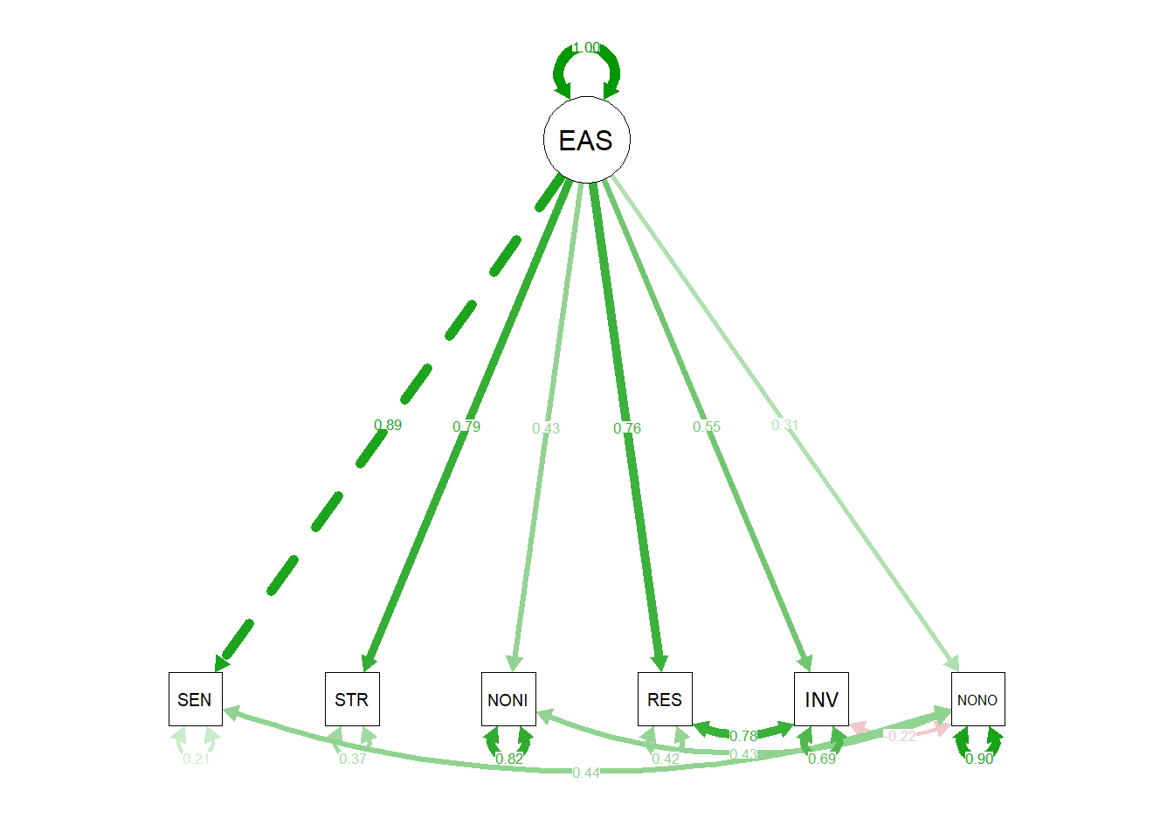

SEN = Sensitivity, STR = Structuring, NONI = Nonintrusiveness, RES = Responsiveness, INV = Involvement, NONO = Nonhostility

Table S1. Results of the model with non imputated data

 | b | SE | t | p
Intercept | 3.87 | 0.67 | 5.81 | < .001
Time | -9.44 | 6.46 | -1.46 | .145
Time² | -12.28 | 4.79 | -2.56 | .011
Cognitive Functioning | 0.01 | 0.01 | 0.89 | .372
Psychopathology | -0.32 | 0.11 | -3.07 | .002
Time*Cognitive Functioning | 0.13 | 0.08 | 1.74 | .083
Time²*Cognitive Functioning | 0.15 | 0.06 | 2.54 | .012
Time*Psychopathology | 0.92 | 1.03 | 0.89 | .376
Time²*Psychopathology | 1.50 | 0.77 | 1.96 | .050
Random Effects
σ2 | 0.14
τ00 ID | 0.19
ρ01 | -0.24
ICC | 0.62
N ID | 60
Marginal R2 / Conditional R2 | 0.154 / 0.677

Table S2. Results of the model with no quadratic effect

 | b | SE | t | p
Time | -0.32 | 0.21 | -1.54 | .123
Cognitive Functioning | -0.01 | 0.01 | -0.67 | .506
Psychopathology | -0.43 | 0.17 | -2.60 | .010
Time * Cognitive Functioning | 0.00 | 0.00 | 1.82 | .070
Time * Psychopathology | 0.03 | 0.03 | 0.99 | .324
Random Effects
σ² | 0.17
τ₀₀ _{ID} | 0.38
τ₁₁ _{ID.T} | 0.01
ρ₀₁ _{ID} | -0.74
ICC | 0.56
N _{ID} | 60
Marginal R² / Conditional R² | 0.135 / 0.623

