**Supplementary material:**

**Measures:**

*Childhood Adversities (CA):*

The cumulative childhood adversity scale (CA) included the following events: suffering/having a family member suffering from a chronic medical illness; parents fighting/screaming at each other/hitting each other/quarrelling a lot; being forced by parents to carry out chores that are difficult or dangerous for someone of the child’s age; being neglected by parents; not being provided with basic needs (clothes, or shoes) so that parents can spend money on themselves; being forced by parents to work in order to make money; having parents who are irritable and who often get easily angry for many years; having parents who often use bad words with the child; and being hit by siblings. ICAST adversities included: Violence exposure (seeing someone at home using knives, guns, stick, rocks or other things to hurt or scare someone else inside the home), psychological victimization (parents doing any of the following to the child: saying they wished you were dead/hadn’t been born; locking you out of the home for a long time; screamed at you in a loud voice or in a violent manner; threatened to leave you or abandon you forever), Physical punishment (threatening to hurt you (including invoking evil spirits against you) or kill you; pushing/grabbing or kicking you; hitting, beating, or spanking you with a hand; hitting, beating, or spanking you with a belt, paddle, a stick or other object; choked you, smothered you or tried to drown you; burned or scalded you, (including putting hot chilies or peppers in your mouth); locked you up in a small place, tied you up, or chained you to something; made you stay in one position holding a heavy load or another burden or making you do exercise as punishment; threatened you with a knife or a gun; pulled your hair, pinched you, or twisted your ear) and Neglect items (the child feeling like he/she did not get enough to eat (went hungry) and/or drink (were thirsty) even though there was enough for everyone; the child feeling uncared for).

**Distribution of Childhood Adversities items**

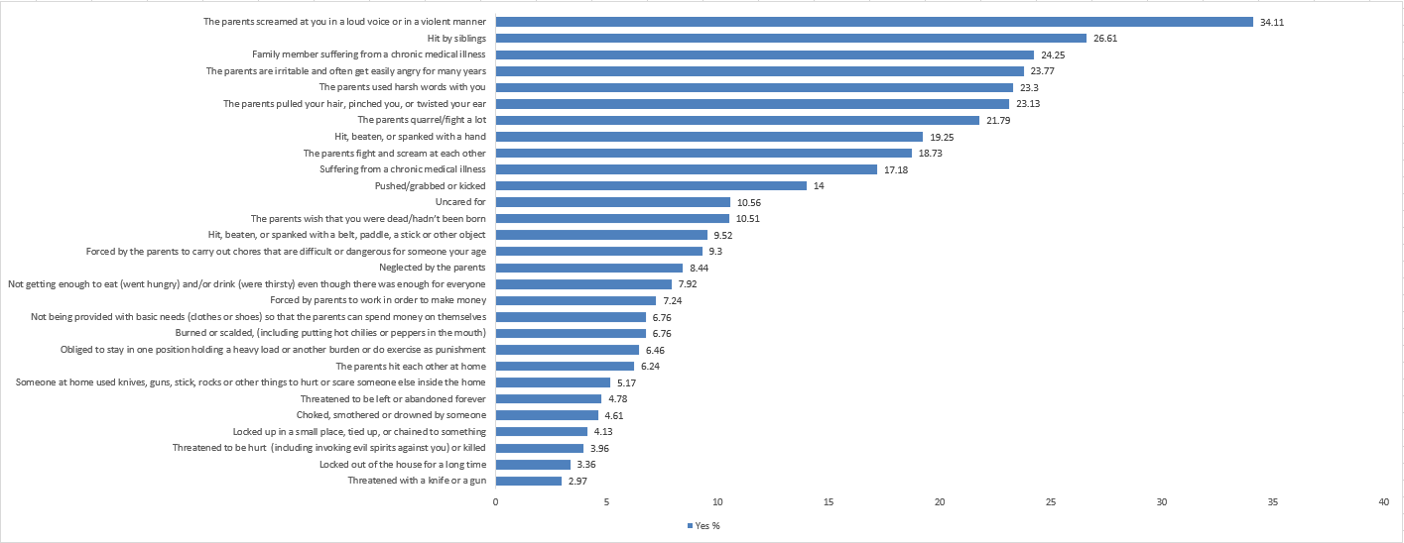

*Positive Home Experiences (PHE):*

The nine items of the cumulative positive home experiences scale (PHE) were: “my parents spend enough time to listen and talk to me”, “my siblings and I help each other in difficult times”, “my parents provide me with security and safety”, “I have leisure activities other than watching TV”, “my parents are present during lunch/dinner time”, “my parents are present with me during play time”, “my parents are present with me during bed time”, “my parents are present with me during homework”, and “I don't lack help at home in my studies”.

**Distribution of Positive Home Experiences items**

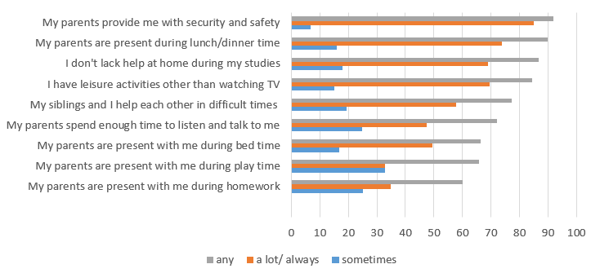

**Tables:**

**Table S1: Descriptives (N=2,412, after imputation)**

|  |  |
| --- | --- |
| Variable | N (%)^ |
| Age (in years) | 12.40 ± 1.68 |
| Gender  Male  Female | 1163 (48.20)  1249 (51.80) |
| PHE** score | 12.14 ± 3.66 |
| CA** score | 3.35 ± 4.31 |
| ES** score | 5.32 ± 0.86 |
| PTSD** score | 7.92 ±8.82 |

^: mean ± sd for continuous variables

**: PHE: Positive Home Experiences, CA: Childhood Adversities, ES: Environmental Sensitivity, PTSD: Post-Traumatic Stress Disorder

**Table S2: Correlation matrix of study variables (after imputation).**

|  |  |  |  |  |  |  |  |
| --- | --- | --- | --- | --- | --- | --- | --- |
|  | | PTSD | ES | CA | PHE | Age | Gender (F) |
| PTSD | Correlation coefficient |  | .099*** | .435*** | -.154*** | .010 | .040* |
| p-value |  | <.001 | <.001 | <.001 | .634 | .047 |
| ES | Correlation coefficient |  |  | -.004 | .029 | .160*** | .092*** |
| p-value |  |  | .837 | .160 | <.001 | <.001 |
| CA | Correlation coefficient |  |  |  | -.331*** | -.099*** | -.114*** |
| p-value |  |  |  | <.001 | <.001 | <.001 |
| ­PHE | Correlation coefficient |  |  |  |  | -.049* | .075*** |
| p-value |  |  |  |  | .017 | <.001 |
| Age | Correlation coefficient |  |  |  |  |  | -.035 |
| p-value |  |  |  |  |  | .084 |

\*\*\**p*<.001, \*\**p*<.01, \**p*<.05.

|  |  |  |  |  |  |  |
| --- | --- | --- | --- | --- | --- | --- |
| **Table S3 Results from models testing the moderating effects of environmental sensitivity between PHE and CAs with PTSD in Lebanese children and adolescents (combined model)** | | | | | | |
| Predictor | B | 95%CI | t | p | R2 | △R2 |
| **Step 1** |  |  |  |  |  |  |
| Gender | .079 | [-.001, .159] | 1.947 | .052 | .002 | .002 |
| Age | .007 | [-.017, .030] | .546 | .585 |  |  |
| **Step 2** |  |  |  |  |  |  |
| PHE_medium | -.018 | [-.107, .072] | -.385 | .700 | .161 | .159*** |
| PHE_high | -.060 | [-.161, .041] | -1.166 | .244 |  |  |
| CAs_medium | .317*** | [.226, .409] | 6.836 | <.001 |  |  |
| CAs_high | .954*** | [.858, 1.050] | 19.481 | <.001 |  |  |
| **Step 3** |  |  |  |  |  |  |
| ES | .085*** | [.047, .122] | 4.447 | <.001 | .168 | .007*** |
| **Step 4** |  |  |  |  |  |  |
| ES × PHE_medium | .023 | [-.066, .112] | .506 | .613 | .170 | .003 |
| ES × PHE_ high | .008 | [-.089, .105] | .165 | .869 |  |  |
| ES × CAs_medium | .005 | [-.085, .094] | .101 | .920 |  |  |
| ES × CAs_ high | .113* | [.018, .207] | 2.338 | .019 |  |  |

***Note***. *F* (11, 2395) =37.152, *p*<.001.The displayed coefficients of the variables at all steps represent the values before inclusion of variables in the next step. PHE=Positive Home Experiences; ES=Environmental Sensitivity; CAs=Childhood Adversities. \*\*\**p*<.001, \*\**p*<.01, \**p*<.05.

**Figure S1** Moderating eﬀect of environmental sensitivity on the relation between CAs and PTSD for males (not significant).

