Supplementary materials

Figure S1
Figure shows distribution of emodiversity scores of Positive emotions.
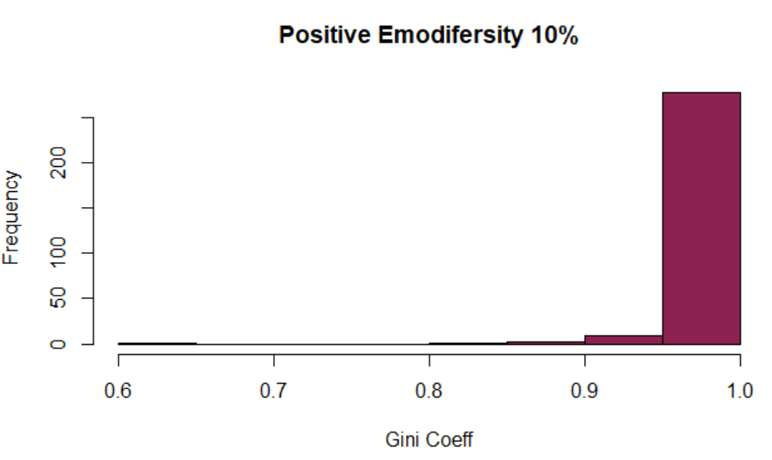
Note. High PA Emodiversity in our sample (10%) indicates that almost everyone reported to experience all six positive emotions over the study period (with scores >10 on scale 0-100). For NA the Gini scores were more nuanced, as some people only reported specific NA emotions and some emotion(s) was/were rarely reported (≥10 on scale 0-100).

Table S1
Model selection
Path nº | Maltreatment type | Path direction | Emotion dynamic | p (path) | Step/df | Model test Δχ2 | p^{dif} | Result | ß
33 | EA | → | Inertia NAA | .975 | 1 | 0.00099381 | .975 | x
86 | EN | → | Inertia PAD | .963 | 2 | 0.0021553 | .963 | x
60 | PN | → | Variability PAD | .955 | 3 | 0.0032301 | .955 | x
35 | EA | → | Emodiversity PA | .934 | 4 | 0.0067829 | .934 | x
45 | SA | → | Instability PAA | .915 | 5 | 0.011458 | .915 | x
11 | PA | → | Instability NAA | .900 | 6 | 0.015588 | .901 | x
31 | EA | → | Inertia PAA | .827 | 7 | 0.047667 | .827 | x
34 | EA | → | Inertia NAD | .839 | 8 | 0.041287 | .839 | x
16 | PA | → | Inertia NAD | .880 | 9 | 0.023120 | .879 | x
72 | PN | → | Emodiversity NA | .795 | 10 | 0.068961 | .793 | x
58 | PN | → | Mean NAD | .870 | 11 | 0.02741 | .869 | x
8 | PA | → | Variability NAD | .753 | 12 | 0.10218 | .749 | x
6 | PA | → | Variability PAD | .807 | 13 | 0.05871 | .809 | x
83 | EN | → | Instability NAA | .705 | 14 | 0.14298 | .705 | x
80 | EN | → | Variability NAD | .798 | 15 | 0.06572 | .798 | x
39 | SA | → | Mean NAA | .700 | 16 | 0.15039 | .698 | x
54 | SA | → | Emodiversity NA | .922 | 17 | 0.00966 | .922 | x
20 | EA | → | Mean PAD | .690 | 18 | 0.15767 | .691 | x
19 | EA | → | Mean PAA | .786 | 19 | 0.07367 | .786 | x
51 | SA | → | Inertia NAA | .642 | 20 | 0.20612 | .650 | x
49 | SA | → | Inertia PAA | .677 | 21 | 0.16882 | .681 | x
42 | SA | → | Variability PAD | .703 | 22 | 0.15324 | .696 | x
41 | SA | → | Variability PAA | .801 | 23 | 0.06189 | .804 | x
57 | PN | → | Mean NAA | .642 | 24 | 0.21505 | .642 | x
9 | PA | → | Instability PAA | .588 | 25 | 0.28975 | .590 | x
12 | PA | → | Instability NAD | .636 | 26 | 0.20940 | .647 | x
17 | PA | → | Emodiversity PA | .597 | 27 | 0.27391 | .601 | x
63 | PN | → | Instability PAA | .565 | 28 | 0.32169 | .571 | x
84 | EN | → | Instability NAD | .590 | 29 | 0.28874 | .591 | x
88 | EN | → | Inertia NAD | .772 | 30 | 0.08363 | .772 | x
55 | PN | → | Mean PAA | .472 | 31 | 0.54675 | .460 | x
38 | SA | → | Mean PAD | .373 | 32 | 0.79276 | .373 | x
37 | SA | → | Mean PAA | .700 | 33 | 0.14087 | .707 | x
5 | PA | → | Variability PAA | .383 | 34 | 0.65007 | .420 | x
69 | PN | → | Inertia NAA | .352 | 35 | 0.82383 | .364 | x
68 | PN | → | Inertia PAD | .389 | 36 | 0.71203 | .399 | x
64 | PN | → | Instability PAD | .385 | 37 | 0.72724 | .394 | x
52 | SA | → | Inertia NAD | .332 | 38 | 0.82372 | .364 | x
40 | SA | → | Mean NAD | .314 | 39 | 0.98897 | .32 | x
1 | PA | → | Mean PAA | .267 | 40 | 1.09910 | .295 | x
2 | PA | → | Mean PAD | .428 | 41 | 0.64175 | .423 | x
7 | PA | → | Variability NAA | .293 | 42 | 0.98740 | .320 | x
4 | PA | → | Mean NAD | .339 | 43 | 0.84963 | .357 | x
32 | EA | → | Inertia PAD | .336 | 44 | 1.13570 | .287 | x
10 | PA | → | Instability PAD | .406 | 45 | 0.71097 | .399 | x
14 | PA | → | Inertia PAD | .689 | 46 | 0.14851 | .700 | x
18 | PA | → | Emodiversity NA | .291 | 47 | 0.98962 | .320 | x
71 | PN | → | Emodiversity PA | .256 | 48 | 1.22450 | .269 | x
53 | SA | → | Emodiversity PA | .265 | 49 | 1.17670 | .278 | x
3 | PA | → | Mean NAA | .246 | 50 | 1.09940 | .294 | x
85 | EN | → | Inertia PAA | .155 | 51 | 1.98840 | .159 | x
59 | PN | → | Variability PAA | .240 | 52 | 1.35100 | .245 | x
70 | PN | → | Inertia NAD | .267 | 53 | 1.18080 | .277 | x
27 | EA | → | Instability PAA | .209 | 54 | 1.60040 | .206 | x
26 | EA | → | Variability NAD | .174 | 55 | 1.84260 | .175 | x
30 | EA | → | Instability NAD | .552 | 56 | 0.34292 | .558 | x
25 | EA | → | Variability NAA | .246 | 57 | 1.28890 | .256 | x
28 | EA | → | Instability PAD | .217 | 58 | 0.85558 | .355 | x
24 | EA | → | Variability PAD | .440 | 59 | 0.58538 | .444 | x
29 | EA | → | Instability NAA | .283 | 60 | 1.13370 | .287 | x
23 | EA | → | Variability PAA | .324 | 61 | 0.94320 | .332 | x
36 | EA | → | Emodiversity NA | .120 | 62 | 2.29090 | .130 | x
21 | EA | → | Mean NAA | .141 | 63 | 2.05350 | .152 | x
22 | EA | → | Mean NAD | .371 | 64 | 0.74571 | .388 | x
15 | PA | → | Inertia NAA | .071 | 65 | 4.03440 | .045 |  | -.05
13 | PA | → | Inertia PAA | 03 |  |  |  |  | .05
43 | SA | → | Variability NAA | .01 |  |  |  |  | .14
44 | SA | → | Variability NAD | < .000 |  |  |  |  | .15
46 | SA | → | Instability PAD | .03 |  |  |  |  | .05
47 | SA | → | Instability NAA | .01 |  |  |  |  | .13
48 | SA | → | Instability NAD | .001 |  |  |  |  | .14
50 | SA | → | Inertia PAD | .02 |  |  |  |  | -.10
56 | PN | → | Mean PAD | .009 |  |  |  |  | .08
61 | PN | → | Variability NAA | .004 |  |  |  |  | -.15
62 | PN | → | Variability NAD | .001 |  |  |  |  | -.15
65 | PN | → | Instability NAA | .01 |  |  |  |  | -.12
66 | PN | → | Instability NAD | .001 |  |  |  |  | -.15
67 | PN | → | Inertia PAA | .045 |  |  |  |  | -.06
73 | EN | → | Mean PAA | < .000 |  |  |  |  | -.22
74 | EN | → | Mean PAD | < .000 |  |  |  |  | -.31
75 | EN | → | Mean NAA | < .000 |  |  |  |  | .22
76 | EN | → | Mean NAD | < .000 |  |  |  |  | .27
77 | EN | → | Variability PAA | .008 |  |  |  |  | -.13
78 | EN | → | Variability PAD | .01 |  |  |  |  | -.12
79 | EN | → | Variability NAA | < .000 |  |  |  |  | .09
81 | EN | → | Instability PAA | .007 |  |  |  |  | -.13
82 | EN | → | Instability PAD | .003 |  |  |  |  | -.13
87 | EN | → | Inertia NAA | .001 |  |  |  |  | .16
89 | EN | → | Emodiversity PA | .05 |  |  |  |  | -.18
90 | EN | → | Emodiversity NA | .002 |  |  |  |  | .18
Note. EA - Emotional Abuse, EN – Emotional Neglect, PA – Physical Abuse, PN – Physical Neglect, SA – Sexual Abuse. PAA - Positive Affect Activation, PAD - Positive Affect Deactivation, NAA - Negative Affect Activation, NAD - Negative Affect. Deactivation. Δχ2 Satorra-Bentler corrected chi square difference test between two nested models. p^{dif} is the p-value of the difference between two models. Step is the step number in the model taken to close insignificant paths; in this case equals to the model df (degrees of freedom) since only one path was closed in each step.

Table S2
Final SEM model with imputed missing values fitted to the final model
 | Emotional Neglect |  | Physical  Neglect |  | Sexual  Abuse |  | Physical  Abuse
 | β | (SE) | β | (SE) | β | (SE) | β | (SE)
Intensity
PAA | -.23*** | (.06)
PAD | -.31*** | (.06) | .08* | (.03)
NAA | .21*** | (.05)
NAD | .27*** | (.06)
Variability
PAA | -.13* | (.05)
PAD | -.12* | (.05)
NAA | .09*** | (.02) | -.14** | (.05) | .14* | (.06)
NAD |  |  | -.15** | (.05) | .15*** | (.04)
Instability
PAA | -.13** | (.05)
PAD | -.12** | (.04) |  |  | .05* | (.02)
NAA |  |  | -.12* | (.05) | .12* | (.06)
NAD |  |  | -.15** | (.05) | .14*** | (.04)
Inertia
PAA |  |  | -.08** | (.04) |  |  | .03 | (.03)
PAD |  |  |  |  | -.09* | (.04)
NAA | .14** | (.04) |  |  |  |  | -.03 | (.03)
Emodiversity
Positive affect | -.18** | (.05)
Negative affect | .18** | (.06)
Note. In bold values that significantly changed (i.e., reached the cut-off of p <.001 or p >.05) in comparison with the original model where missing values were omitted. EA - Emotional Abuse, EN – Emotional Neglect, PA – Physical Abuse, PN – Physical Neglect, SA – Sexual Abuse. PAA - Positive Affect Activation, PAD - Positive Affect Deactivation, NAA - Negative Affect Activation, NAD - Negative Affect

S3

Z test differences between regression coefficients of emotional neglect on mean level (intensity) a) PAA and PAD; b) NAA and NAD

- z = 1.820, p = .069
- z = -1.338, p = .181

