Appendix
Section 1. Convergent validity and discriminant validity of the Campus Aggression and Bullying Scale and the Chinese version of the CDI
Section 2. Longitudinal measurement invariance test for peer victimization and depressive symptoms
Section 3. Unstandardized parameter estimation of the reciprocal effects model
Section 4. RI-CLPM pathways for boys and girls
Section 5. Explanation of sensitivity analysis
References

Section 1. Convergent validity and discriminant validity of the Campus Aggression and Bullying Scale and the Chinese version of the CDI
The convergent validity of the Campus Aggression and Bullying Scale was shown in Table S1. Although the scale have the AVE slightly less than 0.5 across the four-wave measurements, it have the excellent composite reliability (all greater than 0.7). Taken together, the scale is widely used and have psychometric properties that reflect Chinese adolescent peer victimization (Chen et al., 2018; Guo et al., 2022).
The convergent validity and discriminant validity of the Chinese version of the CDI were shown in Table S2 and Table S3, respectively. Although the scale have less desirable convergent and discriminant validity across the four-wave measurements (AVE less than 0.5, CR less than 0.7, and the square root of AVE greater than the inter-factor correlation), the Chinese version of the CDI reflects the status of depressive symptoms in adolescents. Firstly, the construct of the CDI scale is unstable, which may be the cause of poor convergent validity and discriminant validity (Ozono et al., 2019). Secondly, the CDI scale focuses on individuals’ subjective experiences of their own depressive symptoms. The experience of depressive symptoms is inherently diverse for different individuals, and they may have inconsistent understandings of the items, which may result in the construct of the CDI scale that is not easily distinguishable. Nevertheless, the present study adopted the average of scores on the five subscales as a quantitative indicator of depressive symptoms in adolescents, which is widely used and well reflects the overall status of depressive symptoms (Gao et al., 2022; Sun et al., 2021). Therefore, unsatisfactory convergent and discriminant validity of the sub-dimensions do not affect the quantification of depressive symptoms in this study (Carle et al., 2008).

Table S1. Convergent validity of the Campus Aggression and Bullying Scale
 | factor | average variance extracted (AVE) | composite reliability (CR)
T1 | peer victimization | 0.370 | 0.799
T2 | peer victimization | 0.420 | 0.833
T3 | peer victimization | 0.496 | 0.872
T4 | peer victimization | 0.433 | 0.839

Table S2. Convergent validity of the Chinese version of the CDI
factor |  | average variance extracted (AVE) | composite reliability (CR)
T1 | anhedonia | 0.232 | 0.703
 | negative mood | 0.270 | 0.676
 | negative self-esteem | 0.247 | 0.591
 | ineffectiveness | 0.243 | 0.558
 | interpersonal problem | 0.139 | 0.380
T2 | anhedonia | 0.249 | 0.721
 | negative mood | 0.282 | 0.689
 | negative self-esteem | 0.346 | 0.719
 | ineffectiveness | 0.276 | 0.601
 | interpersonal problem | 0.126 | 0.360
T3 | anhedonia | 0.245 | 0.717
 | negative mood | 0.307 | 0.716
 | negative self-esteem | 0.346 | 0.720
 | ineffectiveness | 0.262 | 0.582
 | interpersonal problem | 0.195 | 0.471
T4 | anhedonia | 0.269 | 0.743
 | negative mood | 0.320 | 0.732
 | negative self-esteem | 0.376 | 0.746
 | ineffectiveness | 0.284 | 0.608
 | interpersonal problem | 0.148 | 0.406

Table S3. Discriminant validity of the Chinese version of the CDI
 |  | anhedonia | negative mood | negative self-esteem | ineffectiveness | interpersonal problem
T1 | anhedonia | sqrt(AVE)=0.481
 | negative mood | 0.911 | sqrt(AVE)=0.519
 | negative self-esteem | 0.976 | 0.929 | sqrt(AVE)=0.496
 | ineffectiveness | 0.829 | 0.745 | 0.872 | sqrt(AVE)=0.493
 | interpersonal problem | 0.890 | 0.807 | 0.924 | 0.809 | sqrt(AVE)=0.373
T2 | anhedonia | sqrt(AVE)=0.500
 | negative mood | 0.887 | sqrt(AVE)=0.531
 | negative self-esteem | 0.897 | 0.909 | sqrt(AVE)=0.588
 | ineffectiveness | 0.786 | 0.788 | 0.877 | sqrt(AVE)=0.525
 | interpersonal problem | 0.799 | 0.750 | 0.844 | 0.622 | sqrt(AVE)=0.354
T3 | anhedonia | sqrt(AVE)=0.495
 | negative mood | 0.890 | sqrt(AVE)=0.554
 | negative self-esteem | 0.938 | 0.889 | sqrt(AVE)=0.588
 | ineffectiveness | 0.825 | 0.775 | 0.886 | sqrt(AVE)=0.512
 | interpersonal problem | 0.710 | 0.611 | 0.711 | 0.540 | sqrt(AVE)=0.442
T4 | anhedonia | sqrt(AVE)=0.519
 | negative mood | 0.899 | sqrt(AVE)=0.566
 | negative self-esteem | 0.905 | 0.913 | sqrt(AVE)=0.614
 | ineffectiveness | 0.864 | 0.840 | 0.874 | sqrt(AVE)=0.533
 | interpersonal problem | 0.824 | 0.828 | 0.820 | 0.719 | sqrt(AVE)=0.385

Section 2. Longitudinal measurement invariance test for peer victimization and depressive symptoms

Table S4. Test of longitudinal measurement invariance
Model | χ² (df) | p | RSMEA (90% CI) | SRMR | TLI | CFI | ΔCFI
Peer victimization
Time
Model 1: baseline model | 1170.754 (302) | < 0.001 | 0.034 (0.032, 0.036) | 0.036 | 0.930 | 0.944
Model 2: weak factorial invariance | 1288.962 (320) | < 0.001 | 0.035 (0.033, 0.037) | 0.044 | 0.926 | 0.937 | 0.007
Model 3: strong factorial invariance | 1462.844 (338) | < 0.001 | 0.036 (0.034, 0.038) | 0.045 | 0.919 | 0.927 | 0.004
Gender
Model 1: baseline model | 1336.446 (600) | < 0.001 | 0.031 (0.029, 0.033) | 0.046 | 0.938 | 0.951
Model 2: weak factorial invariance | 1586.088 (624) | < 0.001 | 0.035 (0.033, 0.037) | 0.062 | 0.922 | 0.936 | 0.015
Model 3: strong factorial invariance | 1814.633 (648) | < 0.001 | 0.038 (0.036, 0.040) | 0.069 | 0.909 | 0.922 | 0.029
Depressive symptoms
Time
Model 1: baseline model | 237.872 (134) | < 0.001 | 0.017 (0.014, 0.021) | 0.016 | 0.994 | 0.996
Model 2: weak factorial invariance | 313.062 (146) | < 0.001 | 0.021 (0.018, 0.024) | 0.023 | 0.992 | 0.993 | 0.003
Model 3: strong factorial invariance | 1908.384 (158) | < 0.001 | 0.066 (0.063, 0.069) | 0.048 | 0.918 | 0.932 | 0.064
Gender
Model 1: baseline model | 347.83 (272) | 0.001 | 0.015 (0.010, 0.019) | 0.020 | 0.996 | 0.997
Model 2: weak factorial invariance | 396.227 (288) | < 0.001 | 0.017 (0.013, 0.021) | 0.025 | 0.994 | 0.996 | 0.001
Model 3: strong factorial invariance | 461.327 (304) | < 0.001 | 0.020 (0.016, 0.024) | 0.024 | 0.992 | 0.994 | 0.003

Section 3. Unstandardized parameter estimation of the reciprocal effects model

Table S5. Unstandardized parameter estimation of reciprocal LCSMs
 | B (all / boys / girls) | SE (all / boys / girls) | p (all / boys / girls) | 95% CI (all / boys / girls)
vic intercept (μ) | 1.035 / 1.113 / 0.623 | 0.058 / 0.082 / 0.068 | < 0.001 / < 0.001 / < 0.001 | (0.939, 1.130) / (0.978, 1.248) / (0.511, 0.734)
vic slope (μ) | 0.855 / 0.626 / 1.035 | 0.228 / 0.363 / 0.393 | < 0.001 / 0.085 / 0.008 | (0.479, 1.231) / (0.029, 1.223) / (0.388, 1.682)
dep intercept (μ) | 0.558 / 0.567 / 0.549 | 0.023 / 0.031 / 0.032 | < 0.001 / < 0.001 / < 0.001 | (0.520, 0.596) / (0.516, 0.618) / (0.497, 0.601)
dep slope (μ) | 0.199 / 0.128 / 0.484 | 0.064 / 0.058 / 0.091 | 0.002 / 0.027 / < 0.001 | (0.094, 0.304) / (0.033, 0.224) / (0.336, 0.633)
vic intercept (σ²) | 0.262 / 0.331 / 0.194 | 0.016 / 0.026 / 0.018 | < 0.001 / < 0.001 / < 0.001 | (0.236, 0.289) / (0.288, 0.375) / (0.165, 0.223)
vic slope (σ²) | 0.821 / 0.970 / 1.090 | 0.118 / 0.170 / 0.363 | < 0.001 / < 0.001 / 0.003 | (0.627, 1.015) / (0.690, 1.250) / (0.493, 1.687)
dep intercept (σ²) | 0.088 / 0.088 / 0.099 | 0.008 / 0.010 / 0.017 | < 0.001 / < 0.001 / < 0.001 | (0.075, 0.101) / (0.072, 0.104) / (0.071, 0.127)
dep slope (σ²) | 0.016 / 0.011 / 0.039 | 0.004 / 0.004 / 0.012 | < 0.001 / 0.007 / 0.002 | (0.010, 0.022) / (0.004, 0.018) / (0.018, 0.059)
Correlations
vic intercept ↔ vic slope | 0.394 / 0.437 / 0.443 | 0.049 / 0.075 / 0.088 | < 0.001 / < 0.001 / < 0.001 | (0.314, 0.475) / (0.313, 0.561) / (0.298, 0.588)
dep intercept ↔ dep slope | 0.014 / 0.008 / 0.037 | 0.006 / 0.005 / 0.010 | 0.013 / 0.116 / < 0.001 | (0.005, 0.023) / (0.000, 0.016) / (0.020, 0.054)
vic intercept ↔ dep intercept | 0.073 / 0.086 / 0.060 | 0.005 / 0.008 / 0.006 | < 0.001 / < 0.001 / < 0.001 | (0.064, 0.081) / (0.073, 0.100) / (0.050, 0.070)
vic slope ↔ dep slope | -0.021 / -0.024 / 0.067 | 0.020 / 0.022 / 0.064 | 0.297 / 0.265 / 0.293 | (-0.053, 0.012) / (-0.060, 0.012) / (-0.038, 0.173)
vic intercept ↔ dep slope | 0.001 / -0.004 / 0.037 | 0.013 / 0.015 / 0.020 | 0.937 / 0.803 / 0.059 | (-0.021, 0.023) / (-0.029, 0.021) / (0.005, 0.070)
dep intercept ↔ vic slope | 0.013 / -0.019 / 0.106 | 0.023 / 0.039 / 0.052 | 0.583 / 0.622 / 0.043 | (-0.025, 0.051) / (-0.083, 0.045) / (0.020, 0.191)
Proportional Effects
vic status → vic change | -1.978 / -1.961 / -2.491 | 0.130 / 0.154 / 0.355 | < 0.001 / < 0.001 / < 0.001 | (-2.191, -1.765) / (-2.215, -1.708) / (-3.075, -1.907)
dep status → dep change | -0.476 / -0.354 / -0.778 | 0.077 / 0.093 / 0.092 | < 0.001 / < 0.001 / < 0.001 | (-0.603, -0.350) / (-0.508, -0.201) / (-0.930, -0.627)
Coupling Effects
dep status → vic change | 1.599 / 2.243 / 0.590 | 0.262 / 0.543 / 0.332 | < 0.001 / < 0.001 / 0.075 | (1.168, 2.030) / (1.350, 3.137) / (0.045, 1.135)
vic status → dep change | 0.091 / 0.071 / -0.001 | 0.043 / 0.048 / 0.083 | 0.034 / 0.144 / 0.995 | (0.020, 0.161) / (-0.009, 0.151) / (-0.138, 0.137)
Change to Change Effects
vic change → vic change | 0.699 / 0.620 / 1.390 | 0.131 / 0.140 / 0.410 | < 0.001 / < 0.001 / 0.001 | (0.483, 0.914) / (0.390, 0.851) / (0.717, 2.064)
dep change → vic change | -1.421 / -2.320 / 0.039 | 0.356 / 0.693 / 0.505 | < 0.001 / 0.001 / 0.939 | (-2.007, -0.836) / (-3.460, -1.180) / ( -0.791, 0.869)
dep change → dep change | -0.079 / -0.049 / 0.137 | 0.103 / 0.186 / 0.118 | 0.442 / 0.791 / 0.247 | (-0.247, 0.090) / (-0.356 , 0.257) / (-0.058, 0.331)
vic change → dep change | 0.045 / 0.031 / 0.166 | 0.036 / 0.038 / 0.066 | 0.201 / 0.416 / 0.012 | (-0.013, 0.104) / (-0.032 , 0.094) / (0.057, 0.275)
Covariates
subjective SES → vic intercept | -0.087 / -0.115 / -0.048 | 0.019 / 0.028 / 0.023 | < 0.001 / < 0.001 / 0.038 | (-0.118, -0.057) / (-0.161, -0.069) / (-0.086, -0.010)
subjective SES → vic slope | -0.104 / -0.142 / -0.076 | 0.032 / 0.048 / 0.055 | 0.001 / 0.003 / 0.171 | (-0.157, -0.051) / (-0.220, -0.063) / (-0.166, 0.015)
subjective SES → dep intercept | -0.026 / -0.029 / -0.022 | 0.008 / 0.011 / 0.011 | 0.001 / 0.008 / 0.051 | (-0.039, -0.013) / (-0.047, -0.011) / (-0.041, -0.004)
subjective SES → dep slope | -0.003 / 0.004 / -0.023 | 0.006 / 0.007 / 0.010 | 0.545 / 0.522 / 0.020 | (-0.013, 0.006) / (-0.007, 0.015) / (-0.039, -0.007)
gender → vic intercept | -0.291 / — / — | 0.026 / — / — | < 0.001 / — / — | (-0.333, -0.249) / — / —
gender → vic slope | -0.482 / — / — | 0.052 / — / — | < 0.001 / — / — | (-0.567, -0.396) / — / —
gender → dep intercept | 0.002 / — / — | 0.011 / — / — | 0.873 / — / — | (-0.017, 0.020) / — / —
gender → dep slope | 0.037 / — / — | 0.013 / — / — | 0.004 / — / — | (0.016, 0.058) / — / —
Note: B = unstandardized effect; SE = standard error; μ = mean; σ² = variance. vic, peer victimization; dep, depressive symptoms.

Section 4. RI-CLPM pathways for boys and girls

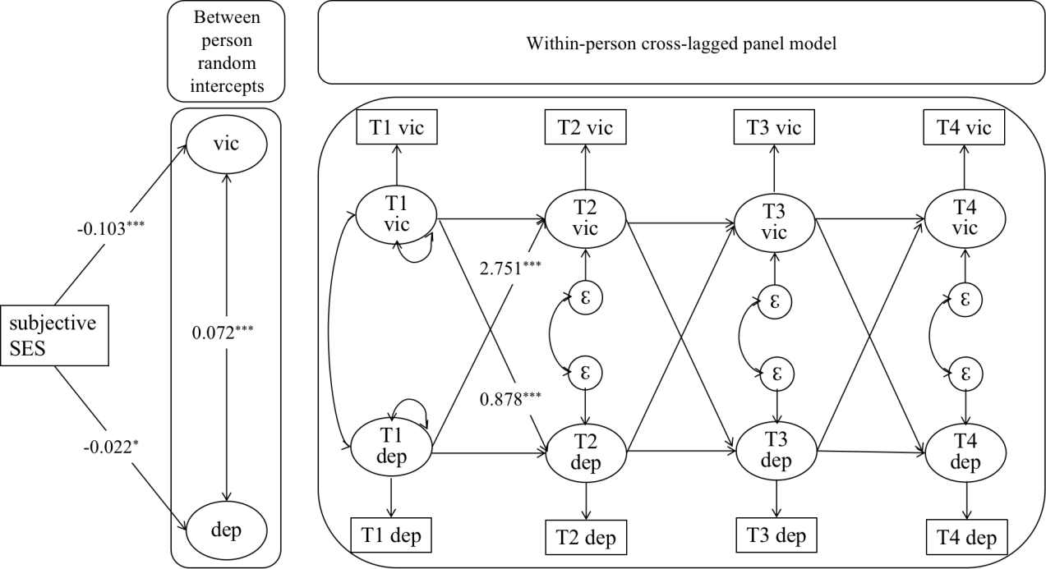
Figure S1. Random-intercepts cross-lagged panel model of peer victimization and depressive symptoms for boys

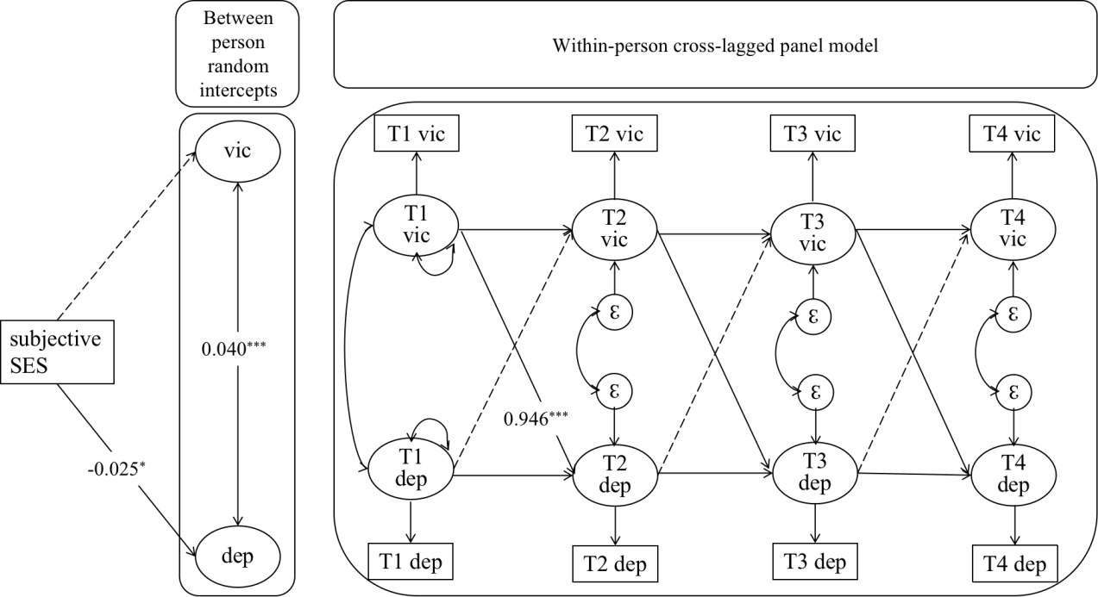
Figure S2. Random-intercepts cross-lagged panel model of peer victimization and depressive symptoms for girls

Section 5. Explanation of sensitivity analysis
Given that the results were adjusted at the initial point in time, there may be substantial bias due to regression to the mean when predicting changes in the results (Sorjonen et al., 2022). We attempted a sensitivity analysis, which constrained the proportional effect to 0. Unfortunately, the sensitivity analysis model could not converge. It may be that the distribution of peer victimization in this study is skewed, and some extreme values make it difficult for the model to converge. Some adolescents in this study authentically suffer from a high frequency of peer victimization, and these extreme values are not appropriate to exclude from the analysis. Therefore, we maintain the original statistical models from the manuscript and demonstrate the robustness of the models in the “Robustness analysis of the results” subsection. Nevertheless, sensitivity analysis is necessary for the accuracy of LCSM results and should be actively attempted by researchers (Zainal & Newman, 2022; 2023).

References
Carle, A. C., Millsap, R. E., & Cole, D. A. (2008). Measurement bias across gender on the Children’s Depression Inventory: Evidence for invariance from two latent variable models. Educational and Psychological Measurement, 68(2), 281-303. https://doi.org/10.1177/0013164407308471
Chen, G., Kong, Y., Deater-Deckard, K., & Zhang, W. (2018). Bullying victimization heightens cortisol response to psychosocial stress in Chinese children. Journal of Abnormal Child Psychology, 46(5), 1051-1059. https://doi.org/10.1007/s10802-017-0366-6
Gao, B., Zhao, M., Feng, Z., & Xu, C. (2022). The chain mediating role of cognitive styles and alienation between life events and depression among rural left-behind children in poor areas in Southwest China. Journal of Affective Disorders, 306, 215-222. https://doi.org/10.1016/j.jad.2022.03.040
Guo, X., Zhang, Y., Chen, Y., & Zhang, L. (2021). School victimization and self‐esteem: Reciprocal relationships and the moderating roles of peer support and teacher support. Aggressive Behavior, 48(2), 187-196. https://doi.org/10.1002/ab.22009
Ozono, S., Nagamitsu, S., Matsuishi, T., Yamashita, Y., Ogata, A., Suzuki, S., Mashida, N., Koseki, S., Sato, H., Ishikawa, S., Togasaki, Y., Sato, Y., Sato, S., Sasaki, K., Shimada, H., & Yamawaki, S. (2019). Reliability and validity of the Children's Depression Inventory–Japanese version. Pediatrics International, 61(11), 1159-1167. https://doi.org/10.1111/ped.13984
Sorjonen, K., Melin, B., Nilsonne, G., 2022. Lord’s paradox in latent change score modeling: An example involving facilitating longitudinal effects between intelligence and academic achievement. Personality and Individual Differences, 189, 111520. https://doi.org/10.1016/j. paid.2022.111520
Sun, X., Qin, X., Zhang, M., Yang, A., Ren, X., & Dai, Q. (2021). Prediction of parental alienation on depression in left-behind children: A 12-month follow-up investigation. Epidemiology and Psychiatric Sciences, 30, e44. https://doi.org/10.1017/S2045796021000329
Zainal, N. H., & Newman, M. G. (2022). Curiosity helps: Growth in need for cognition bidirectionally predicts future reduction in anxiety and depression symptoms across 10 years. Journal of Affective Disorders, 296, 642-652. https://doi.org/10.1016/j.jad.2021.10.001
Zainal, N. H., & Newman, M. G. (2023). Corrigendum: Curiosity does help to protect against anxiety and depression symptoms but not conversely. Journal of Affective Disorders, 323, 894-897. https://doi.org/10.1016/j.jad.2022.11.038

