Supplemental materials

Methods

The coders, who were clinical psychologists or advanced psychology students, received an intense training about Lab-TAB coding principles and they had to achieve 80% reliability with the master coding videos before allowed to conduct independent coding. Additionally, they were supervised throughout the coding in case of problems and questions, and 10% of all videos were coded twice for reliability.
Bacterial DNA was extracted from the samples using GXT Stool Extraction Kit VER 2.0 (Hain Lifescience GmbH, Nehren, Germany) as previously described. DNA concentrations were measured using Qubit dsDNA HS Assay kit and Qubit 2.0 fluorometer (Thermo Fisher Scientific, Waltham, MA, USA). The variable region V4 of 16S rRNA was amplified using in-house generated primers, and the prepared gene libraries were sequenced using the MiSeq platform as previously described (Rintala et al., 2018). Negative and positive controls were included in the sequencing: Extracted aqua samples were used as negative controls, while in-house generated plasmid mixes containing Lactobacillus acidophilus, Bifidobacterium adolescentis, Enterococcus faecalis, Staphylococcus epidermidis, Streptococcus pyogenes, Escherichia coli, and Faecalibacterium prausnitzii were used as mock community positive controls. Sequencing data was pre-processed with DADA2 pipeline (Callahan et al., 2016) using SILVA as the taxonomy reference database as previously described (Keskitalo et al., 2021). The runs were monitored for low read counts in the negative controls and matching mock community composition (Supplemental Figure 8). The resulting data set had on average 177166 reads (33401-1051913).
Analysis of SCFA was performed on fecal homogenate crashed with methanol 1:10 weight: volume (feces: solvent). Samples were first vortexed for 1 min, followed by filtration using 96-Well protein precipitation filter plate (Sigma-Aldrich, 55263-U) and the obtained aliquot was used for GC-MS analysis. GC separation was performed on a Phenomenex Zebron ZB-WAXplus column (30 m × 250 μm × 0.25 μm). A sample volume of 1 μl was injected into a split/splitless inlet at 285°C using split mode at 2:1 split ratio. Septum purge flow and split flow were set to 13 ml min⁻¹ and 3.2 ml min⁻¹, respectively. Helium was used as carrier gas, at a constant flow rate of 1.6 ml min⁻¹. The GC oven program was as follows: initial temperature 50°C, equilibration time 1.0 min, heat up to 150°C at the rate of 10°C min⁻¹, then heat at the rate of 40°C min⁻¹ until 230°C and hold for 2 min. Mass spectra were recorded in Selected Ion Monitoring (SIM) mode. The detector was switched off during the 1 min of solvent delay time. The transfer line, ion source and quadrupole temperatures were set to 230, 230 and 150°C, respectively. Dilution series of SCFA standards of acetic, propionic, butyric, valeric, hexanoic acid, isobutyric, and iso-valeric acid were prepared in concentrations of 0.1, 0.5, 1, 2, 5, 10, 20, 40, and 100 ppm for the construction of standard curves for quantification.
We chose to use Shannon index as a measure of alpha diversity and Bray-Curtis distance measure as a beta diversity index since they are commonly used measures of these diversities in previous research (Aatsinki et al., 2019; Christian et al., 2015; Wang et al., 2020). In addition, we checked the associations by adding sensitivity analyses where we used Gini-Simpson, inverse Simpson and richness measures as an alpha diversity index as well as Unifrac and weighted Unifrac measures as a beta diversity index. Whereas richness focuses only on the estimated number of unique taxonomic groups, the diversity measures also take into account the evenness of their abundance distribution, and to what extent the community is dominated by a few taxa. Shannon diversity gives more emphasis for less abundant taxa than the inverse Simpson index, which emphasizes primarily the distribution of the most abundant taxonomic groups (Hill, 1973). This distinction applies to Gini-Simpson as well in relation to Shannon index.

Covariates

First, associations between the independent and dependent variables and the covariates were investigated using t-test, Wilcoxon’s rank sum tests, Kruskal-Wallis test, Spearman’s rank correlation coefficient and Chi square tests depending on the characteristics of each covariate. All analyses controlled for potential covariates chosen based on the association testing and theoretical framework. Background factors with statistically significant p-values and or strong theoretical framework were included in the further analysis as covariates. Covariates that were chosen based on theoretical framework were delivery mode and sex for observed sample since delivery mode has been found to affect gut microbiota composition in infancy (Dominguez-Bello et al., 2010) and sex differences were important study question in this paper. In addition to that, for observed sample, breastfeeding status showed significant association with community composition. However, some studies suggest that infants who are perceived as having higher negative reactivity, or ‘difficult’ temperament by mothers are be introduced to bottled milk or solid foods before infants that are perceived having higher positive reactivity (Aminabadi et al., 2014; Wasser et al., 2011). On the contrary, there are studies suggesting the opposite: infants at 3 months of age who appear to have more negative reactivity are breastfed for longer⁶⁷ and similar results are found on neonates as well (di Pietro et al., 1987). Hence, breastfeeding may be a mediator and lead to spurious findings when included as a covariate. On the other hand, variation in breastmilk composition has been shown to associate with both fear reactivity (Nolvi et al., 2018) and gut microbiota composition (Borewicz et al., 2020). Taken all this together, breastfeeding status was excluded from the primary analyses for its potential mediating effect between negative reactivity and diversity for being affected by child temperament. The robustness of the association for covariate selection was tested by including breastfeeding as a covariate.
Table 1. Linear regression models for alpha diversity and negative/fear reactivity variables for the whole study population and for girls and boys separately with breastfeeding status added as a covariate.
 |  |  | Reported sample |  | Observed sample
 | Model |  | Reported negative reactivity | Reported fear reactivity | Observed negative reactivity | Observed negative reactivity with breastfeeding | Observed fear reactivity
All | α diversity | adj. R² | <.01 | <-.01 | -.01 |  | <-.01
 |  | β | 0.12 | 0.15 | -0.06 |  | 0.13
 |  | p | .25 | .35 | .68 |  | .35
 | α diversity, adjusted | adj. R² | .03 | .06 | -.03 | -.02 | .04
 |  | β | 0.11 | 0.13 | -0.07 | -0.10 | 0.11
 |  | p | .26 | .39 | .64 | .50 | .44
 | interaction term (diversity x sex) | adj. R² | .03 | .07 | <.01 | <.01 | .03
 |  | β | -0.29 | -0.62 | -0.68 | -0.72 | 0.05
 |  | p | .15 | .05* | .02* | .01* | .85
Girls | α diversity | adj. R² | -.01 | <.01 | .03 |  | -.01
 |  | β | -0.06 | -0.26 | -0.37 |  | 0.09
 |  | p | .68 | .28 | .07 |  | .67
 | α diversity, adjusted | adj. R² | .02 | .02 | .02 | .03 | -.03
 |  | β | -0.04 | -0.21 | -0.34 | -0.41 | 0.09
 |  | p | .78 | .38 | .11 | .06 | .68
Boys | α diversity | adj. R² | .02 | .02 | .02 |  | <-.01
 |  | β | 0.23 | 0.42 | 0.30 |  | 0.19
 |  | p | .07 | .04* | .09 |  | .32
 | α diversity, adjusted | adj. R² | .01 | .03 | .01 | .01 | .09
 |  | β | 0.24 | 0.40 | 0.19 | 0.21 | 0.07
 |  | p | .07 | .05* | .34 | 0.30 | .74

Table 2. PERMANOVA results between community composition and negative/fear reactivity for the whole study samples and for girls and boys separately with breastfeeding status added as a covariate.
 | Model |  | Reported negative reactivity | Reported fear reactivity | Observed negative reactivity | Observed negative reactivity with breastfeeding | Observed fear reactivity
All | β diversity | R² | <.01 | <.01 | .01 |  | .01
 |  | F | 1.1 | 1.1 | 1.1 |  | 1.0
 |  | p | .36 | .41 | .25 |  | .45
 | β diversity, adjusted | R² | <.01 | <.01 | .01 | .01 | .01
 |  | F | 1.2 | 0.9 | 1.2 | 1.2 | 1.1
 |  | p | .28 | .68 | .21 | .26 | .34
Girls | β diversity unadjusted | R² | .01 | .01 | .01 |  | .02
 |  | F | 1.4 | 1.3 | 0.6 |  | 1.2
 |  | p | .14 | .20 | .96 |  | .25
 | β diversity, adjusted | R² | .01 | .01 | .01 | .01 | .02
 |  | F | 1.3 | 1.1 | 0.5 | 0.5 | 1.1
 |  | p | .19 | .32 | .95 | .95 | .29
Boys | β diversity unadjusted | R² | .01 | .01 | .03 |  | .01
 |  | F | 1.2 | 0.8 | 2.0 |  | 0.7
 |  | p | .02* | .72 | .02* |  | .73
 | β diversity adjusted | R² | .01 | .01 | .03 | 0.03 | .01
 |  | F | 2.0 | 0.7 | 2.3 | 2.2 | 0.6
 |  | p | .02* | .77 | .01* | .02* | .73

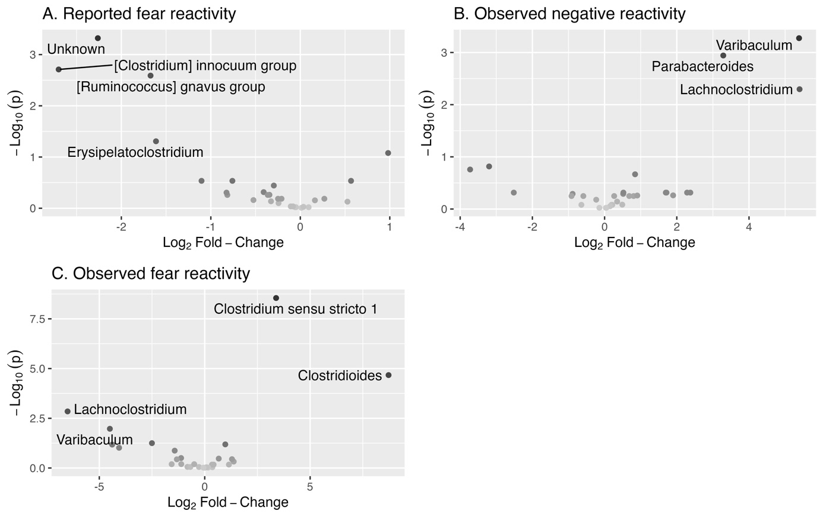
Figure 5. Volcano plots showing associations between genera and negative reactivity and fear for girls. Only statistically significant genera are labelled.
Figure 6. Volcano plots showing associations between genera and negative reactivity and fear for boys. Only statistically significant genera are labelled.

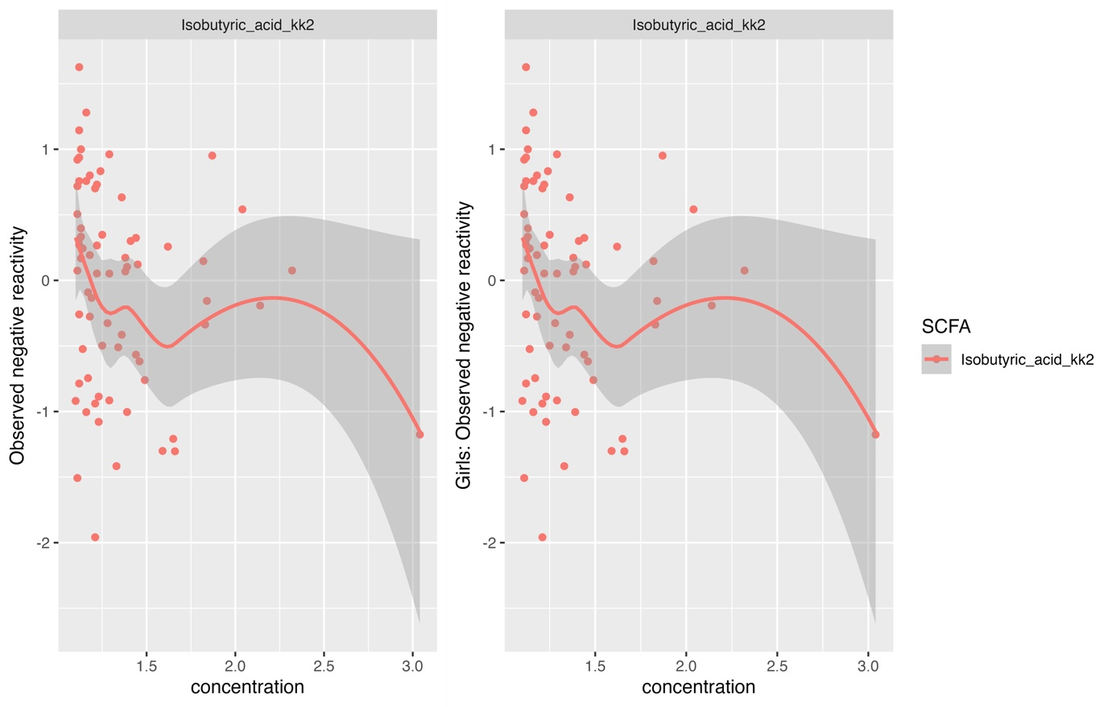
Figure 7. Observed negative reactivity and Isobutyric acid for the whole observed sample and girls. Outlier value included.
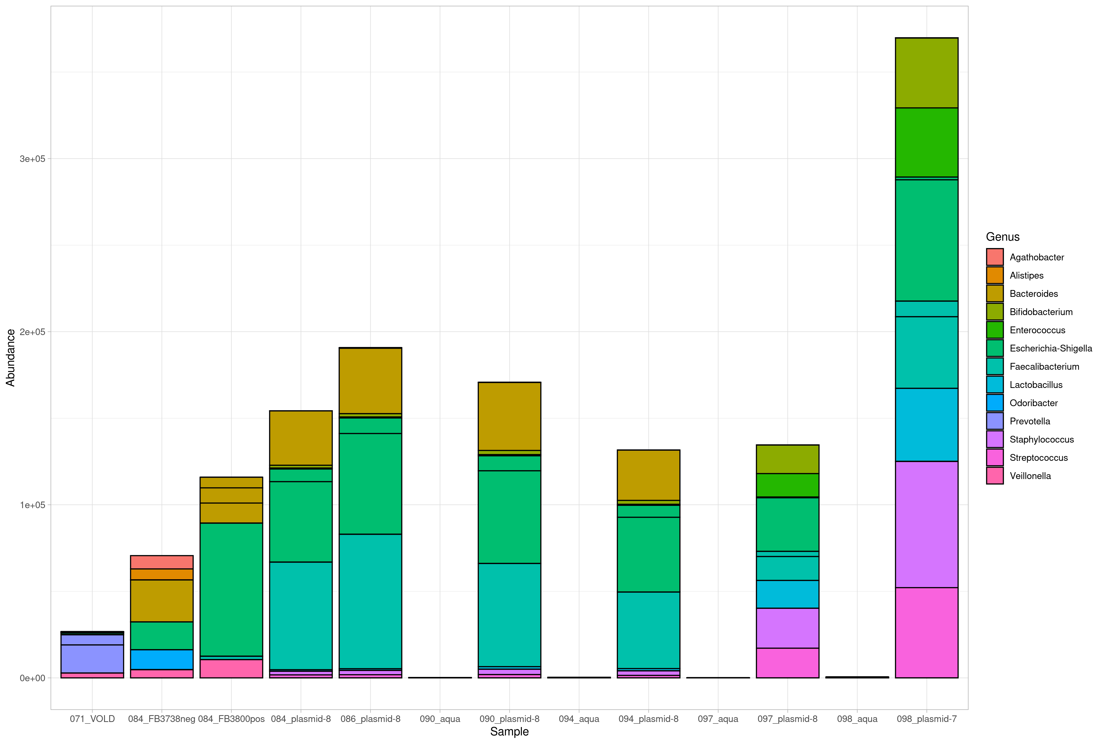
Figure 8. Read counts of positive and negative controls included in the sequecing run. Aqua samples have low read count and plasmid mixes match the expected composition on genus level. 20 most abundant ASVs are used for illustation.
Table 3. Linear regression models for different diversity indices and rarefication.
 |  |  | Reported fear reactivity * sex | Observed negative reactivity * sex | Reported fear reactivity for boys | Observed negative reactivity for boys
Shannon |  | β | -0.68 | -0.67 | 0.42 | 0.30
 |  | p | .03 | .01 | .04 | .09
 | rarefied | β | -0.68 | -0.67 | 0.42 | 0.30
 |  | p | .03 | .01 | .04 | .09
Inverse Simpson |  | β | -0.13 | -0.11 | 0.11 | 0.06
 |  | p | .08 | .08 | .02 | .12
 | rarefied | β | -0.13 | -0.11 | 0.11 | 0.06
 |  | p | .08 | .07 | .02 | .12
Gini-Simpson |  | β | -2.04 | -2.21 | 1.47 | 1.00
 |  | p | .05 | .01 | .02 | .11
 | rarefied | β | -2.03 | -2.22 | 1.47 | 1.00
 |  | p | .05 | .01 | .02 | .11
Fisher |  | β | -0.14 | -0.13 | 0.05 | 0.09
 |  | p | .24 | .26 | .56 | .21
 | rarefied | β | -0.10 | -0.09 | 0.02 | 0.06
 |  | p | .28 | .33 | .77 | .30
Chao1 |  | β | -0.01 | -0.01 | <0.01 | <0.01
 |  | p | .31 | .29 | .60 | .21
 | rarefied | β | -0.02 | -0.01 | <0.01 | <0.01
 |  | p | .16 | .29 | .59 | .30
Observed richness |  | β | -0.01 | -0.01 | <0.01 | <0.01
 |  | p | .31 | .29 | .60 | .21
 | rarefied | β | -0.02 | -0.01 | <0.01 | <0.01
 |  | p | .25 | .34 | .73 | .30

References

Aatsinki, A.-K., Lahti, L., Uusitupa, H.-M., Munukka, E., Keskitalo, A., Nolvi, S., O’Mahony, S., Pietilä, S., Elo, L. L., Eerola, E., Karlsson, H., & Karlsson, L. (2019). Gut microbiota composition is associated with temperament traits in infants. Brain, Behavior, and Immunity, 80, 849–858. https://doi.org/10.1016/j.bbi.2019.05.035
Aminabadi, N. A., Ghoreishizadeh, A., Ghoreishizadeh, M., Oskouei, S. G., & Ghojazadeh, M. (2014). Can Child Temperament Be Related to Early Childhood Caries? Caries Research, 48(1), 3–12. https://doi.org/10.1159/000351636
Borewicz, K., Gu, F., Saccenti, E., Hechler, C., Beijers, R., de Weerth, C., van Leeuwen, S. S., Schols, H. A., & Smidt, H. (2020). The association between breastmilk oligosaccharides and faecal microbiota in healthy breastfed infants at two, six, and twelve weeks of age. Scientific Reports, 10(1), 4270. https://doi.org/10.1038/s41598-020-61024-z
Callahan, B. J., McMurdie, P. J., Rosen, M. J., Han, A. W., Johnson, A. J. A., & Holmes, S. P. (2016). DADA2: High-resolution sample inference from Illumina amplicon data. Nature Methods, 13(7), Article 7. https://doi.org/10.1038/nmeth.3869
Christian, L. M., Galley, J. D., Hade, E. M., Schoppe-Sullivan, S., Kamp Dush, C., & Bailey, M. T. (2015). Gut microbiome composition is associated with temperament during early childhood. Brain, Behavior, and Immunity, 45, 118–127. https://doi.org/10.1016/j.bbi.2014.10.018
di Pietro, J. A., Larson, S. K., & Porges, S. W. (1987). Behavioral and heart rate pattern differences between breast-fed and bottle-fed neonates. Developmental Psychology, 23, 467–474. https://doi.org/10.1037/0012-1649.23.4.467
Dominguez-Bello, M. G., Costello, E. K., Contreras, M., Magris, M., Hidalgo, G., Fierer, N., & Knight, R. (2010). Delivery mode shapes the acquisition and structure of the initial microbiota across multiple body habitats in newborns. Proceedings of the National Academy of Sciences, 107(26), 11971–11975. https://doi.org/10.1073/pnas.1002601107
Hill, M. O. (1973). Diversity and Evenness: A Unifying Notation and Its Consequences. Ecology, 54(2), 427–432. https://doi.org/10.2307/1934352
Keskitalo, A., Aatsinki, A.-K., Kortesluoma, S., Pelto, J., Korhonen, L., Lahti, L., Lukkarinen, M., Munukka, E., Karlsson, H., & Karlsson, L. (2021). Gut microbiota diversity but not composition is related to saliva cortisol stress response at the age of 2.5 months. Stress, 24(5), 551–560. https://doi.org/10.1080/10253890.2021.1895110
Nolvi, S., Uusitupa, H.-M., Bridgett, D. J., Pesonen, H., Aatsinki, A.-K., Kataja, E.-L., Korja, R., Karlsson, H., & Karlsson, L. (2018). Human milk cortisol concentration predicts experimentally induced infant fear reactivity: Moderation by infant sex. Developmental Science, 21(4), e12625. https://doi.org/10.1111/desc.12625
Rintala, A., Riikonen, I., Toivonen, A., Pietilä, S., Munukka, E., Pursiheimo, J.-P., Elo, L. L., Arikoski, P., Luopajärvi, K., Schwab, U., Uusitupa, M., Heinonen, S., Savilahti, E., Eerola, E., & Ilonen, J. (2018). Early fecal microbiota composition in children who later develop celiac disease and associated autoimmunity. Scandinavian Journal of Gastroenterology, 53(4), 403–409. https://doi.org/10.1080/00365521.2018.1444788
Wang, Y., Chen, X., Yu, Y., Liu, Y., Zhang, Q., & Bai, J. (2020). Association between Gut Microbiota and Infant’s Temperament in the First Year of Life in a Chinese Birth Cohort. Microorganisms, 8(5), Article 5. https://doi.org/10.3390/microorganisms8050753
Wasser, H., Bentley, M., Borja, J., Davis Goldman, B., Thompson, A., Slining, M., & Adair, L. (2011). Infants Perceived as “Fussy” Are More Likely to Receive Complementary Foods Before 4 Months. Pediatrics, 127(2), 229–237. https://doi.org/10.1542/peds.2010-0166

