Appendix A

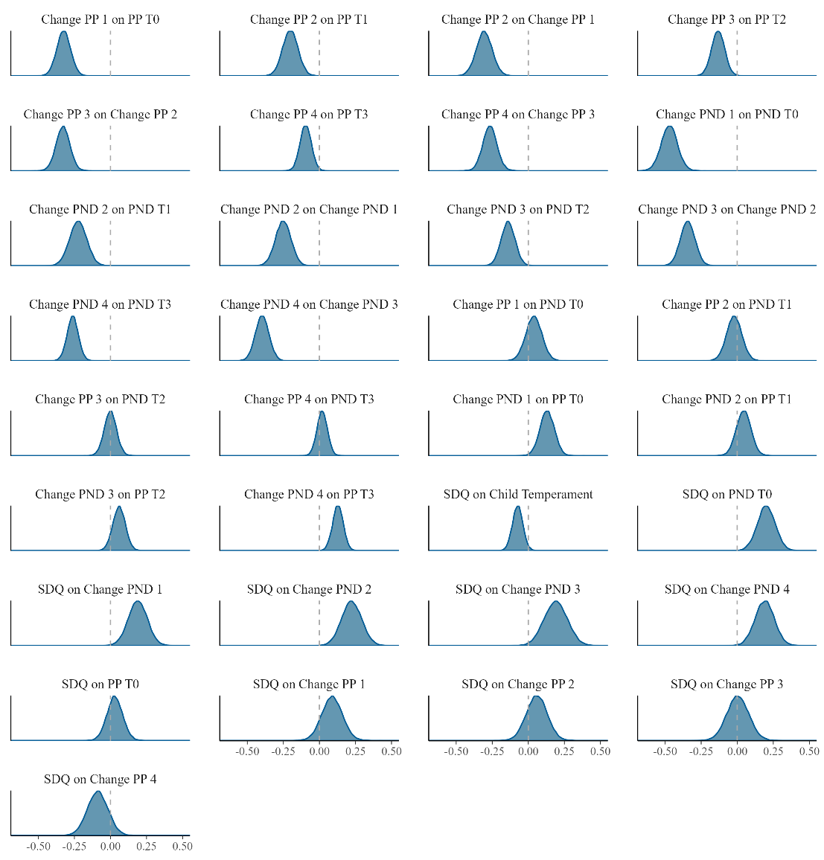
Figure A1. Posterior distributions of unstandardized regression weights. PP = Partnership problems. PND = Perinatal Depressive Symptoms. SDQ = Child Adjustment Difficulties. Change = Latent Change Scores. Dashed lines indicate zero. Y-axis is free for each sub-plot.

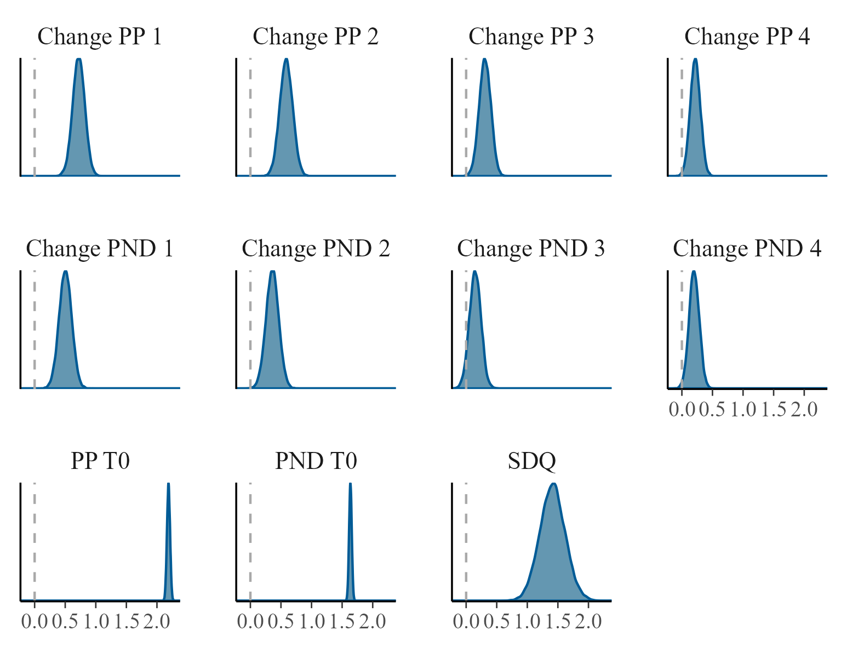
Figure A2. Posterior distributions of intercepts. PP = Partnership problems. PND = Perinatal Depressive Symptoms. SDQ = Child Adjustment Difficulties. Change = Latent Change Scores. Dashed lines indicate zero. Y-axis is free for each sub-plot.

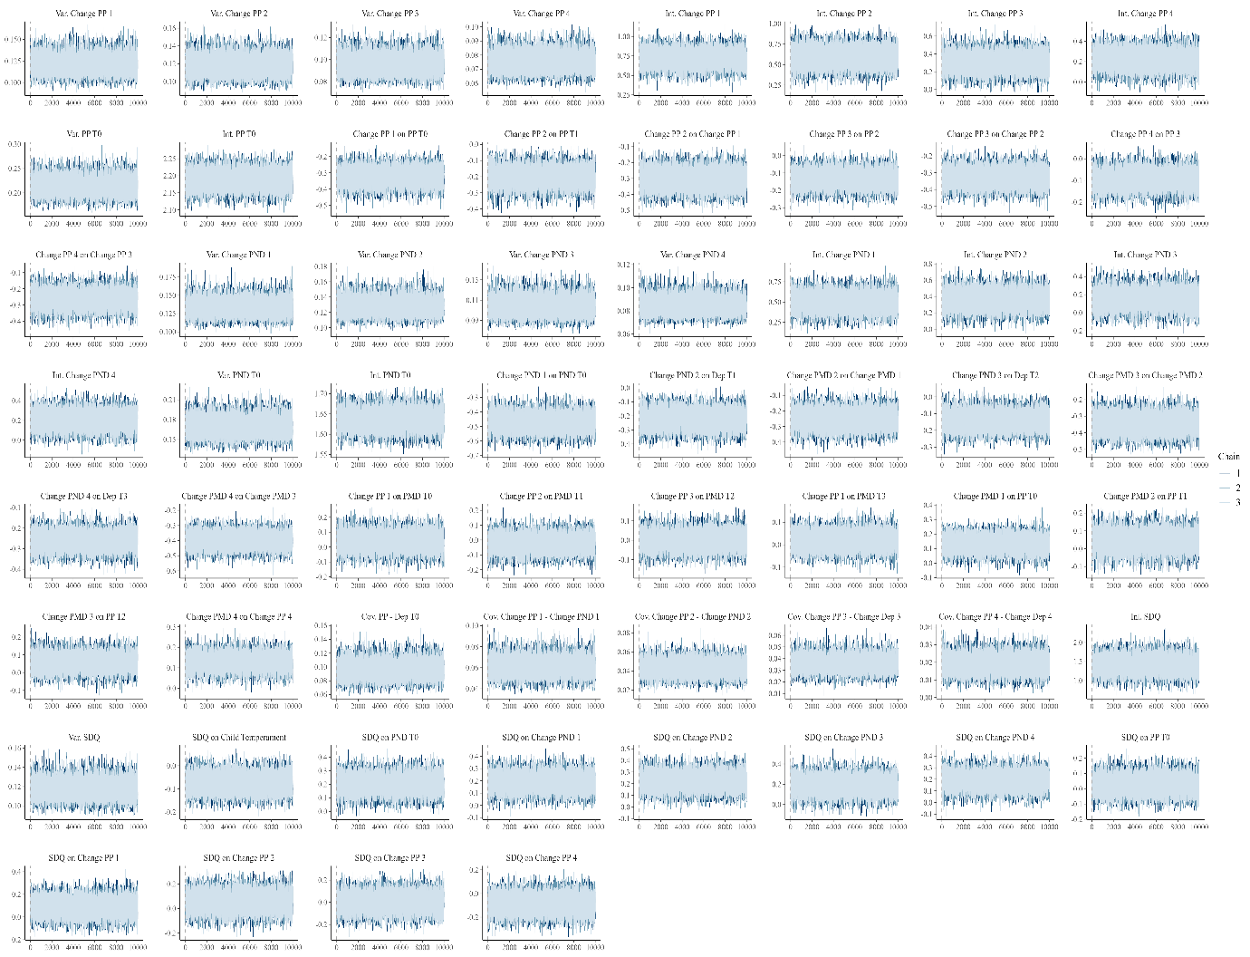
Figure A3. Trace plots of the MCMC chains for all model parameters. PP = Partnership problems. PND = Perinatal Depressive Symptoms. SDQ = Child Adjustment Difficulties. Change = Latent Change Scores.

Table A4
Partnership Trajectories over the study period
Partnership Trajectories | n (%)
Same partner over the study period | 306 (86.4)
New partner during the study period (after separation or being single) | 31 (8.8)
Separation during the study period, no new partner | 6 (1.7)
Without partner over the study period | 3 (0.8)
Note. n = 346 due to 8 (2.3%) participants with missing values

Table A5
Bayesian t-test for mean differences between dropouts and participants at T0
 | Means (n) |  | Lower CI | Upper CI
 | Dropouts | Participants
PND | 1.61 (155) | 1. 64 (354) | -0.0531 | 0.1132
Partnership problems | 2.14 (146) | 2.18 (332) | -0.0430 | 0.1381
Note. Total sample of dropouts n = 165, PND = Perinatal Depressive Symptoms.

