Supplementary Methods1
Construction, interpretation and criteria for model selection of group-based trajectories of resilience to individual ACEs
Latent class growth analysis (LCGA) was used to identify group based longitudinal trajectories of resilience. We use long format data of resilience repeated measures of 14,693 individuals. Variables included are:
- cidB3237: Individual ID
- age: Age of resilience measure, in months
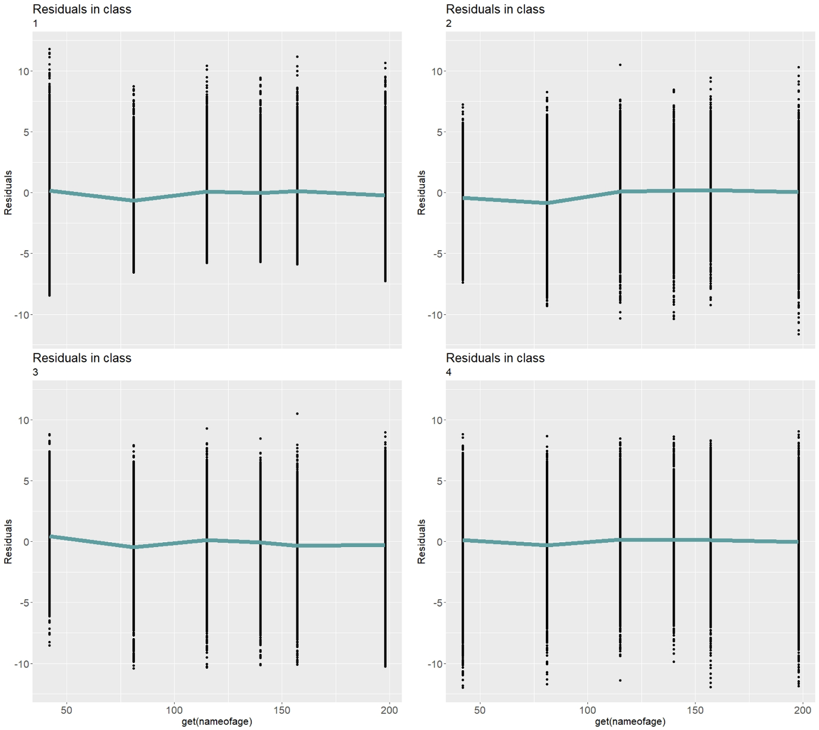
- resilience: Resilience as measured by residuals of the individual at each time point
Figure S 1: Standardised residual plots of fixed-effect model for each class justifying the selection of a random-effect structure in the scoping model
Step 1
To determine the initial working model structure of random effects, we constructed a scoping model provisionally selecting the plausible number of classes based on available literature; in the context of trajectories of resilience, we used K=4 classes as reported elsewhere (Galatzer-Levy et al., 2018; Infurna, 2021). To determine the initial working model structure of random effects, we followed the rationale of Verbeke and Molenberghs (Verbeke & Molenbergh, 2000) and examined the shape of standardised residual plots for each of the four classes in a model with no random effects. If the residual profile could be approximated by a flat, straight line or a curve, then a random intercept, slope or quadratic term, respectively, were considered. Preliminary plots suggested preference for a quadratic random effects model (figure S1).
Step 2
Using the hlme command in the lcmm package version 1.9.5 (Proust-Lima et al., 2017) we refined the preliminary working model from step 1 to determine the optimal number of classes, testing K=1–8. We first assessed a random quadratic model with common variance structure across classes. This allows individuals to vary within classes by initial weight, shape and magnitude, and allows variance structures to differ up to a multiplicative factor to allow some classes to have larger or smaller within class variances
ModelA <- hlme(fixed = resilience ~ 1+ age + I(age^2),
mixture = ~1 + age + I(age^2),
random = ~1 + age,
ng = k, nwg = TRUE,
idiag = FALSE,
data = data.frame(mydata),
subject = "cidB3237")
See R documentation lcmm package vignette for hlme arguments
S Table 1: Model fit statistics for random quadratic model with differing variance structure.
Model | BIC | AIC
2-class model | 455127.3 | 455036.2
3-class model | 454108.3 | 453979.2
4-class model | 453857.3 | 453690.2
5-class model | 453828.2 | 453623.1
6-class model | 453732.8 | 453489.8
7-class model | 453520.5 | 453239.5
8-class model | 453525.3 | 453206.3
Class enumeration includes fitting several LCGA models with differing numbers of latent classes, collecting and tabulating fit information for each fitted model, and studying patterns to decide on how many classes best describe the patterns observed in the data. The number of classes chosen was based on the lowest Bayesian Information Criterion (BIC) and Akaike Information Criteria (AIC). In practice, it is not uncommon that the BIC continues to decrease for each additional class added (e.g. there is no global minimum) and in these instances plots of the values of BIC and AIC can be particularly useful to inspect for an “elbow” point of “diminishing returns” in model fit (e.g. small decreases in the IC for each additional latent class) (Nylund-Gibson & Choi, 2018). See figure S2 for summary plots. The fit of the model visually changes at the 7-class model for AIC, i.e. there is an ‘elbow’ point.
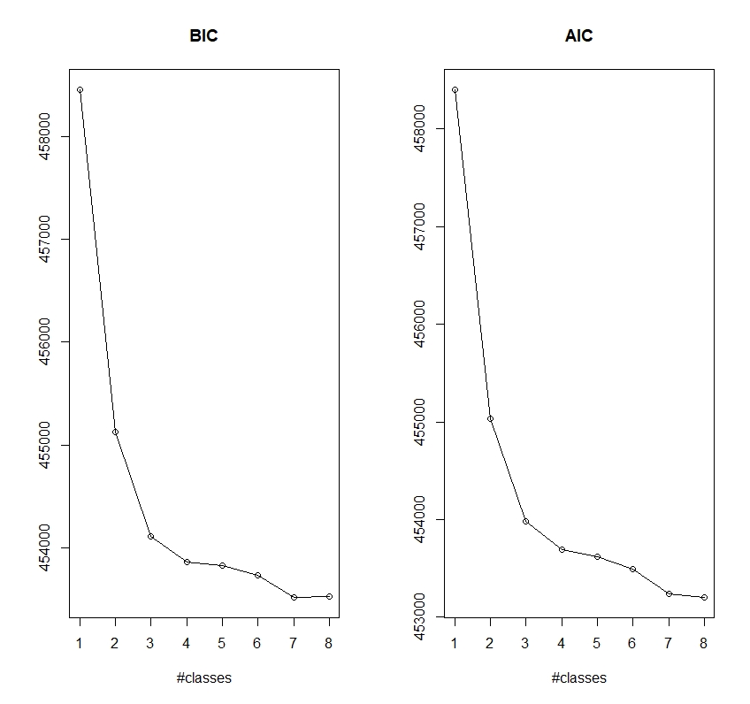
S Figure 1: Visual representation of fit statistics from k=1-8 of AIC and BIC of model A
Step 3
We further refined model A using the favoured K=7 derived in step 2, testing for optimal model structure by changing the flexibility of the previous model, allowing individuals to vary within classes by initial weight, shape and magnitude, however each class is assumed to have the same amount of variability. This is the same code as above but ‘nwg = FALSE’ and we have called model B. See STable 2. BIC and AIC are lower in Model A.
 | AIC | BIC
Model A | 453239.5 | 453520.5
Model B | 453518.1 | 453753.5
S Table 2: AIC and BIC comparisons of Models A and B

Step 4
We then used graphical presentation of the model The conventional approach is to plot mean trajectories with time encompassing each class (see Figure S3 for graphical presentation of model A, k =7).
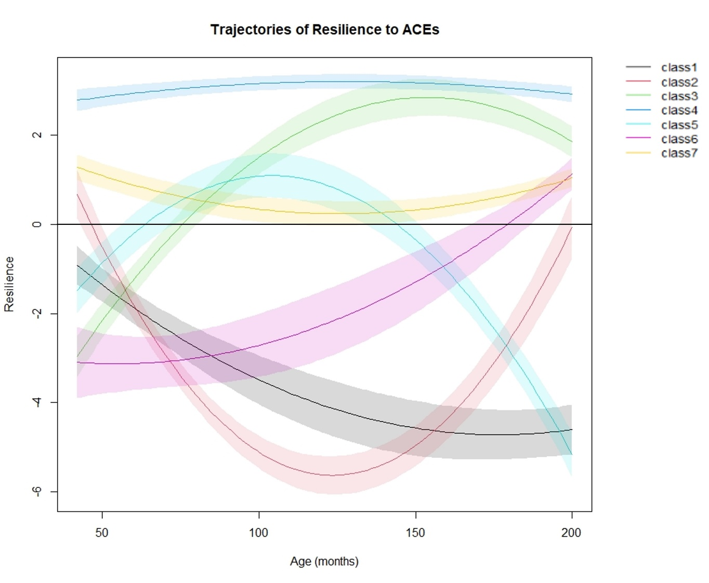
S Figure 2: Graphical representation of Model A, K = 7. Class 1 = 12.71%; Class 2 =5.76%; Class 3 = 13.24%; Class 4 = 26.16%: Class 5 = 5.26%; Class 6 = 10.23%; Class 7 = 26.65%
Having established the favoured model, model A with seven classes, we assigned descriptive labels to each respective class as follows:
Class 1 – Vulnerable to very vulnerable
Class 2 – Resilient to vulnerable to resilient
Class 3 – Early vulnerability to increasing resilient
Class 4 – Stable high resilience
Class 5 – Vulnerable to resilient to vulnerable
Class 6 – Childhood vulnerability to adolescent resilience
Class 7 – Stable moderate resilience
We then tabulated the baseline characteristics according to the seven classes for model A and noted patterns across the tables (Table 3).

Biernacki, C., Celeux, G., & Govaert, G. (2000). Assessing a mixture model for clustering with the integrated completed likelihood. IEEE transactions on pattern analysis and machine intelligence, 22(7), 719-725.
Galatzer-Levy, I. R., Huang, S. H., & Bonanno, G. A. (2018). Trajectories of resilience and dysfunction following potential trauma: A review and statistical evaluation. Clinical Psychological Review, 63, 41-55. doi:10.1016/j.cpr.2018.05.008
Herle, M., Micali, N., Abdulkadir, M., Loos, R., Bryant-Waugh, R., Hübel, C., . . . De Stavola, B. L. (2020). Identifying typical trajectories in longitudinal data: Modelling strategies and interpretations. European Journal of Epidemiology, 35(3), 205-222. doi:10.1007/s10654-020-00615-6
Infurna, F. J. (2021). Utilizing principles of life-span developmental psychology to study the complexities of resilience across the adult life span. The Gerontologist, 61(6), 807-818.
Klijn, S. L., Weijenberg, M. P., Lemmens, P., van den Brandt, P. A., & Lima Passos, V. (2015). Introducing the fit-criteria assessment plot – a visualisation tool to assist class enumeration in group-based trajectory modelling. Statistical Methods in Medical Research, 26(5), 2424-2436. doi:10.1177/0962280215598665
Nagin, D. (2005). Group-based modeling of development harvard university press. Cambridge, Mass, 4159, 9780674041318.
Nylund-Gibson, K., & Choi, A. Y. (2018). Ten frequently asked questions about latent class analysis. Translational Issues in Psychological Science, 4(4), 440.
Proust-Lima, C., Philipps, V., & Liquet, B. (2017). Estimation of extended mixed models using latent classes and latent processes: The r package lcmm. Journal of statistical software, 78(2), 1 - 56. doi:10.18637/jss.v078.i02
Verbeke, G., & Molenbergh, G. (2000). Linear mixed models for longitudinal data New York

