Supplementary information

Explaining the ‘parenting – callous-unemotional traits – antisocial behaviour’ axis in early adolescence:
The role of affiliative reward

Appendix M1. Supplementary Methods
Table M1. Parenting practices: Model fit across different factorial structures.
Fit indicator | Full questionnaire  (24 items)  WLSMV estimator | Full questionnaire  (24 items)  MLR estimator | Brief questionnaire  (12 items)  MLR estimator
χ² | 1967.641*** | 1202.604*** | 146.082***
CFI | .889 | .892 | .969
TLI | .880 | .882 | .961
RMSEA | .048 | .033 | .026
RMSEA 90% CI | .045 – .050 | .030 – .035 | .018 – .032
SRMR | .059 | .046 | .036

Table M2. Affiliative reward: Model fit across different factorial structures.
Fit indicator | By dimension | By informant | By informant with residual correlations
χ² | 2055.240*** | 1513.706*** | 1223.145***
CFI | .889 | .930 | .951
TLI | .867 | .919 | .943
RMSEA | .051 | .040 | .034
RMSEA 90% CI | .049 – .054 | .038 – .042 | .031 – .036
SRMR | .100 | .067 | .064

Table M3. Affiliative reward: First-order factor loadings of the confirmatory factor analysis for the final factorial structure.
Factor | Item | λ  (Mother) | λ  (Father) | λ  (Friend)
Companionship
 | 09. How much free time do you spend with this person? | .61*** | .65*** | .52***
 | 19. How much do you play around and have fun with this person? | .58*** | .59*** | .59***
 | 29. How much do you go places and do enjoyable things with this person? | .67*** | .69*** | .65***
Intimacy
 | 13. How much do you talk about everything with this person? | .72*** | .77*** | .68***
 | 23. How much do you share your secrets and private feelings with this person? | .76*** | .75*** | .78***
 | 33. How much do you talk to this person about things that you don’t want others to know? | .67*** | .68*** | .67***
Affection
 | 15. How much does this person like or love you? | .64*** | .71*** | .69***
 | 25. How much does this person really care about you? | .75*** | .85*** | .73***
 | 35. How much does this person have a strong feeling of affection (loving or liking) toward you? | .70*** | .81*** | .74***
Feelings of worth
 | 16. How much does this person treat you like you’re admired and respected? | .54*** | .60*** | .63***
 | 26. How much does this person treat you like you’re good at many things? | .62*** | .68*** | .67***
 | 36. How much does this person like or approve of the things you do? | .62*** | .66*** | .69***
Note: λ represents fully standardized factor loadings. p < .05*, p < .01**, p < .001***

Table M4. CU traits: Model fit across different factorial structures.
Fit indicator | 3 factors  (24 items)  WLSMV | 3 factors  (24 items)  MLR | 2 factors  (12 items)  WLSMV | 2 factors  (12 items)  MLR
χ² | 1918.471*** | 930.559*** | 161.845*** | 102.463***
CFI | .771 | .788 | .970 | .964
TLI | .746 | .765 | .962 | .955
RMSEA | .077 | .049 | .043 | .029
RMSEA 90% CI | .074 – .080 | .046 – .053 | .035 – .050 | .020 – .037
SRMR | .077 | .070 | .038 | .034

Table M5. Aggression and rule-breaking: Model fit across different factorial structures.
Fit indicator | Full sub-scales | Brief form  with 3 residual correlations
χ² | 941.002*** | 153.617***
CFI | .889 | .935
TLI | .879 | .920
RMSEA | .031 | .026
RMSEA 90% CI | .028 – .033 | .020 – .033
SRMR | .048 | .046

Appendix S2. Supplementary Results

Table S1. Descriptive statistics of the main study variables.
Variables | N | Mean | SD | Min | Max
Positive parenting | 1101 | 12.64 | 2.05 | 3 | 15
Parental involvement | 1106 | 11.27 | 2.25 | 3 | 15
Inconsistent discipline | 1112 | 8.50 | 2.87 | 3 | 15
Poor monitoring | 1092 | 7.15 | 3.38 | 3 | 15
Corporal punishment | 1105 | 4.87 | 2.45 | 3 | 15
Affiliative reward: Mother | 1007 | 51.10 | 7.72 | 18 | 60
Affiliative reward: Father | 970 | 47.81 | 8.72 | 12 | 60
Affiliative reward: Friend | 982 | 46.04 | 9.07 | 14 | 60
Callous | 1057 | 4.02 | 3.64 | 0 | 21
Uncaring | 1105 | 3.85 | 2.87 | 0 | 15
Aggressive behaviors | 1076 | 1.02 | 1.66 | 0 | 12
Rule breaking | 1068 | 0.62 | 1.46 | 0 | 12
Note: N = number of participants with complete data on the items comprising each variable. Scores are calculated as sum scores.

Table S2. Correlation table for the main study variables.
Variables | 1 | 2 | 3 | 4 | 5 | 6 | 7 | 8 | 9 | 10 | 11
1. Positive parenting
2. Parental involvement | .31***
3. Inconsistent discipline | .12*** | .02
4. Poor monitoring | -.03 | -.11*** | .20***
5. Corporal punishment | -.07* | -.03 | .12*** | .17***
6. Affiliative reward: Mother | .25*** | .37*** | -.07* | -.26*** | -.16***
7. Affiliative reward: Father | .28*** | .31*** | -.03 | -.18*** | -.15*** | .73***
8. Affiliative reward: Friend | .07* | .04 | <.01 | -.01 | -.06 | .14*** | .15***
9. Callous | -.03 | -.06 | .19*** | .34*** | .29*** | -.29*** | -.21*** | -.04
10. Uncaring | -.21*** | -.18*** | .08* | .22*** | .15*** | -.27*** | -.22*** | -.14*** | .27***
11. Aggressive behaviors | -.04 | -.05 | .18*** | .23*** | .23*** | -.24*** | -.23*** | <.01 | .36*** | .26***
12. Rule breaking | -.04 | -.12*** | .20*** | .24*** | .19*** | -.30*** | -.26*** | -.07* | .35*** | .22*** | .51***
Note: As all the variables based on sum scores were skewed, Spearman correlation coefficients are presented. p < .05*, p < .001**

Table S3. Results from SEM testing the relevance of control variables: age, biological sex, family affluence and past trauma/stress.
 | Aggression |  | Rule-breaking
Control variable | β | Variance explained | β | Variance explained
Age | .13* | 1.9% (ns) | .11 (p = .05) | 1.6% (ns)
Biological sex | -.19*** | 4.6% ** | -.17*** | 4.1% **
Family affluence | -.07 (ns) | 0.8% (ns) | -.07 (ns) | 0.6% (ns)
Stress | .10* | 0.7% (ns) | .05 (ns) | 0.1% (ns)

Note: Fully standardized regression coefficients are presented. p < .05*, p < .01**, p < .001***. The dummy variable representing biological sex was coded as follows: male = 1, female = 2. As some variables may explain the same variance in the outcome, regression coefficients are taken from an SEM whereby all 4 control variables were entered as predictors. However, to better understand the main sources of explained variance, R² values are taken from models conducted separately for each control variable. The total explained variance when all controls are included is: R²_{aggression} = 7.2%; R²_{rule-breaking} = 5.1%. This model had questionable fit (CFI = .881, TLI = .858, RMSEA = .032 [95% CI = .026 - .038], SRMR = .051), and produced very small significant effects, with very little explained variance in the outcomes. Sex was excluded from further models as it appeared to influence the entire framework (i.e. all the variables, as well as the relationship structure between them): its proper inclusion would be within a multiple-group framework which assesses whether boys and girls interpret the questionnaires in the same way, have different average levels across each of the constructs and display different patterns of relationships across the entire causal chain. Family affluence and stress showed no effects on antisocial behavior and age only had very small effects, explaining less than 2% of variance in the outcome.
Figure S1. SEM testing directionality of effects between affiliative reward and CU traits.

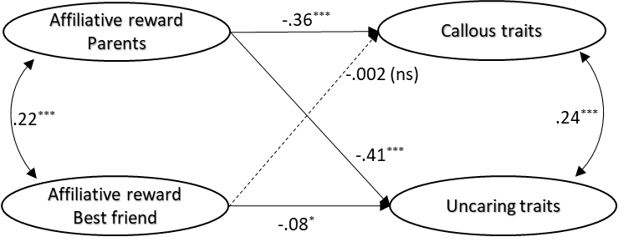

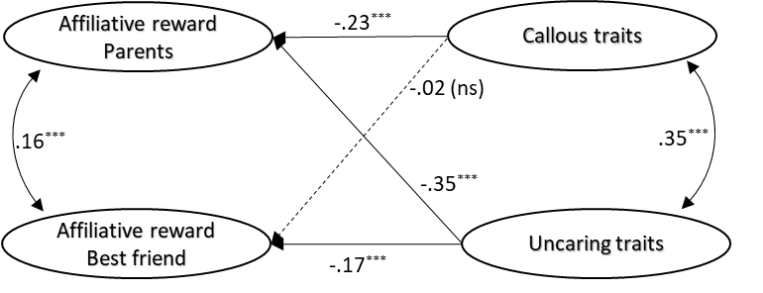
Note: Standardized coefficients are presented. p < .05*, p < .01**, p < .001***. Model fit (the same for both models): χ² = 2004.291***; CFI = .944; TLI = .938; RMSEA = .029; RMSEA 90% CI = [.027 – .031]; SRMR = .056.

