Biological properties of vitamins of the B-complex, part 2 – vitamins B₆ and B₇ (biotin, vitamin H)

Patrícia Dias¹, Tomáš Siatka², Marie Vopršalová¹, Monika Moravcová¹, Jana Pourová¹, Nikola Přívratská^{3,4}, Lenka Kujovská Krčmová^{3,4}, Lenka Javorská³, and Přemysl Mladěnka^{1*}

Supplementary data

17 pages

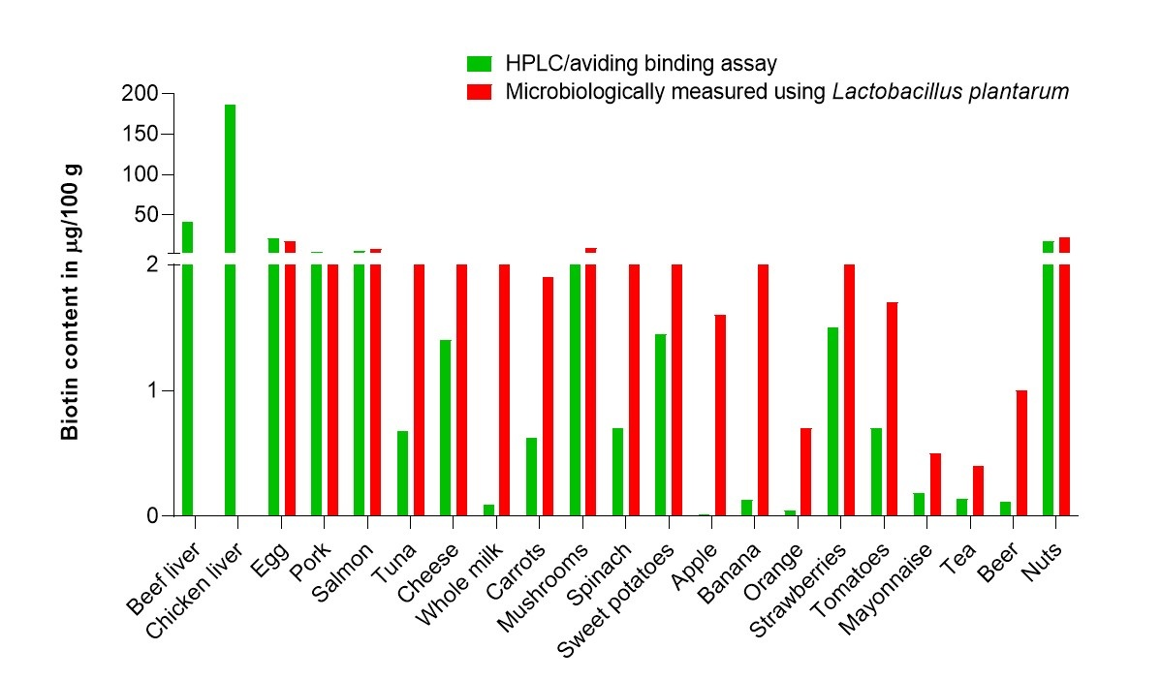

Figure S1. Biotin content of selected foods determined by different methods. Biotin contents were microbiologically measured using Lactobacillus plantarum ⁽¹⁾ and by HPLC/avidin binding assay ⁽²⁾.

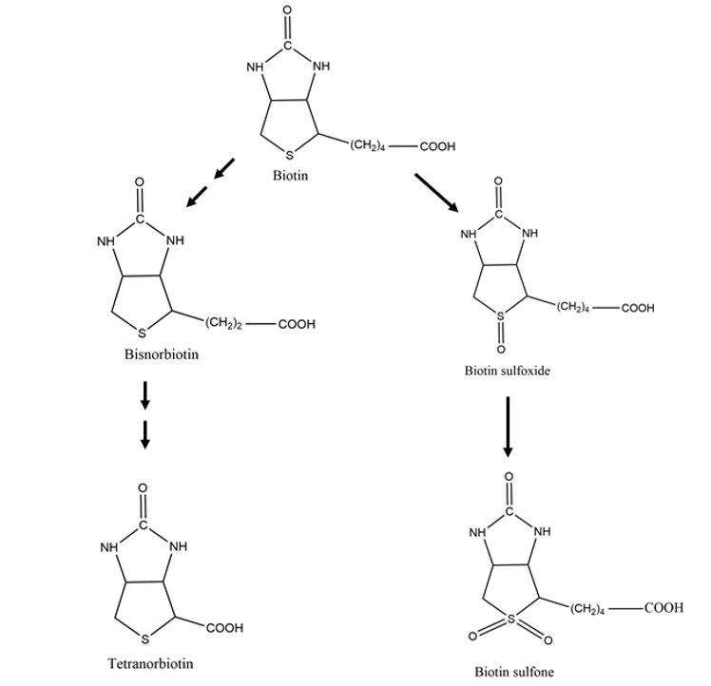

Figure S2. Pathways of catabolic reactions of biotin. Left side: β-oxidation of valeric acid side chain, right side: oxidation of sulphur. Adapted from ⁽³⁾.

Table S1. A rough overview of data on vitamin B₆ losses in some food groups due to processing.

Foods | Vitamin losses (%)
Plant-based foods
Cereals (milling) | 42–89
Wheat (breadmaking) | 33–62
Rice (boiling) | 3–74
Maize (nixtamalization) | 23
Vegetables (boiling, steaming, frying, canning) | 30–35, 15, 10, 31–34
Potatoes (boiling, baking, deep frying) | 30–57, 21, 10
Nuts (roasting) | 2–34
Animal-based foods
Pork (boiling, stewing, roasting, frying) | 55, 33–58, 30, 40–45
Beef (boiling, stewing, roasting, frying) | 60–77, 55–57, 40, 55–58
Chicken (boiling, stewing, roasting, frying) | 40–58, 40–47, 50, 45–56
Fish (grilling, baking) | 55–85, 60–89
Milk (boiling, pasteurisation, ultra-high treatment, sterilisation, evaporation) | 5–20, 5–10, 5–20, 10–50, 40
Eggs (hard cooking, poaching, scrambling, baking, frying) | 20–23, 15, 10, 10, 10

For more data on specific foods, information on conditions, and comments see please the main body of the manuscript.

Table S2. Detailed summary analytical methods for the assessment of vitamins B₆ and B₇ in biological fluids.

Technique | Sensitivity Nmol/L | Analytes | Matrix | Advantages | Disadvantages | Ref. | Publication year
LC-MS  LC-MS | LOQ  B₆-PL 24.6 | B₆, B₆-PL, and others | - human milk  - serum | - short analysis time  - small sample volume (50 µL) | - SIM  - complicated sample preparation (breast milk) | ⁽⁴⁾ | 2012
LC-MS  LC-MS | LLOQ  6 | B₆-P5P, and others | - whole blood | - 250 µL sample volume  - MRM  - simple sample preparation  - short analysis time | - complicated gradient elution | ⁽⁵⁾ | 2017
LC-MS  LC-MS | LOD  0.59 – 8.85  (B₆ – B₆-PM) | B₆, B₆-PM, B₆-PL, B₇, and others | - human milk | - MRM  - short analysis time | - 1 mL sample | ⁽⁶⁾ | 2015
LC-MS  LC-MS | LOQ  0.74 – 1.12 × 10³  (B₁₂ – B₉-THF) | B_{6,7,9,12}  B₆-P5P, B₆-PA, B₉-THF, and others | - whole blood | - simple extraction | - validated only for 9 analytes  - SIM | ⁽⁷⁾ | 2021
LC-MS  LC-MS | LOD  0.30 – 2.05  (B₆ – B₇) | B_{6,7} | - plasma | - small sample volume (100 µL)  - small solvents volumes | - SIM  - complicated sample preparation  - long analysis time | ⁽⁸⁾ | 2020
LC-MS  LC-MS | LLOQ  0.2 – 60  (B₆ – B₆-P5P) | B_{6,7,9} and its vitamers (21 analytes) | - plasma | - simple sample preparation  - MRM |  | ⁽⁹⁾ | 2015
LC-MS  LC-MS | LLOQ  B₆ 5 – 230  B₉ 20 – 30  B₁₂ 7 – 11 | B_{6,9,12} and its metabolites (9 analytes) | - plasma  - milk  - mice brain samples | - small sample volume (30 µL plasma, 20 mg milk or brain tissue)  - short analysis time  - various matrices |  | ⁽¹⁰⁾ | 2015
LC-MS  LC-MS | LOQ  127.51 – 1.63 × 10³  (B₆-PM – B₉) | B₆-PM, B_{7,9},  fat + water soluble vitamins (12 analytes) | - serum  - tears | - one extraction for both groups of vitamins  - simple sample preparation  - MRM  - small sample volume (200 µL serum, 70 µL tears) | - not sufficient validation parameters for all analytes | ⁽¹¹⁾ | 2018
LC-MS  LC-MS | LLOQ  0.1 | B₇ | - serum  - plasma | - MRM | - long analysis time | ⁽¹²⁾ | 2020
LC-MS  LC-MS | LLOQ  0.21 | B₇ | - plasma | - simple sample preparation  - MRM |  | ⁽¹³⁾ | 2015
LC-MS  LC-MS | LOQ  5 | B₆-P5P | - plasma and serum | - MRM  - simple sample preparation  - 180 μL sample volume | only 1 analyte | ⁽¹⁴⁾ | 2021
LC-MS  LC-MS | LLOQ  0.59–203.07  (B₆–B₃) | B_{1,2,3,5,6,7}, B₆-PA | - faeces | - fast  - MRM |  | ⁽¹⁵⁾ | 2024
HPLC-FLD | LOQ  8.32 | B₆-P5P, and others | - whole blood | - 250 µL sample volume | - no IS  - complicated sample preparation  - derivatization  - long analysis time | ⁽¹⁶⁾ | 2020
HPLC-FLD | LLOQ  20 | B₆-P5P, and others | - whole blood | - small sample volume (100 µL)  - simple derivatization procedure | - no IS | ⁽¹⁷⁾ | 2020
HPLC-FLD | LOQ  1.2 – 3.5  (B₆-PA – B₆-P5P) | B₆-P5P, B₆-PL, B₆-PA | - cerebrospinal fluid |  | - derivatization  - long analysis time | ⁽¹⁸⁾ | 2017
HPLC-FLD | LOQ  0.3 – 0.9  (B₆-P5P – B₆-PA) | B₆-P5P, B₆-PA | - serum |  | - post column derivatization  - complicated sample preparation | ⁽¹⁹⁾ | 2004
HPLC-PDA | LOD  7.29 × 10³ | B₆, and others | - urine  - plasma |  | - no optimal recovery  - long analysis time  - poor sensitivity | ⁽²⁰⁾ | 2014
2D-LC-UV | LOD  0.1–4  (B₆-P5P– B₆-PL) | B₆-PL, B₆-P5P, B₆-PA | - animal plasma | - small sample volume (60 µL) | - derivatization  - complicated sample preparation  - no IS | ⁽²¹⁾ | 2023
MLC-PDA | LOD  0.177 × 10³ | B₆, isoniazid | - plasma | - simple sample preparation | - no IS | ⁽²²⁾ | 2021
Sensors / nanodots /  CL / FLD / ECD  Sensors / nanodots /  CL / FLD / ECD  Sensors / nanodots /  CL / FLD / ECD | LOD  86 | B₆ | - serum |  | - 1 mL serum  - standard addition method not suitable in clinical analysis  - nanocomposite preparation | ⁽²³⁾ | 2020
 | LOD  5.4 | B₆-PL | - urine  - plasma | - simple sample preparation | - carbon nanosheet preparation  - research only - not commercially available | ⁽²⁴⁾ | 2018
 | LOD  0.3 × 10³ | B₆ | - whole blood | - small sample volume (10 µL) | - standard addition method not suitable in clinical analysis  - not available in the market  - poor sensitivity | ⁽²⁵⁾ | 2020
 | LOD  0.4 × 10³ | B₆ | - urine |  | - standard addition method not suitable in clinical analysis  - not available in the market  - poor sensitivity | ⁽²⁶⁾ | 2019
 | LOD  5 | B₇ | - plasma | - no sample preparation  - cheap  - simple  - selective | - electrode prepared in laboratory | ⁽²⁷⁾ | 2018
 | LOD  131 | B₆ | - serum | - cheap | - standard addition method not suitable in clinical analysis  - electrode prepared in laboratory | ⁽²⁸⁾ | 2023
 | LOD  9.06 × 10³ | B₆ | - urine | - simple sample preparation | - standard addition method not suitable in clinical analysis  - electrode prepared in laboratory | ⁽²⁹⁾ | 2022
 | LOD  0.37–3.32 × 10³  (B₂– B₆) | B_{2,6}, vitamin C | - artificial urine | - simple sample preparation  - using a common screen-printed carbon electrode  - low solution volume requirement | - higher detection limits compared to modified electrodes  - standard addition method not suitable in clinical analysis | ⁽³⁰⁾ | 2020
 | LOD  0.07 × 10³ | B₆ | - urine | - simple sample preparation | - standard addition method not suitable in clinical analysis  - 10 mL sample  - electrode prepared in laboratory | ⁽³¹⁾ | 2021
 | LOD  5 | B7, dopamine | - serum | - simple sample preparation | - standard addition method not suitable in clinical analysis  - electrode prepared in laboratory | ⁽³²⁾ | 2023
Microbiological test kits | LLOQ  14.57 | B₆-P5P | - serum |  | - high price (working in duplicate recommended)  - long analysis time (24 h) | ⁽³³⁾
Microbiological test kits | LLOQ  2.87 | B₇ | - serum | - small sample volume (50 µL) | - ATBs in patients’ sample could influence results  - high price (working in duplicate recommended)  - long analysis time (24 h) | ⁽³⁴⁾
HPLC-FLD kits | LOD  1.62 | B₆-P5P, and others | - plasma  - whole blood | - small sample volume (100 – 300 µL) | - no IS  - long analysis time  - different extraction procedures for each vitamin  - different analysis conditions (temperature etc.)  - high price for small sample series | ⁽³⁵⁾ | 2021
HPLC-FLD kits | LOD  4.21 | B₆-P5P | - whole blood  - serum  - plasma | - small sample volume (200 µL) | - long analysis time  - high price for small sample series | ⁽³³⁾ | 2021
LC-MS/MS kits | LOD  1.5 – 6.96  (B₆-PL – B₆-P5P) | B₆-PL, B₆-P5P, and others | - whole blood | - IS  - MRM  - short analysis time  - small sample volume (50 µL)  - simple sample preparation | - high price for small sample series | ⁽³⁶⁾ | 2021
ELISA kits | LOD  51.16 × 10⁻³ | B₇ | - serum  - plasma | - small sample volume (250 µL)  - one kit for various matrices  - sensitive | - for research only  - cross reactivity with analogues  - time and money consuming for small sample series | ⁽³⁷⁾ | 2021
ELISA kits | LOD  0.13 | B₇ | - serum  - plasma  - urine | - small sample volume (50 µL) | - for research only  - time and money consuming for small sample series | ⁽³⁸⁾ | 2021
LOD Limit of Detection, LOQ Limit of Quantification, LLOQ Lower Limit of Quantification; B_{1,} - thiamine B₂ -riboflavin, B₃-AM niacinamide; B₆ pyridoxine; B₆-PL pyridoxal; B₆-P5P pyridoxal-5-phosphate; B₆-PM pyridoxamine; B₆-PA pyridoxic acid; B₇ biotin; B₉ folic acid; B₉-THF tetrahydrofolic acid; B₁₂ cyanocobalamin;
ATB Antibiotic; CL Chemiluminescence; ECD Electrochemical Detection; ELISA Enzyme-Linked ImmunoSorbent Assay; FLD Fluorescence Detection; HPLC High Performance Liquid Chromatography; IS Internal Standard; LC-MS Coupling of Liquid Chromatography and Mass Spectrometry; MLC Micellar Liquid Chromatography; MRM Multiple Reaction Monitoring; MS Mass Spectrometer; MS/MS Tandem Mass Spectrometry; PDA PhotoDiode Array Detection; SIM Selected Ion Monitoring; 2D-LC Two-dimensional Liquid Chromatography
Table S3. A rough overview of data on vitamin B₇ losses in some food groups due to processing.

Foods | Vitamin losses (%)
Plant-based foods
Cereals (milling) | 5–86
Vegetables (boiling, steaming, frying, canning) | 30, 15, 10, 40–77
Legumes (cooking) | 5–12
Nuts (baking) | 10–32
Animal-based foods
Pork, beef, chicken, fish (boiling, steaming, braising, frying) | 20–30, 20–30,20–30, 15
Milk (boiling, pasteurisation, ultra-high treatment, evaporation) | 0–10
Eggs (boiling, poaching, frying) | 14, 22, 7

For more data on specific foods, information on conditions, and comments see please the main body of the manuscript.

References
1. Watanabe T, Kioka M, Fukushima A, Morimoto M, Sawamura H. Biotin content table of select foods and biotin intake in Japanese. Int J Anal Bio-Sci Vol. 2014;2(4).
2. Staggs CG, Sealey WM, McCabe BJ, Teague AM, Mock DM. Determination of the biotin content of select foods using accurate and sensitive HPLC/avidin binding. J Food Compost Anal. 2004;17(6):767-76.
3. McCormick DB, Wright LD. Section e - The Metabolism of Biotin and Analogues. In: Florkin M, Stotz EH, editors. Comprehensive Biochemistry. 21: Elsevier; 1970. p. 81-110.
4. Hampel D, York ER, Allen LH. Ultra-performance liquid chromatography tandem mass-spectrometry (UPLC-MS/MS) for the rapid, simultaneous analysis of thiamin, riboflavin, flavin adenine dinucleotide, nicotinamide and pyridoxal in human milk. J Chromatogr B Analyt Technol Biomed Life Sci. 2012;903:7-13.
5. Roelofsen-de Beer R, van Zelst BD, Wardle R, Kooij PG, de Rijke YB. Simultaneous measurement of whole blood vitamin B1 and vitamin B6 using LC-ESI-MS/MS. J Chromatogr B Analyt Technol Biomed Life Sci. 2017;1063:67-73.
6. Ren XN, Yin SA, Yang ZY, et al. Application of UPLC-MS/MS Method for Analyzing B-vitamins in Human Milk. Biomed Environ Sci. 2015;28(10):738-50.
7. Kahoun D, Fojtíková P, Vácha F, et al. Development and validation of an LC-MS/MS method for determination of B vitamins and some its derivatives in whole blood. PLoS One. 2022;17(7):e0271444.
8. Armah S, Ferruzzi MG, Gletsu-Miller N. Feasibility of Mass-Spectrometry to Lower Cost and Blood Volume Requirements for Assessment of B Vitamins in Patients Undergoing Bariatric Surgery. Metabolites. 2020;10(6).
9. Meisser Redeuil K, Longet K, Bénet S, Munari C, Campos-Giménez E. Simultaneous quantification of 21 water soluble vitamin circulating forms in human plasma by liquid chromatography-mass spectrometry. J Chromatogr A. 2015;1422:89-98.
10. Oosterink JE, Naninck EF, Korosi A, Lucassen PJ, van Goudoever JB, Schierbeek H. Accurate measurement of the essential micronutrients methionine, homocysteine, vitamins B6, B12, B9 and their metabolites in plasma, brain and maternal milk of mice using LC/MS ion trap analysis. J Chromatogr B Analyt Technol Biomed Life Sci. 2015;998-999:106-13.
11. Khaksari M, Mazzoleni LR, Ruan C, et al. Detection and quantification of vitamins in microliter volumes of biological samples by LC-MS for clinical screening. AIChE Journal. 2018;64(10):3709-18.
12. Weimann A, Plomgaard P, Hilsted LM, Poulsen HE, Larsen EL. Quantification of biotin in plasma samples by column switching liquid chromatography - tandem mass spectrometry. Scand J Clin Lab Invest. 2021;81(2):127-36.
13. Yagi S, Nishizawa M, Ando I, et al. A simple and rapid ultra-high-performance liquid chromatography-tandem mass spectrometry method to determine plasma biotin in hemodialysis patients. Biomed Chromatogr. 2016;30(8):1285-90.
14. Kushnir MM, Song B, Yang E, Frank EL. Development and Clinical Evaluation of a High-Throughput LC-MS/MS Assay for Vitamin B6 in Human Plasma and Serum. J Appl Lab Med. 2021;6(3):702-14.
15. Xia Y, Ji C, Li M, et al. Simultaneous quantification of seven B vitamins in human faeces by stable isotope label-based high-performance liquid chromatography-tandem mass spectrometry. J Pharm Biomed Anal. 2024;237:115784.
16. Jenčo J, Krčmová LK, Sobotka L, Bláha V, Solich P, Švec F. Development of novel liquid chromatography method for clinical monitoring of vitamin B(1) metabolites and B(6) status in the whole blood. Talanta. 2020;211:120702.
17. Nguyen VL, Darman M, Ireland A, Fitzpatrick M. A high performance liquid chromatography fluorescence method for the analysis of both pyridoxal-5-phosphate and thiamine pyrophosphate in whole blood. Clin Chim Acta. 2020;506:129-34.
18. Akiyama T, Hayashi Y, Hanaoka Y, et al. Pyridoxal 5'-phosphate, pyridoxal, and 4-pyridoxic acid in the paired serum and cerebrospinal fluid of children. Clin Chim Acta. 2017;472:118-22.
19. Rybak ME, Pfeiffer CM. Clinical analysis of vitamin B(6): determination of pyridoxal 5'-phosphate and 4-pyridoxic acid in human serum by reversed-phase high-performance liquid chromatography with chlorite postcolumn derivatization. Anal Biochem. 2004;333(2):336-44.
20. Heydari R, Elyasi NS. Ion-pair cloud-point extraction: a new method for the determination of water-soluble vitamins in plasma and urine. J Sep Sci. 2014;37(19):2724-31.
21. Yang RJ, Wang N, Ma X, et al. A Novel Two-Dimensional Liquid Chromatography Combined with Ultraviolet Detection Method for Quantitative Determination of Pyridoxal 5'-Phosphate, 4-Pyridoxine Acid and Pyridoxal in Animal Plasma. Animals (Basel). 2023;13(8).
22. Goberna-Bravo MÁ, Albiol-Chiva J, Peris-Vicente J, Carda-Broch S, Esteve-Romero J. Determination of isoniazid and pyridoxine in plasma sample of tuberculosis patients by micellar liquid chromatography. Microchem J. 2021;167:106317.
23. Amini R, Asadpour-Zeynali K. Cauliflower-like NiCo2O4−Zn/Al Layered Double Hydroxide Nanocomposite as an Efficient Electrochemical Sensing Platform for Selective Pyridoxine Detection. Electroanalysis. 2020;32(6):1160-9.
24. Yao S, Li G, Liu Y, et al. Electrochemical detection of pyridoxal using a sonoelectrochemical prepared highly-oxidized carbon nanosheets modified electrode. Sensors Actuators B: Chem. 2018;274:324-30.
25. Rejithamol R, Beena S. Electrochemical quantification of pyridoxine (VB6) in human blood from other water-soluble vitamins. Chemical Papers. 2020;74(6):2011-20.
26. Garkani F, Beitollahi H, Tajik S, Jahani S. La3+-doped Co3O4 Nanoflowers Modified Graphite Screen Printed Electrode for Electrochemical Sensing of Vitamin B6. Analytical and Bioanalytical Chemistry Research. 2019;6(1):69-79.
27. Buzid A, McGlacken GP, Glennon JD, Luong JHT. Electrochemical Sensing of Biotin Using Nafion-Modified Boron-Doped Diamond Electrode. ACS Omega. 2018;3(7):7776-82.
28. Banan Khojasteh MH, Majidi MR, Saeb E, Asadpour-Zeynali K. Hydrothermal assisted ultrasonic synthesis of MgFe-LDH as a simple and eco-friendly method for electrochemical detection of vitamin B6. Materials Today Chemistry. 2023;28:101370.
29. Moustafa A, El-Kamel RS, Abdelgawad S, Fekry AM, Shehata M. Electrochemical determination of vitamin B6 (pyridoxine) by reformed carbon paste electrode with iron oxide nanoparticles. Ionics. 2022;28(9):4471-84.
30. Yomthiangthae P, Kondo T, Chailapakul O, Siangproh W. The effects of the supporting electrolyte on the simultaneous determination of vitamin B2, vitamin B6, and vitamin C using a modification-free screen-printed carbon electrode. New Journal of Chemistry. 2020;44(29):12603-12.
31. Hengameh Z, Sarhadi H, Beitollahi H. Electrochemical Sensor Based on Modified Screen Printed Electrode for Vitamin B6 Detection. Surface Engineering and Applied Electrochemistry. 2021;57(2):277-85.
32. Rohani T, Mohammadi SZ, Karimi MA, Amini S. A novel and sensitive electrochemical sensor, MgONP/MWCNT/CCE, for the concurrent detection of biotin and dopamine. Diamond and Related Materials. 2023;136:109915.
33. Immundiagnostik. ID-Vit B6. Vitamin B6. [Available from: http://www.immundiagnostik.com/fileadmin/pdf/ID-Vit_VitaminB6_KIF006.pdf
34. Immundiagnostik. ID-Vit Biotin. Vitamin B7. [Available from: http://www.immundiagnostik.com/fileadmin/pdf/ID-Vit_Biotin_KIF007.pdf
35. Recipe. ClinRep HPLC Complet Kit.Vitamin B1, B2 and B6. [Available from: https://recipe.de/products/combikit-vitamin-b1-b2-b6-whole-blood/.
36. Recipe. Clinmass LC-MS/MS Complet kit. Vitamin B1, B2 and B6. [Available from: https://recipe.de/products/vitamins-b1-b2-b6-in-whole-blood/.
37. LSBio. Biotin Elisa Kit. Vitamin B7. [Available from: https://www.lsbio.com/elisakits/manualpdf/ls-f10160.pdf
38. Eagle Biosciences. Biotin Elisa Assay Kit. Vitamin B7. [Available from: https://www.labscoop.com/p/Eagle-Bioscience-Biotin-Serum-Plasma-Urine-ELISA-Assay-Kit/4197776.

