Table S1 The PRISMA checklist
Section and Topic | Item | Location where item is reported
TITLE
Title | 1 | The report is identified as a systematic review and a meta-analysis.
ABSTRACT
Abstract | 2 | The structured abstract includes Aim, Methods, Results and Conclusion.
INTRODUCTION
Rationale | 3 | Described in the Introduction.
Objectives | 4 | Described in the Abstract and the Introduction.
METHODS
Eligibility criteria | 5 | They are defined in the Methods.
Information sources | 6 | Described in the Methods.
Search strategy | 7 | Described in the Methods.
Selection process | 8 | Described in the Methods.
Data collection process | 9 | Described in the Methods.
Data items | 10 | Described in the Methods and summarized in Table 2, Table 3 and Supplementary Table S3.
Study risk of bias assessment | 11 | Assessed with Newcastle-Ottawa scale and described in the Methods. Shown in Table 2 and Supplementary Table S2.
Effect measures | 12 | Rate Ratio or Hazard Ratio.
Synthesis methods | 13 | Described in Statistical analysis and reported in detail in Results.
Reporting bias assessment | 14 | Publication bias was assessed in Method and the results were shown in Supplementary Figure S2.
Certainty assessment | 15 | This have not provided.
RESULTS
Study selection | 16 | See Flow Diagram in Figure 1.
Study characteristics | 17 | Described in Table 2, Table 3 and Supplementary Table S3.
Risk of bias in studies | 18 | Assessed with Newcastle-Ottawa scale and described in Table 2 and Supplementary Table S2.
Results of individual studies | 19 | Described in Results and shown in Figure 2, Table 4 and Supplementary Table S3.
Results of syntheses | 20 | Described in Results and shown in Figure 2, Table 4 and Supplementary Figure S3.
Reporting biases | 21 | Described in the Discussion.
Certainty of evidence | 22 | This have not provided.
DISCUSSION
Discussion | 23 | All details described in the Discussion.
OTHER INFORMATION
Registration and protocol | 24 | The protocol is described in the Methods. The meta-analysis has registered in PROSPERO website (https://www.crd.york.ac.uk/prospero/) (ID: CRD42023424878).
Support | 25 | This work was supported by Chinese Academy of Engineering 2022 major strategic research and consulting project ‘National Health Management Project Research’ (2022-XBZD-21-02), the National Natural Science Foundation of China (grant number: 82273676), the National Key Research and Development Program of China (grant numbers: 2021YFA1301200, 2021YFA1301202) and Liaoning province scientific and technological project (2021JH2/10300039).
Competing interests | 26 | None.
Availability of data, code and other materials | 27 | The data that support the findings of this study are available on request from the corresponding authors.

Table S2 The study quality scores of the studies included in meta-analysis
 | Selection |  |  |  |  | Comparability |  | Outcome
Author and publication year | Representativeness of the exposed cohort | Selection of the non-exposed cohort | Ascertainment of exposure | Demonstration that outcome of interest was not present at start of study |  | Comparability of cohorts on the basis of the design or analysis |  | Ascertainment of assessment | Was follow-up long enough for outcomes to occur | Adequacy of follow up of cohorts
Nomura et al 1990¹⁹ | * | * | * | * |  | ** |  | 0 | * | *
Kato et al 1992²⁰ | 0 | * | 0 | * |  | ** |  | * | 0 | 0
Inoue et al 1996²¹ | 0 | * | 0 | * |  | ** |  | * | 0 | 0
Galanis et al 1998²² | 0 | * | 0 | * |  | ** |  | * | * | 0
Zhou et al 2005²³ | * | * | 0 | * |  | ** |  | * | 0 | *
Nouraie et al 2005²⁴ | * | * | 0 | * |  | ** |  | * | 0 | 0
Tran et al 2005²⁵ | * | * | 0 | * |  | ** |  | * | 0 | 0
Larsson et al 2006⁸ | * | * | 0 | 0 |  | ** |  | * | * | 0
Freedman et al 2008²⁶ | * | * | 0 | * |  | ** |  | * | * | 0
Epplein et al 2010⁷ | * | * | 0 | * |  | ** |  | * | 0 | *
Steevens et al 2011⁶ | * | * | 0 | * |  | ** |  | * | * | *
Gonzalez et al 2012²⁷ | * | * | 0 | * |  | ** |  | * | * | 0
Shimazu et al 2014²⁸ | * | * | 0 | * |  | ** |  | * | * | *

Table S3 RR or HR and its 95%Cis, and adjustment variables of included studies
Author and publication year | RR/HR (95%CI) | Group | Adjustment | Note
Nomura et al 1990¹⁹ | 0.80(0.40,1.60) | group2 vs group1 | age
Kato et al 1992²⁰ | 0.80(0.29,2.18) | group3 vs group1 | age, sex, residence
 | 0.97(0.40,2.40) | group2 vs group1
Inoue et al 1996²¹ | 0.77(0.36,1.66) | group3 vs group1 | gender, age
 | 0.75(0.38,1.50) | group2 vs group1
Galanis et al 1998²² | 0.80(0.50,1.20) | group2 vs group1 | age, years of education, Japanese place of birth, gender
Zhou et al 2005²³ | 1.571(1.055,2.340) | group2 vs group1 | age
 | 1.551(1.042,2.310) | group2 vs group1 | gender, age
Nouraie et al 2005²⁴ | 0.81(0.27,2.48) | group4 vs group1 | age, total years of smoking, education, dietary nitrate | GCC
 | 0.44(0.16,1.22) | group3 vs group1
 | 1.52(0.74,3.10) | group2 vs group1
 | 0.85(0.43,1.68) | group4 vs group1 |  | GNCC
 | 0.85(0.51,1.40) | group3 vs group1
 | 0.94(0.60,1.45) | group2 vs group1
Tran et al 2005²⁵ | 1.17(0.96,1.42) | group4 vs group1 | gender, age | GCC
 | 1.03(0.88,1.20) | group3 vs group1
 | 0.94(0.80,1.10) | group2 vs group1
 | 1.04(0.71,1.53) | group4 vs group1 |  | GNCC
 | 1.43(1.09,1.87) | group3 vs group1
 | 1.30(0.99,1.71) | group2 vs group1
Larsson et al 2006⁸ | 0.60(0.38,0.96) | group4 vs group1 | age, sex
 | 0.69(0.42,1.13) | group3 vs group1
 | 0.68(0.37,1.24) | group2 vs group1
 | 0.56(0.34,0.93) | group4 vs group1 | age, sex, education, smoking status, pack-years of smoking, diabetes, intakes of total energy, alcohol, processed meat
 | 0.67(0.41,1.11) | group3 vs group1
 | 0.66(0.36,1.21) | group2 vs group1
 | 0.44(0.23,0.84) | group4 vs group1 |  | excluding those identified within first three years follow-up
 | 0.72(0.38,1.36) | group3 vs group1
 | 0.67(0.31,1.45) | group2 vs group1
Note: GCC: gastric cardia cancer, GNCC: gastric noncardia cancer; GCA: Gastric cardia adenocarcinoma, GNCA: Gastric noncardia adenocarcinoma; NHS: The Nurses’ Health Study; HPFS: The Health Professionals Follow-up Study; BMI: body-mass index.
Table S3 RR or HR and its 95%Cis, and adjustment variables of included studies (continued)
Author and publication year | RR/HR (95%CI) | Group | Adjustment | Note
Freedman et al 2008²⁶ | 0.96(0.68,1.37) | group5 vs group1 | sex, age at entry into cohort, BMI, total energy, education, alcohol intake, cigarette-smoke-dose, usual activity throughout the day, vigorous physical activity, ethnicity, continuous fruit intake
 | 1.04(0.94,1.73) | group4 vs group1
 | 1.28(0.94,1.73) | group3 vs group1
 | 1.22(0.91,1.65) | group2 vs group1
 | 0.98(0.88,1.08) |  |  | continuous, daily serving per 1000 calories
Epplein et al 2010⁷ | 0.83(0.58,1.19) | group4 vs group1 | age | female
 | 0.56(0.38,0.84) | group3 vs group1
 | 0.67(0.46,0.97) | group2 vs group1
 | 0.89(0.60,1.31) | group4 vs group1 | age, education, smoking, total energy intake
 | 0.59(0.39,0.90) | group3 vs group1
 | 0.69(0.47,1.01) | group2 vs group1
 | 1.01(0.62,1.63) | group4 vs group1 | age | male
 | 0.97(0.60,1.58) | group3 vs group1
 | 1.11(0.69,1.77) | group2 vs group1
 | 1.00(0.59,1.68) | group4 vs group1 | age, education, smoking, total energy intake
 | 0.99(0.60,1.63) | group3 vs group1
 | 1.13(0.70,1.82) | group2 vs group1
Note: GCC: gastric cardia cancer, GNCC: gastric noncardia cancer; GCA: Gastric cardia adenocarcinoma, GNCA: Gastric noncardia adenocarcinoma; NHS: The Nurses’ Health Study; HPFS: The Health Professionals Follow-up Study; BMI: body-mass index.
Table S3 RR or HR and its 95%Cis, and adjustment variables of included studies (continued)
Author and publication year | RR/HR (95%CI) | Group | Adjustment | Note
Steevens et al 2011⁶ | 0.87(0.50,1.52) | group5 vs group1 | age, sex, cigarette smoking, duration, alcohol consumption, consumption of red meat, consumption of fish | GCA
 | 0.87(0.53,1.45) | group4 vs group1
 | 0.64(0.37,1.09) | group3 vs group1
 | 0.63(0.37,1.06) | group2 vs group1
 | 1.00(0.94,1.07) |  |  | Continuous, per 25 g/day increment
 | 0.90(0.64,1.26) | group5 vs group1 | age, sex, cigarette smoking, duration, alcohol consumption, consumption of red meat, consumption of fish | GNCA
 | 0.80(0.58,1.10) | group4 vs group1
 | 0.88(0.65,1.20) | group3 vs group1
 | 0.79(0.58,1.08) | group2 vs group1
 | 0.98(0.94,1.02) |  |  | Continuous, per 25 g/day increment
Gonzalez et al 2012²⁷ | 0.90(0.66,1.21) | group5 vs group1 | age, sex, BMI, educational level, alcohol intake, smoking, physical activity, energy intake, consumption of red meat, consumption of processed meat, fruit consumption
 | 0.79(0.60,1.03) | group4 vs group1
 | 0.94(0.74,1.20) | group3 vs group1
 | 0.99(0.79,1.24) | group2 vs group1
 | 0.96(0.89,1.04) |  |  | continuous, for an increase of 100 g/day
 | 0.85(0.70,1.02) |  |  | calibrated, controlling for measurement error
Note: GCC: gastric cardia cancer, GNCC: gastric noncardia cancer; GCA: Gastric cardia adenocarcinoma, GNCA: Gastric noncardia adenocarcinoma; NHS: The Nurses’ Health Study; HPFS: The Health Professionals Follow-up Study; BMI: body-mass index.
Table S3 RR or HR and its 95%Cis, and adjustment variables of included studies (continued)
Author and publication year | RR/HR (95%CI) | Group | Adjustment | Note
Shimazu et al 2014²⁸ | 0.90(0.78,1.03) | group5 vs group1 | age, location within the study area | male
 | 0.95(0.83,1.09) | group4 vs group1
 | 0.97(0.84,1.11) | group3 vs group1
 | 0.95(0.83,1.09) | group2 vs group1
 | 0.89(0.77,1.03) | group5 vs group1 | additionally smoking status, sodium intake, total energy intake
 | 0.94(0.81,1.08) | group4 vs group1
 | 0.96(0.83,1.10) | group3 vs group1
 | 0.95(0.82,1.10) | group2 vs group1
 | 0.93(0.78,1.10) | group5 vs group1 | age, location within the study area | male, excluding those identified within first three years follow-up
 | 0.97(0.82,1.14) | group4 vs group1
 | 0.99(0.84,1.16) | group3 vs group1
 | 0.96(0.82,1.14) | group2 vs group1
 | 0.80(0.63,1.02) | group5 vs group1 | age, location within the study area | female
 | 0.93(0.76,1.14) | group4 vs group1
 | 0.84(0.66,1.06) | group3 vs group1
 | 0.77(0.62,0.95) | group2 vs group1
 | 0.83(0.67,1.03) | group5 vs group1 | additionally smoking status, sodium intake, total energy intake
 | 0.92(0.75,1.13) | group4 vs group1
 | 0.82(0.65,1.04) | group3 vs group1
 | 0.76(0.61,0.94) | group2 vs group1
 | 0.84(0.66,1.07) | group5 vs group1 | age, location within the study area | female, excluding those identified within first three years follow-up
 | 0.87(0.69,1.10) | group4 vs group1
 | 0.75(0.59,0.96) | group3 vs group1
 | 0.69(0.53,0.88) | group2 vs group1
Note: GCC: gastric cardia cancer, GNCC: gastric noncardia cancer; GCA: Gastric cardia adenocarcinoma, GNCA: Gastric noncardia adenocarcinoma; NHS: The Nurses’ Health Study; HPFS: The Health Professionals Follow-up Study; BMI: body-mass index.

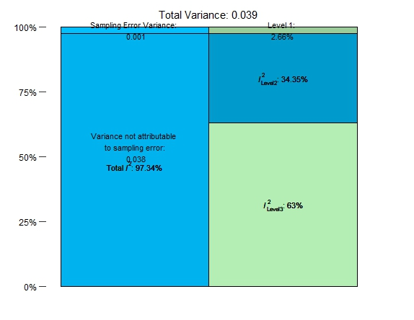
Figure S1 Variance from three-level
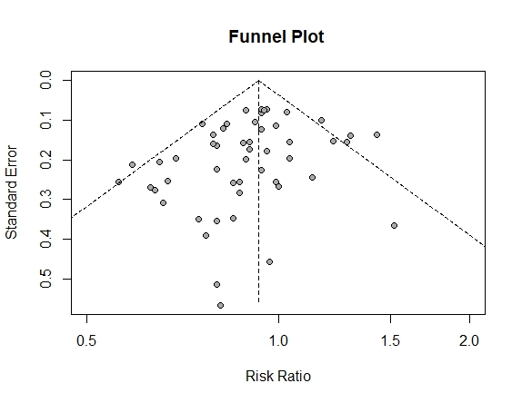
Figure S2 Funnel plots for identifying publication bias in the meta-analysis of prospective studies
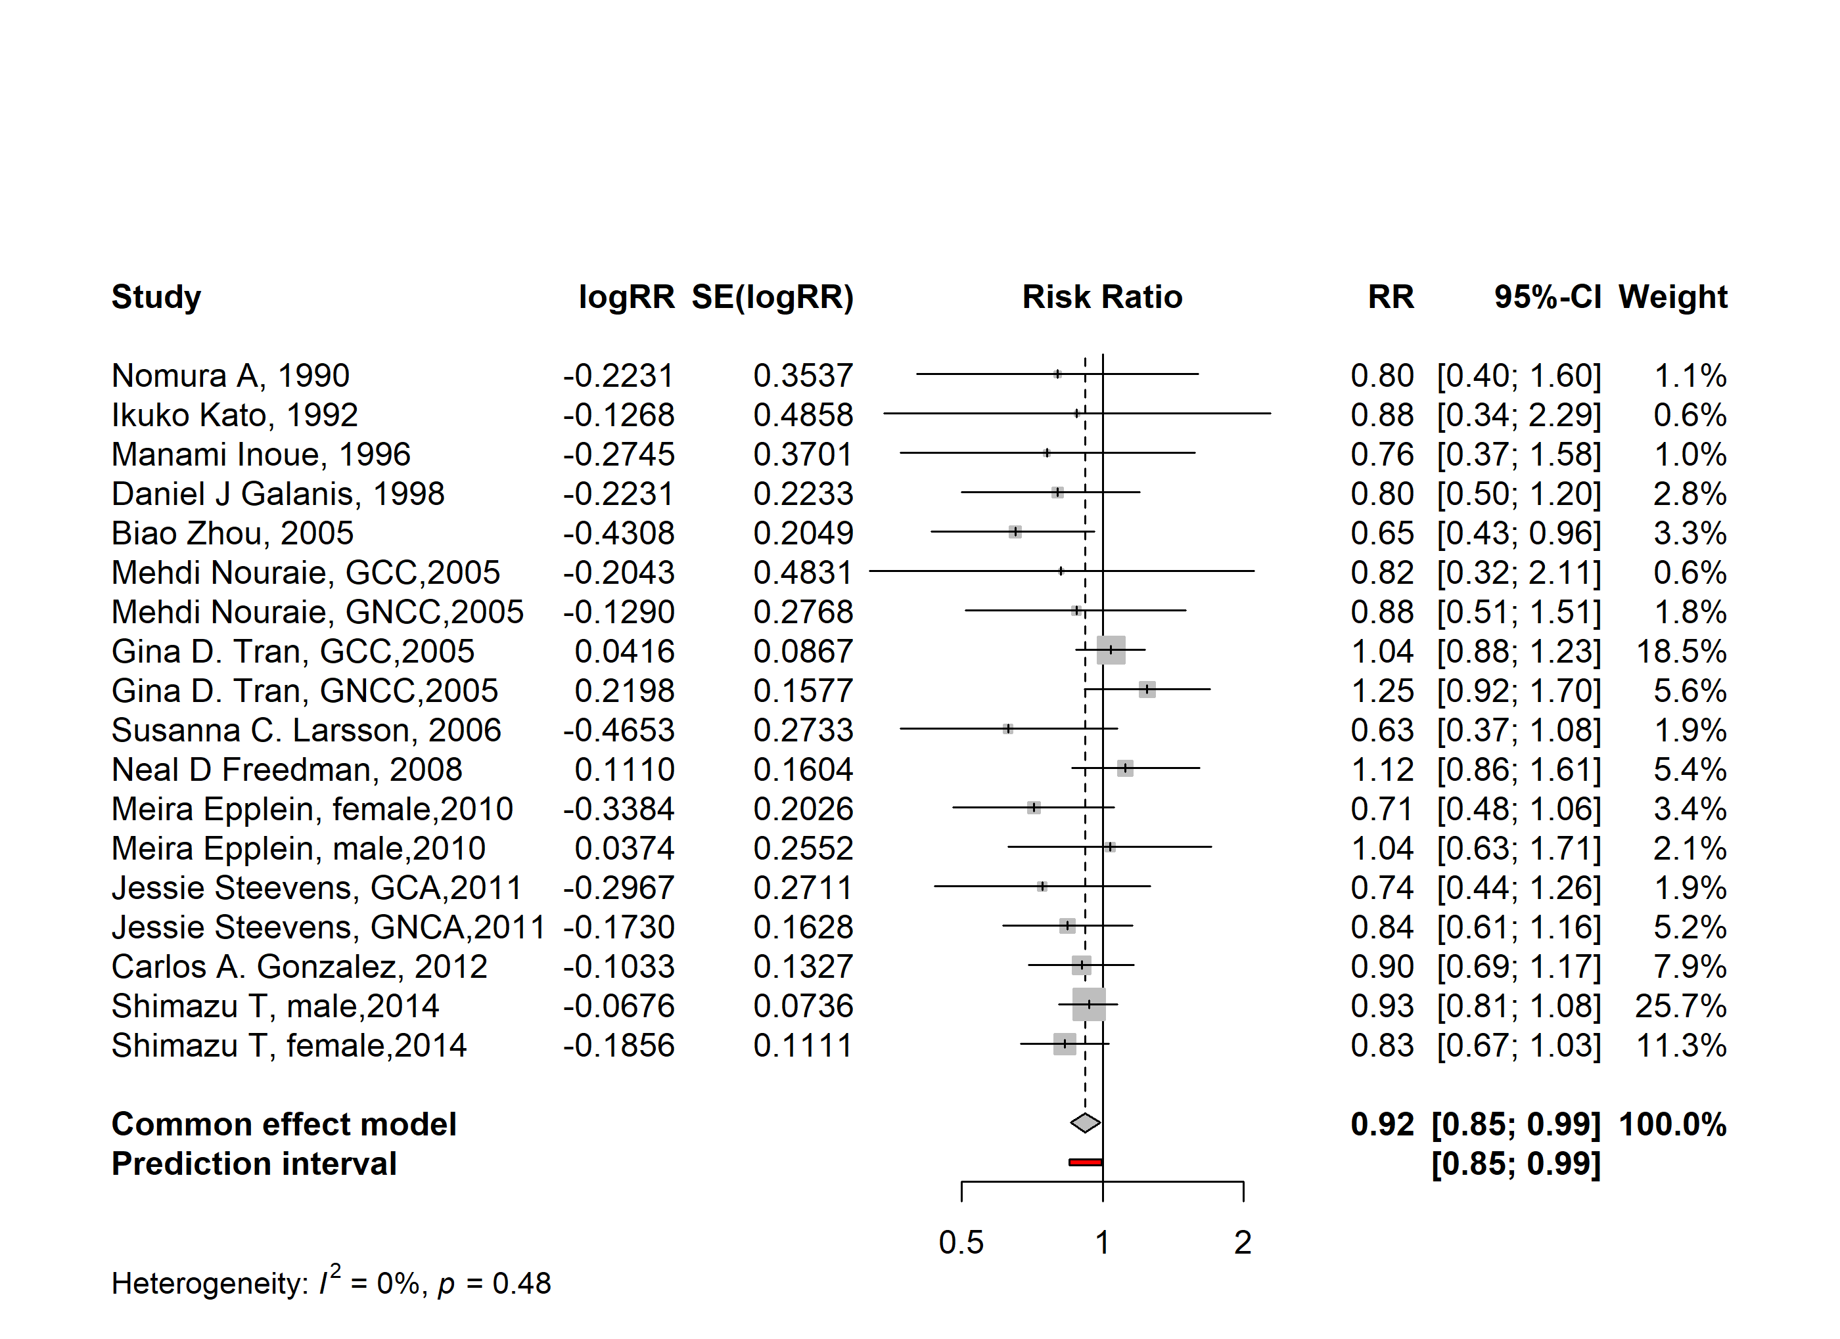
Figure S3 Forest plot of associations between vegetables consumption and gastric cancer risk with aggregated function

