Appendix
This appendix to the main article reports group-level results showing the broad patterns of variation across age and gender within the two localities.

Age effects at the group level
Table A1 summarizes the results of the MANOVA (sole predictor: Vowel) by locality and age group, including significance codes indicating whether a Pillai score is reliably different from zero (i.e., no distinction between the two vowel distributions). Overall, most groups produced some degree of distinction between /a/ and /e/ in harmony-triggering contexts, as indicated by Pillai scores that were significantly higher than zero. However, compared to traditional speakers, urban speakers across all ages produced more merged vowels, which was reflected in substantially lower Pillai scores.
Table A1. Pillai scores quantifying the distinction between /a/ and /e/ in harmony-triggering contexts by locality and age group and for all speakers pooled. Vowel was the only predictor in the MANOVA. Lower scores indicate a weaker distinction. Significance codes (for difference relative to zero): ^{ns} p > 0.05, ∗∗∗ p < 0.001
Locality | Age group
traditional | older adults | younger adults | adolescents
 | 0.49*** | 0.65*** | 0.39***
urban | older adults | younger adults | adolescents
 | 0.14*** | 0.03*** | 0.005^{ns}
traditional + urban | 0.19^{*** (pooled over all ages)}

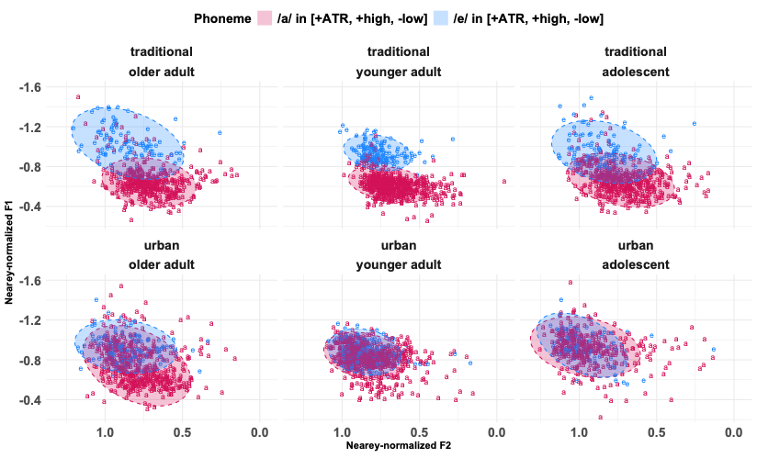
Figure A1. Distributions of [+ATR] realizations of /a/ (i.e., [æ]~[e]) and phonemic [+ATR] /e/ productions in harmony-triggering contexts, by speaker locality and age group. Each point plots the Nearey-normalized F1 and F2 of one vowel token. Each ellipse represents the 95% confidence ellipse around the group mean for the respective vowel category.
Within each locality, there was variation observable across age groups. Figure A1 plots the distributions of /a/ and phonemic /e/ in harmony-triggering contexts by locality and age group. Recall that ATR vowel contrasts are phonologically distinct from tense–lax contrasts, but are similarly reflected in terms of formant variation (see “ATR harmony in Twi and the status of [æ]” in the main article). As shown in Figure A1, in the traditional locality, merged production was more common among adolescents and older adults than younger adults. It is striking that the younger adults in this locality, who, as a group, showed more compact vowel distributions, showed less merged vowels than the older adults given that older speakers are generally more conservative to linguistic change. Together, the group-level analyses suggest that both traditional adolescents and older adults are participating in the merger of [æ] with /e/, but the adolescents, with the lowest Pillai scores of all, are further ahead.
In the urban locality, too, there was variation observable across age groups, although in a different pattern than in the traditional locality. In contrast to traditional speakers’ Pillai scores, urban speakers’ Pillai scores progressively decrease as we move from the oldest to the youngest speakers (see Table A1). Urban older adults exhibited highly merged vowels, as reflected in a low Pillai score; however, as seen in Figure A1, a sizable proportion of their tokens of ATR-harmonized /a/ ([æ]) remained lower and backer than their /e/ tokens. As for urban adolescents and younger adults, both groups showed great overlap between [æ] and /e/, as reflected in even lower Pillai scores. Nevertheless, adolescents still appeared to be ahead in the merger: whereas younger adults’ Pillai score was significantly higher than zero, adolescents’ Pillai score was not. For both the adolescents and the younger adults, the ellipses for [æ] and /e/ almost completely overlapped along the F1 dimension, while along the F2 dimension, most tokens of [æ] were relatively front, aligning with phonemic /e/. Some tokens of [æ] remained lower and backer for both age groups, with a visibly greater proportion for the younger adults. Overall, these results indicate that urban adolescents and younger adults are more advanced in [æ]-raising, and the related [æ]–/e/ merger, than older adults and, further, that the shift from the traditional [æ] to /e/ is nearing completion in the youngest generation of urban speakers.

Gender effects at the group level
Table A2 summarizes the MANOVA results by locality and gender, while Figure A2 presents a token-level analysis of ATR-harmonized /a/ ([æ]) and /e/ productions. As was found in the production variation across age groups, there was generally some degree of distinction produced between [æ] and /e/, regardless of speakers’ gender. All Pillai scores shown in Table A2 were significantly higher than zero.
Table A2. Pillai scores quantifying the distinction between /a/ and /e/ in harmony-triggering contexts by locality and gender. Vowel was the only predictor in the MANOVA. Lower scores indicate a weaker distinction. Significance code (for difference relative to zero): ∗∗∗ p < 0.001
Locality | Gender
traditional | females | males
 | 0.39*** | 0.62***
urban | females | males
 | 0.07*** | 0.02***
However, there was also variation observable between genders. In the traditional locality, female speakers produced substantially more overlap between [æ] and /e/ than male speakers. Yet, despite the occurrence of [æ]-raising, a considerable proportion of [æ] tokens remained lower and backer than /e/ tokens for traditional females (see Figure A2). In contrast, in the urban locality, the gender difference was reversed: male speakers showed more overlap than female speakers, as reflected in the very low Pillai score for urban males (0.02). As shown in the lower half of Figure A2, for urban females, the ellipse for /e/ overlapped completely with that for [æ] along the F2 dimension, but not completely along the F1 dimension. Conversely, for urban males, the ellipse for /e/ overlapped completely with that for [æ] along both F1 and F2, indicating that males were more merged than females in the urban locality. However, as above, some [æ] tokens remained lower and backer than /e/ tokens for urban males, as reflected in their non-zero Pillai score.
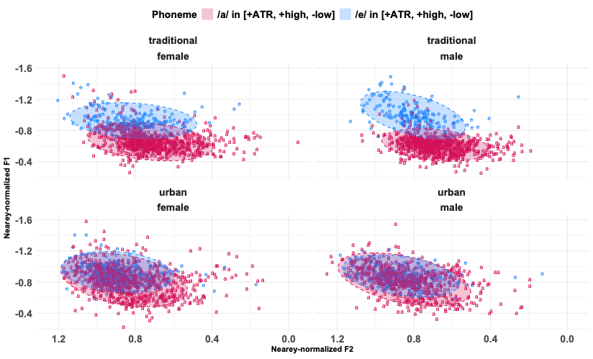
Figure A2. Distributions of [+ATR] realizations of /a/ (i.e., [æ]~[e]) and phonemic [+ATR] /e/ productions in harmony-triggering contexts, by speaker locality and gender. Each point plots the Nearey-normalized F1 and F2 of one vowel token. Each ellipse represents the 95% confidence ellipse around the group mean for the respective vowel category.

