Appendix

Figure A1. Density distribution of number of reported variants pro variable. The y-axis indicates the probability density function, such that the full area below the density line equals 1, i.e. 100%. For interpretative purposes, however, the values are of little relevance; the higher the peak in the density plot, the higher the probability of the respective value on the x-axis.

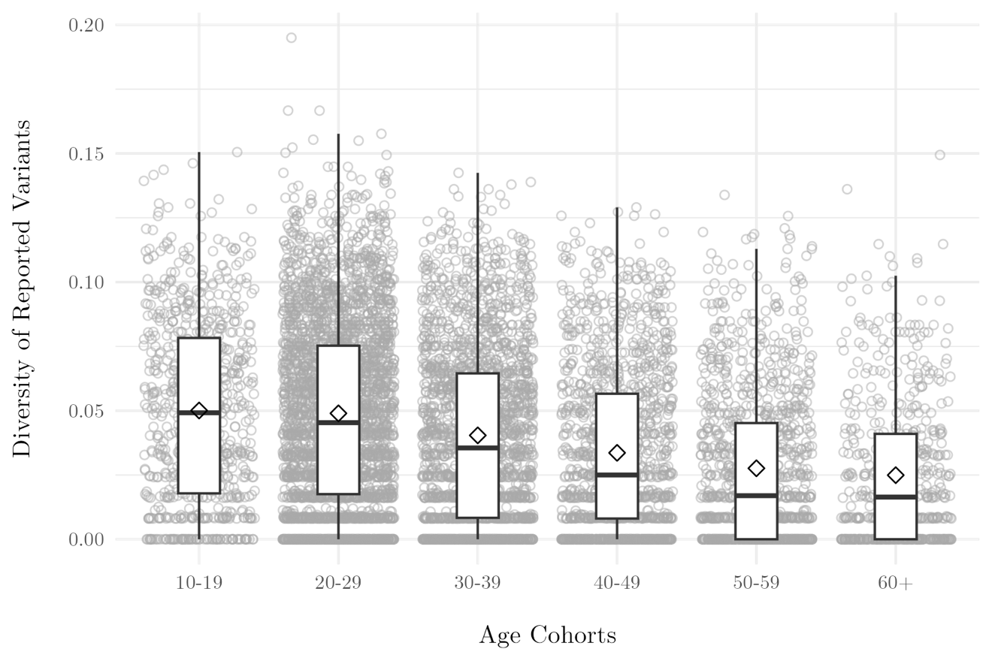

Figure A2. Scaled measure of diversity of reported variants across age cohorts.

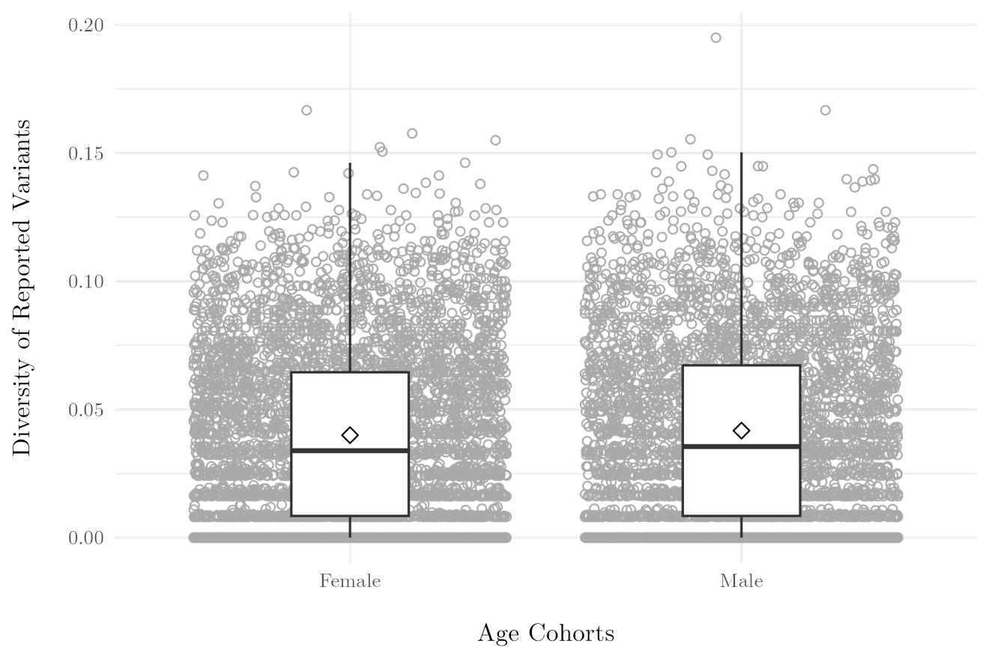

Figure A3. Scaled measure of diversity of reported variants across gender.

Model Specifications

Unadjusted model:

brm(bf(

diversity_of_variants ~

complexity_data +

complexity_people *

complexity_things +

(1 | zip_id),

zi ~

complexity_data +

complexity_people *

complexity_things +

(1 | zip_id)

),

family = zero_inflated_beta)

Age-adjusted model:

brm(bf(

diversity_of_variants ~

age * complexity_data +

age * complexity_people +

age * complexity_things +

(1 | zip_id),

zi ~

age * complexity_data +

age * complexity_people +

age * complexity_things +

(1 | zip_id)

),

family = zero_inflated_beta)

Figure A4. Posterior predictive check: Only occupational complexity

Figure A5. Posterior predictive check: Fully adjusted model