**Supplementary Figure 1.** The extents of the southern elephant seal (*Mirounga leonina*) Isthmus Study Area on the east and west coasts of the Isthmus of Macquarie Island. The subareas (red lettering) are after Carrick et al. (1962). Subarea names in brackets are more recent alternatives, their limits are based on recognisable natural boundaries in the local geography. Figure reproduced and modified from the original in “Observations of Sea-Elephants” (Stephan Csordas 1957 unpublished). Blue shading = ocean and  = tussock grass. The inset shows the position of the Isthmus on Macquarie Island (black dot).

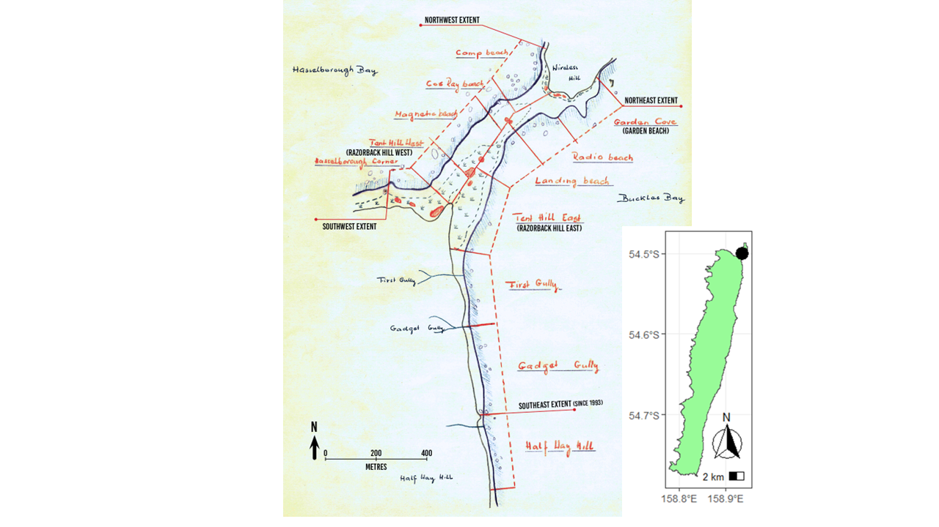

**Supplementary Table 1.** The complete time series of censuses of breeding female southern elephant seals (cows) numbers within the Macquarie Island Isthmus Study Area (ISA) between 1949 and 2023. The ISA is defined as the area shown in Supplementary Figure 1 of this paper. *a* = the day of maximum cow arrival Day 1 = 1st of September (Figure 2), *d* = the duration (days) of cows stay on the beach, *s* = standard deviation of *d*, *n* = the estimated *total number of cows hauling out on the isthmus* during the breeding season, *n.lwr* and *n.upper* are the 95%CI of *n*, *Cows* = the maximum model estimate of number of cows ashore (Figure 2), *Pups* = the estimated maximum number of pups produced. An Asterisk (*) denotes a single count within a week of October 15 (Figure 2). In these years there were too few data to run the model and estimate a maximum number of cows in that season consequently we were only able to report the maximum number of cows ashore on the day of the count (Hindell and Burton 1987). The Section Mark (§) denotes no counts in that year*.*

|  |  |  |  |  |  |  |  |  |  |
| --- | --- | --- | --- | --- | --- | --- | --- | --- | --- |
| ***Year*** | ***# Surveys*** | ***a*** | ***d*** | ***s*** | ***n*** | ***n.lwr*** | ***n.upr*** | ***Cows*** | ***Pups*** |
| **1949** | 4 | 35.73 | 26.35 | 8.75 | 9424 | 7601 | 11248 | 8178 | 9269 |
| **1950\*** | 1 |  |  |  |  |  |  | 6310 |  |
| **1951\*** | 1 |  |  |  |  |  |  | 5620 |  |
| **1952\*** | 1 |  |  |  |  |  |  | 6114 |  |
| **1952§** |  |  |  |  |  |  |  | NA |  |
| **1954\*** | 1 |  |  |  |  |  |  | 6738 |  |
| **1955\*** | 1 |  |  |  |  |  |  | 5186 |  |
| **1956** | 5 | 31.39 | 29.09 | 8.75 | 6137 | 5930 | 6344 | 5544 | 6035 |
| **1957** | 6 | 29.65 | 29.79 | 8.75 | 5462 | 5291 | 5633 | 4974 | 5372 |
| **1958\*** | 1 |  |  |  |  |  |  | 6154 |  |
| **1959** | 32 | 31.10 | 27.41 | 8.75 | 5260 | 5136 | 5383 | 4642 | 5173 |
| **1960\*** | 1 |  |  |  |  |  |  | 6088 |  |
| **1961§** |  |  |  |  |  |  |  | NA |  |
| **1962** | 13 | 26.00 | 34.15 | 8.75 | 2427 | 2343 | 2512 | 2303 | 2388 |
| **1963\*** | 1 |  |  |  |  |  |  | 4815 |  |
| **1964§** |  |  |  |  |  |  |  | NA |  |
| **1965\*** | 1 |  |  |  |  |  |  | 4556 |  |
| **1966** | 23 | 31.27 | 28.43 | 8.75 | 4459 | 4310 | 4607 | 3990 | 4385 |
| **1967§** |  |  |  |  |  |  |  | NA |  |
| **1968§** |  |  |  |  |  |  |  | NA |  |
| **1969§** |  |  |  |  |  |  |  | NA |  |
| **1970** | 10 | 29.66 | 29.88 | 8.75 | 4195 | 3962 | 4428 | 3825 | 4126 |
| **1971** | 23 | 31.02 | 28.63 | 8.75 | 3578 | 3467 | 3689 | 3212 | 3519 |
| **1972\*** | 1 |  |  |  |  |  |  | 3927 |  |
| **1973§** |  |  |  |  |  |  |  | NA |  |
| **1974§** |  |  |  |  |  |  |  | NA |  |
| **1975** | 13 | 31.52 | 30.85 | 8.75 | 4770 | 4639 | 4900 | 4397 | 4690 |
| **1976§** |  |  |  |  |  |  |  | NA |  |
| **1977§** |  |  |  |  |  |  |  | NA |  |
| **1978§** |  |  |  |  |  |  |  | NA |  |
| **1979§** |  |  |  |  |  |  |  | NA |  |
| **1980\*** | 1 |  |  |  |  |  |  | 5020 |  |
| **1981§** |  |  |  |  |  |  |  | NA |  |
| **1982\*** | 1 |  |  |  |  |  |  | 3037 |  |
| **1983§** |  |  |  |  |  |  |  | NA |  |
| **1984** | 22 | 32.89 | 26.81 | 8.75 | 2944 | 2808 | 3080 | 2573 | 2895 |
| **1985** | 70 | 31.12 | 29.53 | 8.75 | 3073 | 3014 | 3132 | 2791 | 3023 |
| **1986** | 5 | 31.78 | 28.72 | 8.75 | 3455 | 3307 | 3603 | 3106 | 3398 |
| **1987** | 25 | 33.07 | 27.14 | 8.75 | 3592 | 3474 | 3709 | 3155 | 3532 |
| **1988** | 81 | 30.05 | 29.29 | 8.75 | 3556 | 3493 | 3619 | 3220 | 3498 |
| **1989** | 80 | 30.42 | 27.28 | 8.75 | 3679 | 3605 | 3754 | 3241 | 3618 |
| **1990** | 84 | 30.22 | 29.37 | 8.75 | 3288 | 3227 | 3349 | 2981 | 3234 |
| **1991** | 67 | 28.83 | 30.85 | 8.75 | 2833 | 2778 | 2888 | 2611 | 2786 |
| **1992** | 48 | 28.56 | 30.91 | 8.75 | 3439 | 3363 | 3514 | 3172 | 3382 |
| **1993** | 56 | 29.62 | 28.90 | 8.75 | 3449 | 3377 | 3520 | 3108 | 3392 |
| **1994** | 49 | 29.67 | 29.68 | 8.75 | 2889 | 2826 | 2951 | 2627 | 2841 |
| **1995** | 29 | 29.75 | 29.95 | 8.75 | 3130 | 3052 | 3209 | 2857 | 3079 |
| **1996** | 51 | 30.30 | 28.82 | 8.75 | 3231 | 3150 | 3312 | 2908 | 3178 |
| **1997** | 57 | 30.41 | 28.55 | 8.75 | 3238 | 3169 | 3307 | 2904 | 3185 |
| **1998** | 48 | 31.00 | 28.50 | 8.75 | 3308 | 3225 | 3391 | 2965 | 3253 |
| **1999** | 74 | 32.01 | 28.24 | 8.75 | 3443 | 3376 | 3510 | 3075 | 3386 |
| **2000** | 60 | 28.73 | 30.63 | 8.75 | 3006 | 2948 | 3063 | 2765 | 2956 |
| **2001** | 85 | 29.53 | 29.48 | 8.75 | 3050 | 2990 | 3109 | 2768 | 2999 |
| **2002\*** | 1 |  |  |  |  |  |  | 2763 |  |
| **2003\*** | 1 |  |  |  |  |  |  | 2879 |  |
| **2004** | 55 | 30.94 | 29.00 | 8.75 | 3268 | 3192 | 3345 | 2948 | 3214 |
| **2005** | 96 | 31.86 | 28.24 | 8.75 | 3145 | 3080 | 3211 | 2810 | 3094 |
| **2006** | 8 | 31.35 | 28.92 | 8.75 | 3020 | 2892 | 3148 | 2722 | 2970 |
| **2007** | 11 | 30.92 | 29.29 | 8.75 | 2881 | 2768 | 2994 | 2608 | 2833 |
| **2008** | 11 | 31.15 | 29.11 | 8.75 | 2945 | 2829 | 3061 | 2661 | 2897 |
| **2009** | 23 | 31.70 | 29.99 | 8.75 | 2691 | 2619 | 2763 | 2457 | 2647 |
| **2010** | 21 | 32.18 | 29.57 | 8.75 | 2931 | 2855 | 3007 | 2664 | 2883 |
| **2011** | 20 | 31.02 | 29.83 | 8.75 | 2498 | 2426 | 2570 | 2277 | 2457 |
| **2012** | 19 | 32.90 | 27.95 | 8.75 | 3056 | 2963 | 3148 | 2718 | 3006 |
| **2013** | 13 | 32.47 | 29.20 | 8.75 | 2517 | 2408 | 2626 | 2277 | 2475 |
| **2014** | 21 | 32.88 | 30.40 | 8.75 | 2393 | 2322 | 2464 | 2196 | 2354 |
| **2015** | 20 | 33.09 | 29.40 | 8.75 | 2932 | 2847 | 3016 | 2658 | 2883 |
| **2016** | 16 | 32.46 | 28.89 | 8.75 | 2475 | 2393 | 2557 | 2230 | 2434 |
| **2017** | 16 | 33.52 | 28.17 | 8.75 | 2375 | 2290 | 2461 | 2119 | 2336 |
| **2018** | 16 | 32.34 | 28.67 | 8.75 | 2844 | 2759 | 2930 | 2555 | 2797 |
| **2019** | 18 | 33.30 | 27.84 | 8.75 | 2222 | 2143 | 2302 | 1974 | 2186 |
| **2020** | 16 | 32.72 | 27.32 | 8.75 | 2794 | 2701 | 2886 | 2461 | 2748 |
| **2021** | 20 | 32.92 | 27.19 | 8.75 | 2624 | 2533 | 2714 | 2306 | 2580 |
| **2022** | 17 | 31.46 | 28.10 | 8.75 | 2538 | 2455 | 2621 | 2261 | 2496 |
| **2023** | 16 | 30.91 | 28.61 | 8.75 | 2553 | 2460 | 2646 | 2292 | 2511 |