Supplementary Information
Spatial and temporal dynamics of surface water physicochemical parameters and the influence of atmospheric conditions in Admiralty Bay, Antarctic Peninsula

Amanda C. Souza^{1,*}, César C. Martins¹, Tatiane Combi², Rafael A. Lourenço^{1,*}
¹ Instituto Oceanográfico. Universidade de São Paulo. Praça do Oceanográfico, 191. 05508-900. São Paulo, SP, Brasil.
² Centro de Estudos do Mar, Campus Pontal do Paraná, Universidade Federal do Paraná, Caixa Postal 61, 8325-976 Pontal do Paraná, PR, Brasil.

*Corresponding authors: amandacamaradesouza@gmail.com (A.C. Souza)
rafaell@usp.br (R.A. Lourenço)

TABLES

Table S1: Location and depth (m) of sampling sites in Admiralty Bay, King George Island, Antarctic Peninsula.
Inlet | Code | Name | LAT (S) | LONG (W) | Mean depth (m)
Ezcurra | P1 | Arctowski | 62°09'27.1" | 058°27'16.3" | 27.2 ± 1.9
Ezcurra | P2 | Thomas Point | 62°09'09.3" | 058°28'48.1" | 31.3 ± 1.8
Ezcurra | P3 | Monsimet Cove | 62°10'25.4" | 058°32'00.1" | 28.6 ± 3.0
Ezcurra | P4 | Barrel Point | 62°10'01.0" | 058°34'33.8" | 29.9 ± 3.5
Ezcurra | P5 | Dufayel North | 62°08'59.1" | 058°31'49.2" | 30.0 ± 1,9
Ezcurra | P6 | Polish Navy Point | 62°07'57.6" | 058°28'43.8" | 32.0 ± 2.6
Mackelar | P7 | Furmanczyk Point | 62°05'35.3" | 058°27'53.7" | 30.4 ± 2.1
Mackelar | P8 | Machu Picchu | 62°05'25.1" | 058°28'22.2" | 32.6 ± 3.4
Mackelar | P9 | Mackellar Glacier | 62°05'26.5" | 058°29'33.3" | 30.4 ± 3.2
Mackelar | P10 | Refúgio II | 62°04'23.6" | 058°25'21.1" | 31.0 ± 1.6
Martel | P11 | Plaza Point | 62°05'39.6" | 058°23'54.2" | 30.0 ± 1.9
Martel | P12 | Ferraz heliponto antigo | 62°05'08.1" | 058°23'20.4" | 30.4 ± 1.3
Martel | P13 | Ferraz Tanques | 62°05'03.0" | 058°23'12.3" | 30.6 ± 1.8
Martel | P14 | Ulmann Point | 62°05'04.3" | 058°20'40.5" | 31.4 ± 1.4
Martel | P15 | Finger Point | 62°05'51.5" | 058°20'15.5" | 30.0 ± 3.0
Martel | P16 | Hennequin Point | 62°07'26.8" | 058°23'58.8" | 30.4 ± 2.8

Table S2: Results of Dunn's post-hoc test for pairwise comparisons of temperature data between January 2020, November 2022, December 2022, January 2023, February 2023, and March 2023. The table displays p-values (upper triangle) and z-statistics (lower triangle). Significant results (p < 0.05) are highlighted in bold.
 | jan/20 | nov/22 | dec/22 | jan/23 | feb/23 | mar/23
jan/20 |  | 5,27E-13 | 9,90E-12 | 0,00263 | 0,07776 | 2,31E-05
nov/22 | 7,22 |  | 0,6766 | 1,87E-05 | 2,95E-08 | 0,0024
dec/22 | 6,81 | 0,42 |  | 0,00011 | 2,94E-07 | 0,00884
jan/23 | 3,01 | 4,28 | 3,86 |  | 0,2062 | 0,2131
feb/23 | 1,76 | 5,55 | 5,13 | 1,26 |  | 0,0121
mar/23 | 4,23 | 3,04 | 2,62 | 1,25 | 2,51

Table S3: Results of Dunn's post-hoc test for pairwise comparisons of salinity data between January 2020, November 2022, December 2022, January 2023, February 2023, and March 2023. The table displays p-values (upper triangle) and z-statistics (lower triangle). Significant results (p < 0.05) are highlighted in bold.
 | jan/20 | nov/22 | dec/22 | jan/23 | feb/23 | mar/23
jan/20 |  | 1,39E-06 | 5,78E-10 | 1,74E-05 | 0,05723 | 0,00033
nov/22 | 4,83 |  | 0,1639 | 0,5891 | 0,00294 | 0,2087
dec/22 | 6,20 | 1,39 |  | 0,05334 | 1,27E-05 | 0,00807
jan/23 | 4,30 | 0,54 | 1,93 |  | 0,01495 | 0,4734
feb/23 | 1,90 | 2,97 | 4,37 | 2,43 |  | 0,08602
mar/23 | 3,59 | 1,26 | 2,65 | 0,72 | 1,72

Table S4: Results of Dunn's post-hoc test for pairwise comparisons of SPM data between January 2020, November 2022, December 2022, January 2023, February 2023, and March 2023. The table displays p-values (upper triangle) and z-statistics (lower triangle). Significant results (p < 0.05) are highlighted in bold.
 | jan/20 | nov/22 | dec/22 | jan/23 | feb/23 | mar/23
jan/20 |  | 0,9998 | 0,9872 | 0,2589 | 0,645 | 0,00024
nov/22 | 0,00 |  | 0,9872 | 0,251 | 0,6397 | 0,00019
dec/22 | 0,02 | 0,02 |  | 0,2445 | 0,6512 | 0,0002
jan/23 | 1,13 | 1,15 | 1,16 |  | 0,1061 | 1,08E-06
feb/23 | 0,46 | 0,47 | 0,45 | 1,62 |  | 0,00111
mar/23 | 3,67 | 3,73 | 3,71 | 4,88 | 3,26

Table S5: Results of Dunn's post-hoc test for pairwise comparisons of pH data between January 2020, November 2022, December 2022, January 2023, February 2023, and March 2023. The table displays p-values (upper triangle) and z-statistics (lower triangle). Significant results (p < 0.05) are highlighted in bold.
 | jan/20 | nov/22 | dec/22 | jan/23 | feb/23 | mar/23
jan/20 |  | 0,30 | 0,16 | 4,70E-05 | 1,56E-08 | 2,90E-08
nov/22 | 1,03 |  | 0,71 | 0,00 | 0,00 | 4,32E-06
dec/22 | 1,39 | 0,37 |  | 0,00 | 0,00 | 2,42E-05
jan/23 | 4,07 | 3,30 | 3,01 |  | 0,66 | 0,7729
feb/23 | 5,66 | 4,72 | 4,35 | 0,44 |  | 0,8432
mar/23 | 5,55 | 4,60 | 4,22 | 0,29 | 0,20

FIGURES
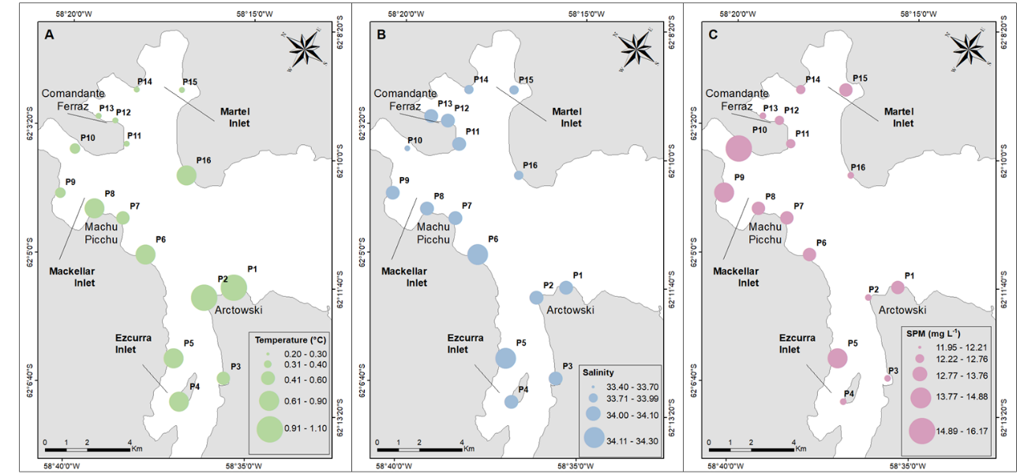Figure S1: Spatial distribution of temperature, in °C (A), salinity (B), and SPM, in mg L⁻¹ (C), in the surface water of Admiralty Bay, King George Island, Antarctic Peninsula, in November 2022.
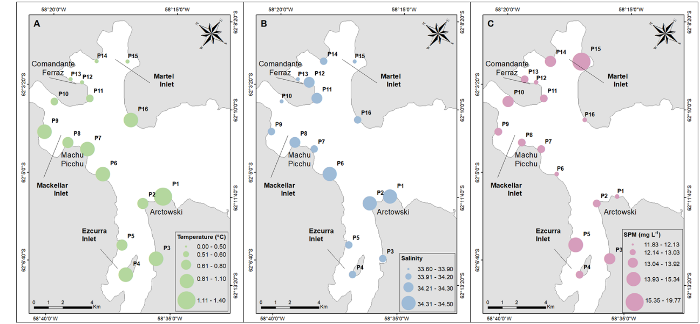
Figure S2: Spatial distribution of temperature, in °C (A), salinity (B), and SPM, in mg L⁻¹ (C), in the surface water of Admiralty Bay, King George Island, Antarctic Peninsula, in December 2022.
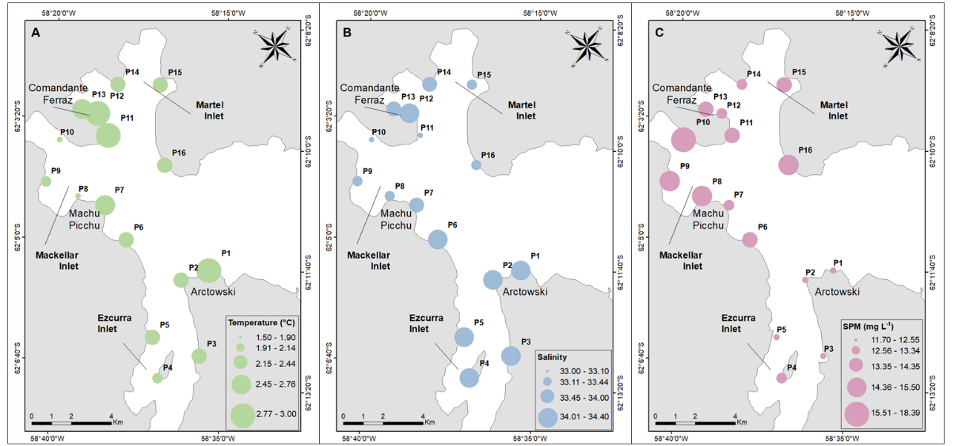
Figure S3: Spatial distribution of temperature, in °C (A), salinity (B), and SPM, in mg L⁻¹ (C), in the surface water of Admiralty Bay, King George Island, Antarctic Peninsula, in January 2023.
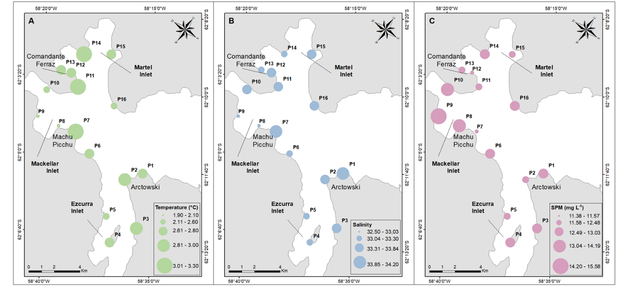Figure S4: Spatial distribution of temperature, in °C (A), salinity (B), and SPM, in mg L⁻¹ (C), in the surface water of Admiralty Bay, King George Island, Antarctic Peninsula, in February 2023.
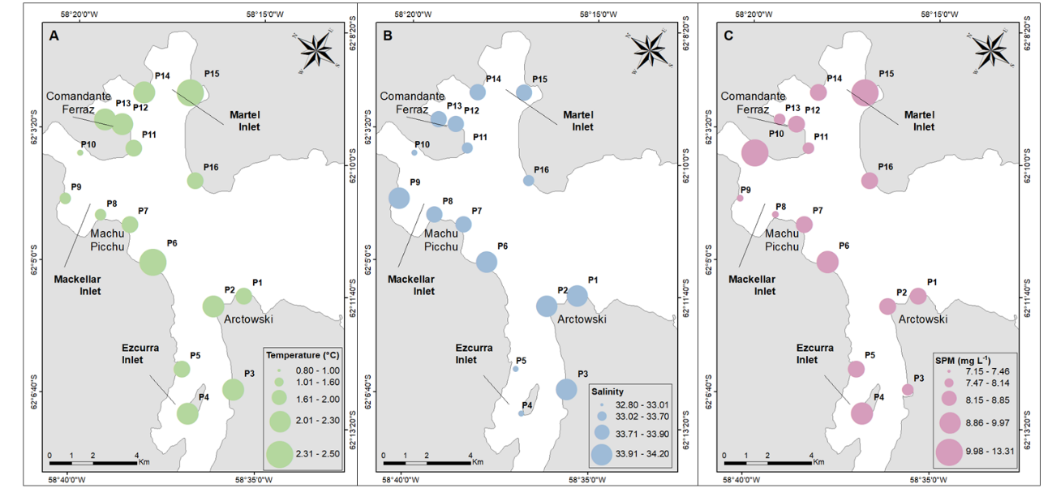Figure S5: Spatial distribution of temperature, in °C (A), salinity (B), and SPM, in mg L⁻¹ (C), in the surface water of Admiralty Bay, King George Island, Antarctic Peninsula, in March 2023.

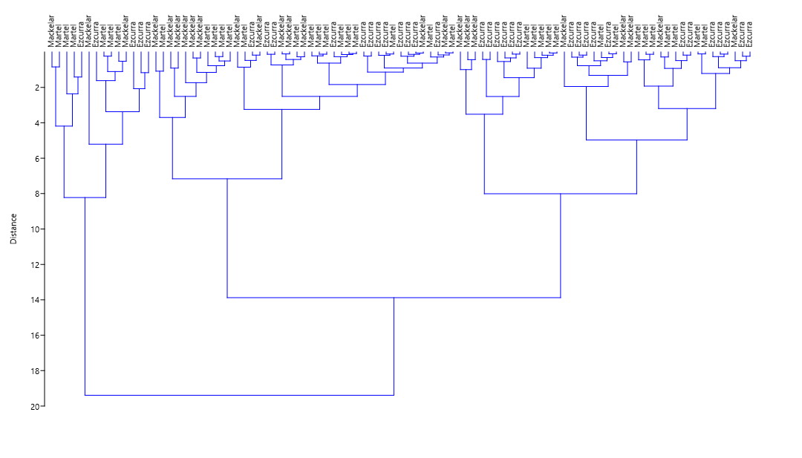
Figure S6: Cluster analyses of hydrological parameters (temperature, salinity, pH, and SPM) in the surface water of Admiralty Bay, King George Island, Antarctic Peninsula, in all campaigns.

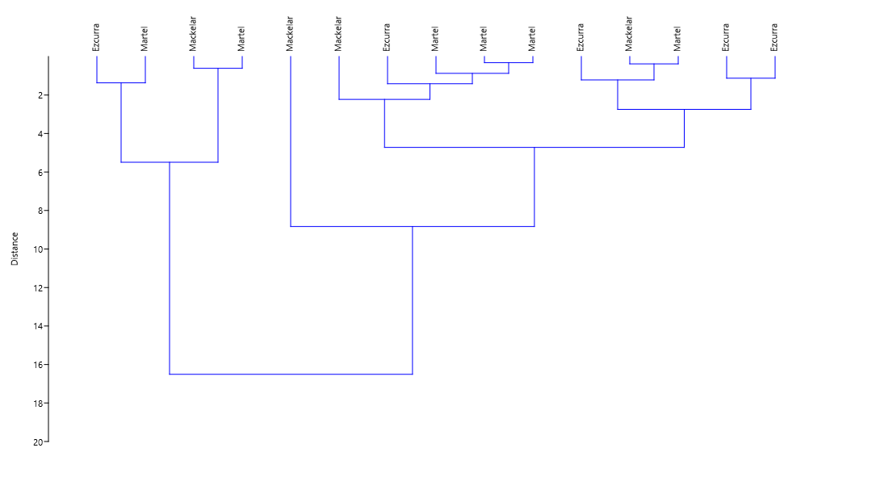
Figure S7: Cluster analyses of hydrological parameters (temperature, salinity, pH, and SPM) in the surface water of Admiralty Bay, King George Island, Antarctic Peninsula, January 2020.

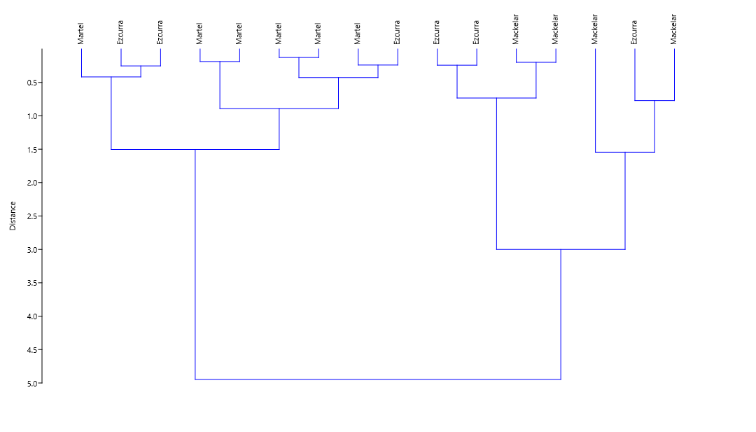
Figure S8: Cluster analyses of hydrological parameters (temperature, salinity, pH, and SPM) in the surface water of Admiralty Bay, King George Island, Antarctic Peninsula, November 2022.

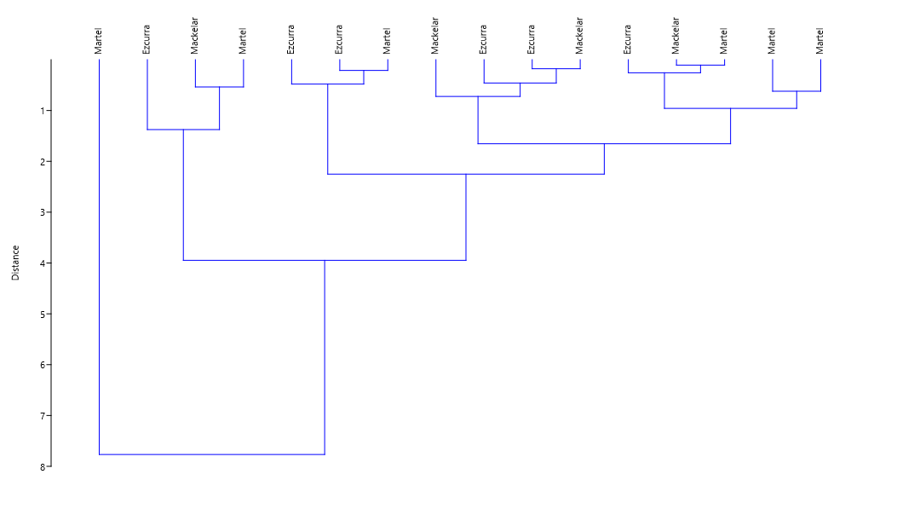
Figure S9: Cluster analyses of hydrological parameters (temperature, salinity, pH, and SPM) in the surface water of Admiralty Bay, King George Island, Antarctic Peninsula, December 2022.
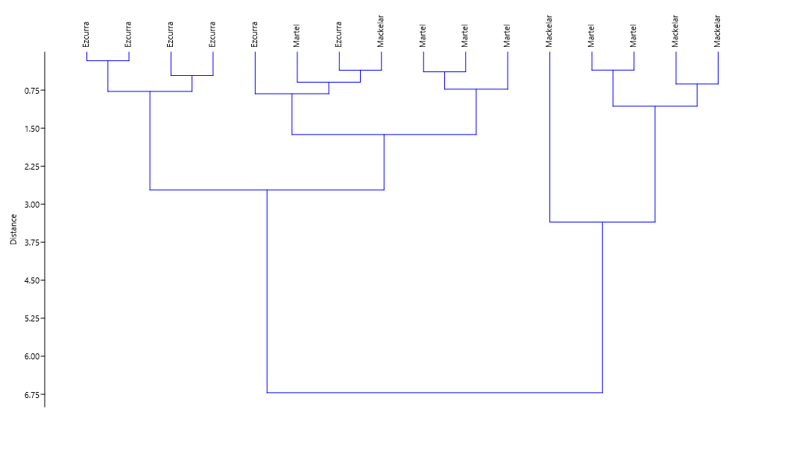
Figure S10: Cluster analyses of hydrological parameters (temperature, salinity, pH, and SPM) in the surface water of Admiralty Bay, King George Island, Antarctic Peninsula, January 2023.
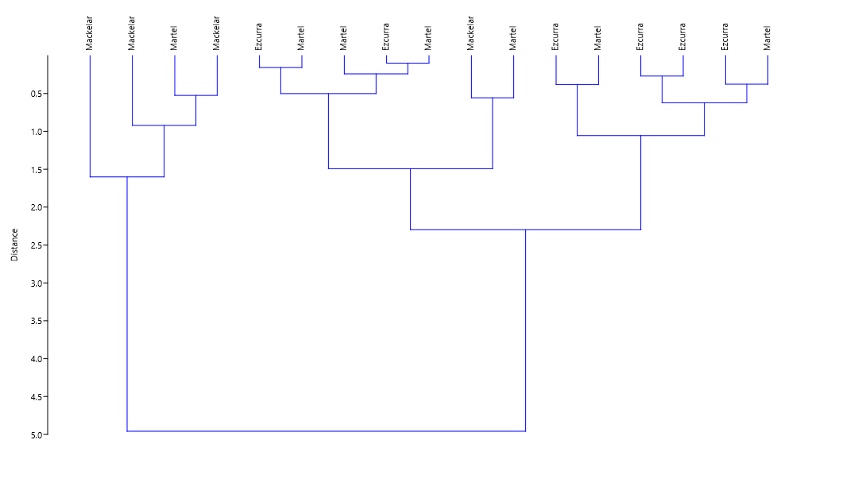
Figure S11: Cluster analyses of hydrological parameters (temperature, salinity, pH, and SPM) in the surface water of Admiralty Bay, King George Island, Antarctic Peninsula, February 2023.
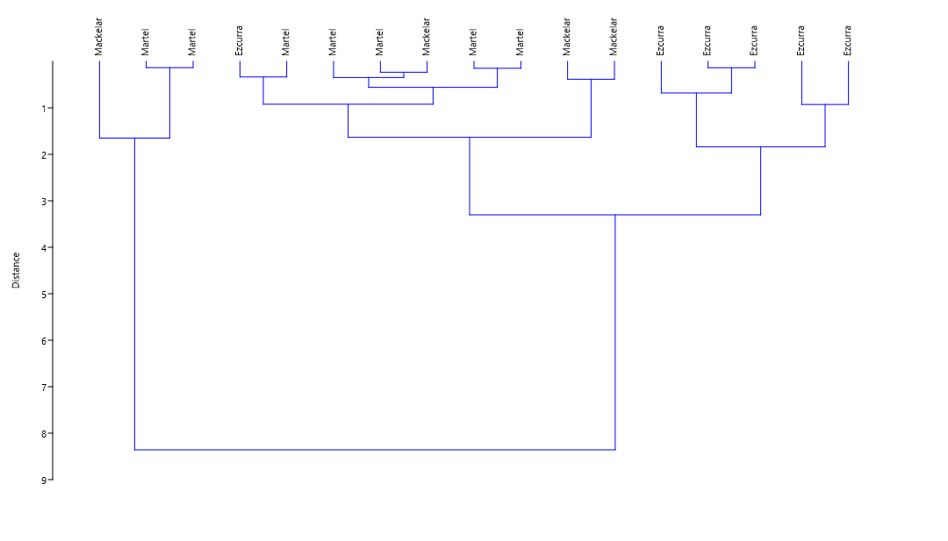
Figure S12: Cluster analyses of hydrological parameters (temperature, salinity, pH, and SPM) in the surface water of Admiralty Bay, King George Island, Antarctic Peninsula, March 2023.

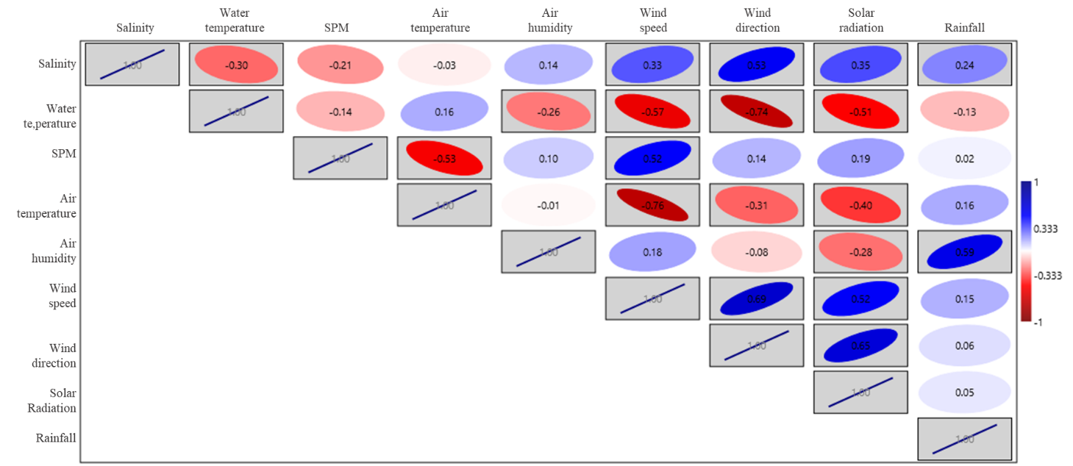
Figure S13: Spearman correlation matrix including data on water temperature (in °C), salinity, SPM (in mg L⁻¹), atmospheric temperature (in °C), air humidity (in %), wind speed and direction, solar radiation (in kJ m⁻²) and rainfall (in mm). *Gray rectangle represents p-value < 0.05.

