Supplementary material

Environmental degradation and loss of polyester marker flags is a major source of localised plastic pollution in the Antarctic

Nadia Frontier, Jo H. Cole and Kevin A. Hughes

Figure S1. Windrose data from the Automatic Weather Station (AWS) close to the flag deployment site near the skiway at Rothera Research Station for the years 2023 (top left); 2022 (top right); 2021 (bottom left) and 2020 (bottom right). Similar wind patterns can be seen over the years with the wind direction predominately from the north-northeast. For each windrose, the central values show the percentage period when the windspeed is >1 knot. In the windrose provided for 2023, the central value of 66.8% is not a reflection of the wind conditions over the year, but is an artifact resulting from the damage of the propvane (see Methods).

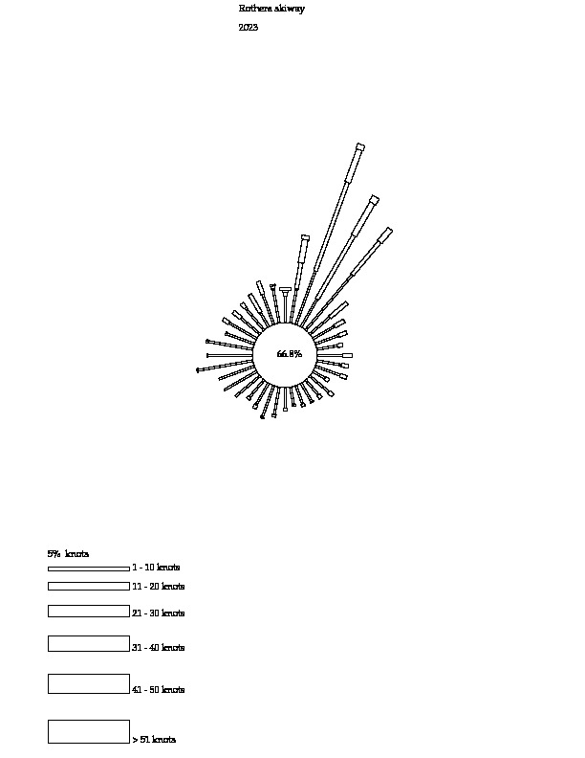
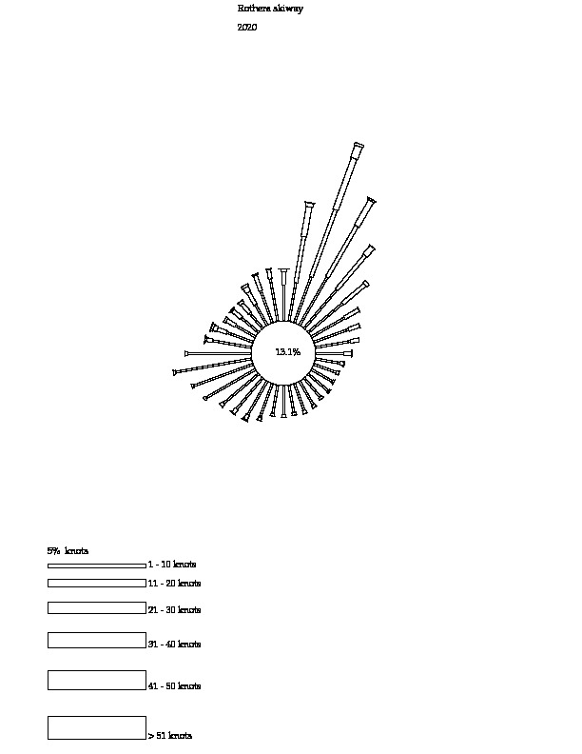
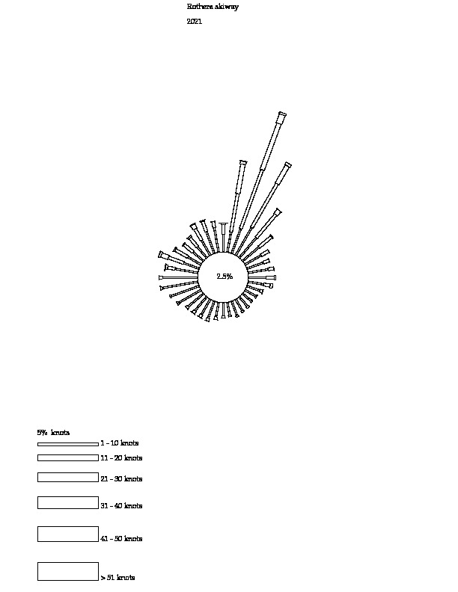
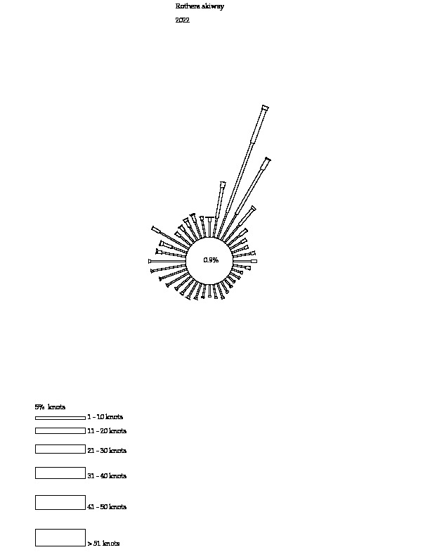

Figure S2: Types of material trialled as part of the experiment a) unhemmed polyester, (
b) hemmed polyester, (c and) hemmed organic canvas (pre and post-deployment), (e) hemmed Ventile L24. Images provided by Nadia Frontier and Eloise Chambers.

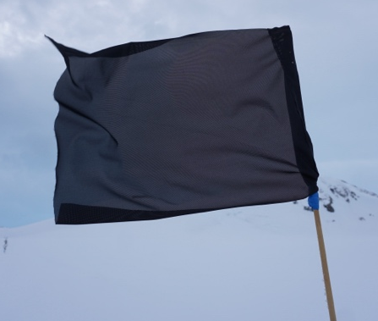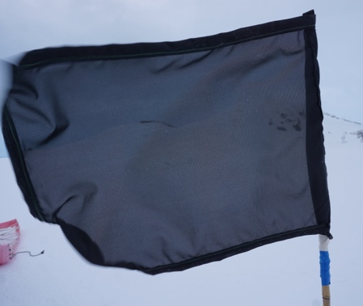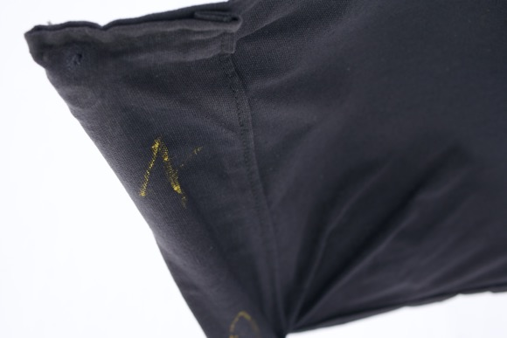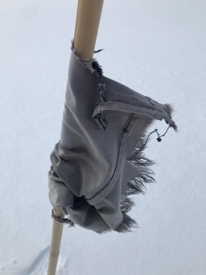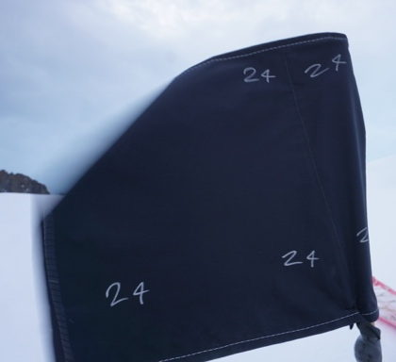
a
b
c
e
d

