Microbial mat activity and soil biogeochemistry across variable phosphorus availability in Taylor Valley, Antarctica
Sarah N. Power, Ernest D. Osburn, and John E. Barrett

Supplemental Information in Order of Appearance

Table S1. Locations and description of the 16 sites used in this study. The general location identifies the closest identifiable landscape feature (note that samples were not collected from within stream channels), glacial drift name, mat type based on visual assessment of the mat color, and dominant genus present based on metagenomic taxonomic sequencing.
Plot ID | Latitude  S | Longitude  E | General Location | Glacial Drift | Mat Type | Dominant Genus
R01 | -77.59846 | 163.26842 | Beside McKnight Creek | Ross Sea | Black | Polaromonas
R02 | -77.61371 | 163.25754 | Beside Von Guerard Stream | Ross Sea | Black | Nostoc
R03 | -77.61382 | 163.04385 | Beside Canada Stream | Ross Sea | Black | Nostoc
R04 | -77.60246 | 163.27255 | Beside Aiken Creek | Ross Sea | Black | Nostoc
R05 | -77.62435 | 163.05362 | Near Green Creek | Ross Sea | Black | Nostoc
R06 | -77.62669 | 163.11385 | Beside Delta Stream | Ross Sea | Black | Nostoc
R07 | -77.63781 | 163.20866 | Beside Crescent Stream | Ross Sea | Black | Nostoc
R08 | -77.62792 | 163.28668 | Beside Relict Channel | Ross Sea | Black | Nostoc
T09 | -77.72765 | 162.46495 | Beside Unnamed Stream, Near Hughes Glacier Pond | Taylor | Black | Nostoc
T10 | -77.72767 | 162.48909 | Beside Hughes Glacier Pond | Taylor | Black | Nostoc
T11 | -77.72469 | 162.47571 | Beside Unnamed Stream, Near Hughes Glacier Pond | Taylor | Orange | Cyanothece
T12 | -77.73006 | 162.33351 | Upper Wormherder Creek | Taylor | Orange | Cyanothece
T13 | -77.72599 | 162.31544 | Lower Wormherder Creek | Taylor | Orange | Oscillatoria
T14 | -77.72674 | 162.28580 | Beside Unnamed Stream, Near Taylor Glacier | Taylor | Orange | Oscillatoria
T15 | -77.72820 | 162.28732 | Beside Unnamed Stream, Near Taylor Glacier | Taylor | Black | Nostoc
T16 | -77.72993 | 162.32300 | Middle Wormherder Creek | Taylor | Orange | Oscillatoria

Table S2. Pigments measured in microbial mat samples using high performance liquid chromatography. Detectable concentrations are denoted with “x”, and nondetectable concentrations are denoted with “ND”.
Pigments Measured | Detection
chlorophyllide-a | ND
chlorophyll c1&c2 | ND
scytonemin | x
reduced scytonemin | x
19 butanoyloxyfucoxanthin | ND
fucoxanthin | ND
19 hexanoyloxyfucoxanthin | ND
9 cis neoxanthin | ND
violaxanthin | ND
diadinoxanthin | ND
antheraxanthin | ND
myxoxanthophyll | x
alloxanthin | ND
diatoxanthin | ND
monadoxanthin | ND
lutein | ND
zeaxanthin | x
gyroxanthin | ND
chlorophyll b | x
chlorophyll a | x
beta-carotene | x
canthaxanthin | x
echinenone | x

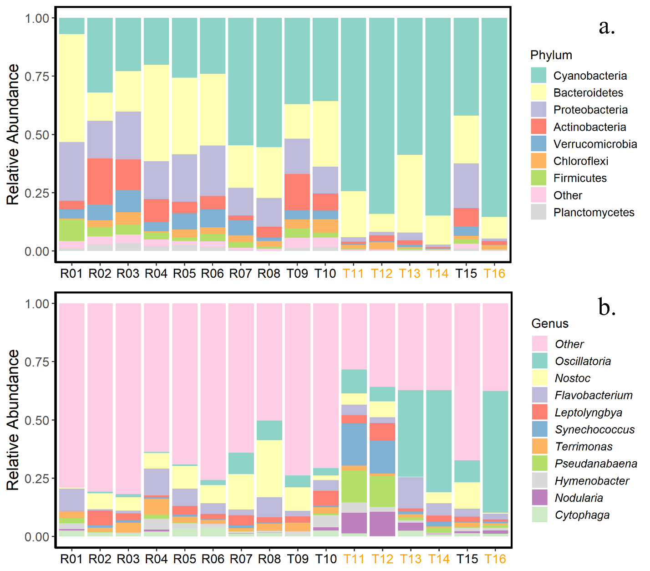
Figure S1. Relative abundance of a.) prokaryotic phyla and b.) prokaryotic genera identified within each of the 16 samples using the SILVA 138.1 sequence library. The remaining prokaryotic phyla and genera of less than 1% and 1.7%, respectively, are represented in “Other”. Samples collected from the Ross Sea drift begin with “R” (i.e., R01 - R08), and samples collected from the Taylor drifts begin with “T” (i.e., T09 - T16). The x-axis label colors represent whether the samples were collected from black or orange microbial mats based upon visual field surveys.

