Supplement 1: Supporting Tables and Figures

Table S1. Comparison of models of prey consumption by *Merizodus soledadinus*. Models 1-6 were compared using the drop1 base R function, while model 7 was created based on known life history of the species.

|  |  |  |  |  |  |
| --- | --- | --- | --- | --- | --- |
| **Number** | **Model** | **Deviance** | **AIC** | **LRT** | **Pr (>Chi)** |
| 1 | prey species + temperature + life stage + number of predators + other prey option (full model) | 120.63 | 146.63 | - | - |
| 2 | temperature + life stage + number of predators + other prey option | 160.24 | 172.24 | 39.612 | 7.48E-05 |
| 3 | prey species + life stage + number of predators + other prey option | 120.64 | 144.65 | 0.014 | 0.9042 |
| 4 | prey species + temperature + number of predators + other prey option | 158.22 | 180.22 | 37.591 | 6.87E-09 |
| 5 | prey species + temperature + life stage + other prey option | 120.64 | 144.63 | 0.004 | 0.9473 |
| 6 | prey species + temperature + life stage + number of predators | 122.98 | 146.98 | 2.349 | 0.1254 |
| 7 | prey species + life stage | 123.18 | 143.18 | - | - |

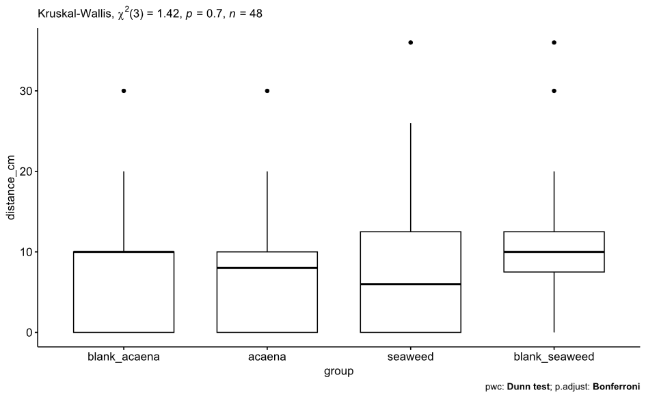

Figure S1. Distance travelled in blank and loaded arms of y-tube olfactometer by *Merizodus soledadinus* exposed to scents of plants characteristic of different habitats in the Kerguelen Archipelago: *Acaena magellanica* is a common ground cover of inland habitats, while decaying seaweeds are characteristic of coastal habitats.

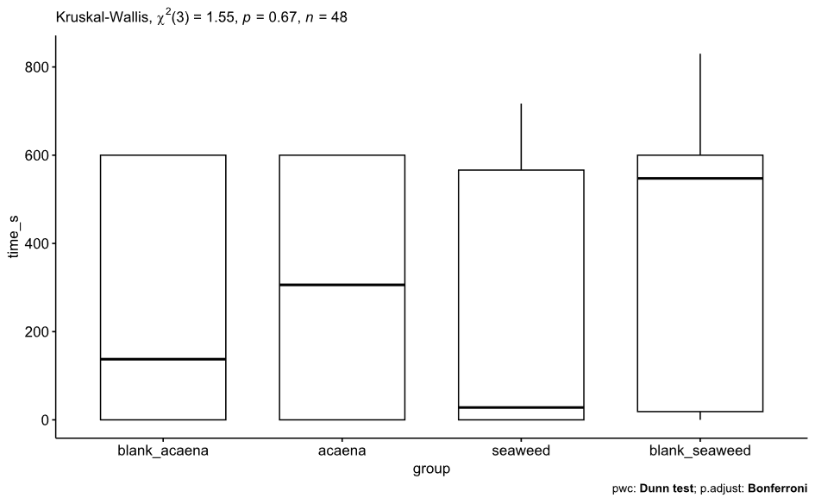

Figure S2. Time spent in blank and loaded arms of y-tube olfactometer by *Merizodus soledadinus* exposed to scents of plants characteristic of different habitats in the Kerguelen Archipelago: *Acaena magellanica* is a common ground cover of inland habitats, while decaying seaweeds are characteristic of coastal habitats.

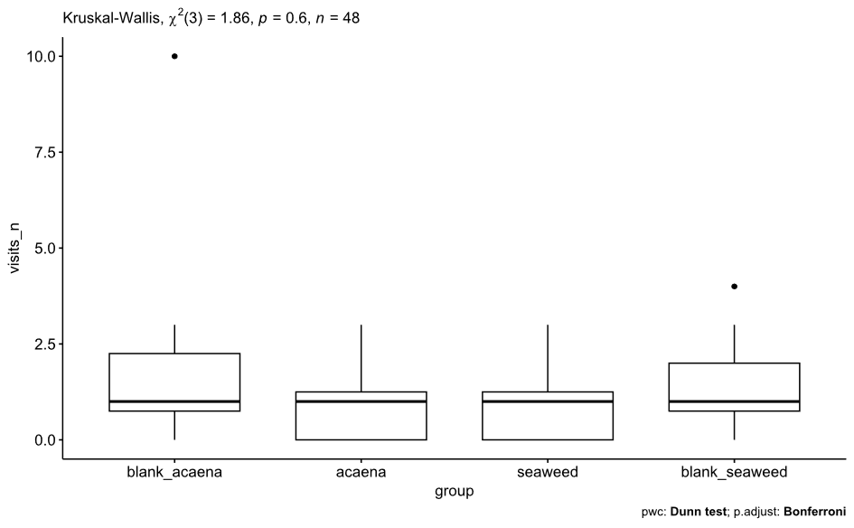

Figure S3. Number of visits to blank and loaded arms of y-tube olfactometer by *Merizodus soledadinus* exposed to scents of plants characteristic of different habitats in the Kerguelen Archipelago: *Acaena magellanica* is a common ground cover of inland habitats, while decaying seaweeds are characteristic of coastal habitats.

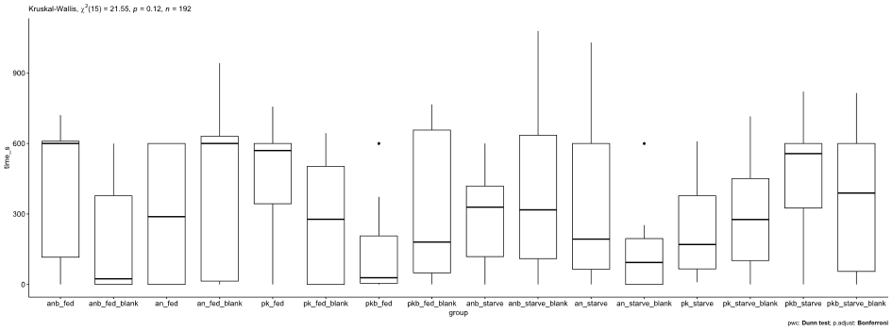

Figure S4. Time spent in blank and loaded arms of y-tube olfactometer by *Merizodus soledadinus* exposed to scents of injured prey species native to Kerguelen Archipelago (AN = *Anatalanta aptera*, pk = *Pringleophaga kerguelensis*). In half of the trials *M. soledadinus* was starved prior to exposure, and half were fed.

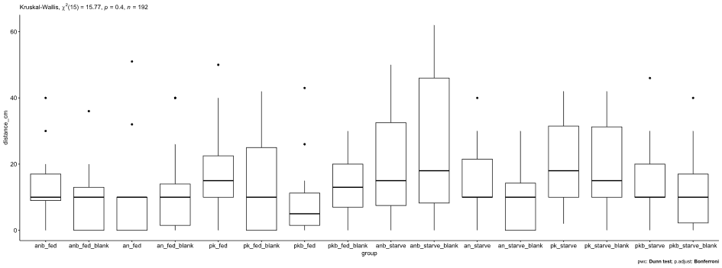

Figure S5. Distance travelled in blank and loaded arms of y-tube olfactometer by *Merizodus soledadinus* exposed to scents of injured prey species native to Kerguelen Archipelago (AN = *Anatalanta aptera*, pk = *Pringleophaga kerguelensis*). In half of the trials *M. soledadinus* was starved prior to exposure, and half were fed.

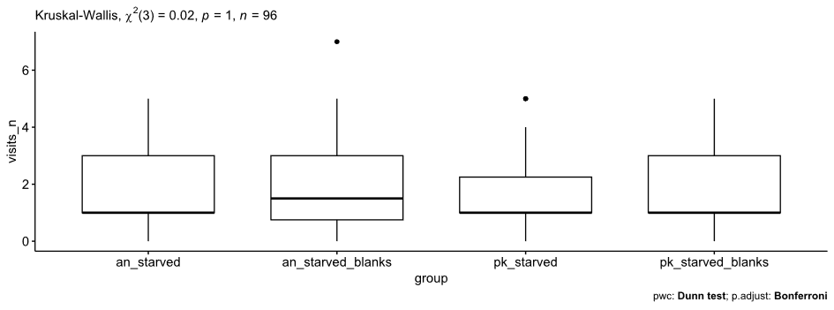

Figure S6. Number of visits to blank and loaded arms of y-tube olfactometer by *Merizodus soledadinus* exposed to scents of injured prey species native to Kerguelen Archipelago (AN = *Anatalanta aptera*, pk = *Pringleophaga kerguelensis*). *M.soledadinus* were starved prior to trials.

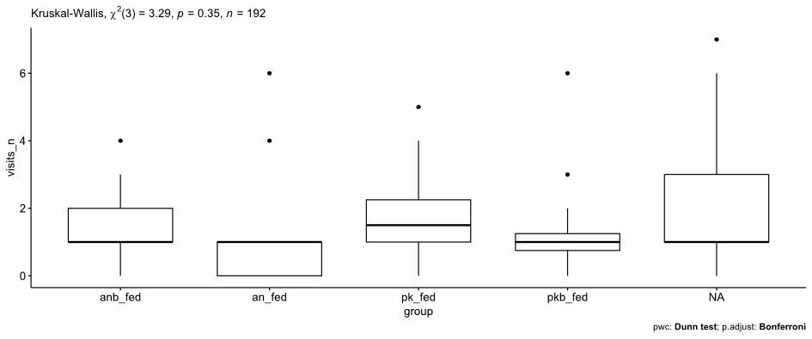

Figure S7. Number of visits to blank and loaded arms of y-tube olfactometer by *Merizodus soledadinus* exposed to scents of injured prey species native to Kerguelen Archipelago (an = intact *Anatalanta aptera*, pk = intact *Pringleophaga kerguelensis*, anb and pkb represent injured *A. aptera* and *P. kerguelensis*, respectively). *M. soledadinus* were fed prior to trials.