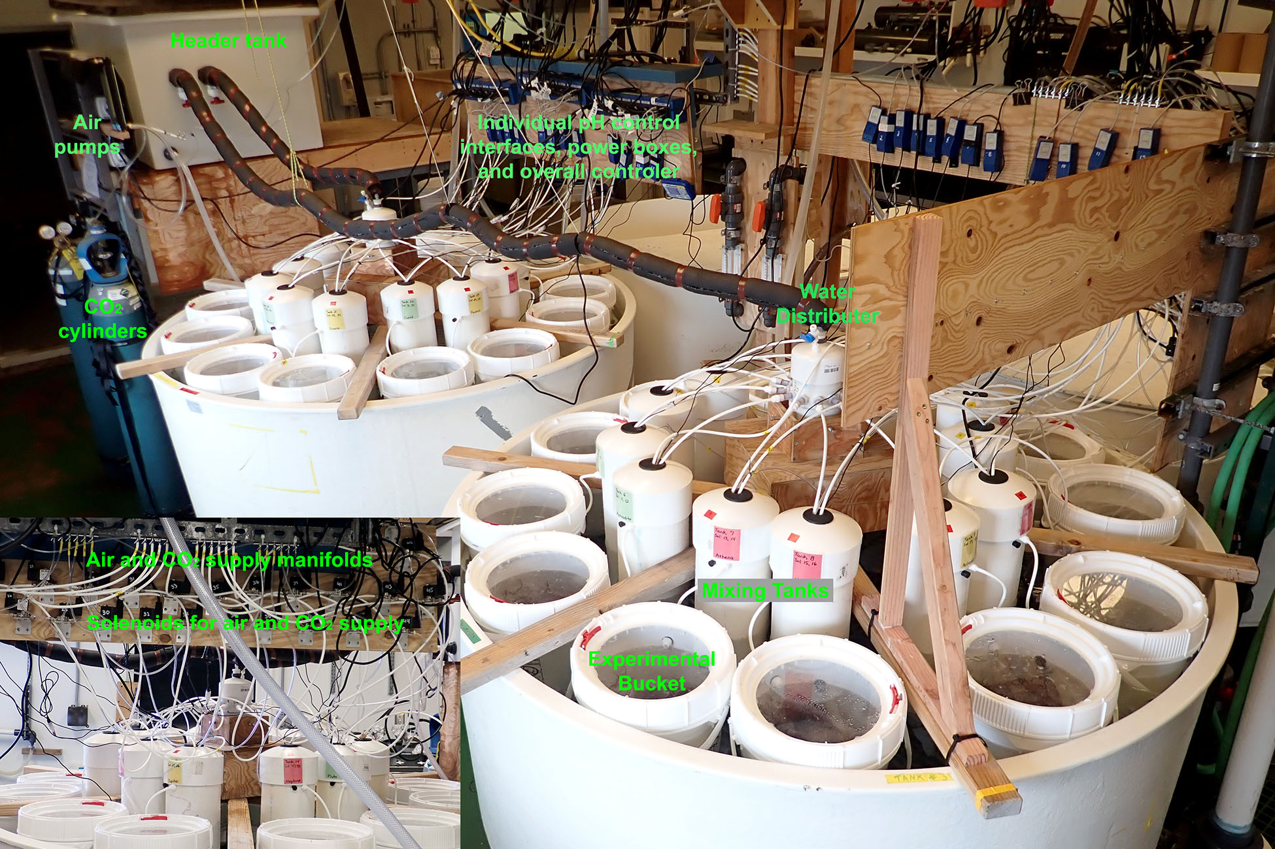
Figure S1. Experimental pH setup. Twin aquarium tanks each held 24 experimental buckets, 24 mixing tanks, and a water distributor. Water flowed from a header tank into the water distributors which split the water tanks and finally into the experimental buckets before flowing out of the experiment. Each mixing tank contained a pH probe, an air tube, and a tube for a CO₂-air mixture which were used to monitor and lower the pH when necessary.

