**Supplemental information**

**First Report of Bumblefoot in the South Polar Skua (*Stercorarius maccormicki*)**

Youmin Kim1, Jong-U Kim1, Younggeun Oh1, 2, and Jeong-Hoon Kim1, *

1Division of Life Sciences, Korea Polar Research Institute, Incheon 21990, Korea

2Department of Life Sciences, Incheon National University, Incheon 22012, Korea

* Corresponding author: Jeong-Hoon Kim ([jhkim94@kopri.re.kr](mailto:jhkim94@kopri.re.kr))

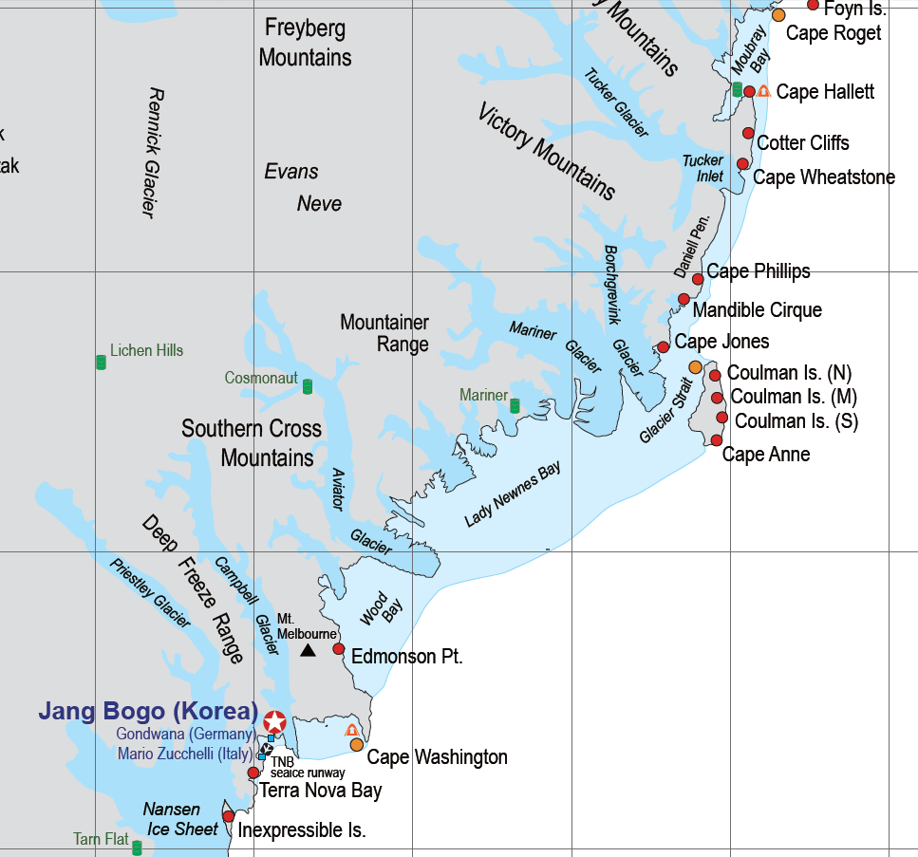

**72°S**

**73°S**

**74°S**

**75°S**

**162°E**

**164°E**

**166°E**

**168°E**

**170°E**

**172°E**

**Cape Hallett**

**Inexpressible**

**Island**

**Cape Möbius**

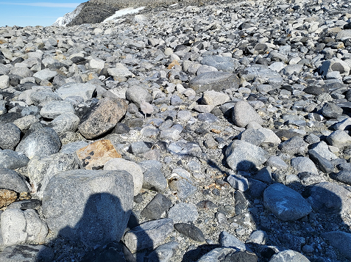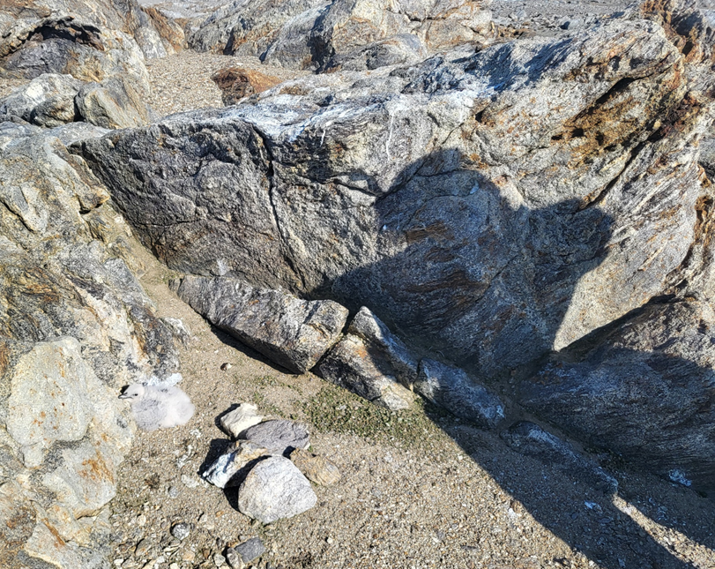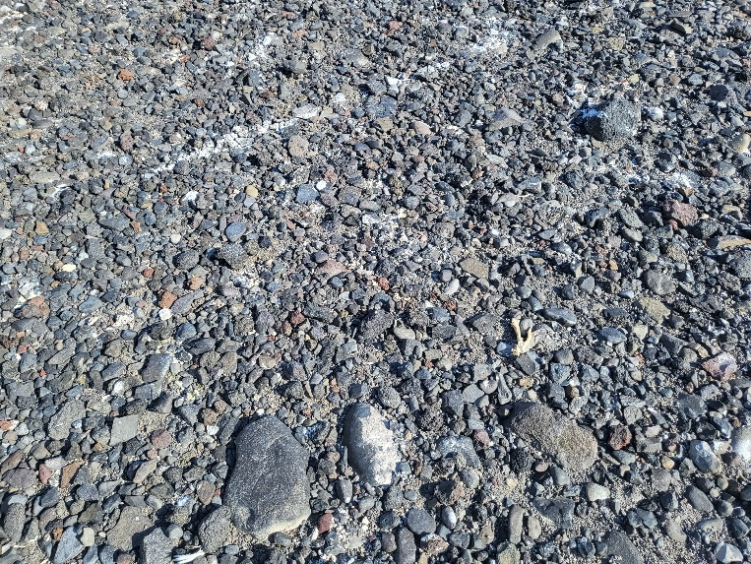

**b**

**c**

**d**

**a**

Online Resource. The flooring substrates of three study sites. (a) The location map of Ross Sea Region (b) Inexpressible Island (74º55´S, 163º43´E), (c) Cape Möbius (74º38´S, 164º13´E), and (d) Cape Hallett (72º19´S, 170º12´E)