**SUPPLEMENTARY MATERIAL**

**Details of ARIMA modeling**

The fitted ARIMA models were used to assess the stationarity (constancy of variance), fluctuation, and autocorrelation of the data. ARIMA models include two modules, Autoregression (AR) and Moving Average (MA), which can be integrated to describe statistical patterns when the data are not stationary but differenced to achieve stationarity.

The ARIMA model is represented as ARIMA (p, d, q), where the p indicates the order of the autoregression, d indicates the order of the differencing, and q indicates the order of the smoothing moving average. The AR (p) process assumes that the recent value can be predicted from previous (i.e., lagged) values, and the number of previous explanatory values is p. Generally:

$y_{t}= ϕ_{t-1}y_{t-1}+ ϕ_{t-2}y_{t-2}+…+ ϕ_{t-p}y_{t-p}$ (1)

where yt is the value of the response variable at time t, yt−1 is the value of the response variable at time t-1, thus lagging 1 time period, and Φt-1 is the coefficient of the effect of the response variable at time t-1, thus being the first autoregressive coefficient. The difference component of an ARIMA model refers to accounting for seasonality in the data (d). Because we use yearly data, the use of this parameter would be warranted in the presence of multi-year cycles. Multi-year cycles were immediately apparent, and we explored models that would include multi-year cycles. The MA (q) adds a smoothing function to the error at each time lag, and q indicates the length of the lag to include in the smoothing function. Therefore, the ARIMA (1,0,1) model is:

$y_{t}= ϕ_{t-1}y_{t-1}+ε_{t-1}- θ_{t-1}ε_{t-1}$ (2)

where εt is the immediate error, εt-1 is the error at time *t*-1, and θt-1 is the smoothing coefficient for the error component at *t*−1.

Because we sought to explain the variance in the current observation (year) after accounting for the autocorrelation or cycle components with our explanatory variables, the use of the MA component was not warranted. Thus, we fitted some variations including only structures where q was zero in the ARIMA models: ARIMA(1,0,0), ARIMA(2,0,0), ARIMA(3,0,0), ARIMA(1,1,0), ARIMA(2,1,0), ARIMA(3,1,0). The appropriate lag [p] and differencing [d] for each species and colony were assessed by examining the autocorrelation (ACF) and partial autocorrelation (PACF) plots.

Finally, we checked the residuals from our chosen model by plotting the ACF of the residuals. To demonstrate covariate effects, we generated variable influence plots as follows. We obtained the predictions from the model and their 95% confidence intervals. In the absence of any other covariates, we could have simply regressed the predictions against the values of the covariate. However, the predictions include the effects of all other covariates as well and thus such a regression would not truly portray the effect of each variable alone in the model. To overcome this limitation, we first regressed the variable of interest against all other variables and extracted the residuals of this regression. We then added these residuals to the mean value of the variable of interest, thereby obtaining the values of the variable not explained by covariation with the other variables. We then plotted predictions against this adjusted covariate.

**Table SM1**. Model AIC comparison between best model and reduced (one variable at a time, i.e., “no”) models for the Cape Crozier Adélie penguin colony, and 1st order autocorrelation (null model).

|  |  |  |  |  |  |  |  |  |  |  |
| --- | --- | --- | --- | --- | --- | --- | --- | --- | --- | --- |
| ***Model*** | ***AIC*** | ***∆AIC*** | | ***K*** | | ***Log-likelihood*** | | ***Adj. R-sq.*** | | |
| Top model: Gyre_lag 4 y + SIE_lag 4 y + CumFish_3y + mnAirTemp_lag 5 y + OpenWater_dateRSP | -8.42 | 0 | | 6 | | 11.21 | | 0.551 | | |
| No Gyre_lag 4 y | -3.18 | 5.24 | | 5 | | 7.59 | | 0.316 | | |
| No SIE_lag 4 y | -2.52 | 5.90 | | 5 | | 7.26 | | 0.318 | | |
| No CumFish_3 y | -7.81 | 0.61 | | 5 | | 9.90 | | 0.502 | | |
| No OpenWater_dayRSP | 2.10 | | 6.32 | | 5 | | 7.05 | | 0.282 |
| No minAirTemp_lag 5 y | -6.65 | | 1.77 | | 5 | | 9.32 | | 0.484 |
| 1st order autocorrelation only | -3.65 | | 4,77 | | 1 | | 3.82 | | 0.136 |

**Table SM2**. Model AIC comparison between best model and reduced (one variable at a time, i.e., “no”) models for the Cape Bird Adélie penguin colony, and 1st order autocorrelation (null model).

|  |  |  |  |  |  |
| --- | --- | --- | --- | --- | --- |
| ***Model*** | ***AIC*** | ***∆AIC*** | ***K*** | ***Log-likelihood*** | ***Adj. R-sq*** |
| Top model: avg_SIE+ Gyre +   CumFish_3y +  OpenWater_dateRSP_lag 4 y | 7.78 | 0 | 5 | 2.11 | 0.307 |
| No avg_SIE | 9.57 | 1.79 | 4 | 0.21 | 0.175 |
| No Gyre | 10.89 | 3.11 | 4 | -0.44 | 0.057 |
| No CumFish_3y | 12.06 | 4.28 | 4 | -1.03 | 0.027 |
| No OpenWater_dateRSP_lag 4 y | 10.77 | 2.99 | 4 | -0.39 | 0.109 |
| 1st order autocorrelation only | 7.95 | 0.17 | 1 | -1.97 | 0.083 |

**Table SM3**. Model AIC comparison between best model and reduced (one variable at a time, i.e., “no”) models for the Erebus Bay Weddell seal population, and the intercept-only model (null model).

|  |  |  |  |  |  |
| --- | --- | --- | --- | --- | --- |
| ***Model*** | ***AIC*** | ***∆AIC*** | ***K*** | ***Log-likelihood*** | ***Adj. R-sq*** |
| Top model: FastIceExtent +  CumFish_3y +  meanOpenWater_MCM_lag 6 y +  Gyre | -9.69 | 0 | 5 | 10.85 | 0.742 |
| No FastIceExtent | 2.71 | 12.4 | 4 | 3.65 | 0.386 |
| No CumFish_3y | -7.69 | 2.0 | 4 | 8.85 | 0.693 |
| No meanOpenWater_ MCM_lag 6 ys | 0.45 | 10.14 | 4 | 4.77 | 0.472 |
| No Gyre | -3.04 | 6.65 | 4 | 6.52 | 0.625 |
| Intercept-only | 10.22 | 19.91 | 1 | -3.11 | 0 |

**Review of the Cape Crozier Adélie penguin growth model results with reference subcolony count data**

To increase confidence in our results, we used an unpublished dataset consisting of counts of all active nests in the same subcolonies over time (6-31 subcolonies depending on year), including those having 10 to 1,000 active nests (Ballard *et al.*, unpubl.). Counts were made within a day of aerial census of the entire colony (Lyver *et al.* 2014; AntarcticaNZ, unpubl.). From this dataset, the proportion of growth was estimated as 1 + (Ct – Ct-1)/Ct-1), where Ct and Ct-1 are, respectively the count of active nests at time t and t-1. Changes in counts of active nests at specific locations may not be a good metric for population growth, and sample sizes may be too small and not representative of the behavior of the entire colony. Therefore, this dataset can provide only a crude indication of the ability of our model to represent the reality of population changes at Crozier. We fit our model to this dataset and evaluated the similarity in slope estimates to our original estimates, as well as the quantile placement of the density data slopes within the distribution of possible values for the slopes from our model.

**Table SM4.** Model fitting results using the best model from Crozier on Adélie penguin growth estimates from reference subcolony count data. The Quantile column provides the quantile (lower tail) of the slope of each covariate in this table within the confidence interval of the estimates shown in Table 2. The Difference column shows the difference between the slope estimates using this dataset and the slopes from our model, shown in Table 2.

|  |  |  |  |  |  |  |
| --- | --- | --- | --- | --- | --- | --- |
| Variable | Estimate | SE | Z-value | P-value | Difference | Quantile |
| 1st order autocorr. | -0.7714 | 0.2268 | -3.401 | 0.0007 | -0.0300 | 44.2% |
| Sea Ice Ext. lag 4 y | -0.1522 | 0.1165 | -1.306 | 0.1916 | -0.1084 | 9.09% |
| Gyre Speed lag 4 y | 0.0485 | 0.0456 | 1.065 | 0.2867 | 0.0676 | 1.91% |
| Air Temp. Lag 5 y | -0.0688 | 0.0455 | -1.513 | 0.1304 | 0.0054 | 43.2% |
| Open Water date RSP | -0.0100 | 0.0072 | -1.400 | 0.1614 | -0.0082 | 5.39% |
| Cum. Fish_3 y | -0.0039 | 0.0039 | -1.000 | 0.3175 | 0.0090 | 0.06% |

**Figure SM1. Cape Crozier Adélie penguin annual growth trend**

* 1. **Uncorrected trend**

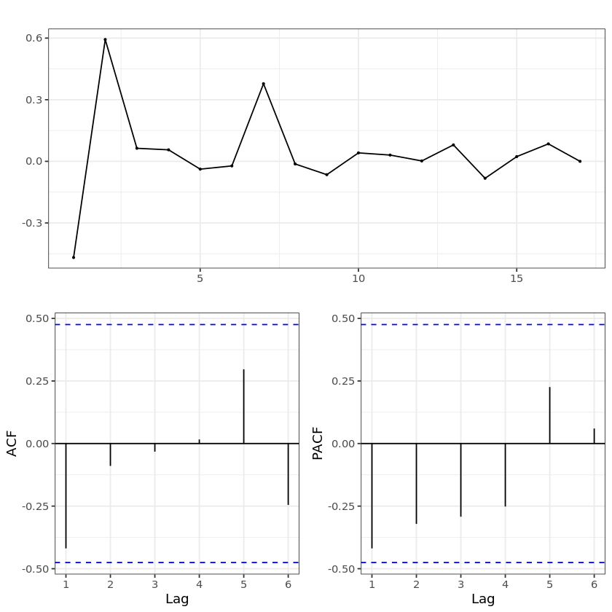

* 1. **Arima (1,0,0)**

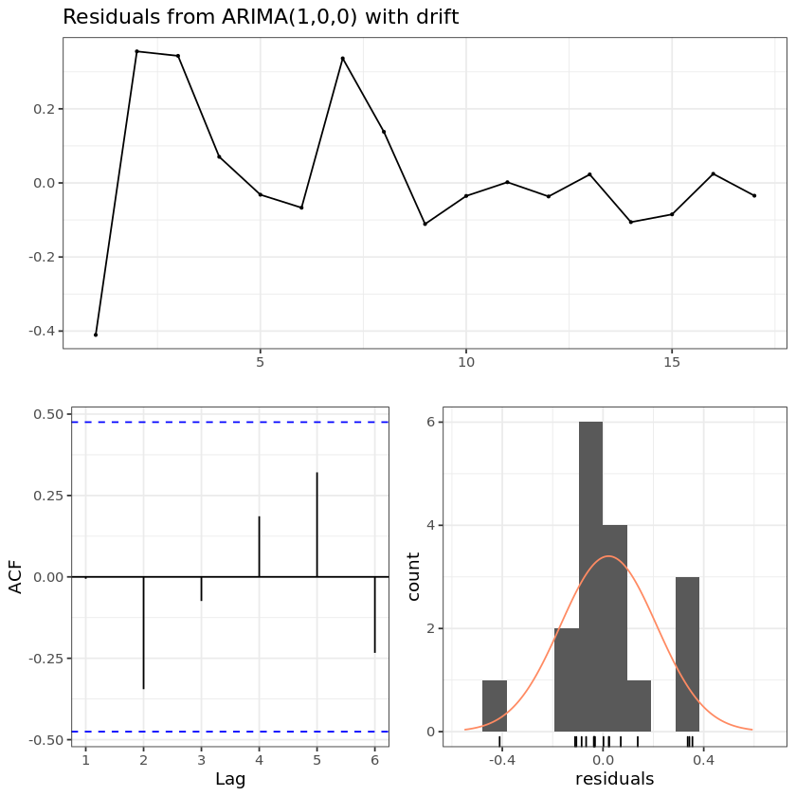

**Fig. SM3. Cape Bird Adélie penguin annual growth trend**

* 1. **Uncorrected trend**

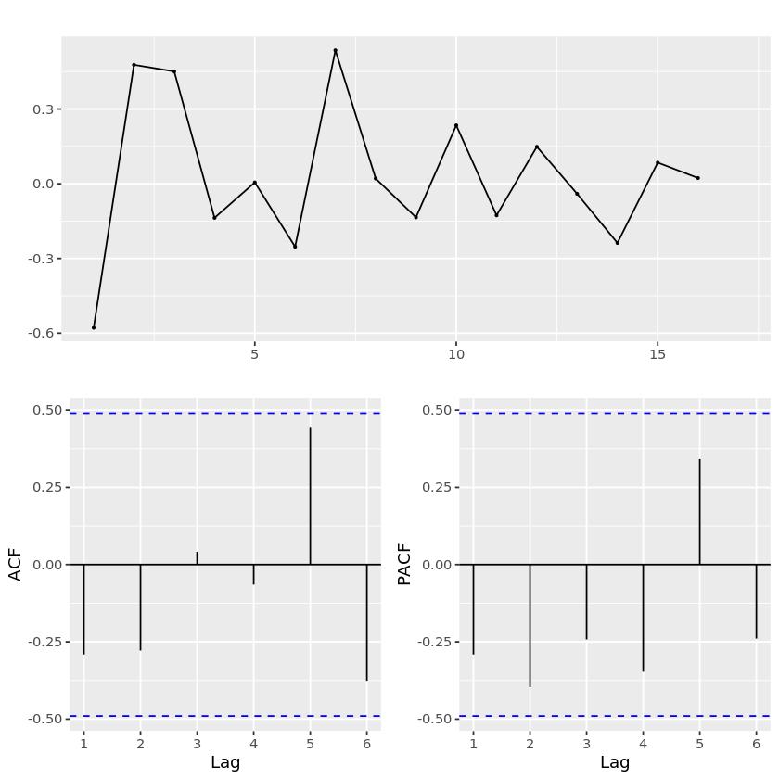

* 1. **Arima (1,0,0)**

