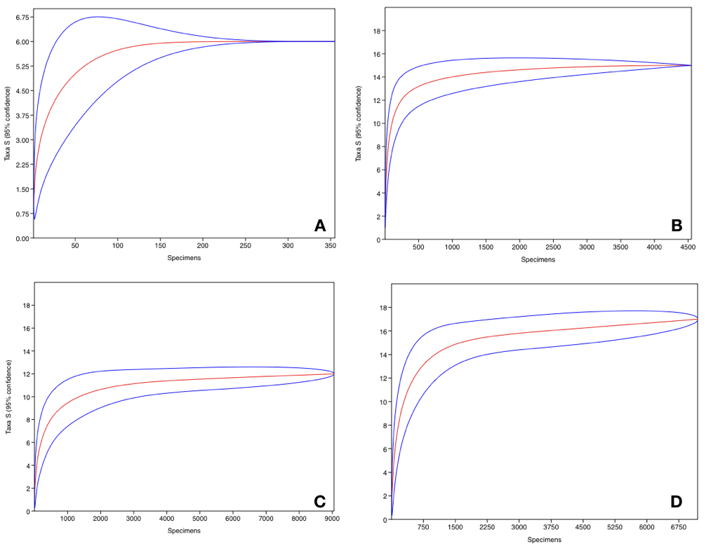

Supll. Figure 1: Rarefaction curves obtained from four air samples (A=1, B=2, C=3 and D=4). Blue lines represent 95% confidence intervals

