S3 Maps of the regional locations of the four colonies in relation to other nearby breeding sites.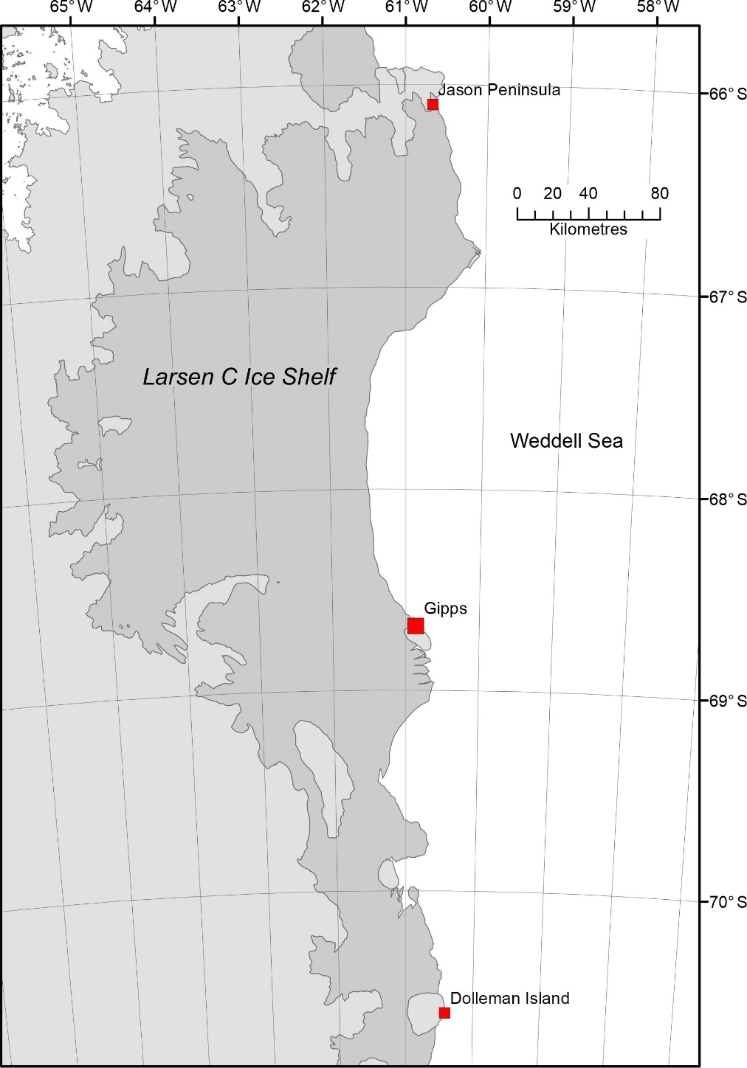
Map S3a Location of Gipps colony
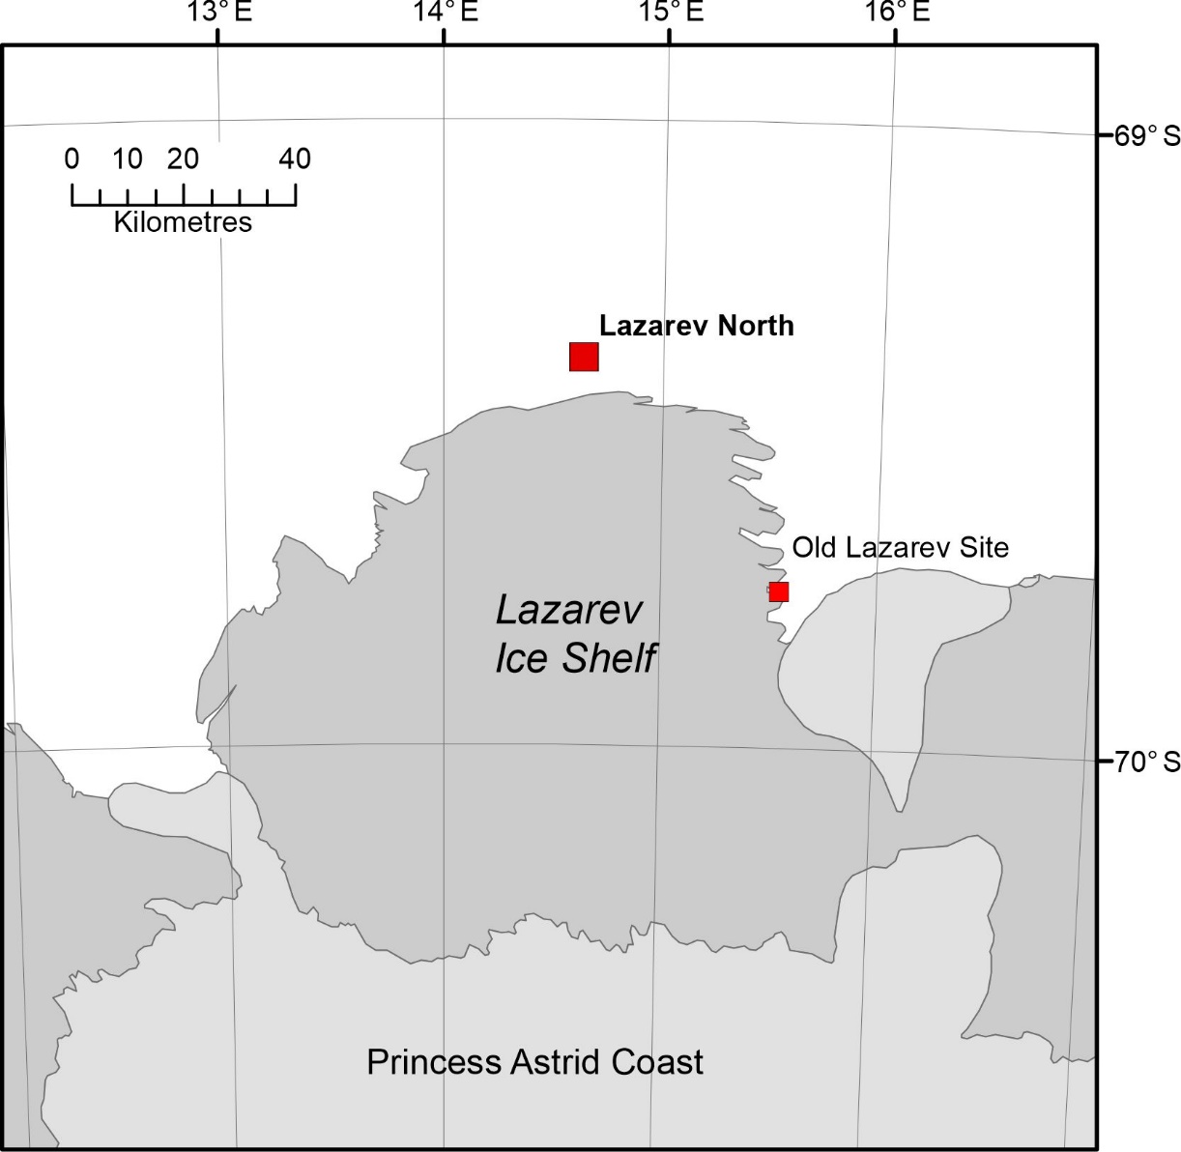
S3b map of Lazarev Ice shelf sites, showing the old location and the new location. Note that the new breeding site is around 65 km around the coast from the old site and although not yet counted, looks much smaller than the 4,500 pairs recorded in 2013.

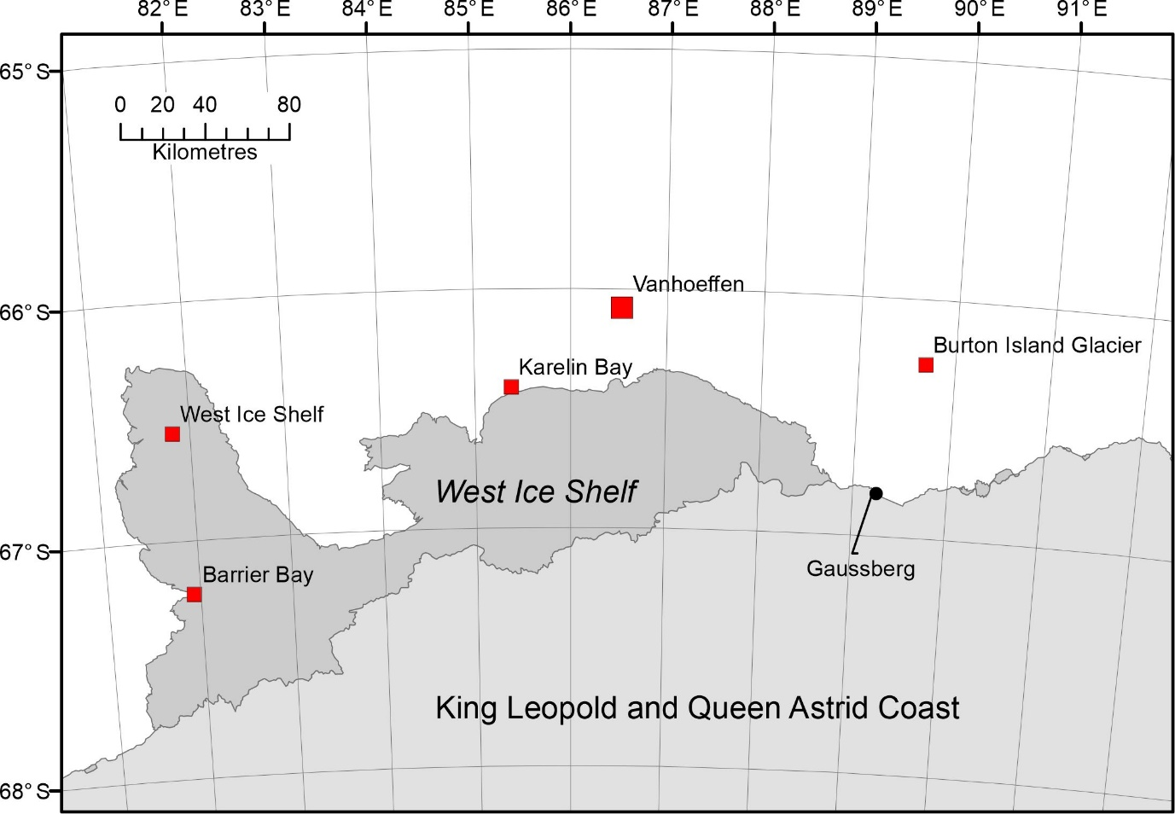
S3c Map of Vanhoeffen colony. There are a number of other breeding sites in the general area of this large new site, satellite imagery shows that there all exists at the same time and are not a movement of one group. The area may be regarded as a metapopulation as suggested by LaRue et al 2014.
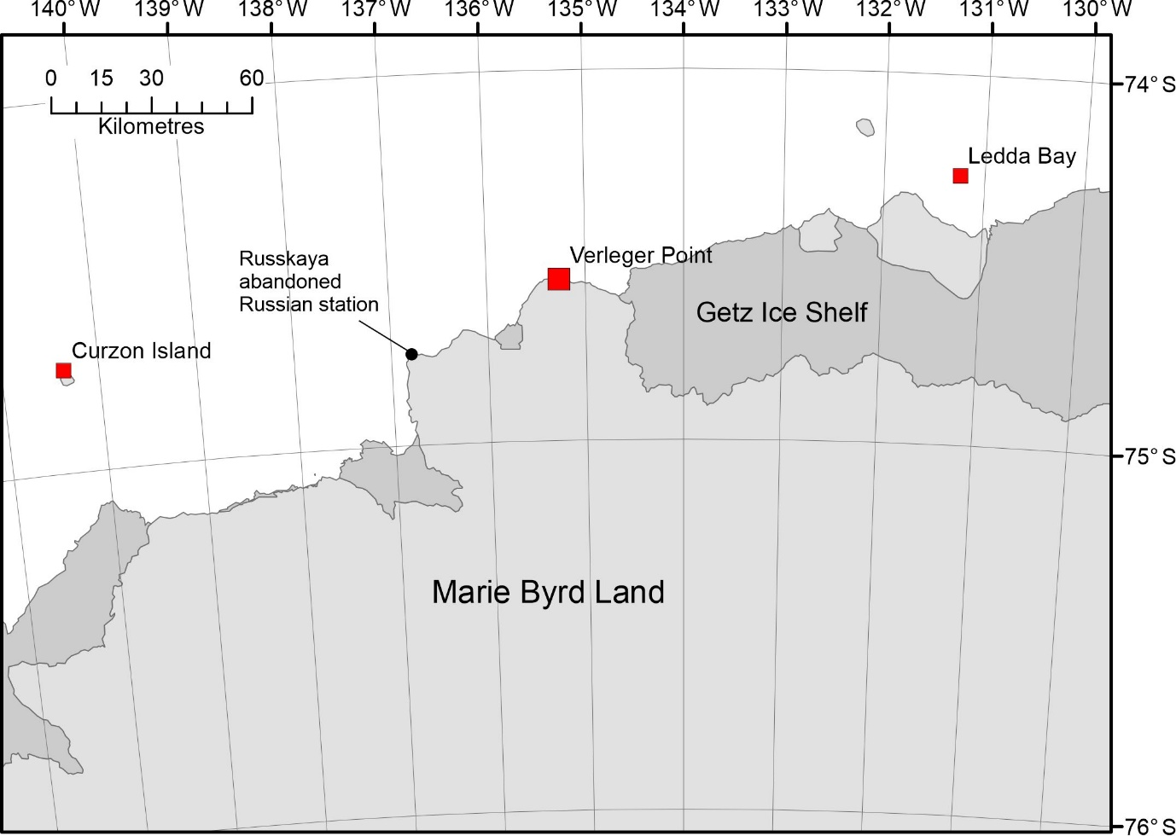
S3c map of the location of Verleger Point colony. This small colony is located equidistant from Ledda Bay and Curzon Island. It is approx. 53 km east of the site of the abandoned Russkaya research station.

