Supplementary material 1. The flowchart of the data process and analysis. This analysis adopting Nextstrain pipeline for mpox

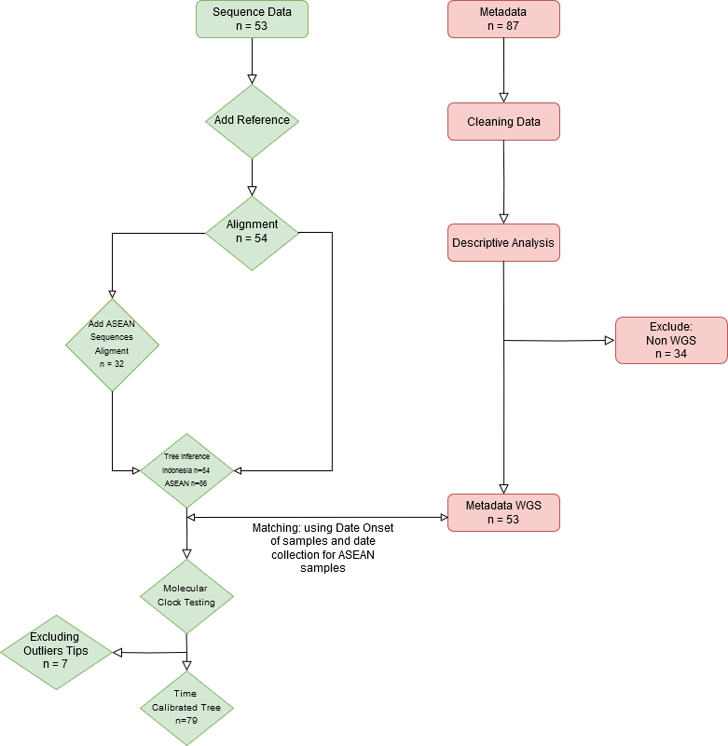
Supplementary material 2. The international tourist visiting trend in Indonesia from 2022 to 2024. The annual high season was reported between August and December where the periods of mpox outbreaks and first cases occurred. The outbreak was occurred 4 months after COVID-19 pandemic status was revoked (21-06-2023). The time introduction that estimated from molecular clock reported after tourist high seasons of 2021 and 2023. The data were scrapped from Indonesia’s Central Bureau of Statistics.

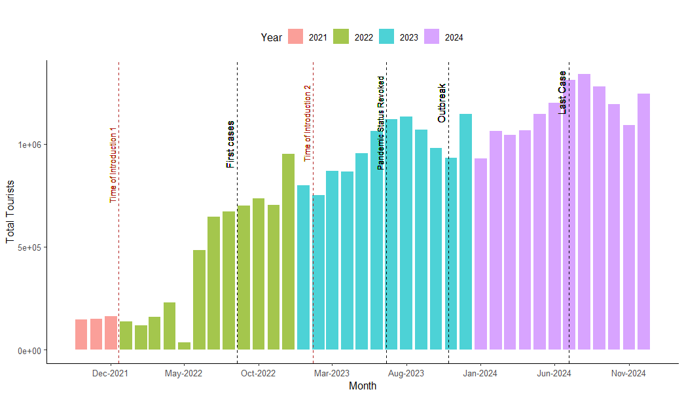

Supplementary material 3. The best model of every tree in analysis. The model selection was performed by ModelFinder in IQ-TREE
Tree | Model | AIC | AICc | BIC
Best Model ASEAN Without Imputation | HKY+F+R5 | 532939.982 | 532940.323 | 534805.121
Best Model ASEAN With Imputation | HKY+F+R5 | 528616.492 | 528616.636 | 529829.342
Best Model Indonesia Without Imputation | HKY+F+I | 528769.032 | 528769.161 | 529910.538
Best Model Indonesia With Imputation | HKY+F+R5 | 528616.492 | 528616.636 | 529829.342

Supplementary material 4. Comprehensive overview of mpox genome sequencing data: sequence identifiers, genome lengths, and coverage depth

Sequence | Accession ID | Length | Coverage
hMpxV/Indonesia/JK-NIHRD-MP005/2023 | EPI_ISL_18436040 | 197,209 | 42x
hMpxV/Indonesia/JK-NIHRD-MP010/2023 | EPI_ISL_18436041 | 197,204 | 84x
hMpxV/Indonesia/JK-NIHRD-MP008/2023 | EPI_ISL_18463158 | 197,204 | 464x
hMpxV/Indonesia/JK-NIHRD-MP015/2023 | EPI_ISL_18463160 | 197,201 | 78x
hMpxV/Indonesia/JK-NIHRD-MP012/2023 | EPI_ISL_18463159 | 197,200 | 51x
hMpxV/Indonesia/JK-NIHRD-MP017/2023 | EPI_ISL_18463161 | 197,200 | 342x
hMpxV/Indonesia/JK-NIHRD-MP023/2023 | EPI_ISL_18467795 | 197,199 | 117
hMpxV/Indonesia/JK-NIHRD-MP022/2023 | EPI_ISL_18467799 | 197,199 | 998x
hMpxV/Indonesia/JK-NIHRD-MP025/2023 | EPI_ISL_18467796 | 197,199 | 272x
hMpxV/Indonesia/JK-NIHRD-MP044/2023 | EPI_ISL_18467805 | 197,199 | 34x
hMpxV/Indonesia/JK-NIHRD-MP036/2023 | EPI_ISL_18467800 | 197,199 | 123x
hMpxV/Indonesia/JK-NIHRD-MP039/2023 | EPI_ISL_18467801 | 197,199 | 1226x
hMpxV/Indonesia/JK-NIHRD-MP035/2023 | EPI_ISL_18467804 | 197,199 | 19x
hMpxV/Indonesia/JB-NIHRD-MP041/2023 | EPI_ISL_18467808 | 197,199 | 105x
hMpxV/Indonesia/JK-NIHRD-MP081/2023 | EPI_ISL_18467798 | 197,199 | 115x
hMpxV/Indonesia/JK-NIHRD-MP061/2023 | EPI_ISL_18467802 | 197,199 | 17x
hMpxV/Indonesia/BT-NIHRD-MP059/2023 | EPI_ISL_18467794 | 197,199 | 300x
hMpxV/Indonesia/JK-NIHRD-MP055/2023 | EPI_ISL_18467797 | 197,199 | 46x
hMpxV/Indonesia/JK-NIHRD-MP080/2023 | EPI_ISL_18467806 | 197,199 | 142x
hMpxV/Indonesia/JK-NIHRD-MP085/2023 | EPI_ISL_18467803 | 197,199 | 3462x
hMpxV/Indonesia/JK-NIHRD-MP088/2023 | EPI_ISL_18467807 | 197,199 | 35x
hMpxV/Indonesia/JK-NIHRD-MP109/2023 | EPI_ISL_18642356 | 197,199 | 340x
hMpxV/Indonesia/JK-NIHRD-MP114/2023 | EPI_ISL_18642357 | 197,199 | 68x
hMpxV/Indonesia/JK-NIHRD-MP118/2023 | EPI_ISL_18642358 | 197,199 | 85x
hMpxV/Indonesia/JK-NIHRD-MP147/2023 | EPI_ISL_18642359 | 197,199 | 66x
hMpxV/Indonesia/JK-NIHRD-MP156/2023 | EPI_ISL_18642360 | 197,199 | 140x
hMpxV/Indonesia/JK-NIHRD-MP177/2023 | EPI_ISL_18642361 | 197,199 | 190x
hMpxV/Indonesia/JB-NIHRD-MP205/2023 | EPI_ISL_18642362 | 197,199 | 187x
hMpxV/Indonesia/JK-NIHRD-MP209/2023 | EPI_ISL_18642363 | 197,199 | 205x
hMpxV/Indonesia/JK-NIHRD-MP218/2023 | EPI_ISL_18642364 | 197,199 | 108x
hMpxV/Indonesia/BT-NIHRD-MP231/2023 | EPI_ISL_18642365 | 197,199 | 89x
hMpxV/Indonesia/JK-NIHRD-MP159/2023 | EPI_ISL_18798834 | 197,199 | 137x
hMpxV/Indonesia/JK-NIHRD-MP225/2023 | EPI_ISL_18798835 | 197,199 | 78x
hMpxV/Indonesia/JK-NIHRD-MP235/2023 | EPI_ISL_18798836 | 197,199 | 172x
hMpxV/Indonesia/JK-NIHRD-MP246/2023 | EPI_ISL_18798837 | 197,199 | 489x
hMpxV/Indonesia/JB-NIHRD-MP254/2023 | EPI_ISL_18798839 | 197,197 | 585x
hMpxV/Indonesia/JB-NIHRD-MP255/2023 | EPI_ISL_18798840 | 197,196 | 45x
hMpxV/Indonesia/JK-NIHRD-MP252/2023 | EPI_ISL_18798838 | 197,196 | 31x
hMpxV/Indonesia/JK-NIHRD-MP276/2023 | EPI_ISL_18798841 | 197,196 | 109x
hMpxV/Indonesia/JK-NIHRD-MP279/2023 | EPI_ISL_18798842 | 197,196 | 148x
hMpxV/Indonesia/JK-Biokes-MP239/2023 | EPI_ISL_19159108 | 197,195 | 46x
hMpxV/Indonesia/JB-Biokes-MP294/2023 | EPI_ISL_19159109 | 197,192 | 29x
hMpxV/Indonesia/JB-Biokes-MP295/2023 | EPI_ISL_19159110 | 197,192 | 136x
hMpxV/Indonesia/JK-Biokes-MP302/2023 | EPI_ISL_19159111 | 197,184 | 23x
hMpxV/Indonesia/BT-Biokes-MP303/2023 | EPI_ISL_19159112 | 197,183 | 274x
hMpxV/Indonesia/JK-Biokes-MP310/2023 | EPI_ISL_19159113 | 197,182 | 198x
hMpxV/Indonesia/JK-Biokes-MP311/2023 | EPI_ISL_19159114 | 197,182 | 35x
hMpxV/Indonesia/JK-Biokes-MP010/2024 | EPI_ISL_19159115 | 197,181 | 439x
hMpxV/Indonesia/JK-Biokes-MP011/2024 | EPI_ISL_19159116 | 197,181 | 55x
hMpxV/Indonesia/JK-Biokes-MP016/2024 | EPI_ISL_19159117 | 197,177 | 17x
hMpxV/Indonesia/JK-Biokes-MP018/2024 | EPI_ISL_19159118 | 197,166 | 18x
hMpxV/Indonesia/JK-Biokes-MP020/2024 | EPI_ISL_19159119 | 197,163 | 4,071x
hMpxV/Indonesia/JK-Biokes-MP029/2024 | EPI_ISL_19159120 | 197,095 | 26x

Supplementary material 5. The molecular signal analysis with TempEst, the Indonesian tree both with and without imputation of ambiguous sequences showed a very weak molecular clock signal
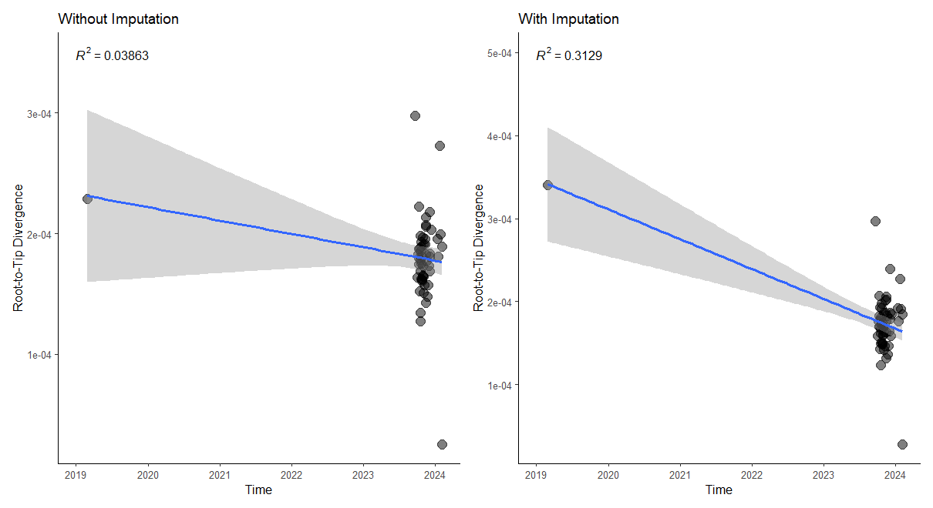
Supplementary material 6. The molecular signal analysis with TempEst, the ASEAN tree without imputation of ambiguous sequences showed better performance in molecular signal analysis than with imputation
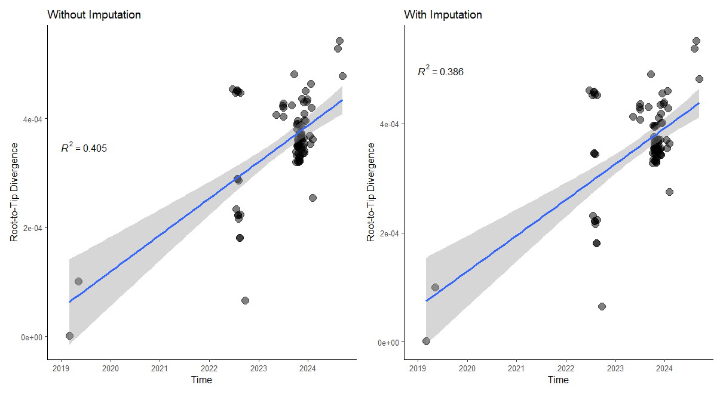

Supplementary material 7. The molecular signal analysis with TempEst showed the outliers in root-to-tip analysis and phylogenetic tree (red dots)
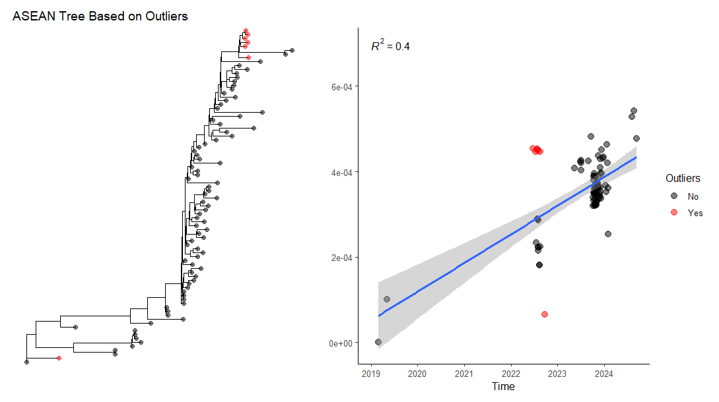

Supplementary material 8. The molecular signal analysis with TempEst of ASEAN tree after removing the outliers showed the strong molecular clock signal (R-square = 0.66)
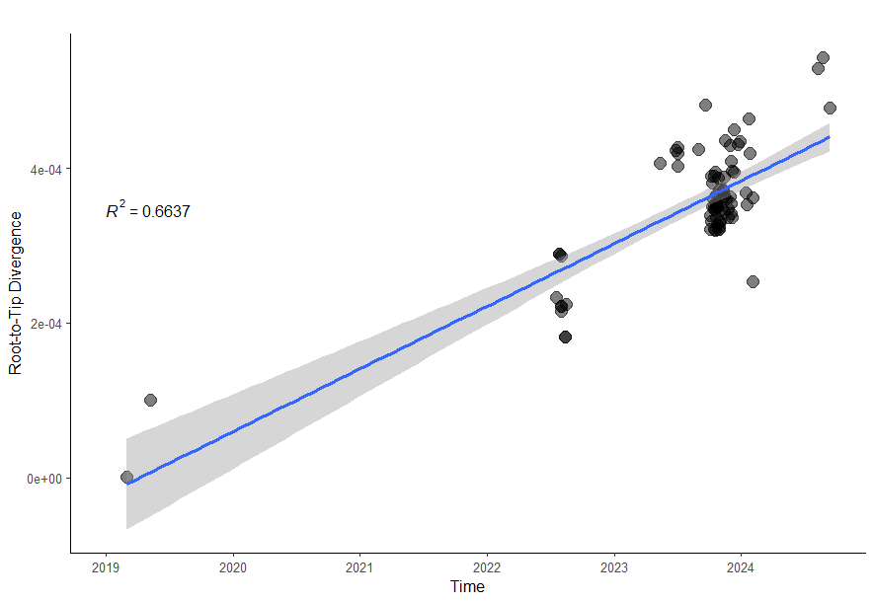

Supplementary material 9. The Treetime output of molecular clock analysis of ASEAN time-calibrated tree. The TMRCA and introduction time was estimated at 2018.5 (2018-07-02)

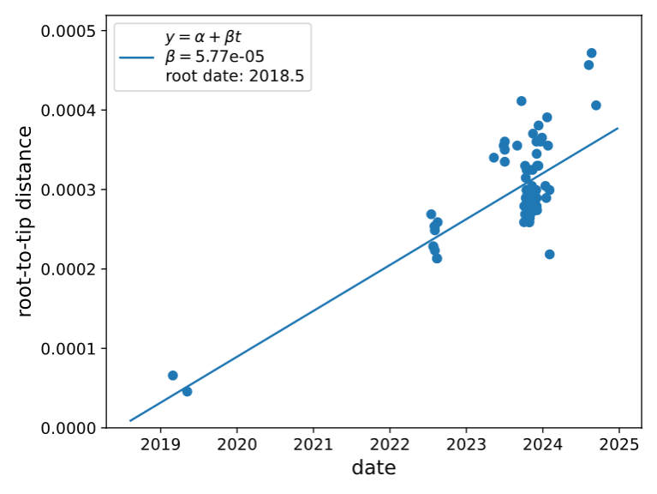

Supplementary material 10. List of GISAID and GenBank sequences that including in this study

Accession ID | Date Access | Submitting lab | Authors | Publications
NC_063383.1 | 2024-11-29 | - | Mauldin,M.R., McCollum,A.M., Nakazawa,Y.J. Mandra,A., Whitehouse,E.R., Davidson,W., Zhao,H., Gao,J., Li,Y., Doty,J., Yinka-Ogunleye,A., Akinpelu,A., Aruna,O., Naidoo,D., Lewandowski,K., Afrough,B., Graham,V., Aarons,E., Hewson,R., Vipond,R., Dunning,J., Chand,M., Brown,C., Cohen-Gihon,I., Erez,N., Shifman,O., Israeli,O., Sharon,M., Schwartz,E., Beth-Din,A., Zvi,A., Mak,T.M., Ng,Y.K., Cui,L., Lin,R.T.P., Olson,V.A., Brooks,T., Paran,N., Ihekweazu,C. and Reynolds,M.G. | Exportation of Monkeypox Virus From the African Continent (doi: 10.1093/infdis/jiaa559)
EPI_ISL_14011193 | 2024-11-29 | Thai Red Cross Emerging Infectious Diseases Clinical Center and Faculty of Medicine, | Kusak Kukiattikoon, Waritta Dararattanaroj, Rome Buathong, Supaporn  Wacharapluesadee, Sininat Petcharat, Ananporn Supataragul, Stefan Fernandez, Achawin  Rojanaviwat, Chonticha Klungthong, Pilailuk Okada, Khajohn Joonlasak, Chakkarat  Pitayawonganon, Opass Putcharoen | Phylogeny and molecular evolution of the first local monkeypox virus cluster in; Guangdong Province, China (https://doi.org/10.1038/s41467-023-44092-3); Multiple introductions of monkeypox virus to Ireland during the international mpox; outbreak, May 2022 to October 2023 (doi: 10.2807/1560-7917.ES.2024.29.16.2300505); Phylogenomic and Structural Analysis of the Monkeypox Virus Shows Evolution towards; Increased Stability (doi: 10.3390/v15010127 )
EPI_ISL_14153982 | 2024-11-29 | National Institute of Health, Department of Medical Sciences, Ministry of Public Health, | Pilailuk Okada; Siripaporn Phuygun; Nuttida Thongpramul; Thanutsapa Thanadachakul; Kazuhisa Okada; Archawin Rojanawiwat; Chakkarat Pitayawonganon; Supakit Sirilak | Global genomic surveillance of monkeypox virus ( doi: 10.1038/s41591-024-03370-3 ); Multiple introductions of monkeypox virus to Ireland during the international mpox; outbreak, May 2022 to October 2023 (doi: 10.2807/1560-7917.ES.2024.29.16.2300505); Phylogenomic and Structural Analysis of the Monkeypox Virus Shows Evolution towards; Increased Stability (doi: 10.3390/v15010127 ); Genetic Features of 84 Genomes of Monkeypox Virus in Recent Circulation — Beijing; Municipality, China, 2023 (doi: 10.46234/ccdcw2023.173); Molecular Evolution of Protein Sequences and Codon Usage in Monkeypox Viruses (https://doi.org/10.1093/gpbjnl/qzad003); Evolutionary trajectory and characteristics of Mpox virus in 2023 based on a large-scale; genomic surveillance in Shenzhen, China (https://doi.org/10.1038/s41467-024-51737-4); Comparative genome analysis reveals driving forces behind Monkeypox virus evolution; and sheds light on the role of ATC trinucleotide motif (doi: 10.1093/ve/veae043 ); Complete Genome Sequence Analysis of the First Imported Mpox Virus Clade Ib Variant in China (doi: 10.3390/pathogens14010102); Structural insights into tecovirimat antiviral activity and poxvirus resistance (https://doi.org/10.1038/s41564-025-01936-6); Genomic epidemiology reveals 2022 mpox epidemic in New York City governed by heavy-; tailed sexual contact networks (doi: 10.1101/2024.07.30.24311083 )
EPI_ISL_14721255 | 2024-11-29 | National Public Health Laboratory, National Centre for Infectious Diseases | Yichen Ding, Benny Yeo, Daniel Lim, Zhenyang Zhou, Royce Ang, Samuel Loo, Lin Cui, Raymond Tzer Pin Lin | Global genomic surveillance of monkeypox virus ( doi: 10.1038/s41591-024-03370-3 ); Retrospective detection of asymptomatic monkeypox virus infections among male sexual; health clinic attendees in Belgium (2022-08-12); Multiple introductions of monkeypox virus to Ireland during the international mpox; outbreak, May 2022 to October 2023 (doi: 10.2807/1560-7917.ES.2024.29.16.2300505); Phylogenomic and Structural Analysis of the Monkeypox Virus Shows Evolution towards; Increased Stability (doi: 10.3390/v15010127 ); Genetic Features of 84 Genomes of Monkeypox Virus in Recent Circulation — Beijing; Municipality, China, 2023 (doi: 10.46234/ccdcw2023.173); Molecular Evolution of Protein Sequences and Codon Usage in Monkeypox Viruses (https://doi.org/10.1093/gpbjnl/qzad003); Evolutionary trajectory and characteristics of Mpox virus in 2023 based on a large-scale; genomic surveillance in Shenzhen, China (https://doi.org/10.1038/s41467-024-51737-4); Comparative genome analysis reveals driving forces behind Monkeypox virus evolution; and sheds light on the role of ATC trinucleotide motif (doi: 10.1093/ve/veae043 ); Genomic epidemiology reveals 2022 mpox epidemic in New York City governed by heavy-; tailed sexual contact networks (doi: 10.1101/2024.07.30.24311083 )
EPI_ISL_14721259 | 2024-11-29 | National Public Health Laboratory, National Centre for Infectious Diseases | Yichen Ding, Benny Yeo, Daniel Lim, Zhenyang Zhou, Royce Ang, Samuel Loo, Lin Cui, Raymond Tzer Pin Lin | Global genomic surveillance of monkeypox virus ( doi: 10.1038/s41591-024-03370-3 ); Multiple introductions of monkeypox virus to Ireland during the international mpox; outbreak, May 2022 to October 2023 (doi: 10.2807/1560-7917.ES.2024.29.16.2300505); Phylogenomic and Structural Analysis of the Monkeypox Virus Shows Evolution towards; Increased Stability (doi: 10.3390/v15010127 ); Molecular Evolution of Protein Sequences and Codon Usage in Monkeypox Viruses (https://doi.org/10.1093/gpbjnl/qzad003); Evolutionary trajectory and characteristics of Mpox virus in 2023 based on a large-scale; genomic surveillance in Shenzhen, China (https://doi.org/10.1038/s41467-024-51737-4); Comparative genome analysis reveals driving forces behind Monkeypox virus evolution; and sheds light on the role of ATC trinucleotide motif (doi: 10.1093/ve/veae043 ); Genomic epidemiology reveals 2022 mpox epidemic in New York City governed by heavy-; tailed sexual contact networks (doi: 10.1101/2024.07.30.24311083 )
EPI_ISL_14721262 | 2024-11-29 | National Public Health Laboratory, National Centre for Infectious Diseases | Yichen Ding, Benny Yeo, Daniel Lim, Zhenyang Zhou, Royce Ang, Samuel Loo, Lin Cui, Raymond Tzer Pin Lin | Global genomic surveillance of monkeypox virus ( doi: 10.1038/s41591-024-03370-3 ); Multiple introductions of monkeypox virus to Ireland during the international mpox; outbreak, May 2022 to October 2023 (doi: 10.2807/1560-7917.ES.2024.29.16.2300505); Phylogenomic and Structural Analysis of the Monkeypox Virus Shows Evolution towards; Increased Stability (doi: 10.3390/v15010127 ); Genetic Features of 84 Genomes of Monkeypox Virus in Recent Circulation — Beijing; Municipality, China, 2023 (doi: 10.46234/ccdcw2023.173); Molecular Evolution of Protein Sequences and Codon Usage in Monkeypox Viruses (https://doi.org/10.1093/gpbjnl/qzad003); Evolutionary trajectory and characteristics of Mpox virus in 2023 based on a large-scale; genomic surveillance in Shenzhen, China (https://doi.org/10.1038/s41467-024-51737-4); Comparative genome analysis reveals driving forces behind Monkeypox virus evolution; and sheds light on the role of ATC trinucleotide motif (doi: 10.1093/ve/veae043 ); Genomic epidemiology reveals 2022 mpox epidemic in New York City governed by heavy-; tailed sexual contact networks (doi: 10.1101/2024.07.30.24311083 )
EPI_ISL_14721265 | 2024-11-29 | National Public Health Laboratory, National Centre for Infectious Diseases | Yichen Ding, Benny Yeo, Daniel Lim, Zhenyang Zhou, Royce Ang, Samuel Loo, Lin Cui, Raymond Tzer Pin Lin | Global genomic surveillance of monkeypox virus ( doi: 10.1038/s41591-024-03370-3 ); Phylogeny and molecular evolution of the first local monkeypox virus cluster in; Guangdong Province, China (https://doi.org/10.1038/s41467-023-44092-3); Multiple introductions of monkeypox virus to Ireland during the international mpox; outbreak, May 2022 to October 2023 (doi: 10.2807/1560-7917.ES.2024.29.16.2300505); Phylogenomic and Structural Analysis of the Monkeypox Virus Shows Evolution towards; Increased Stability (doi: 10.3390/v15010127 ); Genetic Features of 84 Genomes of Monkeypox Virus in Recent Circulation — Beijing; Municipality, China, 2023 (doi: 10.46234/ccdcw2023.173); Molecular Evolution of Protein Sequences and Codon Usage in Monkeypox Viruses (https://doi.org/10.1093/gpbjnl/qzad003); Evolutionary trajectory and characteristics of Mpox virus in 2023 based on a large-scale; genomic surveillance in Shenzhen, China (https://doi.org/10.1038/s41467-024-51737-4); Comparative genome analysis reveals driving forces behind Monkeypox virus evolution; and sheds light on the role of ATC trinucleotide motif (doi: 10.1093/ve/veae043 ); Structural insights into tecovirimat antiviral activity and poxvirus resistance (https://doi.org/10.1038/s41564-025-01936-6); Genomic epidemiology reveals 2022 mpox epidemic in New York City governed by heavy-; tailed sexual contact networks (doi: 10.1101/2024.07.30.24311083 )
EPI_ISL_15373792 | 2024-11-29 | Department of immunology and microbiology - Pasteur Institute in Ho Chi Minh city | Manh H. Dao, Nhung H. P. Vu, Hang T. T. Pham, Thang M. Cao, Thinh V. Nguyen, Quang | Global genomic surveillance of monkeypox virus ( doi: 10.1038/s41591-024-03370-3 ); Phylogeny and molecular evolution of the first local monkeypox virus cluster in; Guangdong Province, China (https://doi.org/10.1038/s41467-023-44092-3); Phylogenomic and Structural Analysis of the Monkeypox Virus Shows Evolution towards; Increased Stability (doi: 10.3390/v15010127 ); Genetic Features of 84 Genomes of Monkeypox Virus in Recent Circulation — Beijing; Municipality, China, 2023 (doi: 10.46234/ccdcw2023.173); Complete Genome Sequence Analysis of the First Imported Mpox Virus Clade Ib Variant in China (doi: 10.3390/pathogens14010102); Structural insights into tecovirimat antiviral activity and poxvirus resistance (https://doi.org/10.1038/s41564-025-01936-6); A comprehensive review of monkeypox virus and mpox characteristics (doi: 10.3389/fcimb.2024.1360586)
EPI_ISL_15380492 | 2024-11-29 | Molecular Biology Laboratory, Research Institute for Tropical Medicine | Samantha Louise P. Bado, Niquitta B. Galap, Bea C. Mateo, Chelsea Mae M. Reyes, Amalea Dulcene Nicolasora, Miguel Francisco B. Abulencia, Francisco Gerardo M. Polotan  on behalf of the Research Institute for Tropical Medicine | Global genomic surveillance of monkeypox virus ( doi: 10.1038/s41591-024-03370-3 ); Multiple introductions of monkeypox virus to Ireland during the international mpox; outbreak, May 2022 to October 2023 (doi: 10.2807/1560-7917.ES.2024.29.16.2300505); Phylogenomic and Structural Analysis of the Monkeypox Virus Shows Evolution towards; Increased Stability (doi: 10.3390/v15010127 ); Genetic Features of 84 Genomes of Monkeypox Virus in Recent Circulation — Beijing; Municipality, China, 2023 (doi: 10.46234/ccdcw2023.173); Update of the Genetic Variability of Monkeypox Virus Clade IIb Lineage B.1 (2024-09-11); Complete Genome Sequence Analysis of the First Imported Mpox Virus Clade Ib Variant in China (doi: 10.3390/pathogens14010102); Structural insights into tecovirimat antiviral activity and poxvirus resistance (https://doi.org/10.1038/s41564-025-01936-6)
EPI_ISL_17187497 | 2024-11-29 | Thai Red Cross Emerging Infectious Diseases Clinical Center and Faculty of Medicine, | Suppasit srisaeng, Praepoly Ruekmuang, Kusuma Swangpun, Arriya Panchaiyaphum, Pakita Salaeh, Natpusda Kongmaung, Pornsiri Limwattanawong, Noree Pholprasert,  Montriya Unteamsom, Kanjana Jeknok, Withak Withaksabut, Sunisa Nilda, Artorn Niakul,  Sopon Iamsirithaworn, Thitipong Yingyong, Rossaporn Kittiyaowamarn, Rome Buathong,  Ratanaporn Tangwangvivat, Supaporn Wacharapluesadee, Sininat Petcharat, Ananporn  Supataragul, Stefan Fernandez, Achawin Rojanaviwat, Chonticha Klungthong, Pilailuk  Okada, Khajohn Joonlasak, Chakkarat Pitayawonganon, Opass Putcharoen | Global genomic surveillance of monkeypox virus ( doi: 10.1038/s41591-024-03370-3 ); Multiple introductions of monkeypox virus to Ireland during the international mpox; outbreak, May 2022 to October 2023 (doi: 10.2807/1560-7917.ES.2024.29.16.2300505); Complete Genome Sequence Analysis of the First Imported Mpox Virus Clade Ib Variant in China (doi: 10.3390/pathogens14010102)
EPI_ISL_17187498 | 2024-11-29 | Thai Red Cross Emerging Infectious Diseases Clinical Center and Faculty of Medicine, | Suppasit srisaeng, Praepoly Ruekmuang, Kusuma Swangpun, Arriya Panchaiyaphum, Pakita Salaeh, Natpusda Kongmaung, Pornsiri Limwattanawong, Noree Pholprasert,  Montriya Unteamsom, Kanjana Jeknok, Withak Withaksabut, Sunisa Nilda, Artorn Niakul,  Sopon Iamsirithaworn, Thitipong Yingyong, Rossaporn Kittiyaowamarn, Rome Buathong,  Ratanaporn Tangwangvivat, Supaporn Wacharapluesadee, Sininat Petcharat, Ananporn  Supataragul, Stefan Fernandez, Achawin Rojanaviwat, Chonticha Klungthong, Pilailuk  Okada, Khajohn Joonlasak, Chakkarat Pitayawonganon, Opass Putcharoen | Global genomic surveillance of monkeypox virus ( doi: 10.1038/s41591-024-03370-3 ); Multiple introductions of monkeypox virus to Ireland during the international mpox; outbreak, May 2022 to October 2023 (doi: 10.2807/1560-7917.ES.2024.29.16.2300505)
EPI_ISL_17187499 | 2024-11-29 | Thai Red Cross Emerging Infectious Diseases Clinical Center and Faculty of Medicine, | Suppasit srisaeng, Praepoly Ruekmuang, Kusuma Swangpun, Arriya Panchaiyaphum, Pakita Salaeh, Natpusda Kongmaung, Pornsiri Limwattanawong, Noree Pholprasert,  Montriya Unteamsom, Kanjana Jeknok, Withak Withaksabut, Sunisa Nilda, Artorn Niakul,  Sopon Iamsirithaworn, Thitipong Yingyong, Rossaporn Kittiyaowamarn, Rome Buathong,  Ratanaporn Tangwangvivat, Supaporn Wacharapluesadee, Sininat Petcharat, Ananporn  Supataragul, Stefan Fernandez, Achawin Rojanaviwat, Chonticha Klungthong, Pilailuk  Okada, Khajohn Joonlasak, Chakkarat Pitayawonganon, Opass Putcharoen | Global genomic surveillance of monkeypox virus ( doi: 10.1038/s41591-024-03370-3 ); Multiple introductions of monkeypox virus to Ireland during the international mpox; outbreak, May 2022 to October 2023 (doi: 10.2807/1560-7917.ES.2024.29.16.2300505)
EPI_ISL_17187500 | 2024-11-29 | Thai Red Cross Emerging Infectious Diseases Clinical Center and Faculty of Medicine, | Nungrathai Srisong, Praepoly Ruekmuang, Kusuma Swangpun, Arriya Panchaiyaphum, Pakita Salaeh, Natpusda Kongmaung, Pornsiri Limwattanawong, Noree Pholprasert,  Montriya Unteamsom, Kanjana Jeknok, Withak Withaksabut, Sunisa Nilda, Artorn Niakul,  Sopon Iamsirithaworn, Thitipong Yingyong, Rossaporn Kittiyaowamarn, Rome Buathong,  Ratanaporn Tangwangvivat, Supaporn Wacharapluesadee, Sininat Petcharat, Ananporn  Supataragul, Stefan Fernandez, Achawin Rojanaviwat, Chonticha Klungthong, Pilailuk  Okada, Khajohn Joonlasak, Chakkarat Pitayawonganon, Opass Putcharoen | Global genomic surveillance of monkeypox virus ( doi: 10.1038/s41591-024-03370-3 ); Phylogeny and molecular evolution of the first local monkeypox virus cluster in; Guangdong Province, China (https://doi.org/10.1038/s41467-023-44092-3); Multiple introductions of monkeypox virus to Ireland during the international mpox; outbreak, May 2022 to October 2023 (doi: 10.2807/1560-7917.ES.2024.29.16.2300505); Evolutionary trajectory and characteristics of Mpox virus in 2023 based on a large-scale; genomic surveillance in Shenzhen, China (https://doi.org/10.1038/s41467-024-51737-4)
EPI_ISL_17187501 | 2024-11-29 | Thai Red Cross Emerging Infectious Diseases Clinical Center and Faculty of Medicine, | Nungrathai Srisong, Praepoly Ruekmuang, Kusuma Swangpun, Arriya Panchaiyaphum, Pakita Salaeh, Natpusda Kongmaung, Pornsiri Limwattanawong, Noree Pholprasert,  Montriya Unteamsom, Kanjana Jeknok, Withak Withaksabut, Sunisa Nilda, Artorn Niakul,  Sopon Iamsirithaworn, Thitipong Yingyong, Rossaporn Kittiyaowamarn, Rome Buathong,  Ratanaporn Tangwangvivat, Supaporn Wacharapluesadee, Sininat Petcharat, Ananporn  Supataragul, Stefan Fernandez, Achawin Rojanaviwat, Chonticha Klungthong, Pilailuk  Okada, Khajohn Joonlasak, Chakkarat Pitayawonganon, Opass Putcharoen | Phylogeny and molecular evolution of the first local monkeypox virus cluster in; Guangdong Province, China (https://doi.org/10.1038/s41467-023-44092-3); Multiple introductions of monkeypox virus to Ireland during the international mpox; outbreak, May 2022 to October 2023 (doi: 10.2807/1560-7917.ES.2024.29.16.2300505); Evolutionary trajectory and characteristics of Mpox virus in 2023 based on a large-scale; genomic surveillance in Shenzhen, China (https://doi.org/10.1038/s41467-024-51737-4)
EPI_ISL_17187502 | 2024-11-29 | Thai Red Cross Emerging Infectious Diseases Clinical Center and Faculty of Medicine, | Supanut Chotichavalrattanakul, , Praepoly Ruekmuang, Kusuma Swangpun, Arriya Panchaiyaphum, Pakita Salaeh, Natpusda Kongmaung, Pornsiri Limwattanawong, Noree Pholprasert,  Montriya Unteamsom, Kanjana Jeknok, Withak Withaksabut, Sunisa Nilda, Artorn Niakul,  Sopon Iamsirithaworn, Thitipong Yingyong, Rossaporn Kittiyaowamarn, Rome Buathong,  Ratanaporn Tangwangvivat, Supaporn Wacharapluesadee, Sininat Petcharat, Ananporn  Supataragul, Stefan Fernandez, Achawin Rojanaviwat, Chonticha Klungthong, Pilailuk  Okada, Khajohn Joonlasak, Chakkarat Pitayawonganon, Opass Putcharoen | Global genomic surveillance of monkeypox virus ( doi: 10.1038/s41591-024-03370-3 ); Phylogeny and molecular evolution of the first local monkeypox virus cluster in; Guangdong Province, China (https://doi.org/10.1038/s41467-023-44092-3); Multiple introductions of monkeypox virus to Ireland during the international mpox; outbreak, May 2022 to October 2023 (doi: 10.2807/1560-7917.ES.2024.29.16.2300505); Evolutionary trajectory and characteristics of Mpox virus in 2023 based on a large-scale; genomic surveillance in Shenzhen, China (https://doi.org/10.1038/s41467-024-51737-4)
EPI_ISL_17187503 | 2024-11-29 | Thai Red Cross Emerging Infectious Diseases Clinical Center and Faculty of Medicine, | Phawinee Montri, Praepoly Ruekmuang, Kusuma Swangpun, Arriya Panchaiyaphum, Pakita Salaeh, Natpusda Kongmaung, Pornsiri Limwattanawong, Noree Pholprasert,  Montriya Unteamsom, Kanjana Jeknok, Withak Withaksabut, Sunisa Nilda, Artorn Niakul,  Sopon Iamsirithaworn, Thitipong Yingyong, Rossaporn Kittiyaowamarn, Rome Buathong,  Ratanaporn Tangwangvivat, Supaporn Wacharapluesadee, Sininat Petcharat, Ananporn  Supataragul, Stefan Fernandez, Achawin Rojanaviwat, Chonticha Klungthong, Pilailuk  Okada, Khajohn Joonlasak, Chakkarat Pitayawonganon, Opass Putcharoen | Phylogeny and molecular evolution of the first local monkeypox virus cluster in; Guangdong Province, China (https://doi.org/10.1038/s41467-023-44092-3); Multiple introductions of monkeypox virus to Ireland during the international mpox; outbreak, May 2022 to October 2023 (doi: 10.2807/1560-7917.ES.2024.29.16.2300505); Evolutionary trajectory and characteristics of Mpox virus in 2023 based on a large-scale; genomic surveillance in Shenzhen, China (https://doi.org/10.1038/s41467-024-51737-4)
EPI_ISL_17187504 | 2024-11-29 | Thai Red Cross Emerging Infectious Diseases Clinical Center and Faculty of Medicine, | Phawinee Montri, Praepoly Ruekmuang, Kusuma Swangpun, Arriya Panchaiyaphum, Pakita Salaeh, Natpusda Kongmaung, Pornsiri Limwattanawong, Noree Pholprasert,  Montriya Unteamsom, Kanjana Jeknok, Withak Withaksabut, Sunisa Nilda, Artorn Niakul,  Sopon Iamsirithaworn, Thitipong Yingyong, Rossaporn Kittiyaowamarn, Rome Buathong,  Ratanaporn Tangwangvivat, Supaporn Wacharapluesadee, Sininat Petcharat, Ananporn  Supataragul, Stefan Fernandez, Achawin Rojanaviwat, Chonticha Klungthong, Pilailuk  Okada, Khajohn Joonlasak, Chakkarat Pitayawonganon, Opass Putcharoen | Global genomic surveillance of monkeypox virus ( doi: 10.1038/s41591-024-03370-3 ); Multiple introductions of monkeypox virus to Ireland during the international mpox; outbreak, May 2022 to October 2023 (doi: 10.2807/1560-7917.ES.2024.29.16.2300505)
EPI_ISL_17187505 | 2024-11-29 | Thai Red Cross Emerging Infectious Diseases Clinical Center and Faculty of Medicine, | Nungrathai Srisong, Praepoly Ruekmuang, Kusuma Swangpun, Arriya Panchaiyaphum, Pakita Salaeh, Natpusda Kongmaung, Pornsiri Limwattanawong, Noree Pholprasert,  Montriya Unteamsom, Kanjana Jeknok, Withak Withaksabut, Sunisa Nilda, Artorn Niakul,  Sopon Iamsirithaworn, Thitipong Yingyong, Rossaporn Kittiyaowamarn, Rome Buathong,  Ratanaporn Tangwangvivat, Supaporn Wacharapluesadee, Sininat Petcharat, Ananporn  Supataragul, Stefan Fernandez, Achawin Rojanaviwat, Chonticha Klungthong, Pilailuk  Okada, Khajohn Joonlasak, Chakkarat Pitayawonganon, Opass Putcharoen | Phylogeny and molecular evolution of the first local monkeypox virus cluster in; Guangdong Province, China (https://doi.org/10.1038/s41467-023-44092-3); Multiple introductions of monkeypox virus to Ireland during the international mpox; outbreak, May 2022 to October 2023 (doi: 10.2807/1560-7917.ES.2024.29.16.2300505)
EPI_ISL_18436040 | 2024-11-29 | National Institute of Health Research and Development | Fajar Nur Sulistyahadi, Arie Ardiansyah Nugraha, Hana Apsari Pawestri, Kartika Dewi Puspa, Herna, Subangkit, IGM Wirabrata | Complete Genome Sequence Analysis of the First Imported Mpox Virus Clade Ib Variant in China (doi: 10.3390/pathogens14010102); Structural insights into tecovirimat antiviral activity and poxvirus resistance (https://doi.org/10.1038/s41564-025-01936-6);
EPI_ISL_18436041 | 2024-11-29 | National Institute of Health Research and Development | Fajar Nur Sulistyahadi, Arie Ardiansyah Nugraha, Hana Apsari Pawestri, Kartika Dewi Puspa, Herna, Subangkit, IGM Wirabrata | Global genomic surveillance of monkeypox virus ( doi: 10.1038/s41591-024-03370-3 ); Evolutionary variation of the monkeypox virus detected for the first time in Nantong,; Jiangsu (2024-12-23); Complete Genome Sequence Analysis of the First Imported Mpox Virus Clade Ib Variant in China (doi: 10.3390/pathogens14010102); Structural insights into tecovirimat antiviral activity and poxvirus resistance (https://doi.org/10.1038/s41564-025-01936-6)
EPI_ISL_18463158 | 2024-11-29 | National Institute of Health Research and Development | Hana Apsari Pawestri, Arie Ardiansyah Nugraha, Fajar Nur Sulistyahadi, Hartanti Dian Ikawati, Kartika Dewi Puspa, Markus Evan Anggia, Subangkit, Nelis Imaningsih, IGM  Wirabrata | Global genomic surveillance of monkeypox virus ( doi: 10.1038/s41591-024-03370-3 ); Multiple introductions of monkeypox virus to Ireland during the international mpox; outbreak, May 2022 to October 2023 (doi: 10.2807/1560-7917.ES.2024.29.16.2300505); Evolutionary trajectory and characteristics of Mpox virus in 2023 based on a large-scale; genomic surveillance in Shenzhen, China (https://doi.org/10.1038/s41467-024-51737-4); Complete Genome Sequence Analysis of the First Imported Mpox Virus Clade Ib Variant in China (doi: 10.3390/pathogens14010102)
EPI_ISL_18463159 | 2024-11-29 | National Institute of Health Research and Development | Hana Apsari Pawestri, Arie Ardiansyah Nugraha, Fajar Nur Sulistyahadi, Hartanti Dian Ikawati, Kartika Dewi Puspa, Markus Evan Anggia, Subangkit, Nelis Imaningsih, IGM  Wirabrata | Global genomic surveillance of monkeypox virus ( doi: 10.1038/s41591-024-03370-3 ); Multiple introductions of monkeypox virus to Ireland during the international mpox; outbreak, May 2022 to October 2023 (doi: 10.2807/1560-7917.ES.2024.29.16.2300505); Evolutionary trajectory and characteristics of Mpox virus in 2023 based on a large-scale; genomic surveillance in Shenzhen, China (https://doi.org/10.1038/s41467-024-51737-4)
EPI_ISL_18463160 | 2024-11-29 | National Institute of Health Research and Development | Hana Apsari Pawestri, Arie Ardiansyah Nugraha, Fajar Nur Sulistyahadi, Hartanti Dian Ikawati, Kartika Dewi Puspa, Markus Evan Anggia, Subangkit, Nelis Imaningsih, IGM  Wirabrata | Global genomic surveillance of monkeypox virus ( doi: 10.1038/s41591-024-03370-3 ); Multiple introductions of monkeypox virus to Ireland during the international mpox; outbreak, May 2022 to October 2023 (doi: 10.2807/1560-7917.ES.2024.29.16.2300505); Evolutionary trajectory and characteristics of Mpox virus in 2023 based on a large-scale; genomic surveillance in Shenzhen, China (https://doi.org/10.1038/s41467-024-51737-4); Complete Genome Sequence Analysis of the First Imported Mpox Virus Clade Ib Variant in China (doi: 10.3390/pathogens14010102)
EPI_ISL_18463161 | 2024-11-29 | National Institute of Health Research and Development | Hana Apsari Pawestri, Arie Ardiansyah Nugraha, Fajar Nur Sulistyahadi, Hartanti Dian Ikawati, Kartika Dewi Puspa, Markus Evan Anggia, Subangkit, Nelis Imaningsih, IGM  Wirabrata | Global genomic surveillance of monkeypox virus ( doi: 10.1038/s41591-024-03370-3 ); Multiple introductions of monkeypox virus to Ireland during the international mpox; outbreak, May 2022 to October 2023 (doi: 10.2807/1560-7917.ES.2024.29.16.2300505)
EPI_ISL_18467794 | 2024-11-29 | National Institute of Health Research and Development | Fajar Nur Sulistyahadi, Hana Apsari Pawestri, Arie Ardiansyah Nugraha, Hartanti Dian Ikawati, Kartika Dewi Puspa, Subangkit, IGM Wirabrata | Global genomic surveillance of monkeypox virus ( doi: 10.1038/s41591-024-03370-3 ); Complete Genome Sequence Analysis of the First Imported Mpox Virus Clade Ib Variant in China (doi: 10.3390/pathogens14010102)
EPI_ISL_18467795 | 2024-11-29 | National Institute of Health Research and Development | Hana Apsari Pawestri, Arie Ardiansyah Nugraha, Fajar Nur Sulistyahadi, Hartanti Dian  Ikawati, Kartika Dewi Puspa, Subangkit, IGM Wirabrata | Global genomic surveillance of monkeypox virus ( doi: 10.1038/s41591-024-03370-3 )
EPI_ISL_18467796 | 2024-11-29 | National Institute of Health Research and Development | Hana Apsari Pawestri, Arie Ardiansyah Nugraha, Fajar Nur Sulistyahadi, Hartanti Dian  Ikawati, Kartika Dewi Puspa, Subangkit, IGM Wirabrata | Global genomic surveillance of monkeypox virus ( doi: 10.1038/s41591-024-03370-3 )
EPI_ISL_18467797 | 2024-11-29 | National Institute of Health Research and Development | Arie Ardiansyah Nugraha, Fajar Nur Sulistyahadi, Hartanti Dian Ikawati, Kartika Dewi  Puspa, Hana Apsari Pawestri, Subangkit, IGM Wirabrata | Global genomic surveillance of monkeypox virus ( doi: 10.1038/s41591-024-03370-3 )
EPI_ISL_18467798 | 2024-11-29 | National Institute of Health Research and Development | Fajar Nur Sulistyahadi, Hana Apsari Pawestri, Arie Ardiansyah Nugraha, Hartanti Dian Ikawati, Kartika Dewi Puspa, Subangkit, IGM Wirabrata | Global genomic surveillance of monkeypox virus ( doi: 10.1038/s41591-024-03370-3 ); Structural insights into tecovirimat antiviral activity and poxvirus resistance (https://doi.org/10.1038/s41564-025-01936-6)
EPI_ISL_18467799 | 2024-11-29 | National Institute of Health Research and Development | Hana Apsari Pawestri, Arie Ardiansyah Nugraha, Fajar Nur Sulistyahadi, Hartanti Dian Ikawati, Kartika Dewi Puspa, Markus Evan Anggia, Subangkit, Nelis Imaningsih, IGM  Wirabrata | Global genomic surveillance of monkeypox virus ( doi: 10.1038/s41591-024-03370-3 )
EPI_ISL_18467800 | 2024-11-29 | National Institute of Health Research and Development | Arie Ardiansyah Nugraha, Fajar Nur Sulistyahadi, Hartanti Dian Ikawati, Kartika Dewi Puspa, Hana Apsari Pawestri, Subangkit, IGM Wirabrata | Global genomic surveillance of monkeypox virus ( doi: 10.1038/s41591-024-03370-3 )
EPI_ISL_18467801 | 2024-11-29 | National Institute of Health Research and Development | Arie Ardiansyah Nugraha, Fajar Nur Sulistyahadi, Hartanti Dian Ikawati, Kartika Dewi Puspa, Hana Apsari Pawestri, Subangkit, IGM Wirabrata | Global genomic surveillance of monkeypox virus ( doi: 10.1038/s41591-024-03370-3 )
EPI_ISL_18467802 | 2024-11-29 | National Institute of Health Research and Development | Fajar Nur Sulistyahadi, Hana Apsari Pawestri, Arie Ardiansyah Nugraha, Hartanti Dian Ikawati, Kartika Dewi Puspa, Subangkit, IGM Wirabrata | Global genomic surveillance of monkeypox virus ( doi: 10.1038/s41591-024-03370-3 )
EPI_ISL_18467803 | 2024-11-29 | National Institute of Health Research and Development | Fajar Nur Sulistyahadi, Hana Apsari Pawestri, Arie Ardiansyah Nugraha, Hartanti Dian Ikawati, Kartika Dewi Puspa, Subangkit, IGM Wirabrata | Global genomic surveillance of monkeypox virus ( doi: 10.1038/s41591-024-03370-3 ); Structural insights into tecovirimat antiviral activity and poxvirus resistance (https://doi.org/10.1038/s41564-025-01936-6)
EPI_ISL_18467804 | 2024-11-29 | National Institute of Health Research and Development | Hana Apsari Pawestri, Arie Ardiansyah Nugraha, Fajar Nur Sulistyahadi, Hartanti Dian Ikawati, Kartika Dewi Puspa, Subangkit, IGM Wirabrata | Global genomic surveillance of monkeypox virus ( doi: 10.1038/s41591-024-03370-3 )
EPI_ISL_18467805 | 2024-11-29 | National Institute of Health Research and Development | Arie Ardiansyah Nugraha, Fajar Nur Sulistyahadi, Hartanti Dian Ikawati, Kartika Dewi Puspa, Hana Apsari Pawestri, Subangkit, IGM Wirabrata | Global genomic surveillance of monkeypox virus ( doi: 10.1038/s41591-024-03370-3 )
EPI_ISL_18467806 | 2024-11-29 | National Institute of Health Research and Development | Fajar Nur Sulistyahadi, Hana Apsari Pawestri, Arie Ardiansyah Nugraha, Hartanti Dian Ikawati, Kartika Dewi Puspa, Subangkit, IGM Wirabrata | Global genomic surveillance of monkeypox virus ( doi: 10.1038/s41591-024-03370-3 ); Complete Genome Sequence Analysis of the First Imported Mpox Virus Clade Ib Variant in China (doi: 10.3390/pathogens14010102)
EPI_ISL_18467807 | 2024-11-29 | National Institute of Health Research and Development | Fajar Nur Sulistyahadi, Hana Apsari Pawestri, Arie Ardiansyah Nugraha, Hartanti Dian Ikawati, Kartika Dewi Puspa, Subangkit, IGM Wirabrata | Global genomic surveillance of monkeypox virus ( doi: 10.1038/s41591-024-03370-3 );
EPI_ISL_18467808 | 2024-11-29 | National Institute of Health Research and Development | Arie Ardiansyah Nugraha, Fajar Nur Sulistyahadi, Hartanti Dian Ikawati, Kartika Dewi Puspa, Hana Apsari Pawestri, Subangkit, IGM Wirabrata | Global genomic surveillance of monkeypox virus ( doi: 10.1038/s41591-024-03370-3 ); Complete Genome Sequence Analysis of the First Imported Mpox Virus Clade Ib Variant in China (doi: 10.3390/pathogens14010102)
EPI_ISL_18642356 | 2024-11-29 | National Institute of Health Research and Development | Hana Apsari Pawestri, Arie Ardiansyah Nugraha, Fajar Nur Sulistyahadi, Markus Evan Anggia, Subangkit, Herna, IGM Wirabrata | Global genomic surveillance of monkeypox virus ( doi: 10.1038/s41591-024-03370-3 ); Multiple introductions of monkeypox virus to Ireland during the international mpox; outbreak, May 2022 to October 2023 (doi: 10.2807/1560-7917.ES.2024.29.16.2300505)
EPI_ISL_18642357 | 2024-11-29 | National Institute of Health Research and Development | Hana Apsari Pawestri, Arie Ardiansyah Nugraha, Fajar Nur Sulistyahadi, Markus Evan Anggia, Subangkit, Herna, IGM Wirabrata | Global genomic surveillance of monkeypox virus ( doi: 10.1038/s41591-024-03370-3 ); Multiple introductions of monkeypox virus to Ireland during the international mpox; outbreak, May 2022 to October 2023 (doi: 10.2807/1560-7917.ES.2024.29.16.2300505)
EPI_ISL_18642358 | 2024-11-29 | National Institute of Health Research and Development | Hana Apsari Pawestri, Arie Ardiansyah Nugraha, Fajar Nur Sulistyahadi, Markus Evan Anggia, Subangkit, Herna, IGM Wirabrata | Global genomic surveillance of monkeypox virus ( doi: 10.1038/s41591-024-03370-3 ); Multiple introductions of monkeypox virus to Ireland during the international mpox; outbreak, May 2022 to October 2023 (doi: 10.2807/1560-7917.ES.2024.29.16.2300505)
EPI_ISL_18642359 | 2024-11-29 | National Institute of Health Research and Development | Hana Apsari Pawestri, Arie Ardiansyah Nugraha, Fajar Nur Sulistyahadi, Markus Evan Anggia, Subangkit, Herna, IGM Wirabrata | Global genomic surveillance of monkeypox virus ( doi: 10.1038/s41591-024-03370-3 ); Multiple introductions of monkeypox virus to Ireland during the international mpox; outbreak, May 2022 to October 2023 (doi: 10.2807/1560-7917.ES.2024.29.16.2300505); Complete Genome Sequence Analysis of the First Imported Mpox Virus Clade Ib Variant in China (doi: 10.3390/pathogens14010102)
EPI_ISL_18642360 | 2024-11-29 | National Institute of Health Research and Development | Hana Apsari Pawestri, Arie Ardiansyah Nugraha, Fajar Nur Sulistyahadi, Markus Evan Anggia, Subangkit, Herna, IGM Wirabrata | Global genomic surveillance of monkeypox virus ( doi: 10.1038/s41591-024-03370-3 ); Multiple introductions of monkeypox virus to Ireland during the international mpox; outbreak, May 2022 to October 2023 (doi: 10.2807/1560-7917.ES.2024.29.16.2300505)
EPI_ISL_18642361 | 2024-11-29 | National Institute of Health Research and Development | Hana Apsari Pawestri, Arie Ardiansyah Nugraha, Fajar Nur Sulistyahadi, Markus Evan Anggia, Subangkit, Herna, IGM Wirabrata | Global genomic surveillance of monkeypox virus ( doi: 10.1038/s41591-024-03370-3 ); Multiple introductions of monkeypox virus to Ireland during the international mpox; outbreak, May 2022 to October 2023 (doi: 10.2807/1560-7917.ES.2024.29.16.2300505)
EPI_ISL_18642362 | 2024-11-29 | National Institute of Health Research and Development | Hana Apsari Pawestri, Arie Ardiansyah Nugraha, Fajar Nur Sulistyahadi, Markus Evan Anggia, Subangkit, Herna, IGM Wirabrata | Global genomic surveillance of monkeypox virus ( doi: 10.1038/s41591-024-03370-3 ); Multiple introductions of monkeypox virus to Ireland during the international mpox; outbreak, May 2022 to October 2023 (doi: 10.2807/1560-7917.ES.2024.29.16.2300505); Complete Genome Sequence Analysis of the First Imported Mpox Virus Clade Ib Variant in China (doi: 10.3390/pathogens14010102)
EPI_ISL_18642363 | 2024-11-29 | National Institute of Health Research and Development | Hana Apsari Pawestri, Arie Ardiansyah Nugraha, Fajar Nur Sulistyahadi, Markus Evan Anggia, Subangkit, Herna, IGM Wirabrata | Global genomic surveillance of monkeypox virus ( doi: 10.1038/s41591-024-03370-3 ); Multiple introductions of monkeypox virus to Ireland during the international mpox; outbreak, May 2022 to October 2023 (doi: 10.2807/1560-7917.ES.2024.29.16.2300505)
EPI_ISL_18642364 | 2024-11-29 | National Institute of Health Research and Development | Hana Apsari Pawestri, Arie Ardiansyah Nugraha, Fajar Nur Sulistyahadi, Markus Evan Anggia, Subangkit, Herna, IGM Wirabrata | Global genomic surveillance of monkeypox virus ( doi: 10.1038/s41591-024-03370-3 ); Evolutionary variation of the monkeypox virus detected for the first time in Nantong,; Jiangsu (2024-12-23); Multiple introductions of monkeypox virus to Ireland during the international mpox; outbreak, May 2022 to October 2023 (doi: 10.2807/1560-7917.ES.2024.29.16.2300505)
EPI_ISL_18642365 | 2024-11-29 | National Institute of Health Research and Development | Hana Apsari Pawestri, Arie Ardiansyah Nugraha, Fajar Nur Sulistyahadi, Markus Evan Anggia, Subangkit, Herna, IGM Wirabrata | Global genomic surveillance of monkeypox virus ( doi: 10.1038/s41591-024-03370-3 ); Multiple introductions of monkeypox virus to Ireland during the international mpox; outbreak, May 2022 to October 2023 (doi: 10.2807/1560-7917.ES.2024.29.16.2300505)
EPI_ISL_18798834 | 2024-11-29 | National Institute of Health Research and Development | Hana Apsari Pawestri, Arie Ardiansyah Nugraha, Fajar Nur Sulistyahadi, Markus Evan  Anggia, Subangkit | Global genomic surveillance of monkeypox virus ( doi: 10.1038/s41591-024-03370-3 )
EPI_ISL_18798835 | 2024-11-29 | National Institute of Health Research and Development | Hana Apsari Pawestri, Arie Ardiansyah Nugraha, Fajar Nur Sulistyahadi, Markus Evan  Anggia, Subangkit | Global genomic surveillance of monkeypox virus ( doi: 10.1038/s41591-024-03370-3 )
EPI_ISL_18798836 | 2024-11-29 | National Institute of Health Research and Development | Hana Apsari Pawestri, Arie Ardiansyah Nugraha, Fajar Nur Sulistyahadi, Markus Evan  Anggia, Subangkit | Global genomic surveillance of monkeypox virus ( doi: 10.1038/s41591-024-03370-3 )
EPI_ISL_18798837 | 2024-11-29 | National Institute of Health Research and Development | Hana Apsari Pawestri, Arie Ardiansyah Nugraha, Fajar Nur Sulistyahadi, Markus Evan  Anggia, Subangkit | Global genomic surveillance of monkeypox virus ( doi: 10.1038/s41591-024-03370-3 )
EPI_ISL_18798838 | 2024-11-29 | National Institute of Health Research and Development | Hana Apsari Pawestri, Arie Ardiansyah Nugraha, Fajar Nur Sulistyahadi, Markus Evan  Anggia, Subangkit | Global genomic surveillance of monkeypox virus ( doi: 10.1038/s41591-024-03370-3 )
EPI_ISL_18798839 | 2024-11-29 | National Institute of Health Research and Development | Hana Apsari Pawestri, Arie Ardiansyah Nugraha, Fajar Nur Sulistyahadi, Markus Evan  Anggia, Subangkit | Global genomic surveillance of monkeypox virus ( doi: 10.1038/s41591-024-03370-3 ); Complete Genome Sequence Analysis of the First Imported Mpox Virus Clade Ib Variant in China (doi: 10.3390/pathogens14010102)
EPI_ISL_18798840 | 2024-11-29 | National Institute of Health Research and Development | Hana Apsari Pawestri, Arie Ardiansyah Nugraha, Fajar Nur Sulistyahadi, Markus Evan  Anggia, Subangkit | Global genomic surveillance of monkeypox virus ( doi: 10.1038/s41591-024-03370-3 )
EPI_ISL_18798841 | 2024-11-29 | National Institute of Health Research and Development | Hana Apsari Pawestri, Arie Ardiansyah Nugraha, Fajar Nur Sulistyahadi, Markus Evan  Anggia, Subangkit | Global genomic surveillance of monkeypox virus ( doi: 10.1038/s41591-024-03370-3 )
EPI_ISL_18798842 | 2024-11-29 | National Institute of Health Research and Development | Hana Apsari Pawestri, Arie Ardiansyah Nugraha, Fajar Nur Sulistyahadi, Markus Evan  Anggia, Subangkit | Global genomic surveillance of monkeypox virus ( doi: 10.1038/s41591-024-03370-3 );
EPI_ISL_19159108 | 2024-11-29 | Balai Besar Laboratorium Biologi Kesehatan | Hana Apsari Pawestri, Arie Ardiansyah Nugraha, Fajar Nur Sulistyahadi, Markus Evan  Anggia, Subangkit | Structural insights into tecovirimat antiviral activity and poxvirus resistance (https://doi.org/10.1038/s41564-025-01936-6);
EPI_ISL_19159109 | 2024-11-29 | Balai Besar Laboratorium Biologi Kesehatan | Hana Apsari Pawestri, Arie Ardiansyah Nugraha, Fajar Nur Sulistyahadi, Markus Evan  Anggia, Subangkit
EPI_ISL_19159110 | 2024-11-29 | Balai Besar Laboratorium Biologi Kesehatan | Hana Apsari Pawestri, Arie Ardiansyah Nugraha, Fajar Nur Sulistyahadi, Markus Evan  Anggia, Subangkit | Complete Genome Sequence Analysis of the First Imported Mpox Virus Clade Ib Variant in China (doi: 10.3390/pathogens14010102); Structural insights into tecovirimat antiviral activity and poxvirus resistance (https://doi.org/10.1038/s41564-025-01936-6);
EPI_ISL_19159111 | 2024-11-29 | Balai Besar Laboratorium Biologi Kesehatan | Hana Apsari Pawestri, Arie Ardiansyah Nugraha, Fajar Nur Sulistyahadi, Markus Evan  Anggia, Subangkit
EPI_ISL_19159112 | 2024-11-29 | Balai Besar Laboratorium Biologi Kesehatan | Hana Apsari Pawestri, Arie Ardiansyah Nugraha, Fajar Nur Sulistyahadi, Markus Evan  Anggia, Subangkit | Structural insights into tecovirimat antiviral activity and poxvirus resistance (https://doi.org/10.1038/s41564-025-01936-6);
EPI_ISL_19159113 | 2024-11-29 | Balai Besar Laboratorium Biologi Kesehatan | Hana Apsari Pawestri, Arie Ardiansyah Nugraha, Fajar Nur Sulistyahadi, Markus Evan  Anggia, Subangkit | Structural insights into tecovirimat antiviral activity and poxvirus resistance (https://doi.org/10.1038/s41564-025-01936-6);
EPI_ISL_19159114 | 2024-11-29 | Balai Besar Laboratorium Biologi Kesehatan | Hana Apsari Pawestri, Arie Ardiansyah Nugraha, Fajar Nur Sulistyahadi, Markus Evan  Anggia, Subangkit
EPI_ISL_19159115 | 2024-11-29 | Balai Besar Laboratorium Biologi Kesehatan | Hana Apsari Pawestri, Arie Ardiansyah Nugraha, Fajar Nur Sulistyahadi, Markus Evan  Anggia, Subangkit | Complete Genome Sequence Analysis of the First Imported Mpox Virus Clade Ib Variant in China (doi: 10.3390/pathogens14010102)
EPI_ISL_19159116 | 2024-11-29 | Balai Besar Laboratorium Biologi Kesehatan | Hana Apsari Pawestri, Arie Ardiansyah Nugraha, Fajar Nur Sulistyahadi, Markus Evan  Anggia, Subangkit
EPI_ISL_19159117 | 2024-11-29 | Balai Besar Laboratorium Biologi Kesehatan | Hana Apsari Pawestri, Arie Ardiansyah Nugraha, Fajar Nur Sulistyahadi, Markus Evan  Anggia, Subangkit
EPI_ISL_19159118 | 2024-11-29 | Balai Besar Laboratorium Biologi Kesehatan | Hana Apsari Pawestri, Arie Ardiansyah Nugraha, Fajar Nur Sulistyahadi, Markus Evan  Anggia, Subangkit
EPI_ISL_19159119 | 2024-11-29 | Balai Besar Laboratorium Biologi Kesehatan | Hana Apsari Pawestri, Arie Ardiansyah Nugraha, Fajar Nur Sulistyahadi, Markus Evan  Anggia, Subangkit
EPI_ISL_19159120 | 2024-11-29 | Balai Besar Laboratorium Biologi Kesehatan | Hana Apsari Pawestri, Arie Ardiansyah Nugraha, Fajar Nur Sulistyahadi, Markus Evan  Anggia, Subangkit | Evolutionary variation of the monkeypox virus detected for the first time in Nantong,; Jiangsu (2024-12-23); Complete Genome Sequence Analysis of the First Imported Mpox Virus Clade Ib Variant in China (doi: 10.3390/pathogens14010102); Structural insights into tecovirimat antiviral activity and poxvirus resistance (https://doi.org/10.1038/s41564-025-01936-6)
EPI_ISL_19336739 | 2024-11-29 | Mahidol University | Namporn,T., Manopwisedjaroen,S., Ngodngamthaweesuk,M., Pasomsub,E., Jiravejchakul,N., Saengfak,R., Nealiga,M.J.L., Sea-be,A., Basu,A., Naruphontjirakul,P.,  Hongeng,S., Tetley,T.D., Thitithanyanont,A. and Ruenraroengsak,P.
EPI_ISL_19420626 | 2024-11-29 | Research Institute for Tropical Medicine | Saul M. Rojas, Ezekiel A. Melo, Jayrecel M. Guitones, Amalea Dulcene Nicolasora, Miguel Francisco B. Abulencia, Francisco Gerardo M. Polotan, Lei Lanna M. Dancel, Timothy John  R. Dizon
EPI_ISL_19420633 | 2024-11-29 | Research Institute for Tropical Medicine | Saul M. Rojas, Ezekiel A. Melo, Jayrecel M. Guitones, Amalea Dulcene Nicolasora, Miguel Francisco B. Abulencia, Francisco Gerardo M. Polotan, Lei Lanna M. Dancel, Timothy John  R. Dizon
EPI_ISL_19437772 | 2024-11-29 | Thai Red Cross Emerging Infectious Diseases Clinical Center, King Chulalongkorn | Putcharoen,O., Rattanatumhi,K., Paitoonpong,L., Supataragul,A., Suwanpimolkul,G., Khunnawutmanotham,W., Jantarabenjakul,W., Thippamom,N., Torvorapanit,P.,  Chantasrisawad,N., Chumpa,N., Yingyong,T. and Wacharapluesadee,S. | Complete Genome Sequence Analysis of the First Imported Mpox Virus Clade Ib Variant in China (doi: 10.3390/pathogens14010102);
EPI_ISL_19437773 | 2024-11-29 | Thai Red Cross Emerging Infectious Diseases Clinical Center, King Chulalongkorn | Putcharoen,O., Rattanatumhi,K., Paitoonpong,L., Supataragul,A., Suwanpimolkul,G., Khunnawutmanotham,W., Jantarabenjakul,W., Thippamom,N., Torvorapanit,P.,  Chantasrisawad,N., Chumpa,N., Yingyong,T. and Wacharapluesadee,S.
EPI_ISL_19437774 | 2024-11-29 | Thai Red Cross Emerging Infectious Diseases Clinical Center, King Chulalongkorn | Putcharoen,O., Rattanatumhi,K., Paitoonpong,L., Supataragul,A., Suwanpimolkul,G., Khunnawutmanotham,W., Jantarabenjakul,W., Thippamom,N., Torvorapanit,P.,  Chantasrisawad,N., Chumpa,N., Yingyong,T. and Wacharapluesadee,S.
EPI_ISL_19437776 | 2024-11-29 | Thai Red Cross Emerging Infectious Diseases Clinical Center, King Chulalongkorn | Putcharoen,O., Rattanatumhi,K., Paitoonpong,L., Supataragul,A., Suwanpimolkul,G., Khunnawutmanotham,W., Jantarabenjakul,W., Thippamom,N., Torvorapanit,P.,  Chantasrisawad,N., Chumpa,N., Yingyong,T. and Wacharapluesadee,S.
EPI_ISL_19437777 | 2024-11-29 | Thai Red Cross Emerging Infectious Diseases Clinical Center, King Chulalongkorn | Putcharoen,O., Rattanatumhi,K., Paitoonpong,L., Supataragul,A., Suwanpimolkul,G., Khunnawutmanotham,W., Jantarabenjakul,W., Thippamom,N., Torvorapanit,P.,  Chantasrisawad,N., Chumpa,N., Yingyong,T. and Wacharapluesadee,S.
EPI_ISL_19437778 | 2024-11-29 | Thai Red Cross Emerging Infectious Diseases Clinical Center, King Chulalongkorn | Putcharoen,O., Rattanatumhi,K., Paitoonpong,L., Supataragul,A., Suwanpimolkul,G., Khunnawutmanotham,W., Jantarabenjakul,W., Thippamom,N., Torvorapanit,P.,  Chantasrisawad,N., Chumpa,N., Yingyong,T. and Wacharapluesadee,S.
EPI_ISL_19437779 | 2024-11-29 | Thai Red Cross Emerging Infectious Diseases Clinical Center, King Chulalongkorn | Putcharoen,O., Rattanatumhi,K., Paitoonpong,L., Supataragul,A., Suwanpimolkul,G.,
EPI_ISL_19437780 | 2024-11-29 | Thai Red Cross Emerging Infectious Diseases Clinical Center, King Chulalongkorn | Putcharoen,O., Rattanatumhi,K., Paitoonpong,L., Supataragul,A., Suwanpimolkul,G., Khunnawutmanotham,W., Jantarabenjakul,W., Thippamom,N., Torvorapanit,P.,  Chantasrisawad,N., Chumpa,N., Yingyong,T. and Wacharapluesadee,S.
EPI_ISL_19456511 | 2024-11-29 | Research Institute for Tropical Medicine | Saul M. Rojas, Ezekiel A. Melo, Jayrecel M. Guitones, Samantha Louise P. Bado, Chelsea Mae M. Reyes, Amalea Dulcene Nicolasora, Miguel Francisco B. Abulencia, Francisco  Gerardo M. Polotan, Lei Lanna M. Dancel, Timothy John R. Dizon
EPI_ISL_19456608 | 2024-11-29 | Research Institute for Tropical Medicine | Saul M. Rojas, Ezekiel A. Melo, Jayrecel M. Guitones, Samantha Louise P. Bado, Chelsea Mae M. Reyes, Amalea Dulcene Nicolasora, Miguel Francisco B. Abulencia, Francisco  Gerardo M. Polotan, Lei Lanna M. Dancel, Timothy John R. Dizon
EPI_ISL_13056274 | 2024-11-29 | Centers for Disease Control and Prevention | Mauldin,M.R., McCollum,A.M., Nakazawa,Y.J., Mandra,A., Whitehouse,E.R., Davidson,W.,  Zhao,H., Gao,J., Li,Y., Doty,J., Yinka-Ogunleye,A., Akinpelu,A., Aruna,O., Naidoo,D.,  Lewandowski,K., Afrough,B., Graham,V., Aarons,E., Hewson,R., Vipond,R., Dunning,J.,  Chand,M., Brown,C., Cohen-Gihon,I., Erez,N., Shifman,O., Israeli,O., Sharon,M.,  Schwartz,E., Beth-Din,A., Zvi,A., Mak,T.M., Ng,Y.K., Cui,L., Lin,R.T.P., Olson,V.A.,  Brooks,T., Paran,N., Ihekweazu,C. and Reynolds,M.G. | Global genomic surveillance of monkeypox virus (doi: 10.1038/s41591-024-03370-3 ); Phylogenomic and Structural Analysis of the Monkeypox Virus Shows Evolution towards; Increased Stability (doi: 10.3390/v15010127 ); Molecular Evolution of Protein Sequences and Codon Usage in Monkeypox Viruses (https://doi.org/10.1093/gpbjnl/qzad003); Comparative genome analysis reveals driving forces behind Monkeypox virus evolution and sheds light on the role of ATC trinucleotide motif (https://doi.org/10.1093/ve/veae043); A comprehensive review of monkeypox virus and mpox characteristics (https://doi.org/10.3389/fcimb.2024.1360586)
EPI_ISL_19437775 | 2024-11-29 | Thai Red Cross Emerging Infectious Diseases Clinical Center, King Chulalongkorn | Putcharoen,O., Rattanatumhi,K., Paitoonpong,L., Supataragul,A., Suwanpimolkul,G.,  Khunnawutmanotham,W., Jantarabenjakul,W., Thippamom,N., Torvorapanit,P.,  Chantasrisawad,N., Chumpa,N., Yingyong,T. and Wacharapluesadee,S.

