Supplementary Material

Epidemiology and Infection

Hospitalizations and emergency attendance averted by influenza vaccination in Victoria, Australia 2017-2019

Catherine GA Pendrey, Arseniy Khvorov, Son Nghiem, Md Rezanur Rahaman, Janet Strachan, Sheena G Sullivan

Supplementary Figure S1. Compartmental model for calculation of numbers of hospitalizations and emergency attendances averted by influenza vaccination (Primary Model) (1)

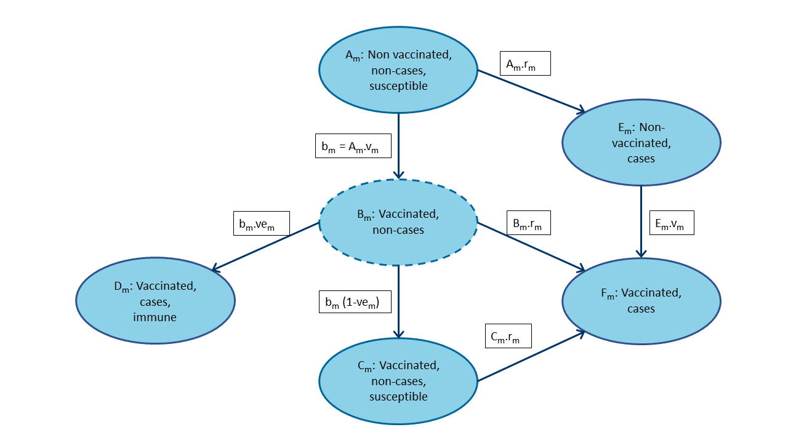
Figure 1 explanatory notes – Primary Model (Method 3 in Tokars et al.)
Step | Variable name | Variableª | Equationª
1 | Incident cases during the month | case_{m} | Input data
2 | Incident vaccinations during the month | vac_{m} | Input data
3 | Vaccine effectiveness | ve_{m} | Input data
4 | Infection rate | r_{m} | case_{m}/(A_{m-1} + C_{m-1})
5 | Vaccination rate | v_{m} | vac_{m}/(A_{m-1} + E_{m-1})
6 | Vaccinated non-cases incident | B_{m} | A_{m-1}·v_{m}
7 | Non-vaccinated non-cases | A_{m} | Initial value: starting population.  Subsequent values: A_{m-1}·(1-r_{m}) – B_{m}
8 | Vaccinated non-cases susceptible | C_{m} | C_{m-1} (1-r_{m}) + B_{m} (1-ve_{m})
9 | Vaccinated non-cases immune | D_{m} | D_{m-1} + B_{m} ve_{m}
10 | Non-vaccinated cases | E_{m} | E_{m-1} (1-v_{m}) + A_{m-1}·r_{m}
11 | Vaccinated cases | F_{m} | F_{m-1} + C_{m-1} r_{m} + E_{m-1}.v_{m}
12 | Cases if no vaccination | casen_{m} | popn_{m-1} · r_{m}
13 | Non-cases if no vaccination | popn_{m} | Initial value: starting population.  Subsequent values: popn_{m-1} – casen_{m}
14 | Averted cases | avert_{m} | casen_{m}- case_{m}
Notes: Image adapted from Tokars et al. Subscripts “m” indicates current month, “m-1” indicates prior month. Does not include 14-day immune lag period (Figure 1, oval B). (1)

Supplementary Figure S2. Estimates of population monthly influenza vaccination coverage based on observations in the sentinel general practice sample, Victoria, 2017-2019

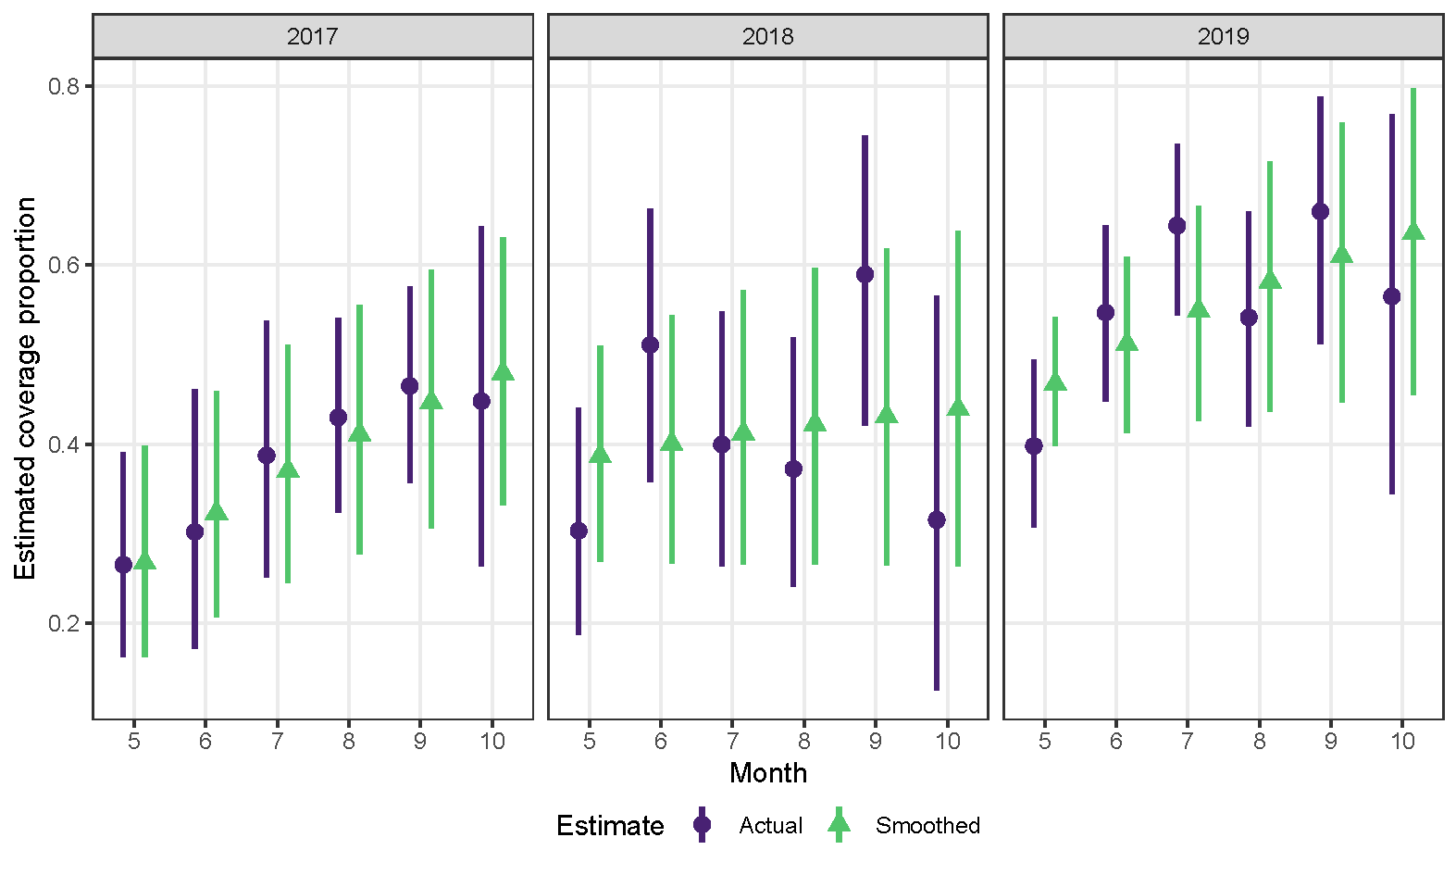
Year | Month | Attendees per month (n) |  | Vaccination coverage proportion estimate
 |  | Vaccinated | Total | Estimate | 95% CI | Smoothed estimate | Smoothed 95% CI
2017 | May | 17 | 64 | 0.27 | (0.16-0.39) | 0.27 | (0.16-0.40)
 | Jun | 13 | 43 | 0.30 | (0.17-0.46) | 0.32 | (0.21-0.46)
 | Jul | 19 | 49 | 0.39 | (0.25-0.54) | 0.37 | (0.25-0.51)
 | Aug | 37 | 86 | 0.43 | (0.32-0.54) | 0.41 | (0.28-0.56)
 | Sep | 40 | 86 | 0.47 | (0.36-0.58) | 0.45 | (0.31-0.60)
 | Oct | 13 | 29 | 0.45 | (0.26-0.64) | 0.48 | (0.33-0.63)
2018 | May | 17 | 56 | 0.30 | (0.19-0.44) | 0.39 | (0.27-0.51)
 | Jun | 23 | 45 | 0.51 | (0.36-0.66) | 0.40 | (0.27-0.54)
 | Jul | 20 | 50 | 0.40 | (0.26-0.55) | 0.41 | (0.27-0.57)
 | Aug | 19 | 51 | 0.37 | (0.24-0.52) | 0.42 | (0.27-0.60)
 | Sep | 23 | 39 | 0.59 | (0.42-0.74) | 0.43 | (0.26-0.62)
 | Oct | 6 | 19 | 0.32 | (0.13-0.57) | 0.44 | (0.26-0.64)
2019 | May | 45 | 113 | 0.40 | (0.31-0.49) | 0.47 | (0.40-0.54)
 | Jun | 58 | 106 | 0.55 | (0.45-0.64) | 0.51 | (0.41-0.61)
 | Jul | 67 | 104 | 0.64 | (0.54-0.74) | 0.55 | (0.43-0.67)
 | Aug | 39 | 72 | 0.54 | (0.42-0.66) | 0.58 | (0.44-0.72)
 | Sep | 33 | 50 | 0.66 | (0.51-0.79) | 0.61 | (0.45-0.76)
 | Oct | 13 | 23 | 0.57 | (0.34-0.77) | 0.64 | (0.46-0.80)

Smoothed estimates of the monthly proportion of vaccinated individuals in the population were calculated by performing ordinary least square linear regression of the monthly proportion of vaccinated individuals within the sentinel sample against the log of the month within each study year. The sample consisted of individuals attending a general practice within the Victorian Sentinel Practices Influenza Network (VicSPIN) during the 2017-2019 influenza seasons, with an influenza-like-illness who tested negative for influenza. Data source: VicSPIN.

Supplementary Table S1. Alternative Modela for calculation of the number of hospitalizations and emergency department attendances averted by influenza vaccination

Step | Variable label | Variable | Equation or value
1 | Incident cases during the month | case_{m} | Input data
2 | Incident proportion of the starting population vaccinated during the month | vc_{m} | Input data
3 | Vaccine effectiveness | ve_{m} | Input data
4 | Vaccine coverage lagged | vc_lag_{m} | (vc_{m} + vc_{m-1})/2
5 | Susceptible population | pops_{m} | Initial value: starting population.  Subsequent values: (pops_{m-1}-case_{m-1}) (1-vc_lag_{m}·ve_{m})
6 | Infection risk | r_{m} | case_{m}/pops_{m}
7 | Non-cases if no vaccination | popn_{m} | Initial value: starting population.  Subsequent values: popn_{m-1}-casen_{m-1}
8 | Cases if no vaccination | casen_{m} | r_{m}*popn_{m}
9 | Averted cases | avert_{m} | casen_{m}-case_{m}
ª Method 1 in Tokars et al. (1)

Supplementary Table S2. Influenza-related hospitalizations by admission type for the influenza-specific (J09-J11) and pneumonia and influenza (J09-J18) scenarios

 | Pneumonia and influenza hospitalizations |  | Influenza-specific hospitalizations
Admission type | n | % | n | %
Emergency | 128008 | 94.7 | 21943 | 95.5
Maternity | 535 | 0.4 | 344 | 1.5
Statistical admission, change in care type | 6639 | 4.9 | 685 | 3.0
Total | 135182 | 100.0 | 22972 | 100.0

Hospitalizations across all care types were only included if an influenza-related diagnostic code was recorded: J09-J11 for the influenza-specific scenario and J09-J18 for the pneumonia and influenza scenario.
ª Statistical hospitalizations were included as these represent the commencement of a distinct new episode of care and do not necessarily have the same diagnostic codes as the previous hospitalization, classified under a different care type. This change in status may, for example, represent a significant change in clinical status following influenza infection. (2)

Supplementary Table S3. Influenza-related hospitalizations and emergency department attendances listed by the first diagnostic field that contains an influenza-specific (J09-J11) or pneumonia and influenza (J09-J18) diagnostic code

 | Emergency department attendances
 | Pneumonia and influenza hospitalizations |  | Influenza-specific hospitalizations
Diagnostic field | n | % | n | %
1 | 59468 | 96.4 | 15530 | 96.1
2 | 2021 | 3.3 | 598 | 3.7
3 | 192 | 0.3 | 40 | 0.2
 | Hospitalizations
 | Pneumonia and influenza hospitalizations |  | Influenza-specific hospitalizations
Diagnostic field | n | % | n | %
1 | 80940 | 59.9 | 16667 | 72.6
2 | 21342 | 15.8 | 3694 | 16.1
3 | 7964 | 5.9 | 963 | 4.2
4 | 4010 | 3.0 | 416 | 1.8
5 | 3942 | 2.9 | 335 | 1.5
6 | 3225 | 2.4 | 237 | 1.0
7 | 2599 | 1.9 | 150 | 0.7
8 | 2034 | 1.5 | 108 | 0.5
9 | 1723 | 1.3 | 82 | 0.4
10 | 1406 | 1.0 | 74 | 0.3
11 | 1089 | 0.8 | 60 | 0.3
12 | 875 | 0.6 | 41 | 0.2
13 | 692 | 0.5 | 24 | 0.1
14 | 606 | 0.4 | 22 | 0.1
15 | 478 | 0.4 | 23 | 0.1
16 | 408 | 0.3 | 15 | 0.1
17 | 305 | 0.2 | 16 | 0.1
18 | 304 | 0.2 | 10 | 0.0
19 | 211 | 0.2 | 6 | 0.0
20 | 186 | 0.1 | 2 | 0.0
21 | 141 | 0.1 | 6 | 0.0
22 | 113 | 0.1 | 3 | 0.0
23 | 96 | 0.1 | 5 | 0.0
24 | 102 | 0.1 | 3 | 0.0
25 | 58 | 0.0 | 2 | 0.0
26 | 53 | 0.0 | 1 | 0.0
27 | 54 | 0.0 | 0 | 0.0
28 | 35 | 0.0 | 1 | 0.0
29 | 34 | 0.0 | 1 | 0.0
30 | 30 | 0.0 | 1 | 0.0
31 | 24 | 0.0 | 0 | 0.0
32 | 23 | 0.0 | 1 | 0.0
33 | 13 | 0.0 | 2 | 0.0
34 | 11 | 0.0 | 0 | 0.0
35 | 15 | 0.0 | 0 | 0.0
36 | 18 | 0.0 | 1 | 0.0
37 | 8 | 0.0 | 0 | 0.0
38 | 6 | 0.0 | 0 | 0.0
39 | 3 | 0.0 | 0 | 0.0
40 | 6 | 0.0 | 0 | 0.0

Data sources: VAED (hospitalizations), VEMD (emergency department attendances).

Supplementary Table S4. Influenza-related hospitalizations and emergency department attendance averted by influenza vaccination, under hybrid scenarioa, Victoria, 2017-2019: number and rate per 100 000 population
Year | Age  (years) | Hospitalizations |  |  |  | ED attendance
 |  | Observed |  | Averted |  | Observed |  | Averted
 |  | n | rate | n | rate | n | rate | n | rate
 |  | Influenza-specific (J09-J11)^{b}
2017 | 0.5-4 | 409 | 92 | 22 | 5 | 288 | 65 | 17 | 4
 | 5-14 | 287 | 38 | 9 | 1 | 402 | 54 | 13 | 2
 | 15-49 | 1883 | 61 | 68 | 2 | 2447 | 79 | 88 | 3
 | 50-64 | 1318 | 123 | 73 | 7 | 868 | 81 | 46 | 4
 | 65+ | 4929 | 551 | 0 | 0 | 1309 | 146 | 0 | 0
 | All ages | 8826 | 141 | 172 | 3 | 5314 | 85 | 164 | 3
2018 | 0.5-4 | 192 | 43 | 50 | 11 | 157 | 35 | 39 | 9
 | 5-14 | 160 | 21 | 24 | 3 | 147 | 19 | 20 | 3
 | 15-49 | 946 | 30 | 134 | 4 | 1142 | 36 | 151 | 5
 | 50-64 | 626 | 58 | 151 | 14 | 393 | 36 | 88 | 8
 | 65+ | 1312 | 143 | 365 | 40 | 448 | 49 | 119 | 13
 | All ages | 3236 | 51 | 724 | 11 | 2287 | 36 | 417 | 7
2019 | 0.5-4 | 705 | 159 | 149 | 34 | 722 | 163 | 157 | 35
 | 5-14 | 591 | 75 | 90 | 11 | 892 | 114 | 152 | 19
 | 15-49 | 2957 | 92 | 442 | 14 | 3965 | 123 | 629 | 20
 | 50-64 | 1642 | 149 | 311 | 28 | 1178 | 107 | 242 | 22
 | 65+ | 5015 | 529 | 1091 | 115 | 1810 | 191 | 403 | 43
 | All ages | 10910 | 168 | 2083 | 32 | 8567 | 132 | 1583 | 24
 |  | Pneumonia and influenza (J09-J18)^{c}
2017 | 0.5-4 | 2134 | 479 | 89 | 20 | 1414 | 318 | 62 | 14
 | 5-14 | 893 | 119 | 27 | 4 | 1011 | 135 | 32 | 4
 | 15-49 | 5917 | 191 | 171 | 6 | 4889 | 158 | 154 | 5
 | 50-64 | 6353 | 590 | 274 | 25 | 3200 | 297 | 149 | 14
 | 65+ | 30301 | 3388 | 0 | 0 | 9568 | 1070 | 0 | 0
 | All ages | 45598 | 728 | 561 | 9 | 20082 | 321 | 397 | 6
2018 | 0.5-4 | 2201 | 493 | 475 | 106 | 1402 | 314 | 321 | 72
 | 5-14 | 706 | 92 | 84 | 11 | 697 | 91 | 84 | 11
 | 15-49 | 5052 | 160 | 596 | 19 | 3478 | 110 | 416 | 13
 | 50-64 | 5682 | 522 | 1156 | 106 | 2510 | 231 | 524 | 48
 | 65+ | 26413 | 2870 | 6082 | 661 | 8204 | 891 | 1882 | 204
 | All ages | 40054 | 628 | 8393 | 132 | 16291 | 255 | 3227 | 51
2019 | 0.5-4 | 2684 | 604 | 582 | 131 | 2106 | 474 | 474 | 107
 | 5-14 | 1258 | 161 | 193 | 25 | 1773 | 226 | 299 | 38
 | 15-49 | 7473 | 233 | 1111 | 35 | 6955 | 216 | 1097 | 34
 | 50-64 | 7019 | 636 | 1449 | 131 | 3722 | 337 | 812 | 74
 | 65+ | 31096 | 3281 | 6785 | 716 | 10752 | 1134 | 2414 | 255
 | All ages | 49530 | 763 | 10120 | 156 | 25308 | 390 | 5096 | 78
ª Hybrid scenario assumptions: vaccination coverage - central estimate used for 0.5-4 year and 50-64 year age groups, low estimate for 5-14 year and 15-49 year age groups, high estimate for 65+ year age group; vaccination effectiveness - low estimate for 65+ year age group, central estimate for all others.
^{b} Influenza-related events defined as events with J09-J11 ICD-10-AM code in any diagnostic field.
^{c} Influenza-related events defined as events with J09-J18 ICD-10-AM codes in any diagnostic field.

Supplementary Table S5. Influenza-specific hospitalizations and emergency department attendance averted by influenza vaccination, Victoria, 2017-2019ª
 |  | Hospitalizations
Year | Age | Observed |  | Averted base scenario |  | Averted low scenario |  | Averted high scenario
 | Years | n | rate | n | rate | n | rate | n | rate
2017 | 0.5-4 | 409 | 92 | 22 | 5 | 0 | 0 | 77 | 17
 | 5-14 | 287 | 38 | 13 | 2 | 0 | 0 | 47 | 6
 | 15-49 | 1883 | 61 | 103 | 3 | 0 | 0 | 344 | 11
 | 50-64 | 1318 | 123 | 73 | 7 | 0 | 0 | 245 | 23
 | 65+ | 4929 | 551 | 286 | 32 | 0 | 0 | 947 | 106
 | All | 8826 | 141 | 497 | 8 | 0 | 0 | 1660 | 27
2018 | 0.5-4 | 192 | 43 | 50 | 11 | 20 | 4 | 101 | 23
 | 5-14 | 160 | 21 | 44 | 6 | 18 | 2 | 90 | 12
 | 15-49 | 946 | 30 | 238 | 8 | 99 | 3 | 496 | 16
 | 50-64 | 626 | 58 | 151 | 14 | 63 | 6 | 315 | 29
 | 65+ | 1312 | 143 | 312 | 34 | 129 | 14 | 654 | 71
 | All | 3236 | 51 | 795 | 12 | 329 | 5 | 1656 | 26
2019 | 0.5-4 | 705 | 159 | 149 | 34 | 89 | 20 | 230 | 52
 | 5-14 | 591 | 75 | 120 | 15 | 72 | 9 | 187 | 24
 | 15-49 | 2957 | 92 | 599 | 19 | 357 | 11 | 938 | 29
 | 50-64 | 1642 | 149 | 311 | 28 | 183 | 17 | 485 | 44
 | 65+ | 5015 | 529 | 1075 | 113 | 639 | 67 | 1675 | 177
 | All | 10910 | 168 | 2254 | 35 | 1340 | 21 | 3515 | 54
 |  | Emergency department attendance
Year | Age | Observedª |  | Averted base scenario |  | Averted low scenario |  | Averted high scenario
 | Years | n | rate | n | rate | n | rate | n | rate
2017 | 0.5-4 | 288 | 65 | 17 | 4 | 0 | 0 | 53 | 12
 | 5-14 | 402 | 54 | 21 | 3 | 0 | 0 | 70 | 9
 | 15-49 | 2447 | 79 | 133 | 4 | 0 | 0 | 441 | 14
 | 50-64 | 868 | 81 | 46 | 4 | 0 | 0 | 157 | 15
 | 65+ | 1309 | 146 | 75 | 8 | 0 | 0 | 252 | 28
 | All | 5314 | 85 | 292 | 5 | 0 | 0 | 973 | 16
2018 | 0.5-4 | 157 | 35 | 39 | 9 | 18 | 4 | 82 | 18
 | 5-14 | 147 | 19 | 37 | 5 | 15 | 2 | 76 | 10
 | 15-49 | 1142 | 36 | 269 | 9 | 114 | 4 | 550 | 17
 | 50-64 | 393 | 36 | 88 | 8 | 37 | 3 | 185 | 17
 | 65+ | 448 | 49 | 103 | 11 | 43 | 5 | 214 | 23
 | All | 2287 | 36 | 536 | 8 | 227 | 4 | 1107 | 17
2019 | 0.5-4 | 722 | 163 | 157 | 35 | 95 | 21 | 238 | 54
 | 5-14 | 892 | 114 | 202 | 26 | 122 | 16 | 313 | 40
 | 15-49 | 3965 | 123 | 853 | 27 | 509 | 16 | 1331 | 41
 | 50-64 | 1178 | 107 | 242 | 22 | 144 | 13 | 378 | 34
 | 65+ | 1810 | 191 | 394 | 42 | 236 | 25 | 618 | 65
 | All | 8567 | 132 | 1848 | 28 | 1106 | 17 | 2878 | 44
ª Influenza-related events defined as events with ICD-10-AM code J09-J11 in any diagnostic field.

Supplementary Table S6. Pneumonia and influenza hospitalizations and emergency department attendance averted by influenza vaccination, Victoria, 2017-2019ª
 |  | Hospitalizations
Year | Age | Observed |  | Averted base scenario |  | Averted low scenario |  | Averted high scenario
 | Years | n | rate | n | rate | n | rate | n | rate
2017 | 0.5-4 | 2134 | 479 | 89 | 20 | 0 | 0 | 295 | 66
 | 5-14 | 893 | 119 | 41 | 5 | 0 | 0 | 135 | 18
 | 15-49 | 5917 | 191 | 260 | 8 | 0 | 0 | 863 | 28
 | 50-64 | 6353 | 590 | 274 | 25 | 0 | 0 | 911 | 85
 | 65+ | 30301 | 3388 | 1310 | 146 | 0 | 0 | 4343 | 486
 | All | 45598 | 728 | 1974 | 32 | 0 | 0 | 6547 | 105
2018 | 0.5-4 | 2201 | 493 | 475 | 106 | 209 | 47 | 948 | 212
 | 5-14 | 706 | 92 | 147 | 19 | 64 | 8 | 301 | 39
 | 15-49 | 5052 | 160 | 1049 | 33 | 451 | 14 | 2141 | 68
 | 50-64 | 5682 | 522 | 1156 | 106 | 498 | 46 | 2360 | 217
 | 65+ | 26413 | 2870 | 5320 | 578 | 2295 | 249 | 10827 | 1176
 | All | 40054 | 628 | 8147 | 128 | 3517 | 55 | 16577 | 260
2019 | 0.5-4 | 2684 | 604 | 582 | 131 | 340 | 77 | 920 | 207
 | 5-14 | 1258 | 161 | 272 | 35 | 157 | 20 | 434 | 55
 | 15-49 | 7473 | 233 | 1556 | 48 | 896 | 28 | 2478 | 77
 | 50-64 | 7019 | 636 | 1449 | 131 | 828 | 75 | 2323 | 210
 | 65+ | 31096 | 3281 | 6576 | 694 | 3755 | 396 | 10544 | 1113
 | All | 49530 | 763 | 10435 | 161 | 5976 | 92 | 16699 | 257
 |  | Emergency department attendance
Year | Age | Observedª |  | Averted base scenario |  | Averted low scenario |  | Averted high scenario
 | Years | n | rate | n | rate | n | rate | n | rate
2017 | 0.5-4 | 1414 | 318 | 62 | 14 | 0 | 0 | 206 | 46
 | 5-14 | 1011 | 135 | 48 | 6 | 0 | 0 | 163 | 22
 | 15-49 | 4889 | 158 | 236 | 8 | 0 | 0 | 783 | 25
 | 50-64 | 3200 | 297 | 149 | 14 | 0 | 0 | 490 | 46
 | 65+ | 9568 | 1070 | 423 | 47 | 0 | 0 | 1400 | 157
 | All | 20082 | 321 | 918 | 15 | 0 | 0 | 3042 | 49
2018 | 0.5-4 | 1402 | 314 | 321 | 72 | 141 | 32 | 642 | 144
 | 5-14 | 697 | 91 | 148 | 19 | 64 | 8 | 304 | 40
 | 15-49 | 3478 | 110 | 734 | 23 | 314 | 10 | 1497 | 47
 | 50-64 | 2510 | 231 | 524 | 48 | 226 | 21 | 1067 | 98
 | 65+ | 8204 | 891 | 1648 | 179 | 711 | 77 | 3349 | 364
 | All | 16291 | 255 | 3375 | 53 | 1456 | 23 | 6859 | 108
2019 | 0.5-4 | 2106 | 474 | 474 | 107 | 279 | 63 | 746 | 168
 | 5-14 | 1773 | 226 | 416 | 53 | 241 | 31 | 659 | 84
 | 15-49 | 6955 | 216 | 1526 | 47 | 887 | 28 | 2417 | 75
 | 50-64 | 3722 | 337 | 812 | 74 | 466 | 42 | 1296 | 117
 | 65+ | 10752 | 1134 | 2338 | 247 | 1334 | 141 | 3751 | 396
 | All | 25308 | 390 | 5566 | 86 | 3207 | 49 | 8869 | 137
ª Influenza-related events defined as events with J09-J18 ICD-10-AM code in any diagnostic field.

Supplementary Table S7. Influenza-related hospitalizations and emergency department attendance averted by influenza vaccination, Victoria, 2017-2019: number, rate per 100 000 population and prevented fractionª

 |  | Hospitalizations
Case definitions | Year | Observed |  | Averted base scenario |  |  | Averted low scenario |  |  | Averted high scenario
 |  | n | rate | n | rate | pfª | n | rate | pf | n | rate | pf
Influenza, J09-J11, any diagnosis^{b} | 2017 | 8826 | 141 | 497 | 8 | 5 | 0 | 0 | 0 | 1660 | 27 | 16
 | 2018 | 3236 | 51 | 795 | 12 | 20 | 329 | 5 | 9 | 1656 | 26 | 34
 | 2019 | 10910 | 168 | 2254 | 35 | 17 | 1340 | 21 | 11 | 3515 | 54 | 24
Influenza, J09-J11, principal diagnosis^{c} | 2017 | 6195 | 99 | 352 | 6 | 5 | 0 | 0 | 0 | 1167 | 19 | 16
 | 2018 | 2420 | 38 | 597 | 9 | 20 | 244 | 4 | 9 | 1239 | 19 | 34
 | 2019 | 8052 | 124 | 1661 | 26 | 17 | 989 | 15 | 11 | 2589 | 40 | 24
P&I, J09-J18, any diagnosis^{d} | 2017 | 45598 | 728 | 1974 | 32 | 4 | 0 | 0 | 0 | 6547 | 105 | 13
 | 2018 | 40054 | 628 | 8147 | 128 | 17 | 3517 | 55 | 8 | 16577 | 260 | 29
 | 2019 | 49530 | 763 | 10435 | 161 | 17 | 5976 | 92 | 11 | 16699 | 257 | 25
P&I, J09-J18, principal diagnosis^{e} | 2017 | 27599 | 441 | 1235 | 20 | 4 | 0 | 0 | 0 | 4093 | 65 | 13
 | 2018 | 23202 | 364 | 4801 | 75 | 17 | 2072 | 32 | 8 | 9767 | 153 | 30
 | 2019 | 30139 | 464 | 6446 | 99 | 18 | 3703 | 57 | 11 | 10300 | 159 | 25
 |  | Emergency department attendance
Case definitions | Year | Observed |  | Averted base scenario |  |  | Averted low scenario |  |  | Averted high scenario
 |  | n | rate | n | rate | pf | n | rate | pf | n | rate | pf
Influenza, J09-J11, any diagnosis | 2017 | 5314 | 85 | 292 | 5 | 3 | 0 | 0 | 0 | 973 | 16 | 10
 | 2018 | 2287 | 36 | 536 | 8 | 14 | 227 | 4 | 7 | 1107 | 17 | 25
 | 2019 | 8567 | 132 | 1848 | 28 | 14 | 1106 | 17 | 9 | 2878 | 44 | 21
Influenza, J09-J11, principal diagnosis | 2017 | 5104 | 82 | 282 | 5 | 4 | 0 | 0 | 0 | 932 | 15 | 13
 | 2018 | 2198 | 34 | 519 | 8 | 18 | 219 | 3 | 8 | 1071 | 17 | 31
 | 2019 | 8228 | 127 | 1774 | 27 | 18 | 1055 | 16 | 12 | 2755 | 42 | 25
P&I, J09-J18, any diagnosis | 2017 | 20082 | 321 | 918 | 15 | 2 | 0 | 0 | 0 | 3042 | 49 | 6
 | 2018 | 16291 | 255 | 3375 | 53 | 8 | 1456 | 23 | 4 | 6859 | 108 | 15
 | 2019 | 25308 | 390 | 5566 | 86 | 10 | 3207 | 49 | 6 | 8869 | 137 | 15
P&I, J09-J18, principal diagnosis | 2017 | 19290 | 308 | 880 | 14 | 3 | 0 | 0 | 0 | 2922 | 47 | 10
 | 2018 | 15717 | 246 | 3257 | 51 | 12 | 1407 | 22 | 6 | 6616 | 104 | 22
 | 2019 | 24461 | 377 | 5366 | 83 | 15 | 3092 | 48 | 9 | 8555 | 132 | 22

ª Pf – prevented fraction = (events averted / [events averted + events])*100
^{b} Influenza-related events defined as events with J09-J11 ICD-10-AM code in any diagnostic field.
^{c} Influenza-related events defined as events with J09-J11 ICD-10-AM code in principal diagnostic field.
^{d} Influenza-related events defined as events with J09-J18 ICD-10-AM codes in any diagnostic field.
^{e} Influenza-related events defined as events with J09-J18 ICD-10-AM codes in principal diagnostic field.

Supplementary Table S8. Influenza-specific hospitalizations and emergency attendance averted by influenza vaccination, Alternative Model,ª Victoria, 2017-2019^{b}: number and rate per 100 000 population

 |  | Hospitalizations
Year | Age | Observed |  | Averted base scenario |  | Averted low scenario |  | Averted high scenario
 | Years | n | rate | n | rate | n | rate | n | rate
2017 | 0.5-4 | 409 | 92 | 22 | 5 | 0 | 0 | 76 | 17
 | 5-14 | 287 | 38 | 14 | 2 | 0 | 0 | 47 | 6
 | 15-49 | 1883 | 61 | 108 | 3 | 0 | 0 | 340 | 11
 | 50-64 | 1318 | 123 | 77 | 7 | 0 | 0 | 240 | 22
 | 65+ | 4929 | 551 | 295 | 33 | 0 | 0 | 925 | 103
 | All ages | 8826 | 141 | 516 | 8 | 0 | 0 | 1628 | 26
2018 | 0.5-4 | 192 | 43 | 46 | 10 | 21 | 5 | 88 | 20
 | 5-14 | 160 | 21 | 39 | 5 | 18 | 2 | 74 | 10
 | 15-49 | 946 | 30 | 225 | 7 | 100 | 3 | 419 | 13
 | 50-64 | 626 | 58 | 142 | 13 | 62 | 6 | 263 | 24
 | 65+ | 1312 | 143 | 291 | 32 | 129 | 14 | 547 | 59
 | All ages | 3236 | 51 | 743 | 12 | 330 | 5 | 1391 | 22
2019 | 0.5-4 | 705 | 159 | 151 | 34 | 91 | 20 | 223 | 50
 | 5-14 | 591 | 75 | 124 | 16 | 75 | 10 | 183 | 23
 | 15-49 | 2957 | 92 | 604 | 19 | 371 | 12 | 895 | 28
 | 50-64 | 1642 | 149 | 314 | 28 | 193 | 17 | 465 | 42
 | 65+ | 5015 | 529 | 1071 | 113 | 656 | 69 | 1587 | 167
 | All ages | 10910 | 168 | 2264 | 35 | 1386 | 21 | 3353 | 52
 |  | Emergency department attendance
Year | Age | Observed^{b} |  | Averted base scenario |  | Averted low scenario |  | Averted high scenario
 | Years | n | rate | n | rate | n | rate | n | rate
2017 | 0.5-4 | 288 | 65 | 17 | 4 | 0 | 0 | 53 | 12
 | 5-14 | 402 | 54 | 21 | 3 | 0 | 0 | 70 | 9
 | 15-49 | 2447 | 79 | 139 | 4 | 0 | 0 | 434 | 14
 | 50-64 | 868 | 81 | 50 | 5 | 0 | 0 | 155 | 14
 | 65+ | 1309 | 146 | 77 | 9 | 0 | 0 | 245 | 27
 | All ages | 157 | 35 | 38 | 9 | 19 | 4 | 71 | 16
2018 | 0.5-4 | 157 | 35 | 38 | 9 | 19 | 4 | 71 | 16
 | 5-14 | 147 | 19 | 34 | 4 | 16 | 2 | 63 | 8
 | 15-49 | 1142 | 36 | 261 | 8 | 119 | 4 | 482 | 15
 | 50-64 | 393 | 36 | 87 | 8 | 38 | 3 | 159 | 15
 | 65+ | 448 | 49 | 101 | 11 | 45 | 5 | 184 | 20
 | All ages | 2287 | 36 | 521 | 8 | 237 | 4 | 959 | 15
2019 | 0.5-4 | 722 | 163 | 158 | 36 | 98 | 22 | 231 | 52
 | 5-14 | 892 | 114 | 206 | 26 | 128 | 16 | 303 | 39
 | 15-49 | 3965 | 123 | 856 | 27 | 525 | 16 | 1269 | 39
 | 50-64 | 1178 | 107 | 242 | 22 | 149 | 13 | 360 | 33
 | 65+ | 1810 | 191 | 396 | 42 | 241 | 25 | 587 | 62
 | All ages | 8567 | 132 | 1858 | 29 | 1141 | 18 | 2750 | 42
ª Table results calculated using Method 1 from Tokars et al. (Supplementary Table S1). (1)
^{b} Influenza-related events defined as events with J09-J11 ICD-10-AM in any diagnostic field.

Supplementary references

1. Tokars JI, Rolfes MA, Foppa IM, Reed C. An evaluation and update of methods for estimating the number of influenza cases averted by vaccination in the United States. Vaccine. 2018;36:7331-7337. Epub 20181014. doi: 10.1016/j.vaccine.2018.10.026. PubMed PMID: 30327213; PubMed Central PMCID: PMC6666399.
2. Victorian Government Department of Health. Victorian Admitted Episodes Dataset (VAED) manual 2021-22. Melbourne: Victorian Government Department of Health, 2021 July 8. Report No.

