Supplementary Tables and Figures.

Spatial-temporal distribution characteristics of pulmonary tuberculosis in eastern China from 2011 to 2021

Ke Chen, Liang Chen, Hao Yu, Limei Zhu, Tenglong Li, Leonardo Martinez, Qiao Liu, Bei Wang

Supplementary Table 1. High-high clustering areas in Jiangsu Province from 2011 to 2021.

Supplementary Figure 1. Registered incidence of Pulmonary tuberculosis from 2011-2021 in Jiangsu Province.

Supplementary Figure 2. Average registered incidence of Pulmonary tuberculosis from 2011-2021 in Jiangsu Province.

Supplementary Figure 3. Trend map of registered pulmonary tuberculosis patients from 2011-2021.

Supplementary Table 1. High-high clustering areas in Jiangsu Province from 2011 to 2021
Year | Name of counties
2011 | Shuyang, Baoying, Gaoyou, Xinghua, Hongze, Lianshui, Jinhu, Xiangshui, Guannan
2012 | Suyu, Shuyang,Sihong, Tongshan, Pizhou, Baoying, Gaoyou, Hongze, Lianshui, Jinhu, Xiangshui, Funing
2013 | Shuyang, Pizhou, Gaoyou, Lianshui, Xiangshui, Guannan
2014 | Shuyang, Pizhou, Gaoyou, Lianshui, Xiangshui, Guannan
2015 | Shuyang, Gaoyou
2016 | Gaoyou, Nanning
2017 | Chongchuan, Shuyang, Baoying, Xishan
2018 | Yizheng, Lianshui, Tinghu
2019 | Jiangdu, Baoying, Huaiyin, Hongze, Lianshui, Jinhu, Guannan
2020 | Hanjiang, Jiangdu, Baoying, Gaoyou, Xinghua, Hongze, Lianshui, Jinhu, Funing
2021 | Sihong, Baoying, Huaian, Huaiyin, Hongze, Lianshui, Xuyi, Jinhu, Funing

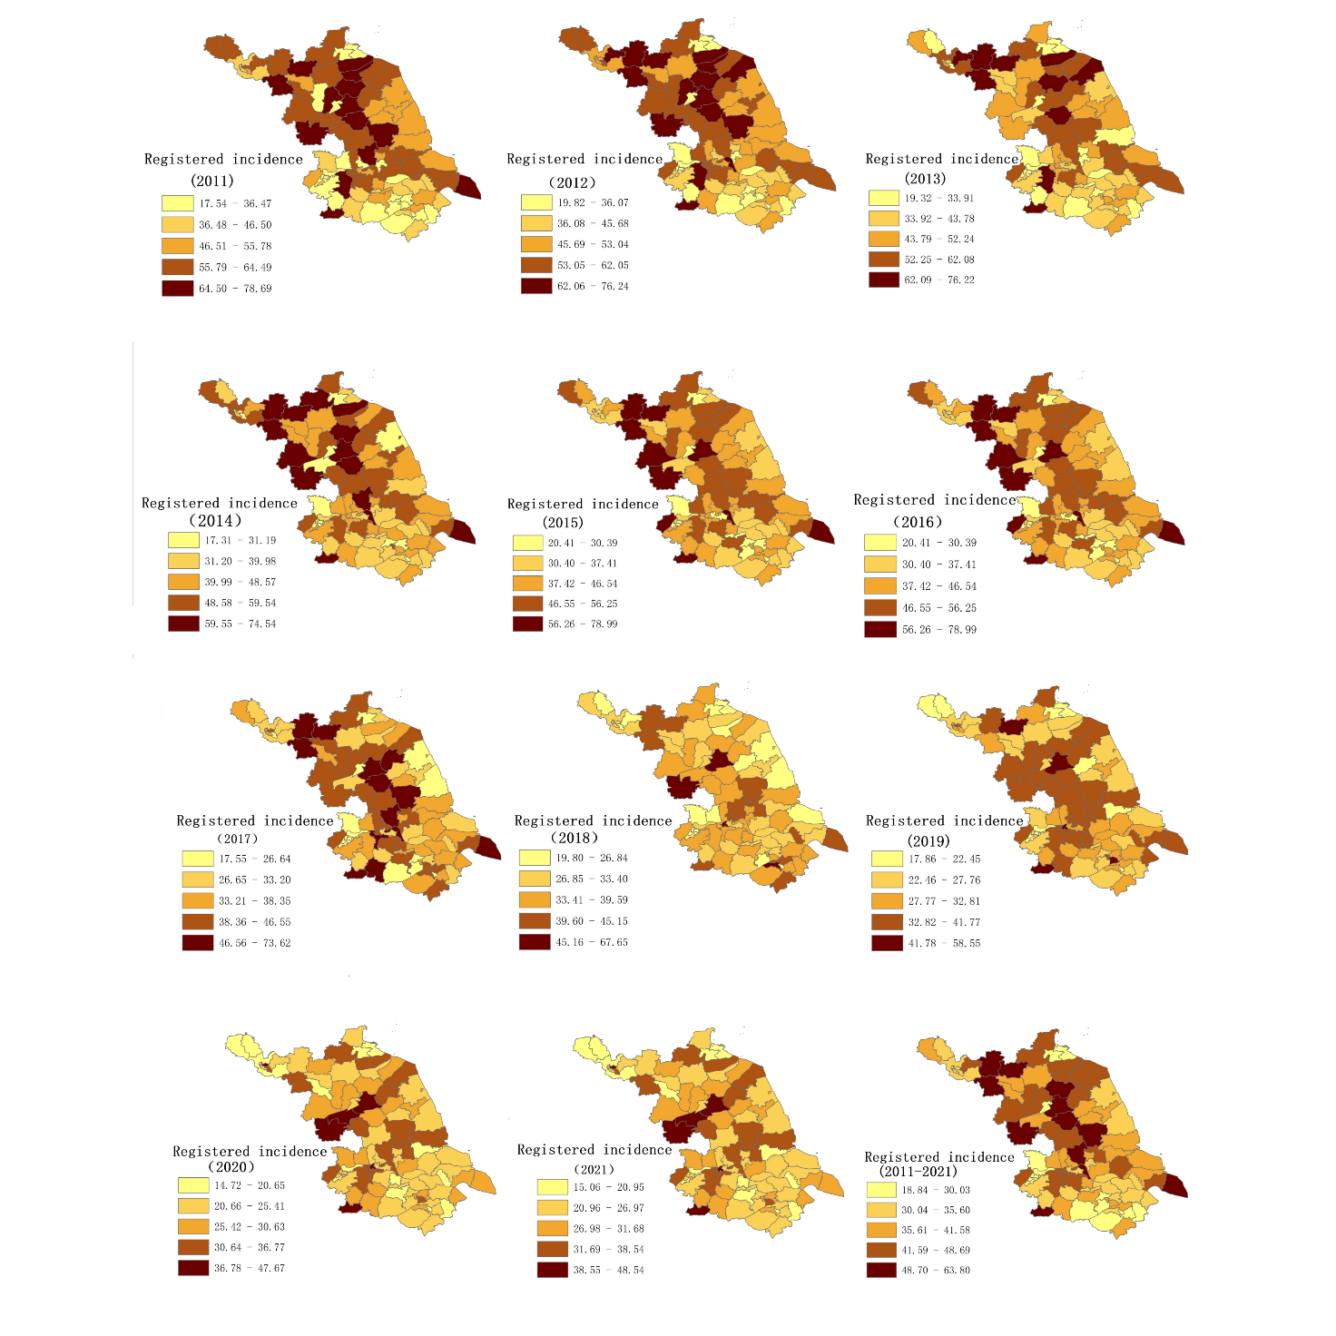
Supplementary Figure 1. Registered incidence of Pulmonary tuberculosis from 2011-2021 in Jiangsu Province.

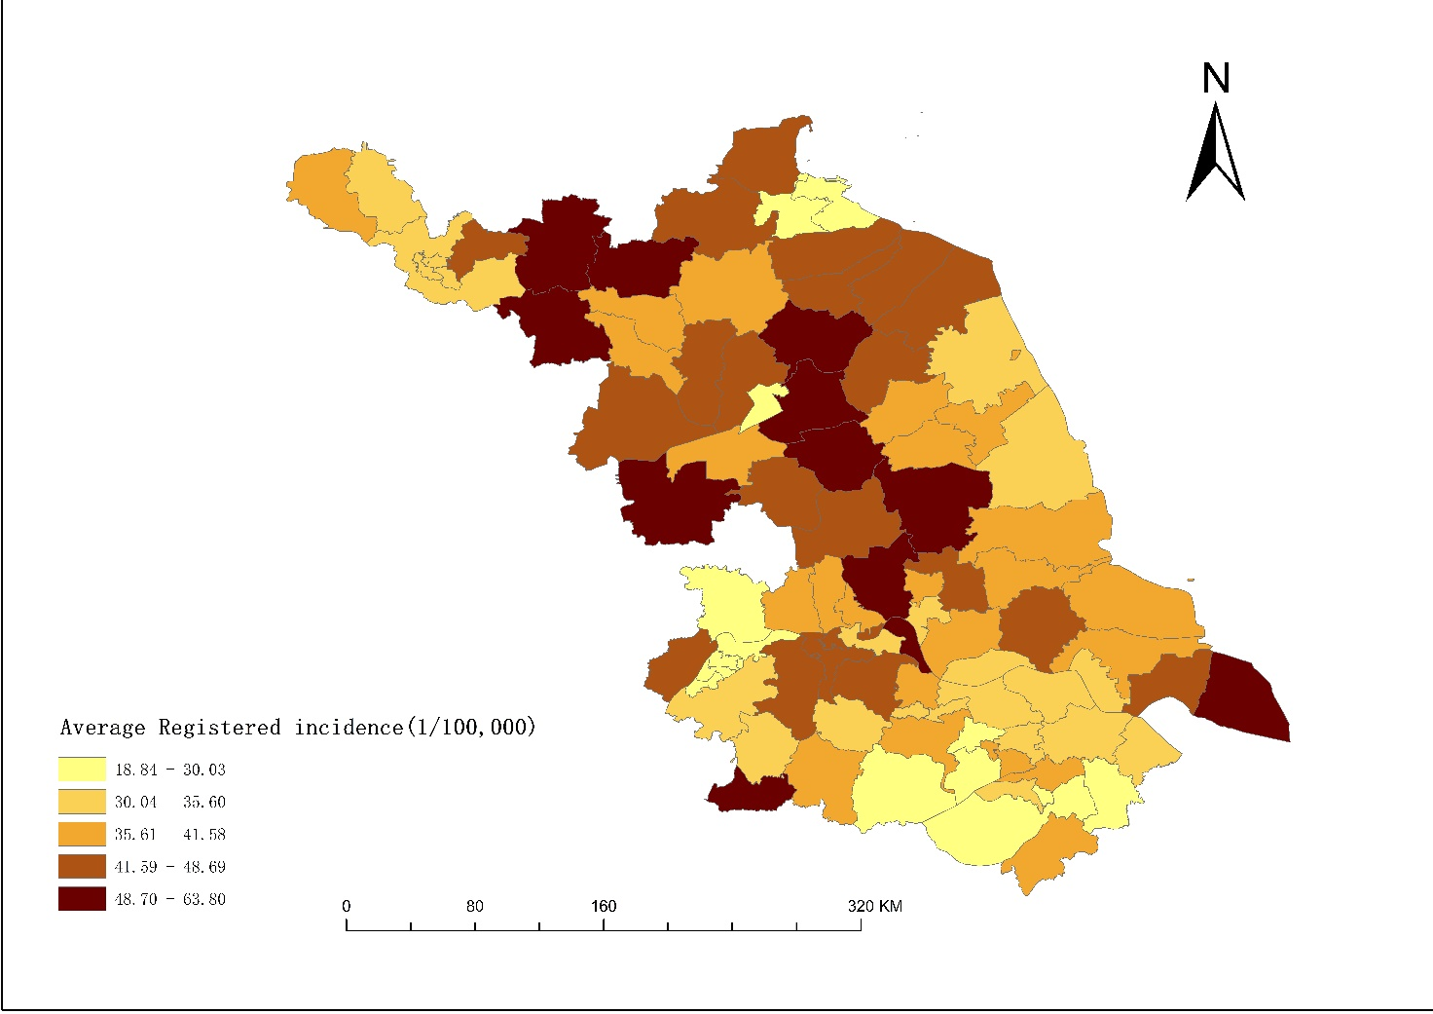
Supplementary Figure 2. Average registered incidence of Pulmonary tuberculosis from 2011-2021 in Jiangsu Province

Supplementary Figure 3. Trend map of registered pulmonary tuberculosis patients from 2011-2021

