Long Covid by Variant: Supplementary Material

Supplementary Figure S1. Virus Watch Recruitment Dates

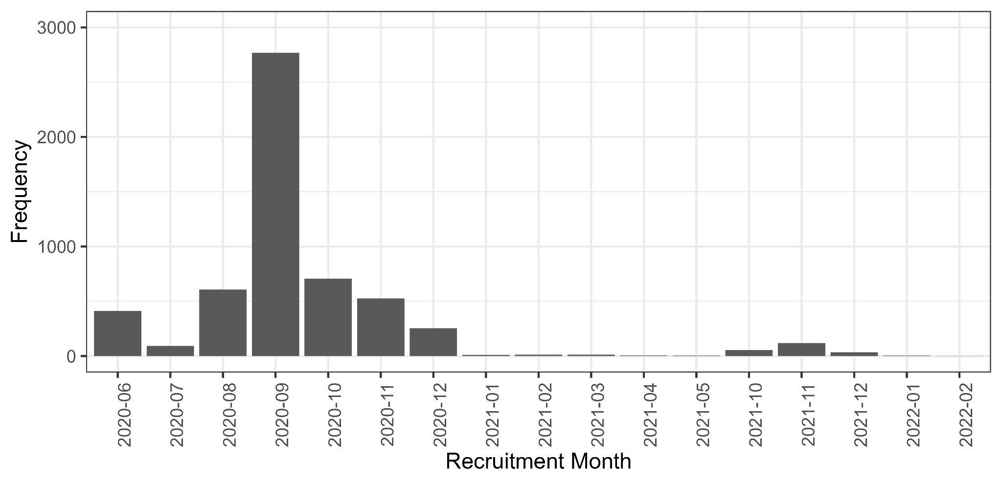

Of participants in the current study, 95% (n=5,369) joined the study in the period up to 12-2020. The most common month of recruitment was 09-2020 (n=2769, 49%).

Virus Watch Testing and Study Outcomes

Swab-Based Testing (Polymerase Chain Reaction and Lateral Flow Tests)
Virus Watch testing availability and protocols changed throughout the study. All participants had polymerase chain reaction (PCR) and lateral flow test (LFT) records based on weekly online self-report and linkage to national records across the study period. Between October 2020 and May 2021, a sub-cohort of participants (n=1,566 in current study) also posted self-administered PCR nasal swabs for laboratory analysis if symptomatic as part of the Virus Watch study. Between January and July 2023 (after the current study period), a further sub-cohort (n=948 in current study) were provided with LFTs to take if symptomatic and report to the study and – if positive – to send a PCR nasal swab for genomic analysis; this analysis is currently underway and genomic results were not available for the current study. However, results around positivity were available and were included in the present data. The study protocol (1) provides further procedural detail regarding swab testing.
Serological Testing

Serological testing in Virus Watch was conducted on a sub-cohort of participants using monthly at-home finger-prick serology and/or in-clinic serological testing conducted by healthcare workers. In-clinic serology was performed twice for included participants between September 2020-January 2021 (Autumn round) and April 2021-July 2021 (Spring round) (see study protocol (1) for details). The monthly at-home finger-prick testing was conducted between February 2021 and April 2022. Samples were tested for anti-nucleocapsid and anti-spike antibodies using the Roche Elecsys Anti-SARS-CoV-2 electro-chemiluminescent immunoassays, with estimated sensitivity and specificity of 97% and 99.8% respectively (2). Further detail of testing is provided in the study protocol (1).

As infection date was required to derive the outcome in the current study, only participants with seropositive results that could be attributable to an estimated infection date were included i.e., participants who were initially seronegative and seroconverted during a definable monthly period. Estimated date of infection was defined as the intermediate date between 10 days prior to the last negative, to account for infections that may not have seroconverted, and 14 days prior to the first positive. These were derived based on monthly finger-prick tests. However, serological results from all sources were used to identify participants with evidence of SARS-CoV-2 infection from any source and exclude them where required to prevent misclassification of infection status during each variant period, as described in the Exposure sections of the Methods section.

References

- Hayward A, Fragaszy E, Kovar J, Nguyen V, Beale S, et al. Risk factors, symptom reporting, healthcare-seeking behaviour and adherence to public health guidance: protocol for Virus Watch, a prospective community cohort study. BMJ open. 2021 Jun 1;11(6):e048042.

- The National SARS-CoV-2 Serology Assay Evaluation Group. Performance characteristics of five immunoassays for SARS-CoV-2: a head-to-head benchmark comparison. Lancet Infect Dis 2020; 20: 1390–400

Virus Watch Long-Term Symptoms Questionnaire: Symptom list

Note: The symptom list was revised prior to the March 2023 questionnaire to reflect evolving knowledge of post-Covid symptoms and to reduce survey burden by collapsing some items into single items. The ‘Other’ option was available in both questionnaires and the majority of symptoms remained consistent or comparable. Symptom lists are provided here for reference although the outcome in the study comprised any symptom(s) of duration >2 months and (if relevant) within 3 months of infection. Symptom profiles by variant - and consequently symptom harmonisation - are the subject of separate planned analysis beyond the scope of this paper.

Original Symptom List (February 2021 - March 2022)

Fatigue / Feeling unusually tired | Fever
Headache | Feeling feverish
Feeling anxious | Loss of Appetite
Feeling depressed/low mood | Trouble Sleeping
Runny Nose; Blocked Nose | Lack of concentration
Lightheaded or dizzy | Confusion, disorientation
Memory loss | Eye redness
Dry cough; | Deterioration of eyesight
Wet cough | Sore throat
Loss of sense of taste | Weakness
Altered/distorted sense of taste | Weight loss
Loss of sense of smell; | Altered/distorted sense of smell;
Reduced sense of smell | Phantom smells in the absence of any odour
Hair loss | Chills
Rash (all over) | Night Sweats
Rash (local) | Sinus pain / congestion
Vomiting (being sick) | Sneezing
Nausea (feeling sick) | Swollen tonsils
Heart Palpitations (Fast or pounding heartbeat) | Wheezing
Chest pain (not changed by breathing) | Chest tightness
Chest pain when breathing in | Sticky eye
Abdominal pain (not inc. menstrual pain) | Eye pain
Shortness of breath/difficulty breathing | Ear pain
Muscle Aches | Tinnitus (ringing or other noises in one or both ears)
Bone or Joint Aches | Change in hearing
Other long-term pain | Other symptom(s)
Swollen glands

Symptom List (March 2023)

Fatigue | Fever
Headache | Change in Appetite
Feeling anxious | Sleep problems (including difficulty falling asleep, staying asleep, oversleeping or sleep apnoea)
Feeling depressed | Brain fog and/or other cognitive problems
Congested/runny nose | Dry eyes/ redness of eyes
Dizziness | Visual changes; Blurry vision
Memory problems | Sore throat or mouth
Cough | Post-exertion malaise (feeling unwell or 'crashing' after exercise or physical exertion)
Change/loss of taste | Unintentional weight gain
Change/loss of smell | Problems with movement, balance, and/or coordination
Hair loss | Paraesthesia (pricking, tingling, or creeping feeling on the skin)
Skin rash | Swelling of hands and/or feet
Unintentional weight loss | Difficulty swallowing (dysphagia)
Nausea and/or vomiting | Easy bruising/ bleeding
Diarrhoea | Acid reflux/heartburn
Tachycardia (fast heartbeat) or palpitations | Gynaecological problems (e.g., change in menstrual cycles or flow)
Chest pain | Urinary symptoms (e.g., bladder frequency, urgency or incontinence)
Abdominal pain | New allergy (e.g., to food, medications, etc.)
Shortness of breath/dyspnoea | Ear pain
Muscle aches | Change in hearing
Bone and joint pain | Tinnitus
Swollen lymph nodes | Other symptom(s), please describe:

Supplementary Table S1. Variant Period Dates by English National Region

Region | Variant Period
 | Wild Type | Alpha | Delta | Omicron BA.1 | Omicron BA.2 | Omicron BA.5 | Omicron Other
East Midlands | 1 Feb 2020 - 9 Dec 2020 | 4 Jan 2021 - 4 May 2021 | 1 Jun 2021 - 11 Dec 2021 | 20 Dec 2021 - 6 Mar 2022 | 7 Mar 2022 - 12 June 2022 | 4 Jul 2022 - 20 Nov 2022 | < 7 Mar 2023
East of England | 1 Feb 2020 - 16 Nov 2020 | 15 Dec 2020 - 27 April 2021 | 25 May 2021 - 11 Dec 2021 | 19 Dec 2021 - 6 Mar 2022 | 7 Mar 2022 - 12 June 2022 | 4 Jul 2022 - 20 Nov 2022 | < 7 Mar 2023
London | 1 Feb 2020 - 16 Nov 2020 | 10 Dec 2020 - 13 Apr 2021 | 25 May 2021 - 7 Dec 2021 | 14 Dec 2021 - 6 Mar 2022 | 7 Mar 2022 - 12 June 2022 | 4 Jul 2022 - 20 Nov 2022 | < 7 Mar 2023
North East | 1 Feb 2020 - 9 Dec 2020 | 7 Jan 2021 - 11 May 2021 | 1 Jun 2021 - 13 Dec 2021 | 22 Dec 2021 - 6 Mar 2022 | 7 Mar 2022 - 12 June 2022 | 4 Jul 2022 - 20 Nov 2022 | < 7 Mar 2023
North West | 1 Feb 2020 - 9 Dec 2020 | 12 Jan 2021 - 20 Apr 2021 | 18 May 2021 - 11 Dec 2021 | 19 Dec 2021 - 6 Mar 2022 | 7 Mar 2022 - 12 June 2022 | 4 Jul 2022 - 20 Nov 2022 | < 7 Mar 2023
South East | 1 Feb 2020 - 9 Nov 2020 | 8 Dec 2020 - 27 Apr 2021 | 25 May 2021 - 10 Dec 2021 | 19 Dec 2021 - 6 Mar 2022 | 7 Mar 2022 - 12 June 2022 | 4 Jul 2022 - 20 Nov 2022 | < 7 Mar 2023
South West | 1 Feb 2020 - 2 Dec 2020 | 5 Jan 2021 - 13 Apr 2021 | 25 May 2021 - 12 Dec 2021 | 20 Dec 2021 - 6 Mar 2022 | 7 Mar 2022 - 12 June 2022 | 4 Jul 2022 - 20 Nov 2022 | < 7 Mar 2023
West Midlands | 1 Feb 2020 - 7 Dec 2020 | 31 Dec 2020 - 11 May 2021 | 25 May 2021 - 12 Dec 2021 | 20 Dec 2021 - 6 Mar 2022 | 7 Mar 2022 - 12 June 2022 | 4 Jul 2022 - 20 Nov 2022 | < 7 Mar 2023
Yorkshire and the Humber | 1 Feb 2020 - 16 Dec 2020 | 19 Jan 2021 - 17 May 2021 | 08 Jun 2021 - 12 Dec 2021 | 20 Dec 2021 - 6 Mar 2022 | 7 Mar 2022 - 12 June 2022 | 4 Jul 2022 - 20 Nov 2022 | < 7 Mar 2023
Note: Missing dates represent time with no variant attributed to >75% of infections; dates for Omicron sub-lineages were only available for England overall; final Omicron Other date represents the closing date of the final survey, with all Omicron dates outside the specified sub-lineages before this date included
Occupational Categories

Occupational categories were developed to triangulate occupation, work-related exposure risk, and employment status while preserving statistical power in the current analysis. Occupations had been previously coded in Virus Watch using methodology described elsewhere (1), with categories collapsed to reflect exposure risk based on findings from other Virus Watch studies and previous literature(1)(2,3). The following groups were consequently included in each category:

Category | Included groups - n (%) of current study population (N=5,630)
Higher exposure risk occupation | Healthcare  219 (3.9%)  Indoor Trades, Process & Plant  142 (2.5%)  Leisure & Personal Service  99 (1.8%)  Sales & Customer Service  114 (2.0%)  Social Care & Community Protective Services  130 (2.3%)  Teaching, Education & Childcare  250 (4.4%)  Transport & Mobile Machine  41 (0.7%)
Lower exposure risk occupation | Administrative & Secretarial  322 (5.7%)  Managers, Directors & Senior Officials  191 (3.4%)  Other Professional & Associate Occupations  687 (12%)  Outdoor Trades  57 (1.0%)
Retired | Retired  2,444 (43%)
Not in employment | Not in Employment or Homemaker  129 (2.3%)  Permanently sick or disabled  66 (1.2%)  Student  46 (0.8%)
Unknown or Other Status | Unknown or Other Status  693 (12%)

References
1. Beale S, Hoskins S, Byrne T, Fong WLE, Fragaszy E, Geismar C, et al. Differential Risk of SARS-CoV-2 Infection by Occupation: Evidence from the Virus Watch prospective cohort study in England and Wales. J Occup Med Toxicol. 2023 Apr 3;18(1):1–11.
2. Beale S, Hoskins S, Byrne T, Fong WL, Fragaszy E,et al. Workplace contact patterns in England during the COVID-19 pandemic: Analysis of the Virus Watch prospective cohort study. The Lancet Regional Health - Europe. 2022 May 1;16:100352.
3. Beale S, Patel P, Rodger A, Braithwaite I, Byrne T, Fong WLE, et al. Occupation, work-related contact and SARS-CoV-2 anti-nucleocapsid serological status: findings from the Virus Watch prospective cohort study. Occup Environ Med. 2022 Nov 1;79(11):729–35.

Supplementary Figure S2. Directed Acyclic Graph for the Impact of Infection Status during each Variant Period on Development of Long-Term Symptoms
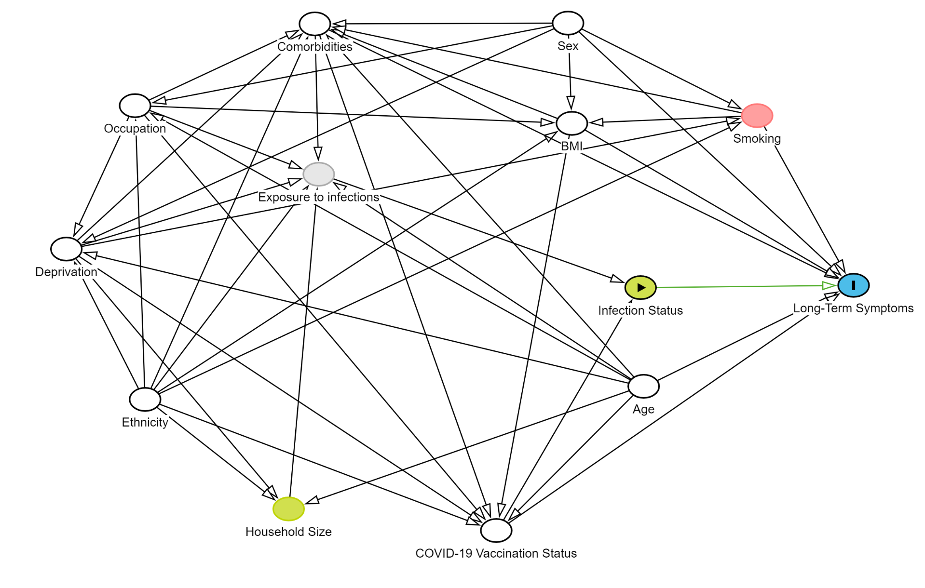

Supplementary Table S2. Development of New-Onset Long-Term Symptoms by Infection Status and Variant Period

 | SARS-CoV-2 |  |  | Other ARI |  |  | No Infection
 | Total | No Long-Term Symptoms | Long-Term Symptoms | Total | No Long-Term Symptoms | Long-Term Symptoms | Total | No Long-Term Symptoms | Long-Term Symptoms
Wild Type | 119 | 46 (39%) | 73 (61%) | 186 | 145 (78%) | 41 (22%) | 3,818 | 3,741 (98%) | 77 (2.0%)
Alpha | 127 | 59 (46%) | 68 (54%) | 337 | 279 (83%) | 58 (17%) | 3,597 | 3,530 (98%) | 67 (1.9%)
Delta | 434 | 323 (74%) | 111 (26%) | 1,165 | 1,011 (87%) | 154 (13%) | 2,531 | 2,489 (98%) | 42 (1.7%)
Omicron BA.1 | 659 | 546 (83%) | 113 (17%) | 522 | 458 (88%) | 64 (12%) | 2,865 | 2,827 (99%) | 38 (1.3%)
Omicron BA.2 | 959 | 865 (90%) | 94 (9.8%) | 486 | 455 (94%) | 31 (6.4%) | 2,428 | 2,415 (99%) | 13 (0.5%)
Omicron BA.5 | 790 | 666 (84%) | 124 (16%) | 424 | 363 (86%) | 61 (14%) | 2,532 | 2,495 (99%) | 37 (1.5%)
Omicron Other | 289 | 240 (83%) | 49 (17%) | 125 | 93 (74%) | 32 (26%) | 2,662 | 2,641 (99%) | 21 (0.8%)
1 n (row %)
Note: Participants in the ‘Other ARI’ and ‘No Infection’ groups could be included across multiple variant periods and participants’ infection status and consequently inclusion could change between variant periods; thus, total ns for all variant periods vary

Supplementary Table S3. Odds Ratios for New-Onset Long-Term Symptoms by Variant Period and Infection Status (n=5,630)

Variant Period | Infection Status
 | SARS-CoV-2 | Other ARI | No Infection
Wild Type | 2.78 (1.12,6.92) | 1.52 (0.41,5.63) | 1.56 (0.41,5.94)
Alpha | 2.73 (1.14,6.54) | 1.32 (0.38,4.57) | 1.45 (0.38,5.48)
Delta | 3.79 (2.14,6.72) | 4.22 (2.23,8.01) | 4.16 (1.10,15.71)
Omicron BA.1 | 2.61 (1.81,3.76) | 2.66 (1.64,4.32) | 3.26 (1.58,6.76)
Omicron BA.2 | REF | REF | REF
Omicron BA.5 | 0.77 (0.51,1.16) | 1.15 (0.64,2.05) | 1.94 (0.81,4.63)
Omicron Other | 1.01 (0.64,1.59) | 2.84 (1.55,5.19) | 1.06 (0.45,2.50)

Note: REF= reference category

Supplementary Figure S3. Predicted Probability of New-Onset Long-Term Symptoms by Variant Period and Infection Status: Sensitivity analysis using complete cases (n=4332)

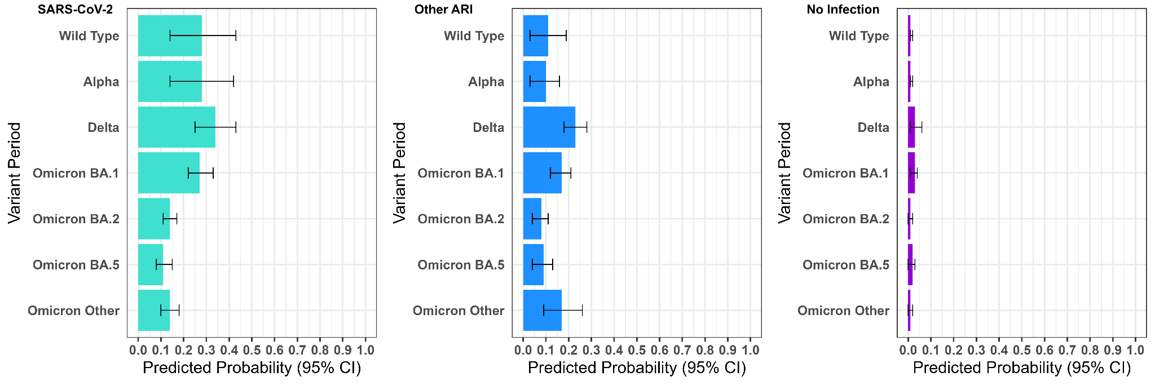

Supplementary Figure S4. Predicted Probability of New-Onset Long-Term Symptoms by Variant Period and Infection Status: Sensitivity analysis excluding body mass index (BMI) from adjusted models (n=5,630)

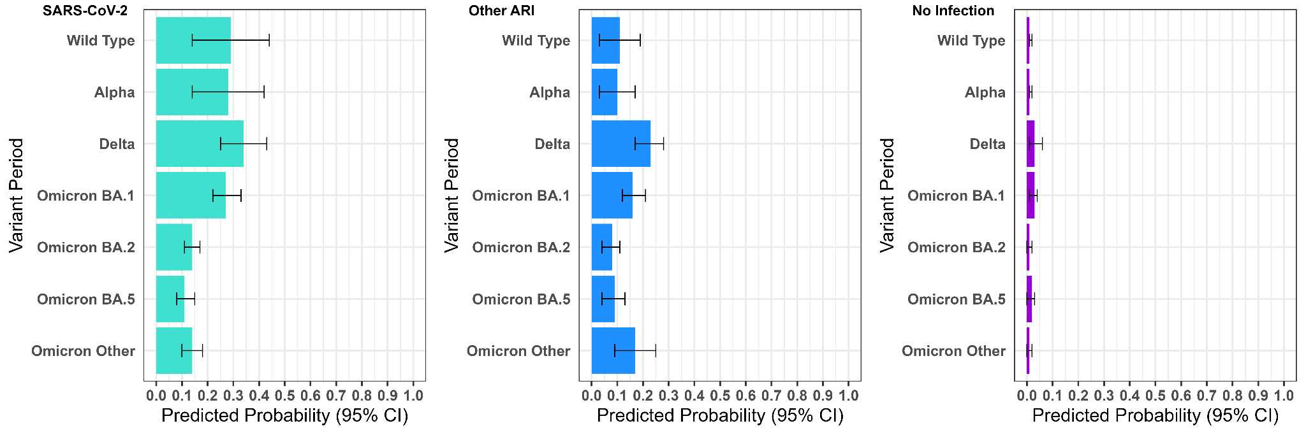

Supplementary Figure S5. Predicted Probability of New-Onset Long-Term Symptoms by Variant Period and Infection Status: Sensitivity analysis including only serological sub-cohort (n=4381)

