Supplementary materials (Supplementary Table 1-7, Supplementary Figure 1-4)
Journal: Epidemiology and Infection
Title: Temporal trend analysis of acute hepatitis B virus infection in China, 1990-2019
Authors: Ying Han, Yuansheng Li, Shuyuan Wang, Jialu Chen, Junhui Zhang*

Supplementary Tables 1-7
Supplementary Table 1. Annual percentage change (APC) for the age-specific crude incidence rate (CIR) of acute hepatitis B virus (AHBV) infections in Chinese males based on joinpoint regression models, 1990-2019
age-group  (year) | Trend 1 |  | Trend 2 |  | Trend 3 |  | Trend 4 |  | Trend 5 |  | Trend 6
 | Duration | APC (95% CI), % | Duration | APC (95% CI), % | Duration | APC (95% CI), % | Duration | APC (95% CI), % | Duration | APC (95% CI), % | Duration | APC (95% CI), %
0-4 | 1990-1995 | -3.36* (-4.28, -2.43) | 1995-1999 | 5.33* (3.09, 7.61) | 1999-2002 | -8.65* (-12.49, -4.64) | 2002-2005 | -43.87* (-46.23, -41.40) | 2005-2009 | -17.67* (-19.42, -15.88) | 2009-2019 | -0.74* (-1.07, -0.40)
5-9 | 1990-2004 | -0.15 (-0.49, 0.19) | 2004-2007 | -12.84* (-19.02, -6.20) | 2007-2010 | -40.25* (-44.48, -35.69) | 2010-2014 | -14.92* (-17.99, -11.73) | 2014-2019 | -3.36* (-4.94, -1.76) | NA | NA
10-14 | 1990-2011 | -0.95* (-1.15, -0.75) | 2011-2015 | -35.10* (-37.57, -32.54) | 2015-2019 | -15.29* (-17.34, -13.19) | NA | NA | NA | NA | NA | NA
15-19 | 1990-2015 | -1.20* (-1.44, -0.96) | 2015-2019 | -33.93* (-36.46, -31.29) | NA | NA | NA | NA | NA | NA | NA | NA
20-24 | 1990-1994 | -0.90* (-1.01, -0.79) | 1994-2000 | -0.18* (-0.26, -0.10) | 2000-2005 | -2.58* (-2.69, -2.47) | 2005-2010 | -1.74* (-1.85, -1.63) | 2010-2017 | -0.66* (-0.72, -0.60) | 2017-2019 | -1.25* (-1.59, -0.90)
25-29 | 1990-1998 | -0.45* (-0.49, -0.42) | 1998-2001 | -1.20* (-1.55, -0.84) | 2001-2005 | -2.23* (-2.41, -2.06) | 2005-2010 | -0.96* (-1.07, -0.85) | 2010-2015 | -2.19* (-2.30, -2.08) | 2015-2019 | -0.56* (-0.67, -0.44)
30-34 | 1990-1999 | -0.53* (-0.57, -0.49) | 1999-2006 | -1.15* (-1.22, -1.08) | 2006-2014 | -1.87* (-1.92, -1.81) | 2014-2017 | -0.65* (-1.06, -0.25) | 2017-2019 | -2.85* (-3.24, -2.46) | NA | NA
35-39 | 1990-1997 | -0.75* (-0.79, -0.70) | 1997-2004 | -1.15* (-1.21, -1.10) | 2004-2009 | -1.76* (-1.87, -1.66) | 2009-2014 | -1.47* (-1.58, -1.37) | 2014-2017 | -1.05* (-1.38, -0.72) | 2017-2019 | -2.25* (-2.57, -1.92)
40-44 | 1990-1995 | -0.31* (-0.40, -0.22) | 1995-2000 | -1.41* (-1.54, -1.28) | 2000-2010 | -1.08* (-1.12, -1.04) | 2010-2019 | -1.79* (-1.83, -1.75) | NA | NA | NA | NA
45-49 | 1990-1996 | -0.48* (-0.56, -0.40) | 1996-2005 | -1.50* (-1.56, -1.45) | 2005-2011 | -0.97* (-1.08, -0.85) | 2011-2014 | -1.62* (-2.11, -1.12) | 2014-2017 | -2.19* (-2.68, -1.69) | 2017-2019 | -1.07* (-1.56, -0.57)
50-54 | 1990-1995 | -0.09 (-0.32, 0.14) | 1995-2007 | -1.24* (-1.31, -1.17) | 2007-2014 | -2.18* (-2.35, -2.01) | 2014-2019 | -0.53* (-0.76, -0.30) | NA | NA | NA | NA
55-59 | 1990-1996 | -0.22* (-0.30, -0.15) | 1996-2005 | -1.03* (-1.07, -0.98) | 2005-2010 | -1.50* (-1.64, -1.37) | 2010-2016 | -2.18* (-2.28, -2.08) | 2016-2019 | -0.80* (-1.02, -0.58) | NA | NA
60-64 | 1990-1995 | -0.18* (-0.33, -0.03) | 1995-1999 | -1.34* (-1.67, -1.01) | 1999-2007 | -0.58* (-0.67, -0.49) | 2007-2011 | -1.18* (-1.51, -0.85) | 2011-2014 | -3.53* (-4.17, -2.89) | 2014-2019 | -1.33* (-1.48, -1.19)
65-69 | 1990-1995 | 0.21* (0.05, 0.38) | 1995-2000 | -1.41* (-1.63, -1.18) | 2000-2007 | -0.39* (-0.52, -0.27) | 2007-2010 | -1.13* (-1.85, -0.41) | 2010-2016 | -2.76* (-2.92, -2.60) | 2016-2019 | -0.45* (-0.81, -0.09)
70-74 | 1990-1995 | 0.43* (0.16, 0.70) | 1995-2000 | -1.84* (-2.22, -1.46) | 2000-2006 | -0.12 (-0.39, 0.15) | 2006-2011 | -1.18* (-1.56, -0.79) | 2011-2014 | -2.89* (-4.07, -1.70) | 2014-2019 | -1.38* (-1.65, -1.11)
75-79 | 1990-1995 | 0.34* (0.23, 0.45) | 1995-2000 | -1.57* (-1.73, -1.42) | 2000-2006 | 0.29* (0.17, 0.40) | 2006-2011 | -0.98* (-1.14, -0.82) | 2011-2015 | -3.40* (-3.64, -3.15) | 2015-2019 | -1.49* (-1.64, -1.33)
80-84 | 1990-1995 | 0.85* (0.72, 0.98) | 1995-2000 | -1.35* (-1.52, -1.17) | 2000-2006 | 0.10 (-0.03, 0.23) | 2006-2011 | -0.90* (-1.08, -0.72) | 2011-2015 | -3.69* (-3.97, -3.42) | 2015-2019 | -1.53* (-1.71, -1.35)
Notes: APC stands for annual percentage change; *Indicates that APC is significantly different from zero at a significance level of 0.05; NA stands for not applicable.

Supplementary Table 2. Annual percentage change (APC) for the age-specific crude incidence rate (CIR) of acute hepatitis B virus (AHBV) infections in Chinese females based on joinpoint regression models, 1990-2019
age-group  (year) | Trend 1 |  | Trend 2 |  | Trend 3 |  | Trend 4 |  | Trend 5 |  |  | Trend 6
 | Duration | APC (95% CI), % | Duration | APC (95% CI), % | Duration | APC (95% CI), % | Duration | APC (95% CI), % | Duration | APC (95% CI), % |  | Duration | APC (95% CI), %
0-4 | 1990-1995 | -2.36* (-3.28, -1.43) | 1995-1999 | 4.61* (2.42, 6.85) | 1999-2002 | -8.84* (-12.62, -4.89) | 2002-2005 | -44.04* (-46.36, -41.61) | 2005-2009 | -16.40* (-18.16, -14.61) |  | 2009-2019 | -1.50* (-1.83, -1.18)
5-9 | 1990-2004 | 0.03 (-0.33, 0.38) | 2004-2007 | -13.28* (-19.56, -6.49) | 2007-2010 | -39.40* (-43.80, -34.67) | 2010-2014 | -14.58* (-17.74, -11.30) | 2014-2019 | -4.99* (-6.57, -3.37) |  | NA | NA
10-14 | 1990-2009 | -0.91* (-1.14, -0.68) | 2009-2012 | -9.85* (-16.59, -2.56) | 2012-2015 | -39.24* (-43.78, -34.33) | 2015-2019 | -14.90* (-16.97, -12.78) | NA | NA |  | NA | NA
15-19 | 1990-2015 | -1.27* (-1.52, -1.02) | 2015-2019 | -34.52* (-37.13, -31.81) | NA | NA | NA | NA | NA | NA |  | NA | NA
20-24 | 1990-1996 | -0.02 (-0.11, 0.07) | 1996-2000 | -1.01* (-1.27, -0.75) | 2000-2004 | -2.08* (-2.34, -1.82) | 2004-2011 | -1.51* (-1.59, -1.42) | 2011-2014 | -1.85* (-2.37, -1.33) |  | 2014-2019 | -1.12* (-1.24, -1.01)
25-29 | 1990-1995 | -0.52* (-0.59, -0.45) | 1995-2000 | -0.22* (-0.32, -0.12) | 2000-2005 | -2.59* (-2.69, -2.50) | 2005-2011 | -1.11* (-1.18, -1.05) | 2011-2014 | -2.30* (-2.60, -2.00) |  | 2014-2019 | -1.93* (-2.00, -1.86)
30-34 | 1990-1996 | 0.12 (-0.03, 0.27) | 1996-2001 | -1.11* (-1.38, -0.83) | 2001-2004 | -2.08* (-2.94, -1.21) | 2004-2010 | -1.46* (-1.66, -1.27) | 2010-2019 | -2.17* (-2.25, -2.09) |  | NA | NA
35-39 | 1990-1992 | 0.93* (0.38, 1.49) | 1992-1996 | 0.01 (-0.27, 0.28) | 1996-2011 | -1.59* (-1.62, -1.57) | 2011-2016 | -2.55* (-2.72, -2.38) | 2016-2019 | -2.03* (-2.30, -1.76) |  | NA | NA
40-44 | 1990-1995 | 0.02 (-0.11, 0.15) | 1995-2003 | -1.59* (-1.67, -1.52) | 2003-2010 | -1.24* (-1.34, -1.15) | 2010-2014 | -2.90* (-3.18, -2.63) | 2014-2017 | -1.26* (-1.82, -0.70) |  | 2017-2019 | -2.77* (-3.32, -2.21)
45-49 | 1990-1997 | -0.63* (-0.67, -0.60) | 1997-2001 | -1.22* (-1.36, -1.09) | 2001-2004 | -2.34* (-2.61, -2.07) | 2004-2011 | -1.30* (-1.35, -1.26) | 2011-2017 | -2.53* (-2.59, -2.47) |  | 2017-2019 | -3.48* (-3.74, -3.21)
50-54 | 1990-1995 | 0.95* (0.58, 1.32) | 1995-2000 | -2.76* (-3.26, -2.26) | 2000-2009 | -1.07* (-1.24, -0.89) | 2009-2014 | -3.43* (-3.92, -2.93) | 2014-2017 | -1.05 (-2.65, 0.58) |  | 2017-2019 | -4.25* (-5.80, -2.67)
55-59 | 1990-1995 | 1.05* (0.81, 1.30) | 1995-2000 | -2.89* (-3.23, -2.56) | 2000-2006 | -0.86* (-1.10, -0.62) | 2006-2011 | -2.07* (-2.40, -1.73) | 2011-2014 | -3.95* (-4.99, -2.89) |  | 2014-2019 | -2.35* (-2.59, -2.11)
60-64 | 1990-1995 | 0.76* (0.60, 0.93) | 1995-2000 | -2.36* (-2.58, -2.13) | 2000-2006 | -0.45* (-0.61, -0.28) | 2006-2011 | -1.94* (-2.16, -1.71) | 2011-2015 | -4.12* (-4.48, -3.77) |  | 2015-2019 | -2.31* (-2.54, -2.09)
65-69 | 1990-1995 | 0.32* (0.05, 0.60) | 1995-2000 | -2.47* (-2.85, -2.09) | 2000-2007 | -0.46* (-0.67, -0.25) | 2007-2011 | -2.03* (-2.63, -1.42) | 2011-2014 | -4.36* (-5.54, -3.17) |  | 2014-2019 | -3.04* (-3.30, -2.77)
70-74 | 1990-1995 | 0.92* (0.50, 1.34) | 1995-2000 | -3.19* (-3.77, -2.61) | 2000-2006 | -0.05 (-0.47, 0.37) | 2006-2011 | -1.52* (-2.11, -0.94) | 2011-2014 | -4.66* (-6.44, -2.85) |  | 2014-2019 | -3.07* (-3.48, -2.66)
75-79 | 1990-1995 | 1.00* (0.46, 1.54) | 1995-2000 | -3.30* (-4.03, -2.57) | 2000-2006 | -0.10 (-0.63, 0.44) | 2006-2010 | -1.26* (-2.43, -0.07) | 2010-2019 | -3.57* (-3.78, -3.36) | NA |  | NA
80-84 | 1990-1995 | 1.05* (0.35, 1.75) | 1995-2000 | -3.02* (-3.96, -2.06) | 2000-2006 | 0.27 (-0.43, 0.96) | 2006-2011 | -2.06* (-3.02, -1.10) | 2011-2014 | -5.18* (-8.07, -2.20) | 2014-2019 |  | -2.89* (-3.56, -2.22)
Notes: APC stands for annual percentage change; *Indicates that APC is significantly different from zero at a significance level of 0.05; NA stands for not applicable.

Supplementary Table 3. Annual percentage change (APC) for the age-specific crude incidence rate (CIR) of acute hepatitis B virus (AHBV) infections for both genders in China based on joinpoint regression models, 1990-2019
age-group  (year) | Trend 1 |  | Trend 2 |  | Trend 3 |  | Trend 4 |  | Trend 5 |  | Trend 6
 | Duration | APC (95% CI), % | Duration | APC (95% CI), % | Duration | APC (95% CI), % | Duration | APC (95% CI), % | Duration | APC (95% CI), % | Duration | APC (95% CI), %
0-4 | 1990-1995 | -2.93* (-3.77, -2.09) | 1995-1999 | 5.08* (3.07, 7.14) | 1999-2002 | -8.70* (-12.17, -5.10) | 2002-2005 | -43.92* (-46.04, -41.70) | 2005-2009 | -17.17* (-18.76, -15.55) | 2009-2019 | -1.06* (-1.35, -0.76)
5-9 | 1990-2004 | -0.03 (-0.38, 0.32) | 2004-2007 | -13.00* (-19.23, -6.29) | 2007-2010 | -39.92* (-44.23, -35.29) | 2010-2014 | -14.78* (-17.89, -11.55) | 2014-2019 | -4.00* (-5.58, -2.39) | NA | NA
10-14 | 1990-2011 | -0.93* (-1.13, -0.73) | 2011-2015 | -35.05* (-37.53, -32.47) | 2015-2019 | -15.62* (-17.67, -13.51) | NA | NA | NA | NA | NA | NA
15-19 | 1990-2015 | -1.20* (-1.44, -0.96) | 2015-2019 | -34.06* (-36.61, -31.41) | NA | NA | NA | NA | NA | NA | NA | NA
20-24 | 1990-2000 | -0.47* (-0.48, -0.45) | 2000-2004 | -2.50* (-2.62, -2.39) | 2004-2009 | -1.78* (-1.85, -1.70) | 2009-2014 | -1.13* (-1.20, -1.05) | 2014-2017 | -0.56* (-0.79, -0.33) | 2017-2019 | -1.22* (-1.45, -0.99)
25-29 | 1990-1997 | -0.37* (-0.41, -0.33) | 1997-2000 | -0.75* (-1.06, -0.44) | 2000-2005 | -2.34* (-2.44, -2.25) | 2005-2011 | -1.12* (-1.19, -1.05) | 2011-2015 | -2.33* (-2.49, -2.18) | 2015-2019 | -0.93* (-1.03, -0.84)
30-34 | 1990-1996 | -0.29* (-0.34, -0.24) | 1996-2001 | -0.91* (-1.00, -0.82) | 2001-2010 | -1.56* (-1.59, -1.53) | 2010-2014 | -2.13* (-2.27, -1.99) | 2014-2017 | -1.06* (-1.34, -0.77) | 2017-2019 | -2.79* (-3.07, -2.51)
35-39 | 1990-1996 | -0.32* (-0.40, -0.24) | 1996-2005 | -1.39* (-1.44, -1.34) | 2005-2017 | -1.70* (-1.73, -1.67) | 2017-2019 | -2.07* (-2.54, -1.61) | NA | NA | NA | NA
40-44 | 1990-1995 | -0.29* (-0.40, -0.18) | 1995-2003 | -1.39* (-1.46, -1.33) | 2003-2011 | -1.21* (-1.28, -1.15) | 2011-2014 | -2.47* (-2.95, -1.99) | 2014-2017 | -1.57* (-2.05, -1.08) | 2017-2019 | -2.07* (-2.55, -1.59)
45-49 | 1990-1992 | -0.32 (-0.65, 0.01) | 1992-1996 | -0.66* (-0.83, -0.50) | 1996-2001 | -1.38* (-1.48, -1.27) | 2001-2004 | -1.87* (-2.20, -1.55) | 2004-2011 | -1.16* (-1.22, -1.11) | 2011-2019 | -2.09* (-2.12, -2.05)
50-54 | 1990-1995 | 0.29* (0.06, 0.52) | 1995-1999 | -2.04* (-2.53, -1.54) | 1999-2008 | -1.24* (-1.35, -1.13) | 2008-2014 | -2.61* (-2.83, -2.39) | 2014-2017 | -0.72 (-1.73, 0.29) | 2017-2019 | -2.15* (-3.14, -1.15)
55-59 | 1990-1995 | 0.32* (0.23, 0.42) | 1995-2000 | -1.68* (-1.81, -1.56) | 2000-2006 | -1.07* (-1.16, -0.98) | 2006-2011 | -1.88* (-2.00, -1.75) | 2011-2015 | -2.78* (-2.97, -2.58) | 2015-2019 | -1.56* (-1.69, -1.44)
60-64 | 1990-1995 | 0.21* (0.07, 0.34) | 1995-1999 | -1.77* (-2.07, -1.47) | 1999-2007 | -0.67* (-0.75, -0.59) | 2007-2011 | -1.63* (-1.94, -1.33) | 2011-2015 | -3.57* (-3.87, -3.27) | 2015-2019 | -1.47* (-1.66, -1.27)
65-69 | 1990-1995 | 0.36* (0.23, 0.48) | 1995-2000 | -1.80* (-1.97, -1.63) | 2000-2006 | -0.32* (-0.44, -0.20) | 2006-2010 | -1.20* (-1.47, -0.93) | 2010-2015 | -3.34* (-3.51, -3.18) | 2015-2019 | -1.81* (-1.98, -1.64)
70-74 | 1990-1995 | 0.73* (0.41, 1.05) | 1995-2000 | -2.27* (-2.71, -1.83) | 2000-2006 | -0.04 (-0.35, 0.28) | 2006-2011 | -1.25* (-1.69, -0.81) | 2011-2014 | -3.63* (-4.98, -2.26) | 2014-2019 | -2.09* (-2.40, -1.78)
75-79 | 1990-1995 | 0.71* (0.50, 0.92) | 1995-2000 | -2.23* (-2.51, -1.94) | 2000-2006 | 0.28* (0.08, 0.49) | 2006-2011 | -1.08* (-1.36, -0.79) | 2011-2014 | -3.90* (-4.78, -3.00) | 2014-2019 | -2.38* (-2.58, -2.18)
80-84 | 1990-1995 | 1.03* (0.80, 1.27) | 1995-2000 | -2.17* (-2.49, -1.84) | 2000-2006 | 0.34* (0.10, 0.58) | 2006-2011 | -1.23* (-1.56, -0.90) | 2011-2014 | -4.45* (-5.45, -3.44) | 2014-2019 | -2.23* (-2.46, -2.00)
Notes: APC stands for annual percentage change; *Indicates that APC is significantly different from zero at a significance level of 0.05; NA stands for not applicable.

Supplementary Table 4. Relative risks (RR) for the age effects, period effects, and cohort effects on the crude incidence rate (CIR) of acute hepatitis B virus (AHBV) infections in China, stratified by gender
Factor | China
 | Male | Female | Both
 | RR (LCI, UCI) | RR (LCI, UCI) | RR (LCI, UCI)
Age (year)
0-4 | 0.49 (0.48, 0.51) | 0.54 (0.52, 0.56) | 0.52 (0.50, 0.53)
5-9 | 0.50 (0.49, 0.52) | 0.54 (0.52, 0.55) | 0.52 (0.50, 0.53)
10-14 | 0.68 (0.66, 0.70) | 0.70 (0.68, 0.72) | 0.69 (0.67, 0.71)
15-19 | 0.86 (0.83, 0.89) | 0.87 (0.85, 0.90) | 0.87 (0.84, 0.90)
20-24 | 1.18 (1.15, 1.22) | 1.17 (1.13, 1.21) | 1.18 (1.15, 1.22)
25-29 | 1.37 (1.33, 1.41) | 1.35 (1.31, 1.40) | 1.37 (1.33, 1.41)
30-34 | 1.36 (1.32, 1.41) | 1.37 (1.33, 1.42) | 1.37 (1.33, 1.41)
35-39 | 1.36 (1.31, 1.40) | 1.37 (1.32, 1.41) | 1.37 (1.33, 1.41)
40-44 | 1.33 (1.29, 1.37) | 1.33 (1.28, 1.37) | 1.34 (1.29, 1.38)
45-49 | 1.25 (1.21, 1.29) | 1.28 (1.24, 1.32) | 1.27 (1.23, 1.31)
50-54 | 1.18 (1.15, 1.22) | 1.19 (1.15, 1.23) | 1.19 (1.15, 1.23)
55-59 | 1.10 (1.07, 1.14) | 1.10 (1.07, 1.14) | 1.11 (1.07, 1.14)
60-64 | 1.05 (1.02, 1.09) | 1.04 (1.01, 1.07) | 1.05 (1.02, 1.08)
65-69 | 1.03 (1.00, 1.06) | 1.01 (0.98, 1.04) | 1.02 (0.99, 1.05)
70-74 | 1.02 (0.99, 1.05) | 0.98 (0.95, 1.01) | 1.00 (0.97, 1.03)
75-79 | 1.00 (0.96, 1.03) | 0.94 (0.91, 0.97) | 0.95 (0.92, 0.98)
80-84 | 0.97 (0.94, 1.00) | 0.89 (0.86, 0.92) | 0.90 (0.87, 0.93)
Period (year)
1990-1994 | 1.27 (1.25, 1.29) | 1.31 (1.29, 1.33) | 1.29 (1.27, 1.31)
1995-1999 | 1.18 (1.16, 1.20) | 1.22 (1.20, 1.24) | 1.20 (1.18, 1.22)
2000-2004 | 1.08 (1.06, 1.10) | 1.10 (1.08, 1.12) | 1.09 (1.07, 1.11)
2005-2009 | 0.96 (0.95, 0.98) | 0.97 (0.95, 0.98) | 0.96 (0.95, 0.98)
2010-2014 | 0.86 (0.84, 0.87) | 0.84 (0.83, 0.86) | 0.85 (0.84, 0.86)
2015-2019 | 0.75 (0.74, 0.76) | 0.70 (0.69, 0.71) | 0.73 (0.72, 0.74)
Cohort (year)
1910-1914 | 0.83 (0.78, 0.90) | 0.89 (0.82, 0.95) | 0.85 (0.79, 0.91)
1915-1919 | 0.89 (0.85, 0.94) | 0.92 (0.88, 0.97) | 0.89 (0.85, 0.94)
1920-2024 | 0.95 (0.91, 0.99) | 0.96 (0.92, 1.00) | 0.94 (0.90, 0.98)
1925-1929 | 1.01 (0.98, 1.05) | 1.00 (0.97, 1.04) | 1.01 (0.97, 1.04)
1930-1934 | 1.07 (1.04, 1.11) | 1.04 (1.01, 1.08) | 1.06 (1.03, 1.10)
1935-1940 | 1.12 (1.08, 1.15) | 1.09 (1.05, 1.12) | 1.11 (1.08, 1.14)
1940-1944 | 1.18 (1.14, 1.22) | 1.14 (1.10, 1.17) | 1.17 (1.13, 1.21)
1945-1949 | 1.24 (1.20, 1.28) | 1.17 (1.13, 1.21) | 1.22 (1.18, 1.26)
1950-1955 | 1.29 (1.24, 1.33) | 1.21 (1.17, 1.25) | 1.26 (1.21, 1.30)
1955-1959 | 1.33 (1.29, 1.38) | 1.26 (1.21, 1.30) | 1.30 (1.26, 1.35)
1960-1964 | 1.37 (1.32, 1.42) | 1.30 (1.25, 1.35) | 1.34 (1.30, 1.39)
1965-1969 | 1.45 (1.40, 1.50) | 1.37 (1.33, 1.42) | 1.42 (1.37, 1.47)
1970-1974 | 1.51 (1.46, 1.56) | 1.44 (1.39, 1.50) | 1.49 (1.44, 1.54)
1975-1979 | 1.58 (1.53, 1.64) | 1.53 (1.48, 1.59) | 1.56 (1.51, 1.61)
1980-1984 | 1.63 (1.58, 1.68) | 1.59 (1.54, 1.64) | 1.61 (1.56, 1.66)
1985-1989 | 1.67 (1.62, 1.72) | 1.67 (1.62, 1.72) | 1.67 (1.62, 1.72)
1990-1994 | 1.74 (1.69, 1.79) | 1.77 (1.71, 1.82) | 1.75 (1.70, 1.80)
1995-1999 | 1.87 (1.81, 1.93) | 1.91 (1.85, 1.98) | 1.89 (1.83, 1.95)
2000-2004 | 1.29 (1.24, 1.34) | 1.35 (1.30, 1.40) | 1.32 (1.27, 1.37)
2005-2009 | 0.26 (0.25, 0.27) | 0.28 (0.27, 0.29) | 0.27 (0.26, 0.28)
2010-2014 | 0.17 (0.16, 0.18) | 0.20 (0.19, 0.21) | 0.18 (0.17, 0.19)
2015-2019 | 0.19 (0.18, 0.21) | 0.21 (0.20, 0.23) | 0.20 (0.18, 0.22)

Supplementary Table 5. Predictions for annual age-standardized incidence rates (ASIRs) of acute hepatitis B virus (AHBV) infections in China until 2030 based on the BAPC model, stratified by gender
Year | China
 | Male | Female | Both
 | ASIR (1/100,000) | ASIR (1/100,000) | ASIR (1/100,000)
1990 | 3416.37 | 2127.04 | 2789.15
1991 | 3392.66 | 2123.39 | 2775.09
1992 | 3363.90 | 2114.68 | 2755.91
1993 | 3337.26 | 2106.07 | 2737.80
1994 | 3318.18 | 2100.41 | 2725.02
1995 | 3301.96 | 2095.06 | 2713.84
1996 | 3281.78 | 2086.25 | 2699.31
1997 | 3266.13 | 2073.95 | 2685.35
1998 | 3247.89 | 2056.19 | 2667.27
1999 | 3224.86 | 2035.89 | 2645.46
2000 | 3193.48 | 2015.19 | 2619.20
2001 | 3138.66 | 1980.07 | 2573.96
2002 | 3048.91 | 1921.41 | 2499.27
2003 | 2945.20 | 1852.58 | 2412.38
2004 | 2848.51 | 1787.85 | 2331.04
2005 | 2779.63 | 1743.30 | 2273.9
2006 | 2721.24 | 1707.78 | 2226.72
2007 | 2651.29 | 1664.15 | 2169.54
2008 | 2580.47 | 1619.06 | 2111.12
2009 | 2516.28 | 1577.02 | 2057.60
2010 | 2465.72 | 1543.22 | 2015.17
2011 | 2410.33 | 1504.02 | 1967.80
2012 | 2331.56 | 1445.99 | 1899.15
2013 | 2246.66 | 1381.71 | 1824.26
2014 | 2171.29 | 1322.96 | 1756.95
2015 | 2119.46 | 1281.69 | 1710.36
2016 | 2033.06 | 1220.90 | 1636.45
2017 | 1939.66 | 1154.84 | 1556.17
2018 | 1884.81 | 1110.68 | 1506.53
2019 | 1830.91 | 1064.04 | 1456.19
2020 | 1751.37 | 1000.41 | 1382.17
2021 | 1682.52 | 948.74 | 1321.28
2022 | 1602.89 | 892.26 | 1252.49
2023 | 1529.10 | 840.00 | 1188.74
2024 | 1467.75 | 795.46 | 1135.15
2025 | 1413.44 | 755.68 | 1087.46
2026 | 1349.40 | 712.14 | 1033.03
2027 | 1275.22 | 664.56 | 971.46
2028 | 1207.24 | 621.05 | 915.06
2029 | 1152.02 | 584.78 | 868.71
2030 | 1105.18 | 553.31 | 828.97

Supplementary Table 6. Predictions for the annual number of cases of acute Hepatitis B virus (AHBV) infections in China until 2030 based on the BAPC model, stratified by gender
year | China
 | Male | Female | Both
 | Cases (No. ×10⁵) | Cases (No. ×10⁵) | Cases (No. ×10⁵)
1990 | 208.58 | 122.98 | 331.55
1991 | 209.87 | 124.34 | 334.21
1992 | 211.07 | 125.55 | 336.61
1993 | 212.24 | 126.64 | 338.88
1994 | 213.41 | 127.66 | 341.07
1995 | 214.75 | 128.70 | 343.45
1996 | 216.08 | 129.58 | 345.66
1997 | 217.19 | 130.15 | 347.34
1998 | 217.95 | 130.43 | 348.38
1999 | 218.24 | 130.46 | 348.70
2000 | 218.14 | 130.37 | 348.52
2001 | 216.25 | 129.22 | 345.48
2002 | 212.21 | 126.65 | 338.87
2003 | 207.37 | 123.55 | 330.91
2004 | 202.90 | 120.72 | 323.62
2005 | 200.06 | 119.00 | 319.05
2006 | 197.73 | 117.68 | 315.40
2007 | 194.52 | 115.84 | 310.36
2008 | 191.02 | 113.79 | 304.81
2009 | 187.80 | 111.82 | 299.62
2010 | 185.48 | 110.28 | 295.77
2011 | 182.72 | 108.21 | 290.93
2012 | 178.43 | 104.93 | 283.36
2013 | 173.53 | 101.16 | 274.69
2014 | 169.00 | 97.63 | 266.63
2015 | 165.93 | 95.13 | 261.07
2016 | 160.98 | 91.75 | 252.72
2017 | 155.82 | 88.17 | 243.98
2018 | 152.62 | 85.34 | 237.96
2019 | 149.04 | 81.91 | 230.95
2020 | 143.41 | 77.70 | 220.70
2021 | 139.01 | 74.38 | 212.90
2022 | 134.06 | 70.83 | 204.32
2023 | 129.40 | 67.48 | 196.23
2024 | 125.37 | 64.49 | 189.12
2025 | 121.71 | 61.77 | 182.64
2026 | 117.50 | 58.90 | 175.46
2027 | 112.76 | 55.85 | 167.58
2028 | 108.38 | 53.02 | 160.30
2029 | 104.71 | 50.57 | 154.09
2030 | 101.55 | 48.40 | 148.64

Supplementary Table 7. Predictions for the number of cases of acute Hepatitis B virus (AHBV) infections in China from 2020 to 2030 based on the APC (2011-2019) trend, a pessimistic estimate of a 1% increase or an optimistic estimate of a 1% decrease annually
Year | Number of cases (No. ×10⁵)
 | Male (down 1%, up 1%) | Female (down 1%, up 1%) | Both (down 1%, up 1%)
2020 | 144.84(143.35, 146.34) | 78.67(77.85, 79.49) | 223.41(221.10, 225.73)
2021 | 140.74(137.85, 143.65) | 75.56(73.99, 77.14) | 216.10(211.65, 220.59)
2022 | 136.74(132.56, 141.01) | 72.55(70.31, 74.84) | 209.00(202.58, 215.55)
2023 | 132.85(127.46, 138.41) | 69.66(66.80, 72.60) | 202.11(193.88, 210.60)
2024 | 129.03(122.52, 135.82) | 66.85(63.45, 70.40) | 195.39(185.49, 205.70)
2025 | 125.27(117.72, 133.22) | 64.14(60.23, 68.25) | 188.81(177.39, 200.83)
2026 | 121.57(113.07, 130.62) | 61.52(57.18, 66.15) | 182.40(169.59, 196.02)
2027 | 117.93(108.55, 128.01) | 58.99(54.25, 64.08) | 176.12(162.07, 191.24)
2028 | 114.36(104.18, 125.42) | 56.55(51.47, 62.07) | 170.02(154.84, 186.52)
2029 | 110.91(100.00, 122.89) | 54.21(48.82, 60.12) | 164.14(147.93, 181.93)
2030 | 107.59(96.00, 120.43) | 51.97(46.32, 58.24) | 158.49(141.36, 177.48)

Supplementary Figures 1-4

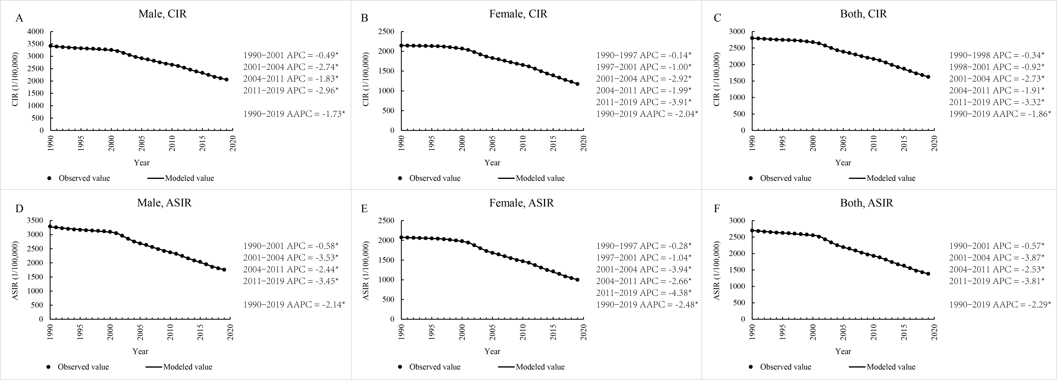
Supplementary Figure 1. Crude incidence rate (CIR) and age-standardized incidence rate (ASIR) of acute hepatitis B virus (AHBV) infections in China based on joinpoint regression models from 1990 to 2019, stratified by gender.

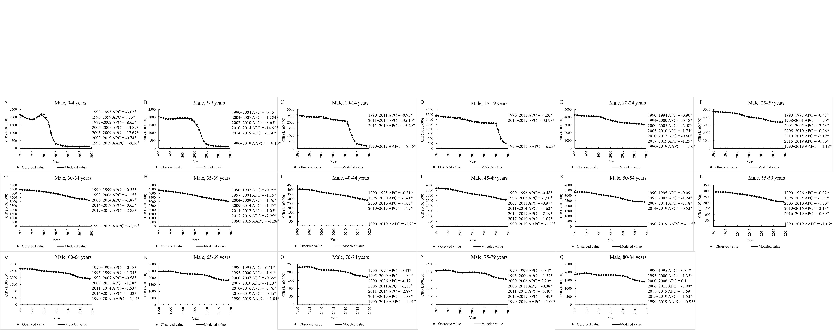
Supplementary Figure 2. Annual percentage change (APC) for the age-specific crude incidence rate (CIR) of acute Hepatitis B virus (AHBV) infection in Chinese males based on joinpoint regression models from 1990 to 2019.

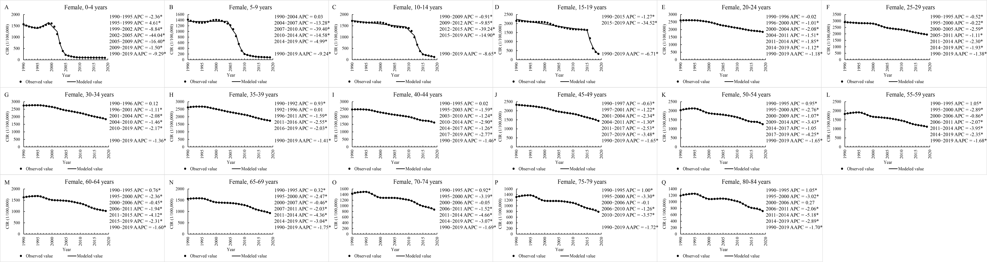

Supplementary Figure 3. Annual percentage change (APC) for the age-specific crude incidence rate (CIR) of acute Hepatitis B virus (AHBV) infection in Chinese females based on joinpoint regression models from 1990 to 2019.

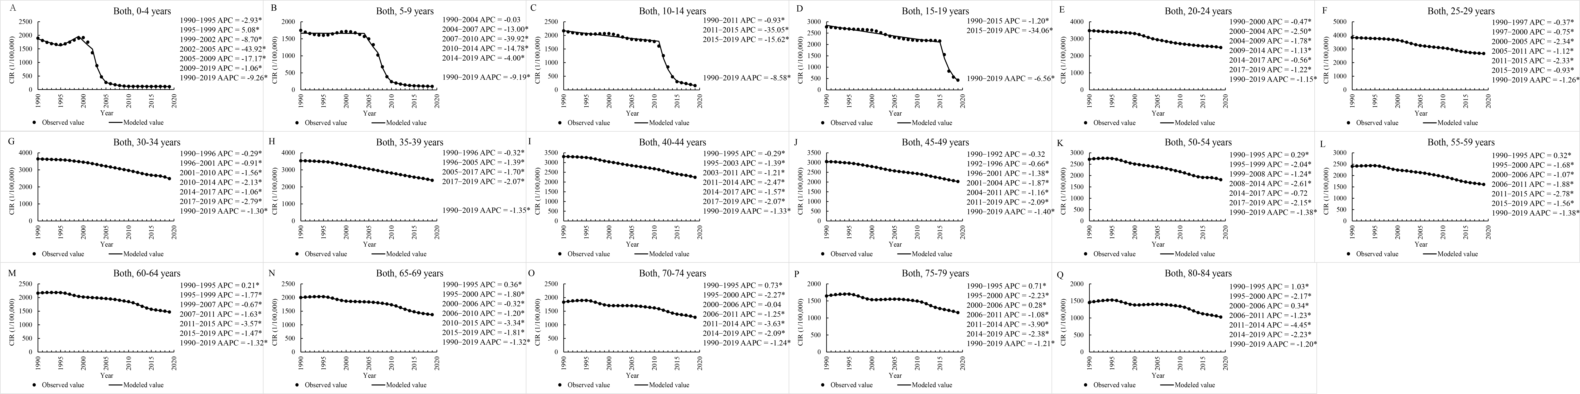
Supplementary Figure 4. Annual percentage change (APC) for the age-specific crude incidence rate (CIR) of acute Hepatitis B virus (AHBV) infection for both genders based on joinpoint regression models from 1990 to 2019.

