Supporting information
for
Environmental predictors of Escherichia coli concentration at Marine beaches in Vancouver, Canada: A Bayesian mixed-effect modelling analysis

Figure A in S1 Text 2
Figure B in S1 Text 3
Figure C in S1 Text 4
Figure D in S1 Text 5
Figure E in S1 Text 6
Figure F in S1 Text 7
Figure G in S1 Text 8
Figure H in S1 Text 9
Table A in S1 Text 19
Table B in S1 Text 19
Table C in S1 Text 20
Figure I in S1 Text 23
Figure J in S1 Text 24
Figure K in S1 Text 25
Figure L in S1 Text 26
Table D in ST Text 27
Table E in ST Text 28
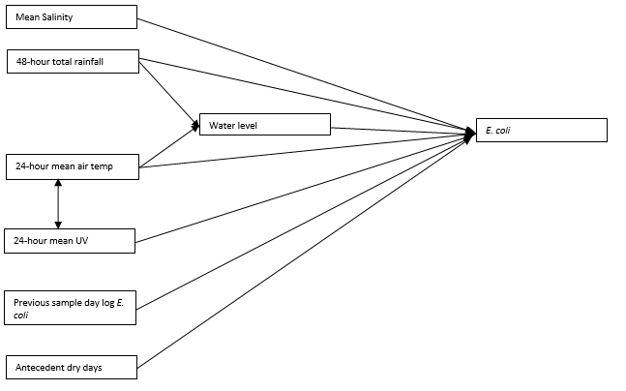
Figure A in S1 Text. Directed Acyclic Graph (DAG) of the relationship between variables affecting E. coli.

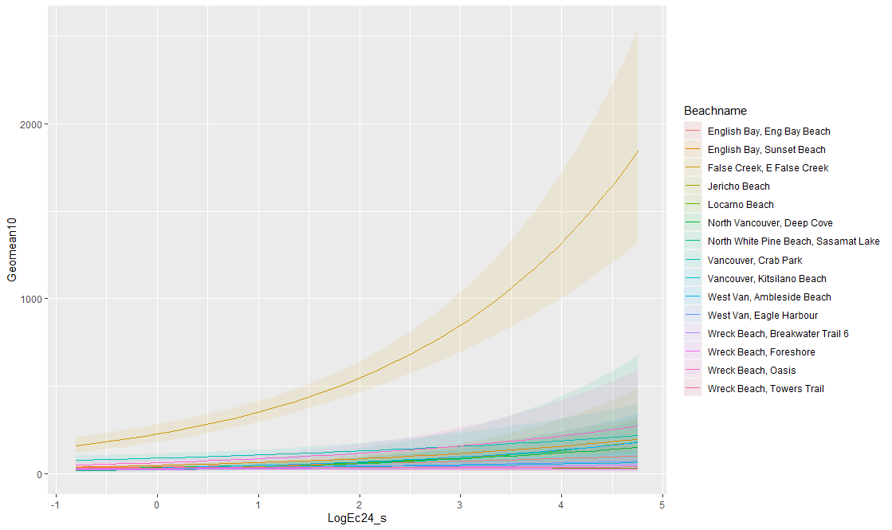
Log Previous Sample Day E. coli Geometric Mean
Predicted E. coli Geometric Mean

Figure B in S1 Text. Conditional adjusted prediction plots to check the appropriateness of varying slopes for the beach-specific average effect of the previous sample day log geometric mean of E. coli on the geometric E. coli concentration at beaches in the Metro Vancouver Region, 2013 - 2021.
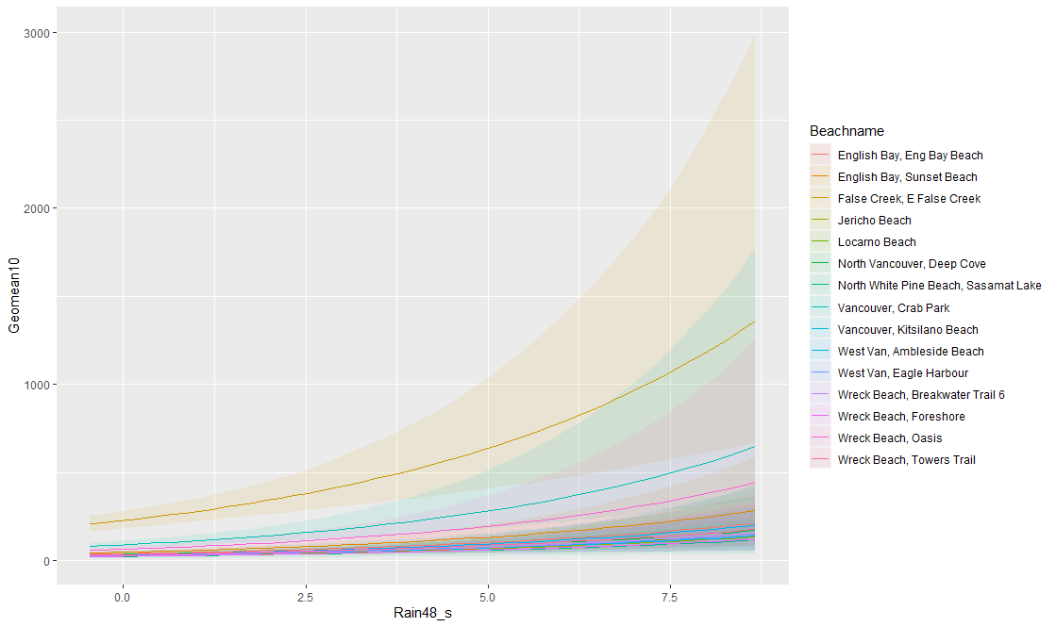
48 hr Rainfall
Predicted E. coli Geometric Mean

Figure C in S1 Text. Conditional adjusted prediction plots to check the appropriateness of varying slopes for the beach-specific average effect of 48 h rainfall on the geometric E. coli concentration at beaches in the Metro Vancouver Region, 2013 - 2021.
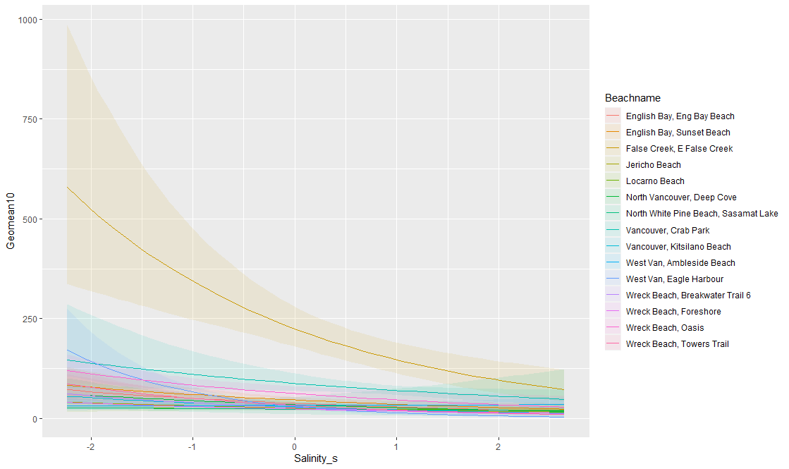
Mean Salinity
Predicted E. coli Geometric Mean
Figure D in S1 Text. Conditional adjusted prediction plots to check the appropriateness of varying slopes for the beach-specific average effect of mean salinity on the geometric E. coli concentration at beaches in the Metro Vancouver Region, 2013 - 2021.

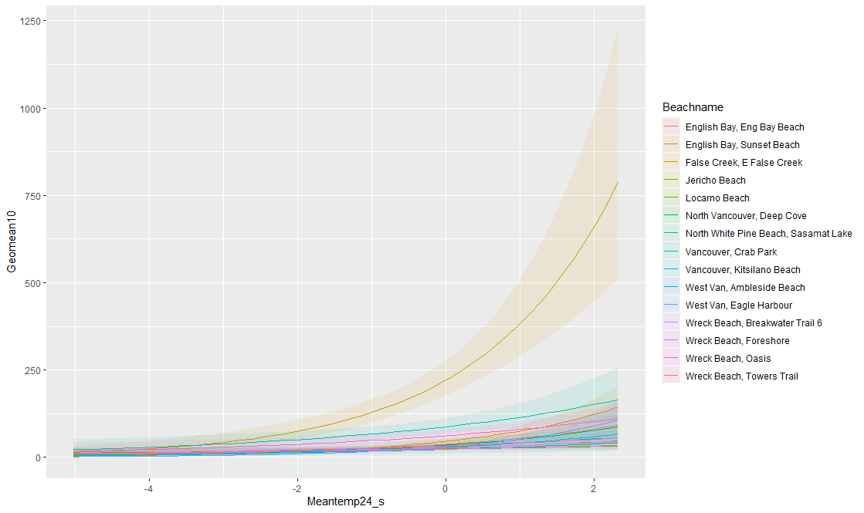
24 hr Mean Temperature
Predicted E. coli Geometric Mean
Figure E in S1 Text. Conditional adjusted prediction plots to check the appropriateness of varying slopes for the beach-specific average effect of 24 hr mean temperature on the geometric E. coli concentration at beaches in the Metro Vancouver Region, 2013 - 2021.
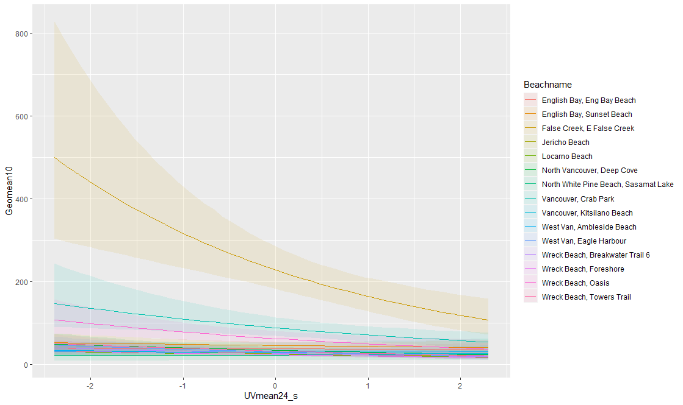
24 hr Mean UV
Predicted E. coli Geometric Mean
Figure F in S1 Text. Conditional adjusted prediction plots to check the appropriateness of varying slopes for the beach-specific average effect of 24 hr mean UV index on the geometric E. coli concentration at beaches in the Metro Vancouver Region, 2013 - 2021.
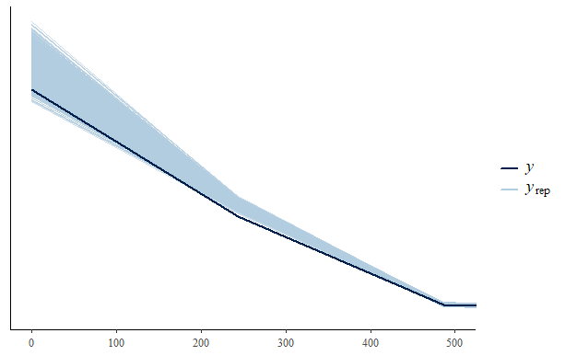
Figure G in S1 Text. Graphical posterior predictive density overlay check showing the observed E. coli values (y) and the kernel density estimate of one of the replications of y from the posterior predictive distribution in our Bayesian mixed-model effects model. (Showing most of the observed data points align with the data we generated in the modelling, indicating that our model accounted for a large proportion of observed values (y)).

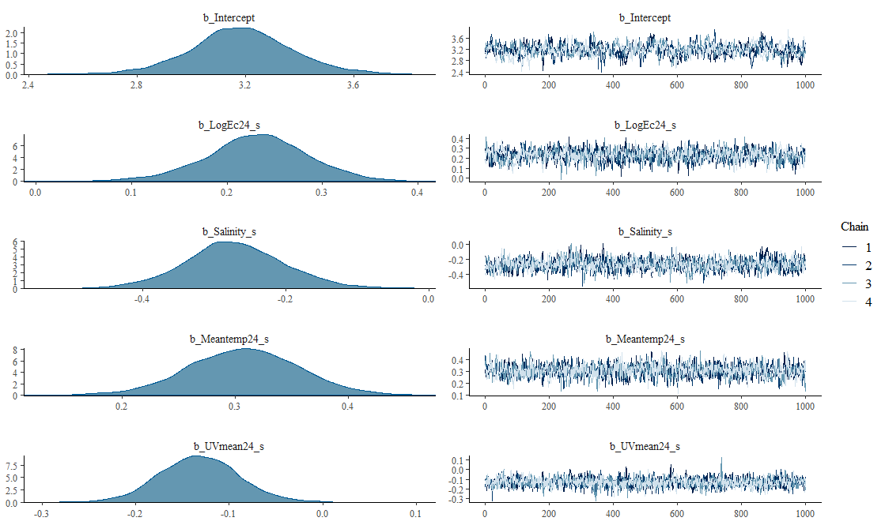

Figure H in S1 Text. Markov chain Monte Carlo (MCMC) trace plot showing convergence in the final model. (Model convergence can be detected when the chains explore the same region of each parameter value)
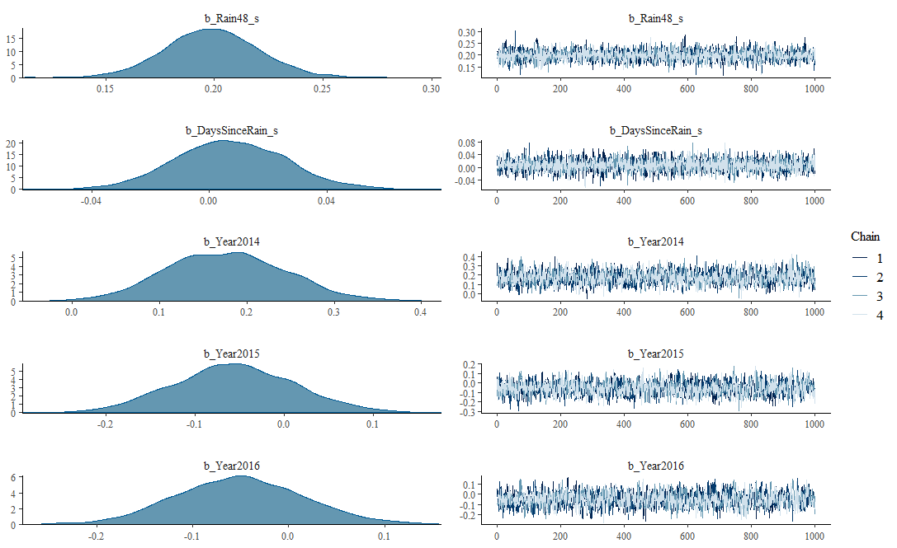
Figure H in S1 Text (continued). Markov chain Monte Carlo (MCMC) trace plot showing convergence in the final model. (Model convergence can be detected when the chains explore the same region of each parameter value)
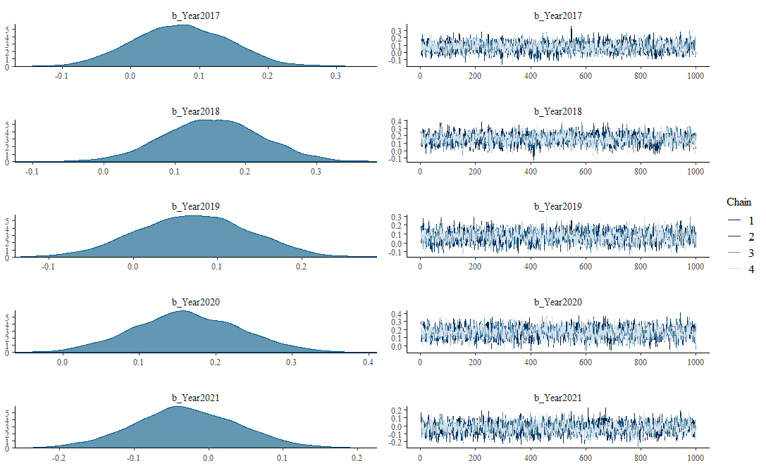
Figure H in S1 Text (continued). Markov chain Monte Carlo (MCMC) trace plot showing convergence in the final model. (Model convergence can be detected when the chains explore the same region of each parameter value)

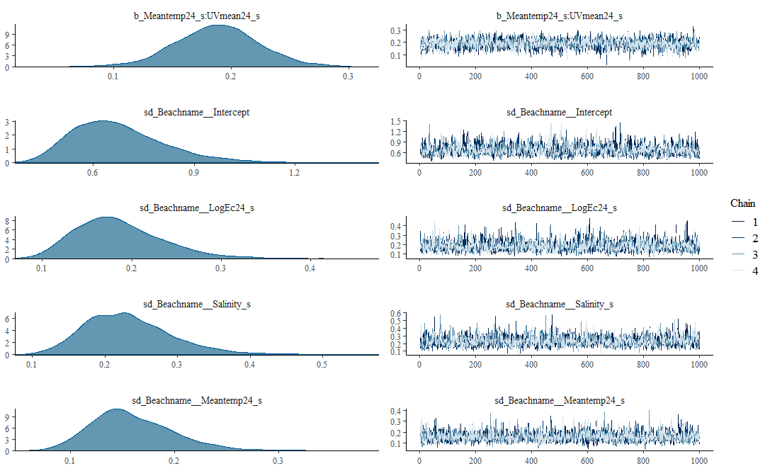
Figure H in S1 Text (continued). Markov chain Monte Carlo (MCMC) trace plot showing convergence in the final model. (Model convergence can be detected when the chains explore the same region of each parameter value)
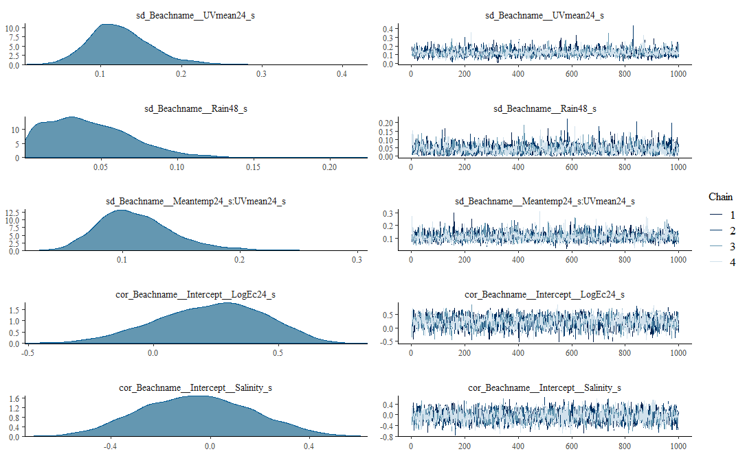
Figure H in S1 Text (continued). Markov chain Monte Carlo (MCMC) trace plot showing convergence in the final model. (Model convergence can be detected when the chains explore the same region of each parameter value)

Figure H in S1 Text (continued). Markov chain Monte Carlo (MCMC) trace plot showing convergence in the final model. (Model convergence can be detected when the chains explore the same region of each parameter value)
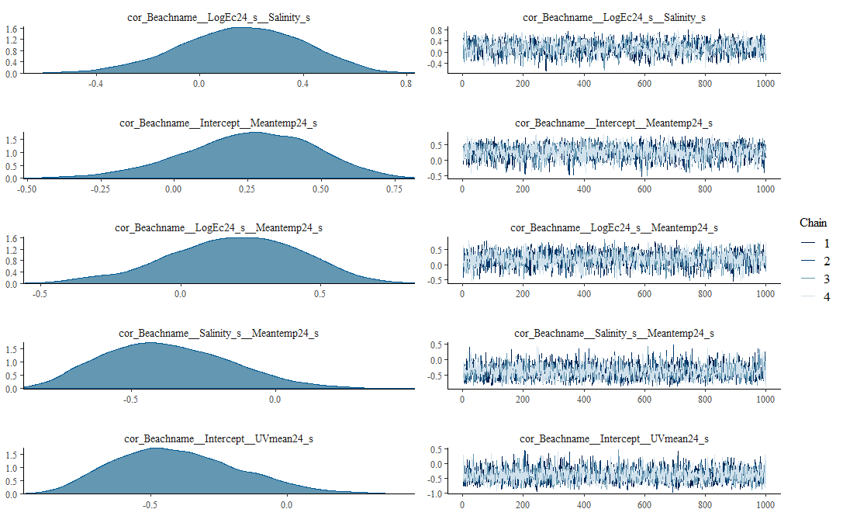
Figure H in S1 Text (continued). Markov chain Monte Carlo (MCMC) trace plot showing convergence in the final model. (Model convergence can be detected when the chains explore the same region of each parameter value)
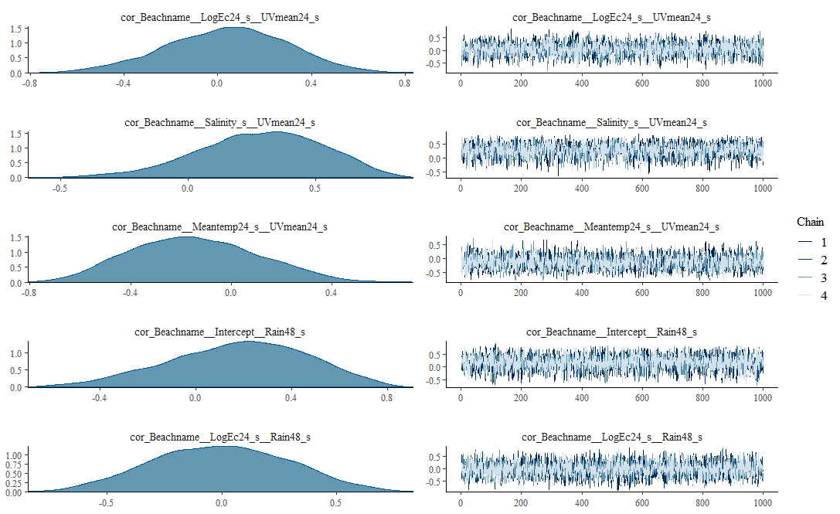
Figure H in S1 Text (continued). Markov chain Monte Carlo (MCMC) trace plot showing convergence in the final model. (Model convergence can be detected when the chains explore the same region of each parameter value)
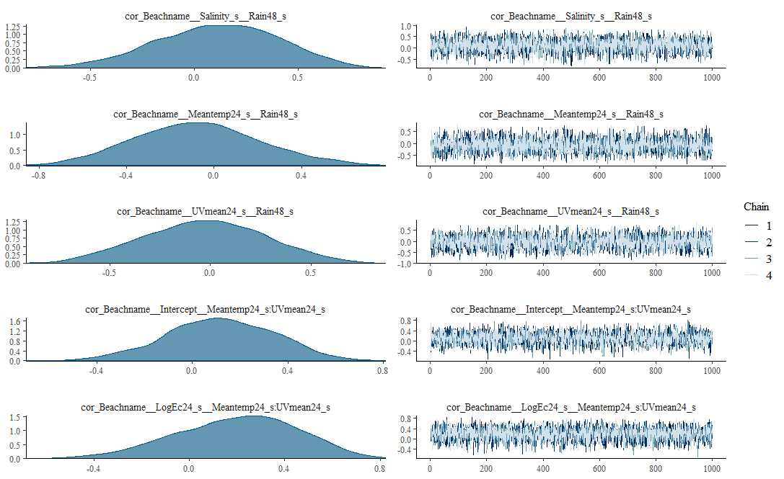
Figure H in S1 Text (continued). Markov chain Monte Carlo (MCMC) trace plot showing convergence in the final model. (Model convergence can be detected when the chains explore the same region of each parameter value)
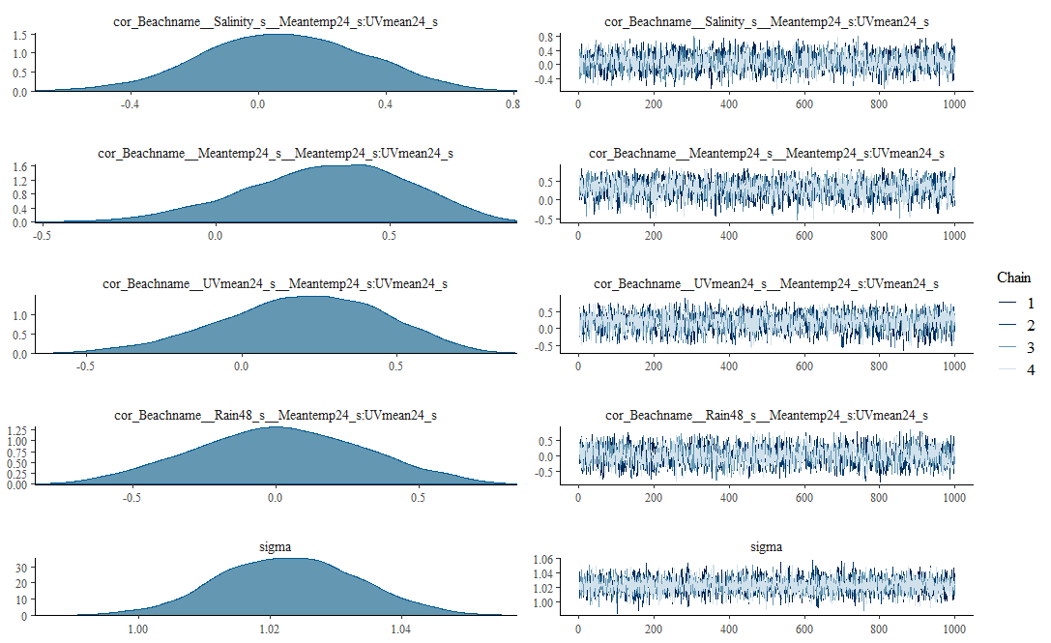
Figure H in S1 Text (continued). Markov chain Monte Carlo (MCMC) trace plot showing convergence in the final model. (Model convergence can be detected when the chains explore the same region of each parameter value)
Table A in ST Text. Showing Loo model comparison using expected log predictive density difference. The final model (top row with zero value) is better.
Model comparison | Expected log predictive density difference | Standard error difference
Model containing varying slope predictors, beach a varying effect and a two-way interaction effect | 0.0 | 0.0
Model containing beach as a varying intercept effect | -103.9 | 16.3

Table B in ST Text. Showing Loo model comparison using expected log predictive density difference. The final model (top row with zero value) is better.
Model comparison | Expected log predictive density difference | Standard error difference
Model not containing varying slope for antecedent dry days | 0.0 | 0.0
Model containing varying slope for antecedent dry days | -0.7 | 0.4

Table C in ST Text. Bayesian log-normal mixed-effects model of the relationship between environmental factors and geometric mean E. coli concentration at 15 beaches in the Metro Vancouver Region, 2013-2021 (Group-effect parameters).
Outcome/parameterª |  | Estimate^{b} | 95% credible interval | R-hat^{c} | Bulk ESS^{c} | Tail ESS^{c}
Group-level effects
SD (Intercept) |  | 0.68 | (0.46, 1.01) | 1 | 1211 | 1949
SD (Previous sample day log E. coli) |  | 0.19 | (0.11, 0.31) | 1 | 1760 | 2648
SD (48 hr total rainfall) |  | 0.23 | (0.13, 0.38) | 1 | 1546 | 2069
SD (Mean Salinity) |  | 0.16 | (0.09, 0.25) | 1 | 2650 | 2850
SD (Antecedent dry days) |  | 0.12 | (0.06, 0.21) | 1 | 2003 | 2243
SD (24 hr mean air temperature) |  | 0.04 | (0.00, 0.11) | 1 | 1449 | 1984
SD (24 hr mean UV) |  | 0.11 | (0.06, 0.19) | 1 | 2153 | 2812
SD (24 hr mean air temperature * 24 hr mean UV) |  | 0.23 | (-0.22, 0.61) | 1 | 2127 | 3141
COR (Intercept, Previous sample day log E. coli) |  | -0.05 | (-0.47, 0.37) | 1 | 2296 | 2632
COR (Intercept, Mean Salinity) |  | 0.16 | (-0.32, 0.59) | 1 | 1656 | 2557
COR (Previous sample day log E. coli, Mean Salinity) |  | 0.25 | (-0.21, 0.65) | 1 | 2565 | 2798
COR (Intercept, 24 hr mean air temperature) |  | 0.19 | (-0.31, 0.62) | 1 | 2409 | 2951
COR (Previous sample day log₁₀ E. coli, 24 hr mean air temperature) |  | -0.37 | (-0.75, 0.09) | 1 | 2747 | 3235
COR (Mean Salinity, 24 hr mean air temperature) |  | -0.40 | (-0.78, 0.08) | 1 | 3353 | 3027
COR (Intercept, 24 hr mean UV) |  | 0.04 | (-0.49, 0.53) | 1 | 3272 | 2426
COR (Previous sample day log E. coli, 24 hr mean UV) |  | 0.28 | (-0.23, 0.71) | 1 | 3145 | 3125
COR (Mean Salinity, 24 hr mean UV) |  | -0.14 | (-0.60, 0.36) | 1 | 2827 | 2555
COR (24 hr mean air temperature, 24 hr mean UV) |  | 0.18 | (-0.41, 0.69) | 1 | 4615 | 2828
COR (Intercept, 48 hr total rainfall) |  | -0.01 | (-0.57, 0.57) | 1 | 4767 | 3206
COR (Previous sample day log E. coli, 48 hr total rainfall) |  | 0.11 | (-0.49, 0.65) | 1 | 4433 | 3387
COR (Mean Salinity, 48 hr total rainfall) |  | -0.08 | (0.62, 0.52) | 1 | 4822 | 3191
COR (24 hr mean air temperature, 48 hr total rainfall) |  | -0.03 | (-0.61, 0.54) | 1 | 3942 | 3389
COR (Intercept, 24 hr mean air temperature * 24 hr mean UV) |  | 0.12 | (-0.34, 0.54) | 1 | 3137 | 2512
COR (Previous sample day log E. coli, 24 hr mean air temperature * 24 hr mean UV) |  | 0.20 | (-0.32, 0.64) | 1 | 3510 | 3155
COR (Mean Salinity, 24 hr mean air temperature * 24 hr mean UV) |  | 0.08 | (-0.42, 0.56) | 1 | 3304 | 3277
COR (24 hr mean air temperature, 24 hr mean air temperature * 24 hr mean UV) |  | 0.32 | (-0.17, 0.73) | 1 | 3022 | 2944
COR (24 hr mean UV, 24 hr mean air temperature * 24 hr mean UV) |  | 0.20 | (-0.34, 0.66) | 1 | 2982 | 3386
COR (48 hr total rainfall, 24 hr mean air temperature * 24 hr mean UV) |  | 0.01 | (-0.56, 0.59) | 1 | 2454 | 3126
Fixed effects
Year | 2013 | Ref. | Ref. | Ref. | Ref. | Ref.
 | 2014 | 0.18 | (0.05, 0.13) | 1 | 1735 | 2683
 | 2015 | -0.06 | (-0.19, 0.08) | 1 | 1629 | 2214
 | 2016 | -0.05 | (-0.18, 0.08) | 1 | 1691 | 2543
 | 2017 | 0.07 | (-0.06, 0.21) | 1 | 1718 | 2447
 | 2018 | 0.15 | (0.02, 0.29) | 1 | 1609 | 2211
 | 2019 | 0.07 | (-0.06, 0.20) | 1 | 1785 | 2579
 | 2020 | 0.16 | (0.03, 0.30) | 1 | 1924 | 2788
 | 2021 | -0.03 | (-0.17, 0.11) | 1 | 1721 | 2859

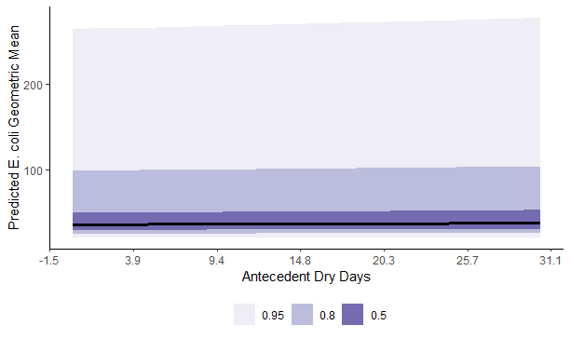
Figure I in S1 Text. Posterior predictions of the average expected value of the geometric E. coli concentration per values of antecedent dry days at beaches in the Metro Vancouver Region, 2013 - 2021.
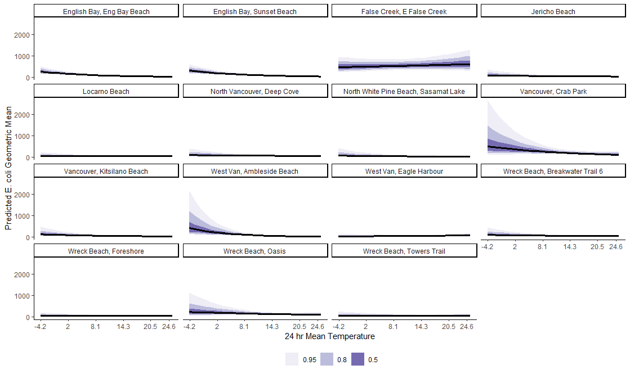
Figure J in S1 Text. Posterior predictions of the beach-specific average expected value of the geometric E. coli concentration per 24 hr mean temperature at minimum (0.01) value of 24 hr mean UV index, at beaches in the Metro Vancouver Region, 2013 - 2021.

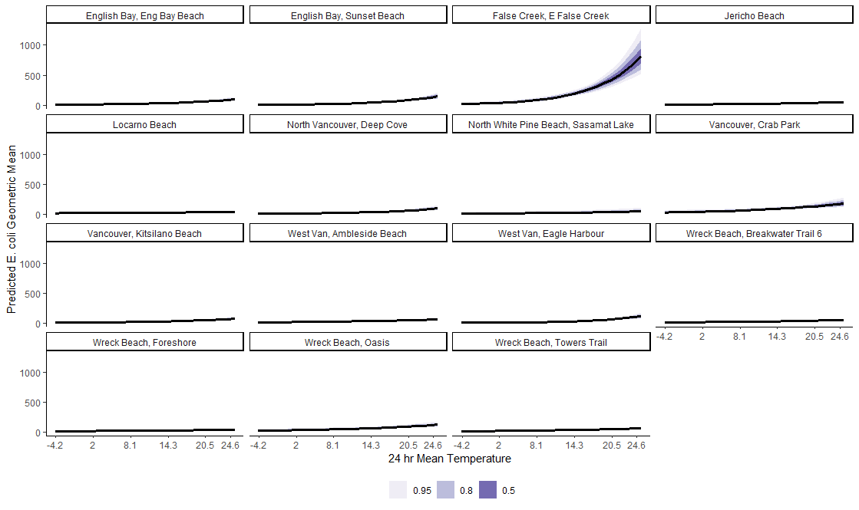
Figure K in S1 Text. Posterior predictions of the beach-specific average expected value of the geometric E. coli concentration per 24 hr mean temperature at median (1.29) value of 24 hr mean UV index, at beaches in the Metro Vancouver Region, 2013 - 2021.

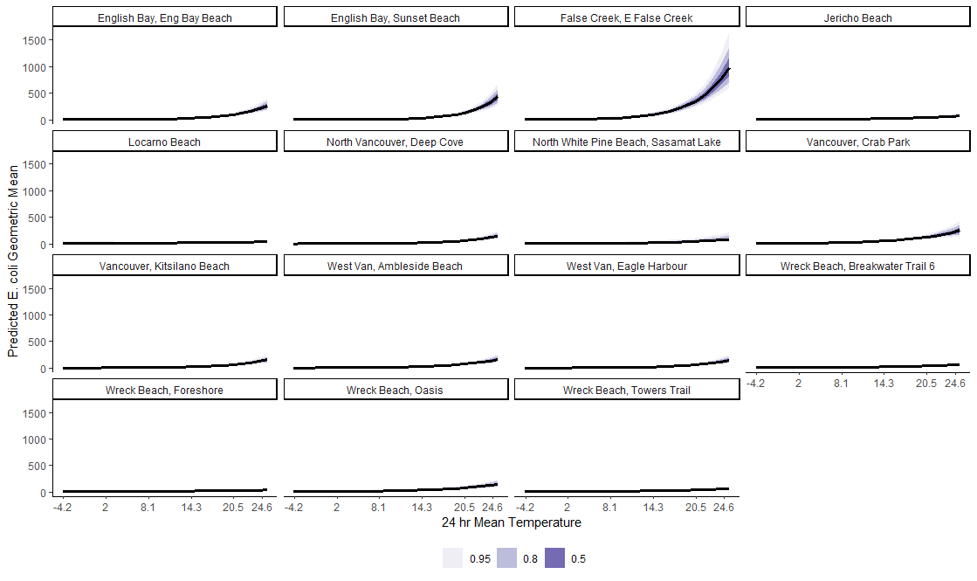
Figure L in S1 Text. Posterior predictions of the beach-specific average expected value of the geometric E. coli concentration per 24 hr mean temperature at 95th percentile (2.13) value of 24 hr mean UV index, at beaches in the Metro Vancouver Region, 2013 - 2021.

Sensitivity Analysis
Table D in ST Text. Data missingness in among the variables used in the final Bayesian log-normal mixed-effects model of the relationship between environmental factors and geometric mean E. coli concentration at 15 beaches in the Metro Vancouver Region, 2013-2021.
 | 24 hr mean UV | Antecedent dry days | Year | Beach Name | Date | Geometric mean of E. coli | Mean Salinity | Previous sample day log E. coli geomean | 24 hr mean air temperature | 48 hr total rainfall | Total
4536 | 1 | 1 | 1 | 1 | 1 | 1 | 1 | 1 | 1 | 1 | 0
145 | 1 | 1 | 1 | 1 | 1 | 1 | 1 | 1 | 1 | 0 | 1
50 | 1 | 1 | 1 | 1 | 1 | 1 | 1 | 1 | 0 | 0 | 2
22 | 1 | 1 | 1 | 1 | 1 | 1 | 1 | 0 | 1 | 1 | 1
17 | 1 | 1 | 1 | 1 | 1 | 1 | 0 | 1 | 1 | 1 | 1
7 | 1 | 1 | 1 | 1 | 1 | 0 | 1 | 1 | 1 | 1 | 1
Total | 0 | 0 | 0 | 0 | 0 | 7 | 17 | 22 | 50 | 195 | 291

Table E in ST Text. Comparison of model outputs from the final Bayesian log-normal mixed-effects model without treating missing observation and with treating missing information with full Bayesian imputation, of the relationship between environmental factors and geometric mean E. coli concentration at 15 beaches in the Metro Vancouver Region, 2013-2021.
 | Final model with out treating missing data |  |  | Final model treating missing data using full Bayesian imputation
Outcome/parameterª | Estimate^{b} | Standard error | 95% credible interval | Estimate^{b} | Standard error | 95% credible interval
Fixed-level effects
Intercept | 3.17 | 0.19 | (2.79, 3.54) | 3.17 | 0.18 | (2.81, 3.51)
Previous sample day log E. coli geomean | 0.23 | 0.05 | (0.13, 0.34) | 0.23 | 0.05 | (0.12, 0.33)
48 hr total rainfall | 0.20 | 0.02 | (0.16, 0.24) | 0.19 | 0.02 | (0.15, 0.24)
Mean Salinity | -0.28 | 0.07 | (-0.41, -0.13) | -0.28 | 0.07 | (-0.42, -0.15)
Antecedent dry days | 0.01 | 0.02 | (-0.03, 0.04) | 0.01 | 0.02 | (-0.03, 0.04)
24 hr mean air temperature | 0.31 | 0.05 | (0.21, 0.41) | 0.31 | 0.05 | (0.21, 0.41)
24 hr mean UV | -0.13 | 0.04 | (-0.22, -0.05) | -0.14 | 0.04 | (-0.23, -0.05)
24 hr mean air temperature * 24 hr mean UV (interaction term) | 0.19 | 0.04 | (0.11, 0.26) | 0.18 | 0.04 | (0.10, 0.25)
Group-level effects for Beach (SD) | 1.02 | 0.01 | (1.00, 1.04) | 1.02 | 0.01 | (1.00, 1.04)
ª Models conditioned on study year as a fixed effect
^{b} All the fixed-effect estimates and credible intervals are shown here on the mean centered and standardized scale.

