SUPPLEMENTARY MATERIAL

Supplementary Figure 1. Flow diagram of study population
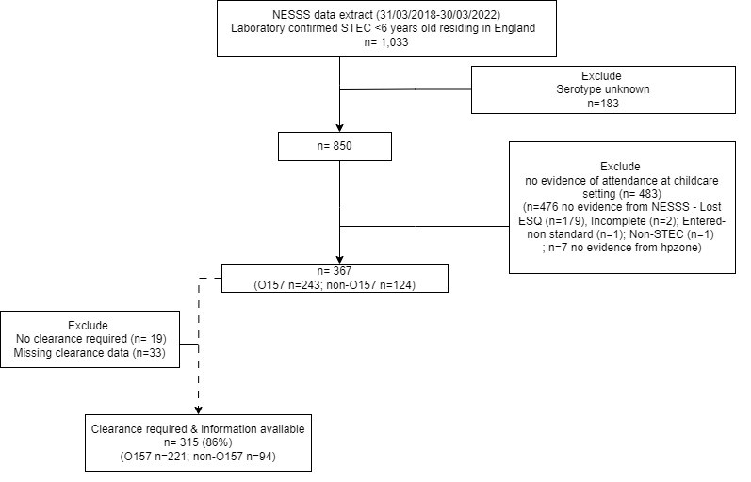
Subset of study population

