Epidemiology and Infection

Association between Face mask use and Risk of SARS-CoV-2 Infection – Cross-sectional study.

Elgersma, A. Fretheim, P. Elstrøm, P. Aavitsland.

Supplementary material

Supplementary Table S1: Results from sensitivity analysis with fractional polynomials for time
Exposure group | Adjusted risk ratio (95% CI)
Almost never / Never | Reference
Sometimes / Often | 1.03 (1.00 - 1.06)
Almost always / Always | 1.04 (1.01 - 1.07)

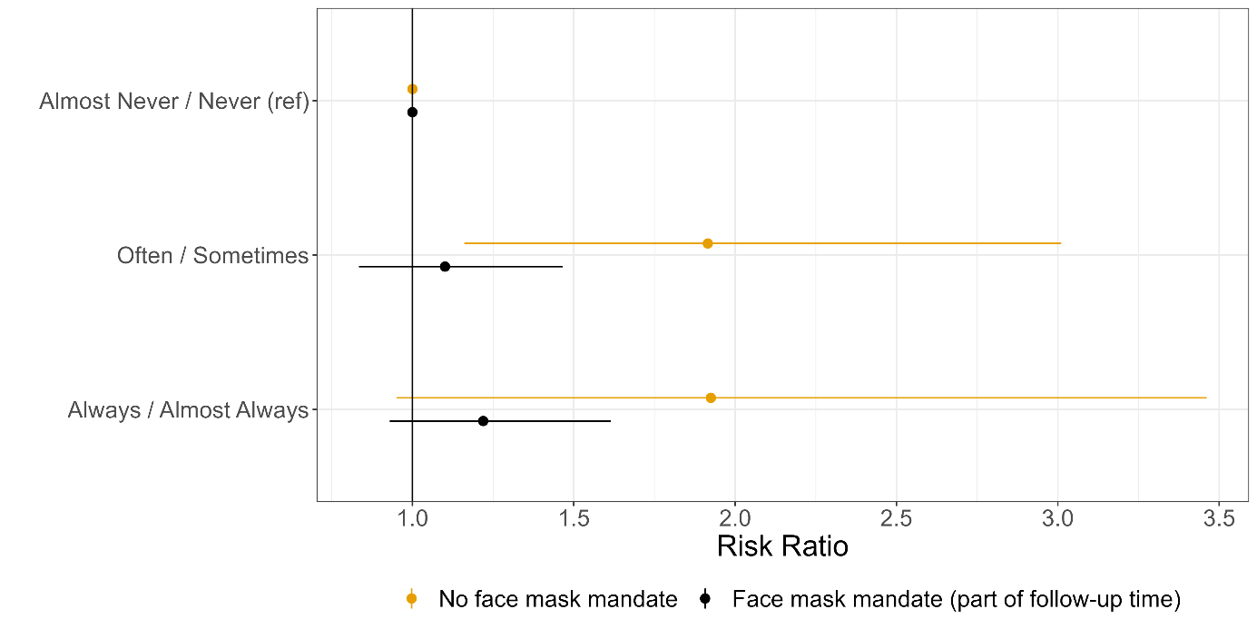
Supplementary Figure S1: Analysis of association between wearing a face mask (almost never/never as reference and group) and incidence of self-reported COVID-19 during and after the face mask mandate was in place

Exposure group | Adjusted risk ratio (95% CI)
Almost never / Never | Reference
Sometimes / Often | 1.03 (1.00 - 1.06)
Almost always / Always | 1.04 (1.01 - 1.07)
Table S2: Sensitivity analysis suggested by reviewer. Results from sensitivity analysis with fractional polynomials for time and age
Note: Peer reviewer suggested to use fractional polynomial terms for age instead of quadratic terms for age, with the benefit of fractional polynomials being more flexible in terms of modelling non-linearity. Table S2 shows the results of this analysis. The aRRs are identical to that in the prespecified analysis(see table S1).

