Supplementary materials
Figures
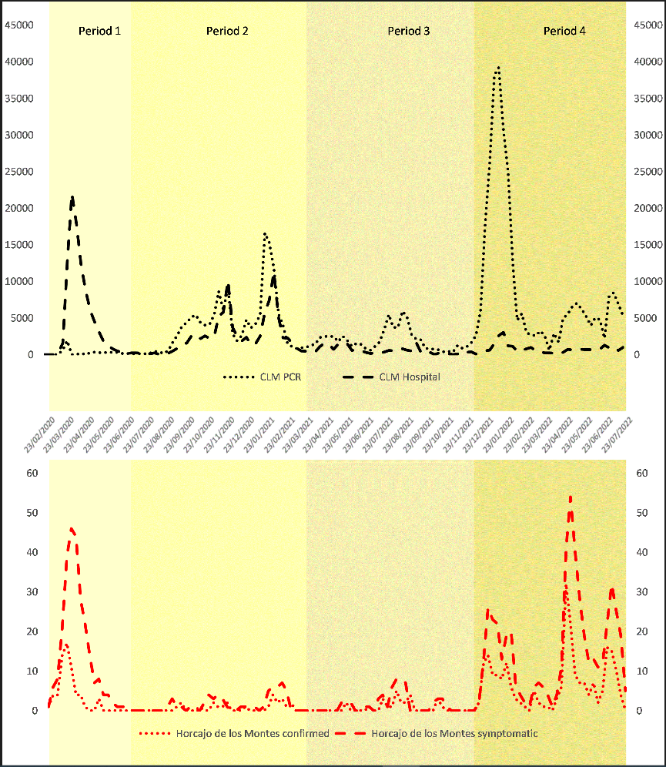
Figure S1.- Timeline of COVID-19 cases in the region Castilla La Mancha (upper panel) and the rural village Horcajo de los Montes (lower panel), by period (background color). Dashed black: regional hospitalized patients; dotted black: regional PCR-confirmed cases; dashed red: patients with symptoms in Horcajo de los Montes; dotted red: confirmed cases in Horcajo de los Montes.
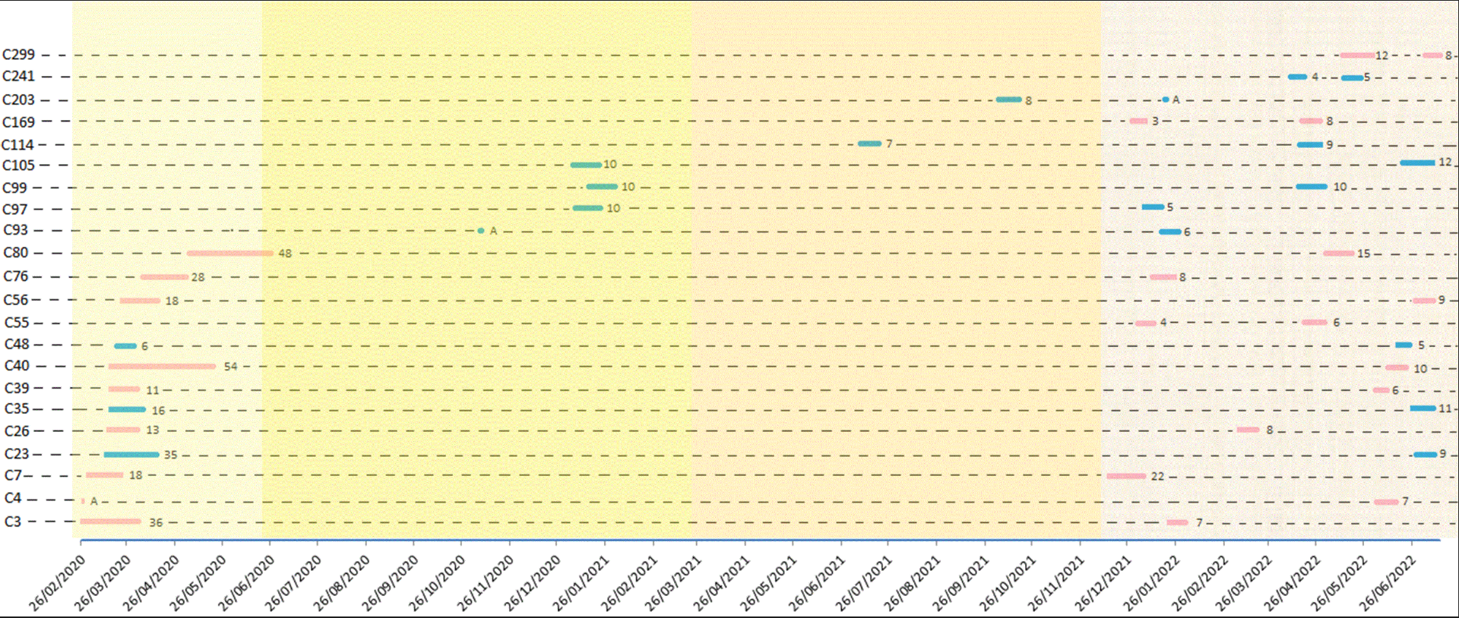
Figure S2. Diagram illustrating 22 cases with two COVID-19 episodes in Horcajo de los Montes, Spain, between February 2020 and July 2022. In 12 cases, the primary infection occurred in period 1 with a second episode in period 4. Background color indicates periods.

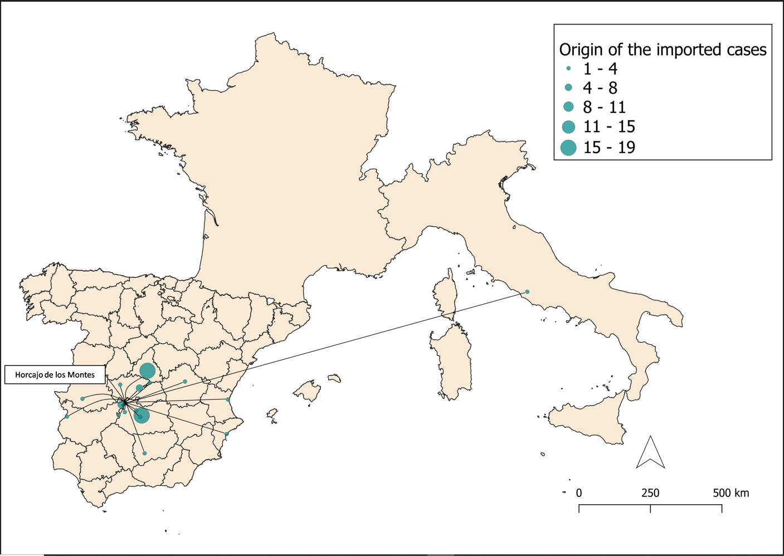
Figure S3. Known COVID-19 cases entering Horcajo de los Montes, Spain, between February 2020 and July 2022.

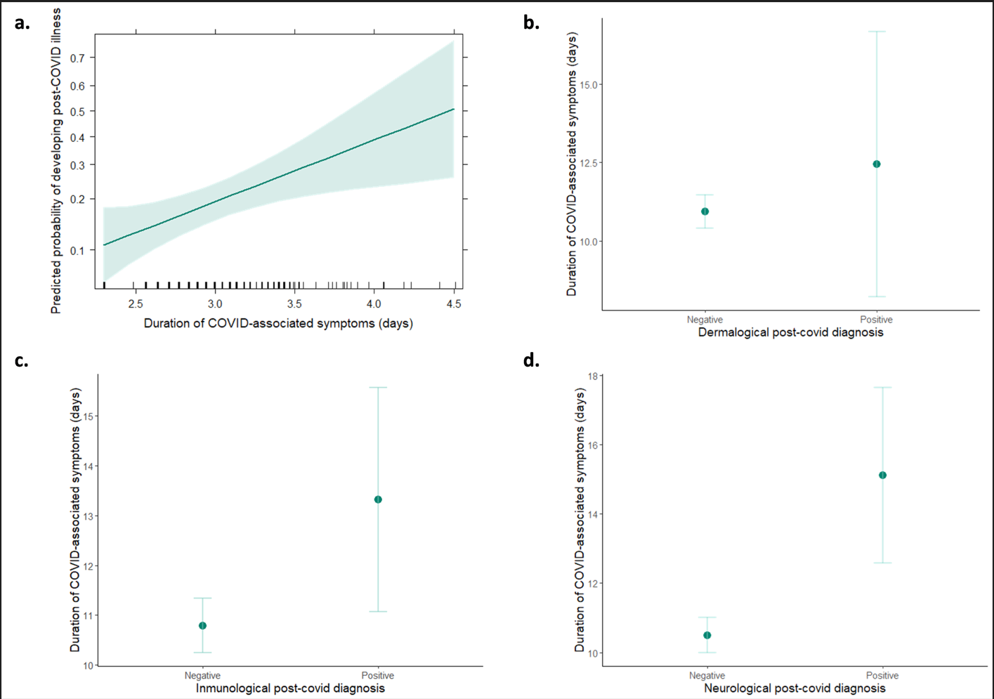
Figure S4. Post-COVID illness and symptom duration in patients from Horcajo de los Montes, Spain. The predicted probability of presenting post-COVID illness (± 95% CI represented by the shaded band) correlated with symptom duration (Panel a). Plots represent the mean duration (± standard error represented by the error bars) of COVID-associated symptoms for patients reporting (or not) dermatological (Panel b), immunological (Panel c) or neurological residual symptoms (Panel d).

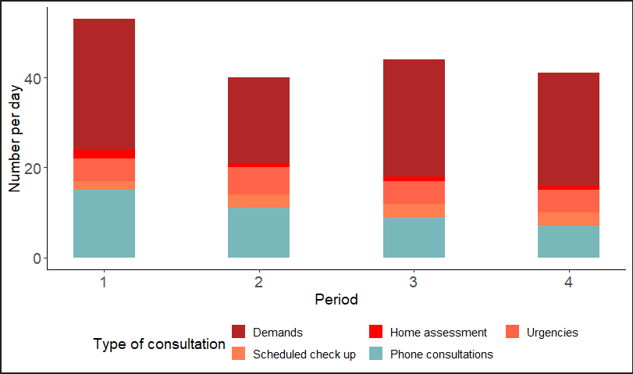
Figure S5. Evolution of the number of each type of consultation received by the primary care team of Horcajo de los Montes during the four periods of the COVID-19 pandemic. Telematic consultations are displayed in blue whereas presential consultations are shown in red tones.

Tables
Table S1a. Details of model selection for the duration of the COVID-associated symptoms (days) related to the age, sex, period, belonging to a risk group and vaccination in 350 patients from Horcajo (Castilla-La Mancha, Spain). Best model is highlighted in bold font. K means the number of variables in the model; AIC Akaike's Information Criterion; Δi difference of AIC with respect to the best model; and wi Akaike weight

Duration of the COVID symptoms (n=350) | K | AIC | Δi | w_{i}
Days symptoms_log~Age+Sex+Period+Risk_group | 8 | 189.84 | 0.00 | 0.51
Days symptoms_log ~Age+Sex+Period | 7 | 189.90 | 0.06 | 0.49
Days symptoms_log ~Age+Sex+Risk_group+Period+Vaccine | 9 | 190.13 | 41.07 | 0.00
Days symptoms_log ~Age+Sex+Vaccine | 5 | 229.62 | 39.78 | 0.00
Days symptoms_log ~Age+Sex+Risk_group+Vaccine | 7 | 230.91 | 41.07 | 0.00
Days symptoms_log ~Age+Sex | 4 | 262.74 | 72.90 | 0.00
Days symptoms_log ~Age+Sex+Risk_group | 5 | 262.84 | 73.00 | 0.00

Table S1b. Details of model selection for post-COVID illness (positive/negative) diagnosis related to the duration of the COVID-associated symptoms, age, sex, period, belonging to a risk group and vaccination in 350 patients from Horcajo (Castilla-La Mancha, Spain). Best model is highlighted in bold font. K means the number of variables in the model; AIC Akaike's Information Criterion; Δi difference of AIC with respect to the best model; and wi Akaike weight

Duration of the COVID symptoms (n=350) | K | AIC | Δi | w_{i}
Post-COVID illness~Age+Sex+ days symptoms_log | 4 | 340.66 | 0 | 0.74
Post-COVID illness~Age+Sex+ days symptoms_log +Risk_group | 5 | 344.05 | 3.39 | 0.14
Post-COVID illness~days symptoms_log +Age+Sex+Risk_group+Period | 8 | 346.15 | 5.49 | 0.05
Post-COVID illness~Age+Sex+Risk_group | 4 | 347.02 | 6.36 | 0.03
Post-COVID illness~Age+Sex | 3 | 347.73 | 7.07 | 0.02
Post-COVID illness ~Age+Sex+Risk_group | 4 | 348.82 | 8.16 | 0.01
Post-COVID illness~Age+Sex+Period | 6 | 349.95 | 9.29 | 0.01
Post-COVID illness ~Age+Sex+Risk_group+Period | 7 | 351.14 | 10.48 | 0.00

Table S1c. Details of model selection for the severity of COVID disease (mild, moderate, severe) related to the duration of the COVID-associated symptoms, age, sex, period, belonging to a risk group and vaccination in 350 patients from Horcajo (Castilla-La Mancha, Spain). Best model is highlighted in bold font. K means the number of variables in the model; AIC Akaike's Information Criterion; Δi difference of AIC with respect to the best model; and wi Akaike weight

Severity of COVID disease (n=350) | K | AIC | Δi | w_{i}
COVID disease severity~Age+Sex+ days symptoms_log+Risk_group+Period | 10 | 567.79 | 0 | 1.00
COVID disease severity~Age+Sex+ days symptoms_log+Risk_group+Vaccine | 8 | 589.44 | 21.65 | 0.00
COVID disease severity~Age+Sex+ days symptoms_log | 6 | 606.79 | 39 | 0.00
COVID disease severity~Age+Sex+ days symptoms_log+Risk_group | 7 | 608.05 | 40.26 | 0.00
COVID disease severity~Age+Sex+Risk_group+Period | 9 | 686.44 | 118.65 | 0.00
COVID disease severity~Age+Sex+Period | 8 | 687.48 | 119.69 | 0.00
COVID disease severity~Age+Sex+Vaccine | 6 | 735.31 | 167.52 | 0.00
COVID disease severity~Age+Sex+Risk_group+Vaccine | 7 | 736.15 | 168.36 | 0.00
COVID disease severity~Age+Sex+Risk_group | 6 | 800.65 | 232.86 | 0.00
COVID disease severity~Age+Sex+Risk_group | 6 | 800.65 | 232.86 | 0.00
COVID disease severity~Age+Sex | 5 | 801.52 | 233.73 | 0.00

Questionnaire
Individual and anonymous epidemiological questionnaire
Case Assignment Code: C
Sex: Female Male
Age: _______ years.
COVID-19 diagnostic: ____ PCR ; ____ Serology; ____ Antigen test;
Date of onset of symptoms: __________________.
Healing date: ______________________.
Required hospital admission: Yes No
If you were admitted to the hospital, how many days did you stay?_____ days
If you were admitted to the hospital, did you require admission to the ICU?
Yes No
In the case of requiring admission to the ICU, how many days did you stay?_____ days
Do you suffer from chronic diseases or do you undergo any immunosuppressive treatment? Yes No
With what severity diagnosis were you classified?
Asymptomatic Mild Moderate Severe
After healing from COVID-19, did residual symptoms persist? Yes No
In the quarter after recovering from COVID-19 ¿were you diagnosed with any of these types of illness?
Neurological Dermatological Immunological Others
Address: ___________________________________________________________
Specify the names of people with whom you had contact in the 48 hours before the onset of symptoms (less than 1.5 m away and for more than 15 minutes): ___________________________________________________________________________________________________________________________________________________________________________________________________________________________

