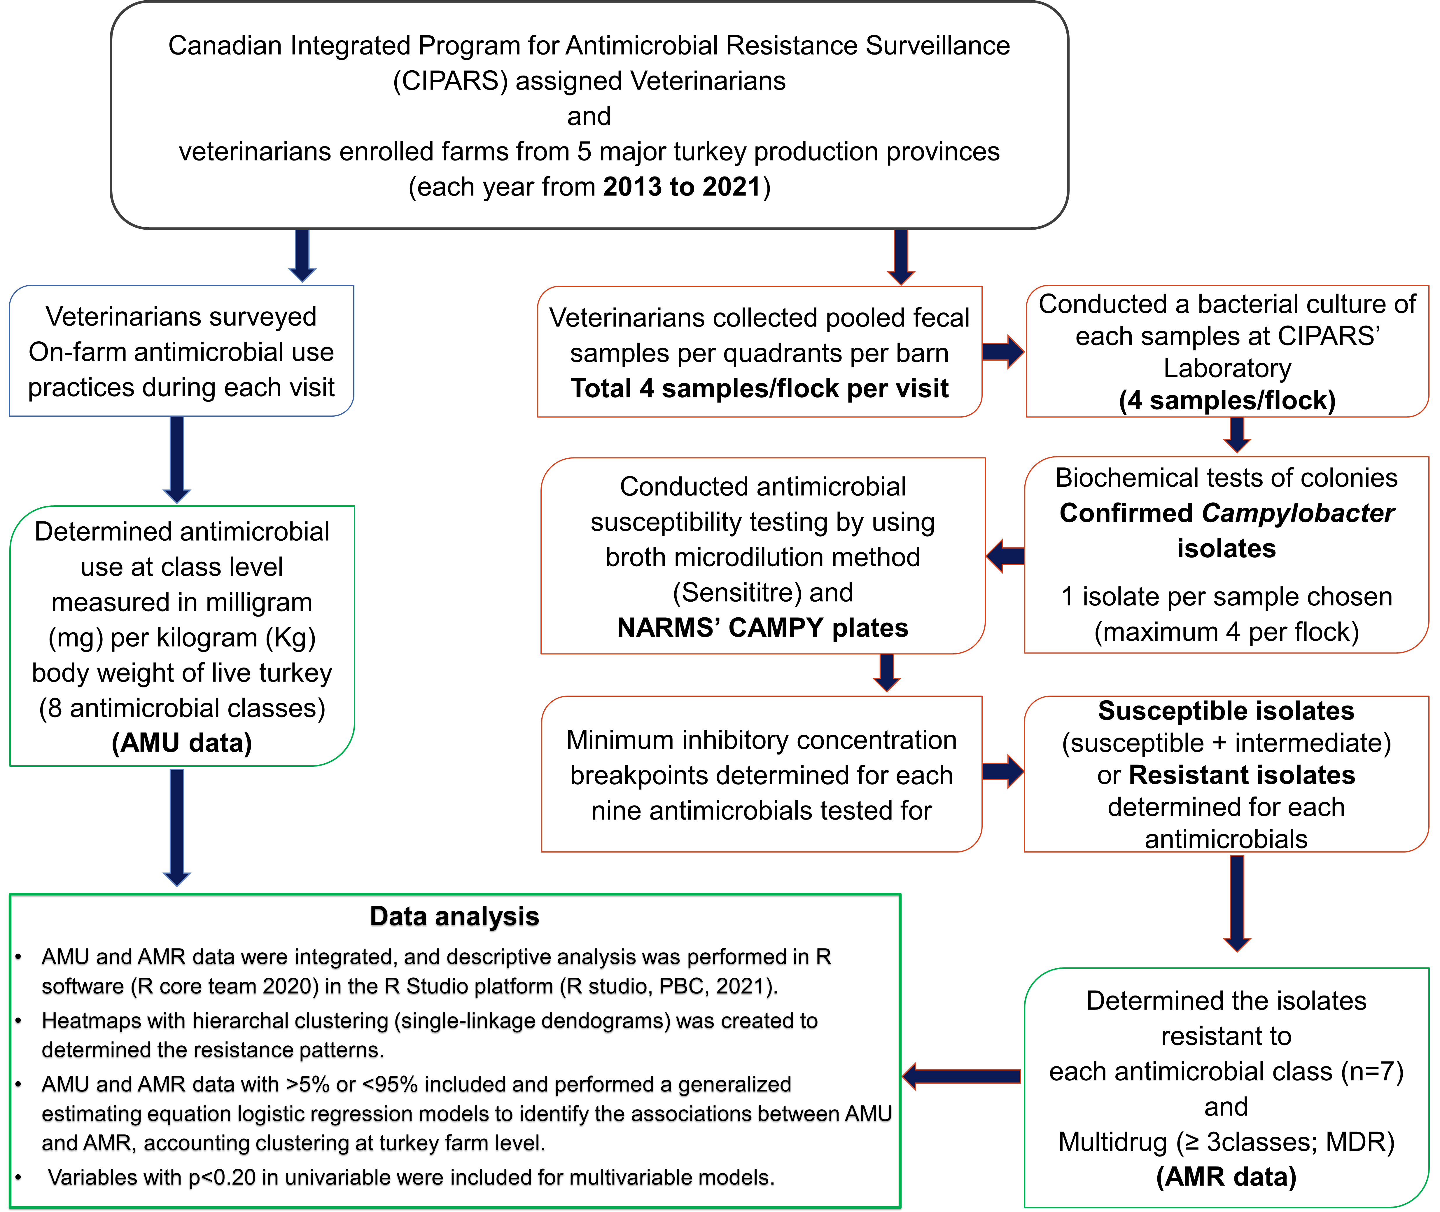
Fig S1: Diagram of the study design including sample and AMU data collection, Campylobacter isolation, AMR identification, and data analysis

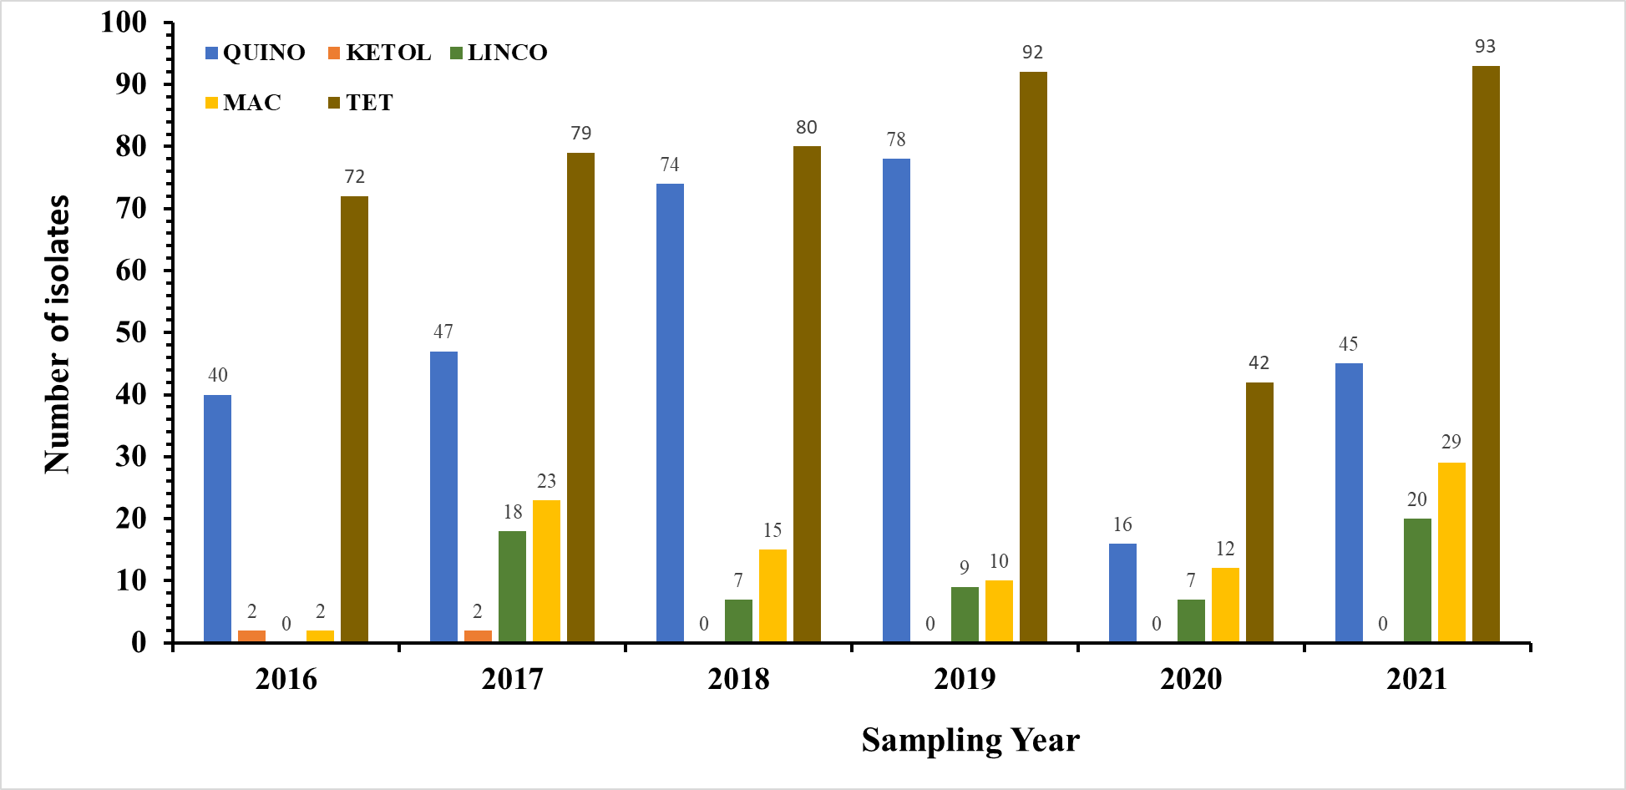
Fig S2: Number of Campylobacter isolates resistant to antimicrobial classes by sampling year: Fluoroquinolones (QUINO), Ketolides (KETOL), Lincosamides (LINCO), Macrolides (MAC), Tetracyclines (TET)
Table S1: References for previous studies or websites that explain a detailed method of CIPARS farm surveillance [1–5].
References:
1. A. Agunos, S. P. Gow, D. F. Léger, A. E. Deckert, C. A. Carson, A. L. Bosman, S. Kadykalo, & R. J. Reid-Smith, Antimicrobial Use Indices—The Value of Reporting Antimicrobial Use in Multiple Ways Using Data From Canadian Broiler Chicken and Turkey Farms. Frontiers in Veterinary Science, 7 (2020). https://doi.org/10.3389/fvets.2020.567872.
2. A. Agunos, S. P. Gow, A. E. Deckert, G. Kuiper, & D. F. Léger, Informing Stewardship Measures in Canadian Food Animal Species through Integrated Reporting of Antimicrobial Use and Antimicrobial Resistance Surveillance Data&mdash;Part I, Methodology Development. Pathogens, 10 (2021). https://doi.org/10.3390/pathogens10111492.
3. A. Agunos, S. P. Gow, A. E. Deckert, & D. F. Léger, Informing Stewardship Measures in Canadian Food Animal Species through Integrated Reporting of Antimicrobial Use and Antimicrobial Resistance Surveillance Data—Part II, Application. Pathogens, 10 (2021) 1491. https://doi.org/10.3390/pathogens10111491.
4. R. D. Shrestha, A. Agunos, S. P. Gow, A. E. Deckert, & C. Varga, Associations between antimicrobial resistance in fecal Escherichia coli isolates and antimicrobial use in Canadian turkey flocks, 2016-2019. Frontiers in Microbiology, (n.d.) 2902.
5. L. Huber, A. Agunos, S. P. Gow, C. A. Carson, & T. P. Van Boeckel, Reduction in antimicrobial use and resistance to Salmonella, Campylobacter, and Escherichia coli in broiler chickens, Canada, 2013–2019. Emerging Infectious Diseases, 27 (2021) 2434.

Table S2: Antimicrobial agents by antimicrobial classes that were included in the AMR and AMU analysis.
Resistance to Antimicrobial Class  (Antimicrobial agents) | Antimicrobials used in turkey flocks at class level (Antimicrobial agents)
Aminoglycosides (Gentamicin) | Aminoglycosides (Gentamicin)
Ketolides (Telithromycin) | Bacitracins (Bacitracins)
Lincosamides (Clindamycin) | Beta-lactams (Penicillins)
Macrolides (Azithromycin & Erythromycin) | Macrolides (Azithromycin & Erythromycin)
Phenicols (Florfenicol) | Quinolones (Ciprofloxacin & Nalidixic acid)
Quinolones (Ciprofloxacin & Nalidixic acid) | Streptogramins (Virginiamycin)
Tetracyclines (Tetracycline) | Trimethoprim-sulfamethoxazole
 | Orthomycins
 | Flavophospholipids (Flavinomycins)
 | Tetracyclines (Tetracycline)

Table S3: Total number of farms sampled, and Campylobacter isolated by year
Sampling  year | Number of turkey farms enrolled and sampled | Number of
 |  | Campylobacter | C. jejuni | C. coli | C. spp.
2016 | 47 | 171 | 107 | 64 | 0
2017 | 45 | 157 | 60 | 32 | 65
2018 | 50 | 191 | 118 | 73 | 0
2019 | 58 | 214 | 145 | 60 | 9
2020 | 26 | 90 | 54 | 36 | 0
2021 | 67 | 240 | 167 | 71 | 2

Table S4: Number of Campylobacter isolates by minimum inhibition concentration (mg/L) values or clinical breakpoint.
Minimum Inhibitory  concentrations (mg/L) | Antimicrobial agents in CAMPY plate
 | AZM | CIP | CLIN | ERY | FLR | GEN | NAL | TEL | TET
0.015 | 20 | - | - | - | - | - | - | - | -
0.03 | 362 | 2 | 1 | - | - | - | - | - | -
0.06 | 461 | 207 | 48 | 1 | - | - | - | - | 4
0.12 | 109 | 507 | 362 | 34 | 1 | - | - | 5 | 195
0.25 | 19 | 47 | 485 | 541 | 1 | 8 | - | 106 | 296
0.5 | 1 | - | 72 | 266 | 57 | 465 | - | 189 | 67
1 | - | - | 4 | 100 | 908 | 568 | - | 110 | 33
2 | - | - | 1 | 26 | 92 | 22 | - | 58 | 4
4 | - | 12 | 29 | 4 | 4 | - | 522 | 37 | 2
8 | - | 91 | 51 | - | - | - | 233 | 10 | 6
16 | - | 156 | 8 | - | - | - | 8 | 4 | 9
32 | - | 41 | 2 | 2 | - | - | 2 | - | 26
64 | - | - | - | 36 | - | - | 32 | - | 175
128 | 91 | - | - | 53 | - | - | 266 | - | 248
Antimicrobial agents: AZM: azithromycin; CIP: ciprofloxacin; CLIN: clindamycin; ERY: erythromycin; FLR: florfenicol; GEN: gentamicin; NAL: Nalidixic acid; TEL: telithromycin; TET: tetracycline

Table S5: Summary of the antimicrobial resistance in Campylobacter isolates by regions and years (2016-2021).
Region | Year | Resistance to Antimicrobialsª |  |  |  |  |  |  |  |  |  |  | MDR^{b}
 |  | AZM | CHL | CIP | CLIN | ERY | FLR | GEN | MEM | NAL | TEL | TET
Ontario | 2016 | 2 | 0 | 3 | 0 | 2 | 0 | 0 | 0 | 3 | 2 | 46 | 2
 | 2017 | 8 | 0 | 6 | 4 | 8 | 0 | 0 | 0 | 5 | 2 | 28 | 8
 | 2018 | 4 | 0 | 13 | 4 | 4 | 0 | 0 | 0 | 13 | 0 | 28 | 1
 | 2019 | 1 | 0 | 13 | 1 | 1 | 0 | 0 | 0 | 13 | 0 | 22 | 0
 | 2020 | 0 | 0 | 3 | 0 | 0 | 0 | 0 | 0 | 3 | 0 | 10 | 0
 | 2021 | 3 | 0 | 14 | 2 | 3 | 0 | 0 | 0 | 14 | 0 | 58 | 3
Quebec | 2016 | 0 | 0 | 0 | 0 | 0 | 0 | 0 | 0 | 0 | 0 | 12 | 0
 | 2017 | 14 | 0 | 0 | 14 | 14 | 0 | 0 | 0 | 0 | 0 | 6 | 3
 | 2018 | 9 | 0 | 2 | 3 | 9 | 0 | 0 | 0 | 2 | 0 | 7 | 0
 | 2019 | 9 | 0 | 14 | 8 | 9 | 0 | 0 | 0 | 14 | 0 | 29 | 0
 | 2020 | 12 | 0 | 0 | 7 | 12 | 0 | 0 | 0 | 0 | 0 | 4 | 0
 | 2021 | 26 | 0 | 17 | 18 | 26 | 0 | 0 | 0 | 17 | 0 | 16 | 0
Western | 2016 | 0 | 0 | 37 | 0 | 0 | 0 | 0 | 0 | 37 | 0 | 14 | 0
 | 2017 | 1 | 0 | 41 | 0 | 1 | 0 | 0 | 0 | 41 | 0 | 45 | 0
 | 2018 | 2 | 0 | 59 | 0 | 2 | 0 | 0 | 0 | 59 | 0 | 45 | 0
 | 2019 | 0 | 0 | 51 | 0 | 0 | 0 | 0 | 0 | 50 | 0 | 41 | 0
 | 2020 | 0 | 0 | 13 | 0 | 0 | 0 | 0 | 0 | 13 | 0 | 28 | 0
 | 2021 | 0 | 0 | 14 | 0 | 0 | 0 | 0 | 0 | 14 | 0 | 19 | 0
Grand Total |  | 91 | 0 | 300 | 61 | 91 | 0 | 0 | 0 | 298 | 4 | 458 | 17
ª Antimicrobial resistance tested for: Azithromycin (AZM), Ciprofloxacin (CIP), Chloramphenicols (CHL), Clindamycin (CLIN), Erythromycin (ERY), Florfenicol (FLR), Gentamicin (GEN), Nalidixic acid (NAL), Telithromycin (TEL), Tetracycline (TET)
^{b} Multidrug resistance (MDR) resistance to ≥3 antimicrobial classes

Table S6: Total quantity of antimicrobials used in turkey farms (n=293) where Campylobacter were isolated, by year.
Year | Quantity of antimicrobials used (mg/kg biomass)
 | Total | Mean (SD) | Median (Range)
2016 | 7,088.98 | 45.74 (29.73) | 22.72 (0.13-114.42)
2017 | 6,533.36 | 53.99 (45.93) | 19.94 (0.07-181.36)
2018 | 6,951.88 | 52.27 (40.21) | 66.26 (0.56-152.82)
2019 | 11,259.12 | 69.93 (41.38) | 37.13 (3.8-153.93)
2020 | 1,552.06 | 29.85 (26.95) | 46.81 (2.71-111.74)
2021 | 3,236.20 | 37.63 (31.43) | 43.11 (1.5-175.27)
- Total | 36,621.59 | 51.73 (39.68) | 23.70 (0.07-181.36)

