Supplementary Material

Treatment type definitions

PSYCH-BRIEF: psychiatric or psychological brief consultation
PSYCH-BRIEF includes mostly single 10min consultation with psychiatrists but also single consultations of 25 to 40min with psychotherapists. All these consultations do not involve formal psychotherapy and are delivered in outpatient settings, i.e., in psychiatric or psychotherapist practices. In the SHI data on outpatient care, PSYCH-BRIEF is defined by specific codes used for reimbursement purposes (EBM Codes: 35150; 35151; 35152; 21220; 21221; 22220; 22221; 22222; 23220). We considered PSYCH-BRIEF consultations with an F10.1-9 ICD-10 code as confirmed diagnosis. For each consultation, the day was registered as intervention date.

PSYCH-LONG: short- or long-term psychotherapy
PSYCH-LONG includes formal psychotherapy that is delivered in 50min (single) or 100min (group) sessions by trained psychotherapists. Unlike PSYCH-BRIEF, PSYCH-LONG needs to be approved by the SHI before being delivered. In terms of psychotherapy types, patients can choose between a) Depth psychology-based psychotherapy („Tiefenpsychologisch fundierte Psychotherapie“, b) Analytical psychotherapy (“Analytische Psychotherapie”), c) Behavioral therapy („Verhaltenstherapie“), and d) Systemic therapy (“Systemische Therapie“). As part of a short-term psychotherapy, 12 or 24 sessions are delivered. In a long-term psychotherapy, up to 60 sessions with possible extension are delivered. PSYCH-LONG interventions are entirely delivered in outpatient settings, i.e., in psychotherapist practices. In the SHI data on outpatient care, PSYCH-LONG is defined by specific codes used for reimbursement purposes (EBM Codes: 3540*; 3541*; 3542*; 3543*; 3550*; 3551*; 3552*; 3553*; 3554*; 3555*; 3570*; 3571*). We considered PSYCH-LONG consultations with an F10.1-9 ICD-10 code as confirmed diagnosis. To describe the intervention duration, the first and the last day of a therapy session was registered.

PHARMA: Prescription of alcohol-specific medications
PHARMA includes medications that are specifically prescribed for AUD treatment as defined by the ATC grouping N07BB*. This includes Disulfiram, Calcium Carbimide, Acamprosate, Naltrexone and Nalmefene. In the current study, Disulfiram and Calcium Carbimide were not prescribed. We considered only those prescriptions that were also dispensed. The dispensary day (not the prescription day) was registered as intervention date.

INPAT-STANDARD: standard inpatient treatment
INPAT-STANDARD includes mostly short-term inpatient treatment that mostly covers psysical but not psychosocial care. In the SHI data on inpatient care, STAND is defined by specific codes used for reimbursement purposes (OPS Codes: 9-60x; 9-61x; 9-62x). We considered INPAT treatment episodes with an F10.2-4 ICD-10 code as primary diagnosis.

INPAT-INTENSIVE: Intensive inpatient treatment (qualified withdrawal treatment)
INPAT-INTENSIVE includes detoxification and subsequent psychosocial care. It is usually delivered in psychiatric wards of general hospitals and represents an essential recommendation of German AUD treatment guidelines (see reference #21 in main text or DOI: 10.1159/000522335). In the SHI data on inpatient care, QWT is defined by specific codes used for reimbursement purposes (OPS Codes 8-985 and 9-647). We considered QWT treatment episodes with a) an F10.2-4 ICD-10 code as primary diagnosis or b) any F10 ICD-10 primary diagnosis and F10.2 as secondary diagnosis.

REHA: Rehabilitation treatment
REHA covers long-term support for people with disabiling conditions. The aim of REHA is to achieve full recovery and to facilitate social and occupational re-integration. REHA interventions can be delivered in outpatient or inpatient settings and usually take several months but can also last up to a year or longer. In the PF data, we considered REHA treatment episodes with a) an F10 approval diagnosis, b) approval grouping “alcohol use disorder”, or c) an F10 primary diagnosis. In the SHI data, we considered REHA treatment episodes with a) an F10 primary diagnosis or b) an F10 application diagnosis. Duplicates between SHI and PF documented REHA episodes were few and removed.

COUNSEL: First contact for low-threshold alcohol counselling
COUNSEL encompasses low-threshold alcohol counselling services within the municipality-funded outpatient addiction support system, sourced from the Hamburg monitoring system of outpatient addiction care services (see www.bado.de). The primary aim of alcohol counselling in this low-threshold setting is to serve as the first point of contact and subsequently refer clients to appropriate treatment programs. Prior to matching with SHI data, we ensured the inclusion of only alcohol-specific counselling by: 1) excluding opioid-specific cases and substitution programs, which often involve concomitant alcohol-related issues but treat alcohol only secondarily; 2) including only contacts for which alcohol-related problems or an F10 diagnosis were documented; and 3) excluding all service types that are not specifically counselling (e.g., integration assistance). Given that the data provided only exact dates for the first and last contacts within a facility, without clear temporal resolution for services in between, we defined COUNSEL as the initial corresponding contact within the addiction support system, without accounting for the frequency of contacts.

Model selection
The model selection including key model fit parameters is summarised in Supplementary Table 1. Using a step-up approach, a 2-class model was estimated as the simplest model. Subsequently, classes were added until the Bayesian Information Criterion (BIC) was minimized. Class balance (i.e., the number of patients assigned to each class relative to other classes) and composition (i.e., the distinctiveness of dominant treatments within each class) were assessed to ensure meaningful and relevant outcomes. To ensure model convergence on global minima, the maximal number of iterations was set to 100,000 and model runs were replicated 5 times using different random starting values. Minimum BIC and optimal class compositions were reached at 6 classes. While the 7-class solution had a lower BIC, the small size of the smallest class (n=21), we preferred the 6-class solution, which also demonstrated a high average latent class posterior probability (ALCPP; 94.32%) and a high standardized entropy of 0.92.

Supplementary Figures
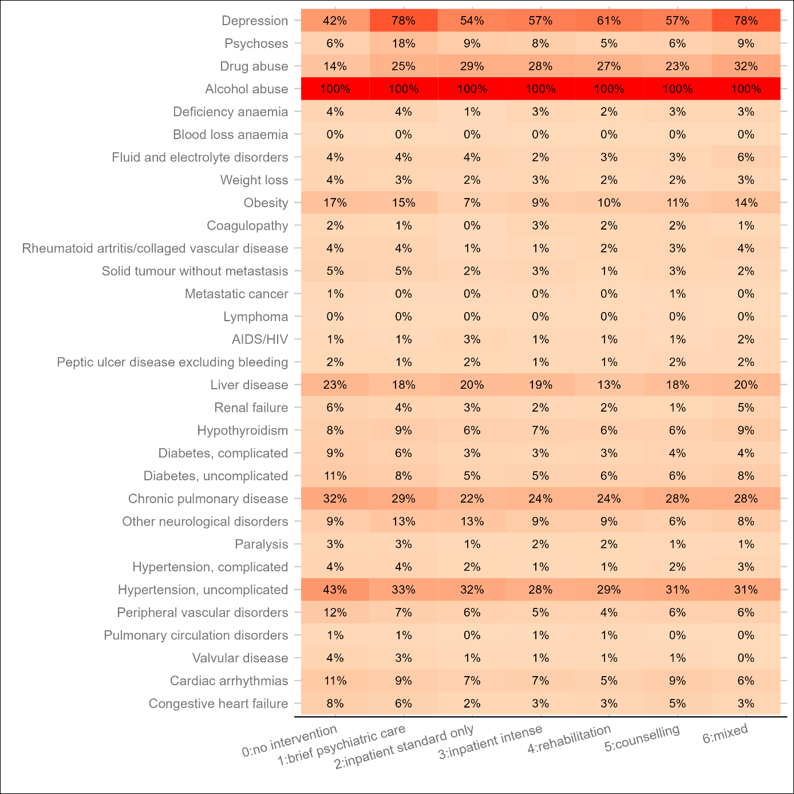
Supplementary Figure 1. The share of patients with at least one diagnosis pertaining to 31 diagnostic groupings, defined by the Elixhauser comorbidity score, for six treatment utilisation pattern classes and among no-treatment seekers (class 0). Diagnoses are from inpatient and outpatient settings and refer to the 12 months before the new AUD diagnosis.

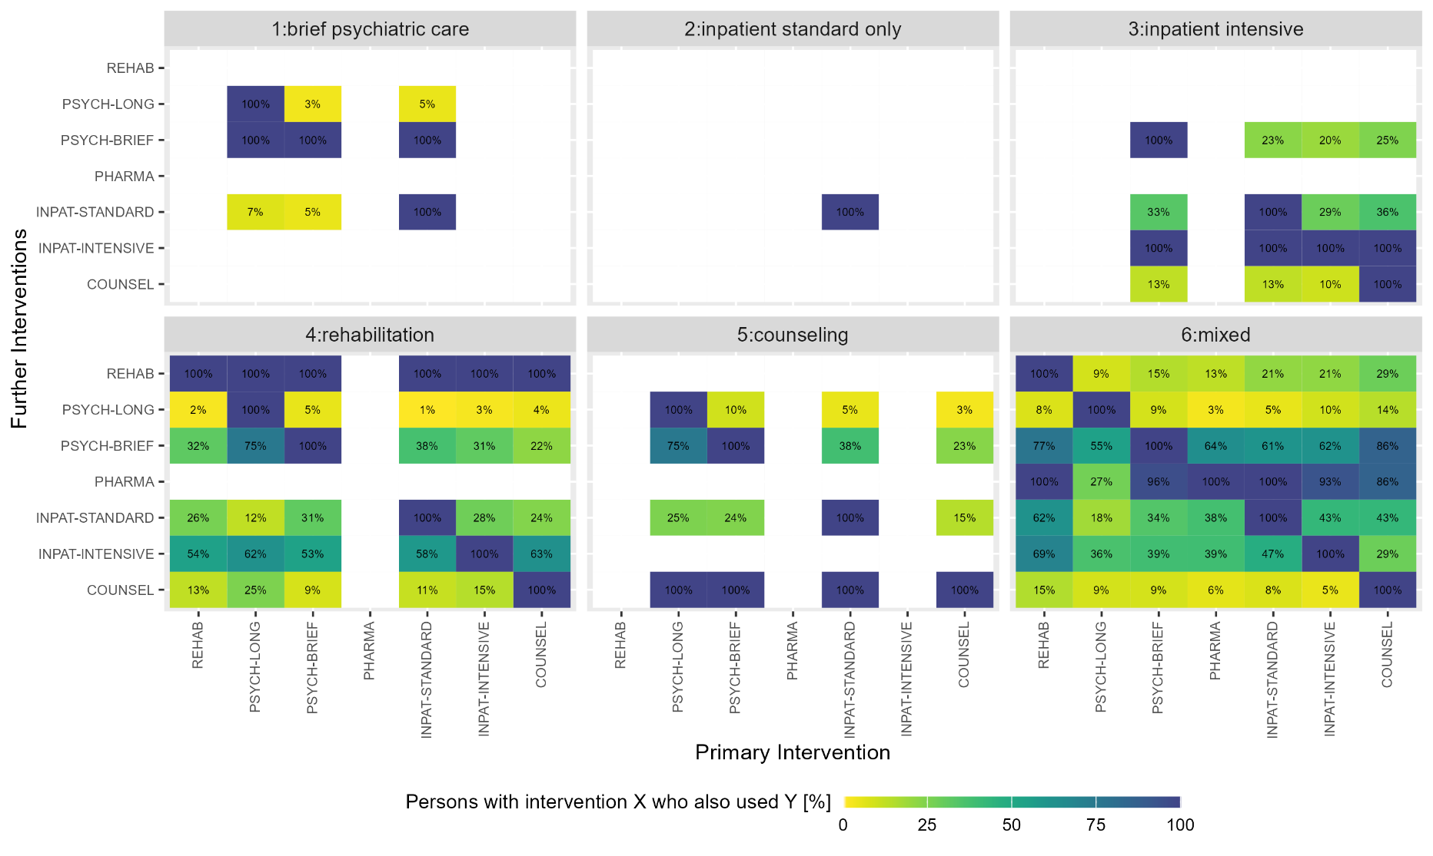
Supplementary Figure 2. Cross utilisation of seven different treatment types within 24 months after AUD diagnosis for six latent classes. The x axis displays treatment taken, while the y axis displays treatment utilised conditional on the treatment in the x axis. Color codes the percentage of patients within each class, using treatment x, who also use treatment y. For example, in class 4 ‘rehabilitation’, 53% of the patients who utilised brief psychiatric consultations have also been in inpatient intensive treatment.
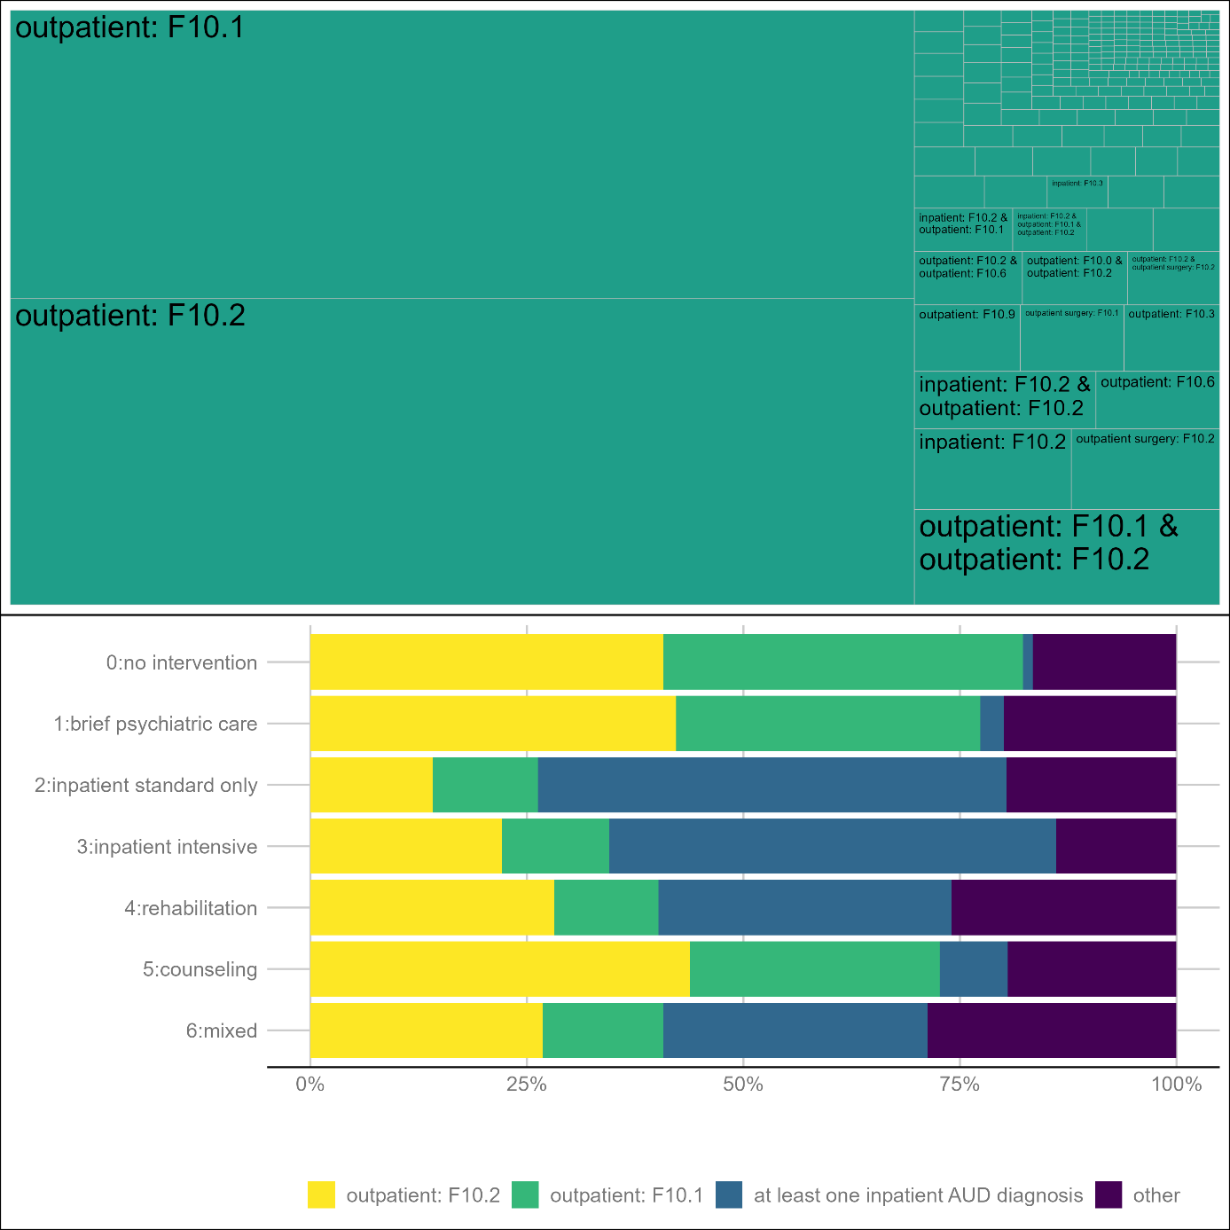
Supplementary Figure 3. Distribution of setting and AUD diagnosis during first quarter (index date). The upper part of the graph shows all combinations of AUD diagnosis and setting observed in the total sample (n=9,491), with the relative size of each tile being proportional to the observed frequency. For example, 38.5% (n=3,654) received only an F10.2 diagnosis in outpatient settings and the tile “outpatient: F10.2” takes 38.5% of the space. The lower part condenses the possible combinations of setting and diagnoses into four categories. The relative frequency of each of the four category is shown as bar plot for each treatment utilisation pattern.
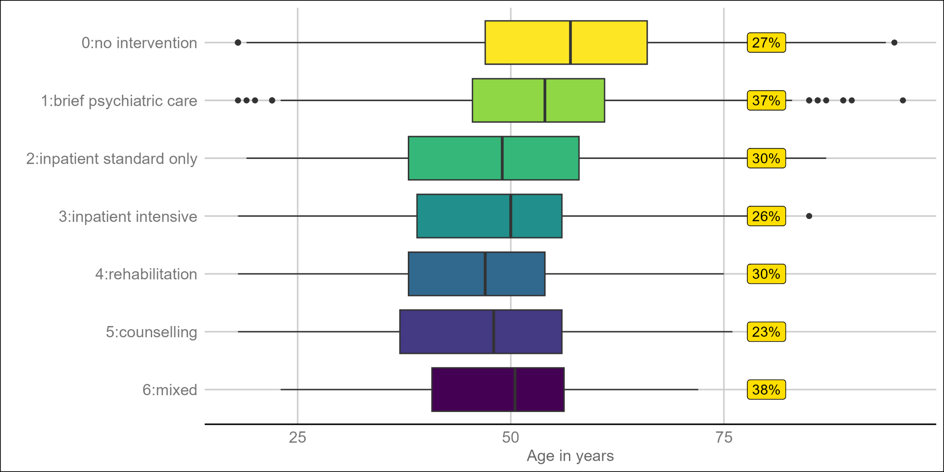
Supplementary Figure 4. Box plots of age (median: vertical black line; interquartile range: box; whiskers: +/- 1.5 interquartile range boundaries; points: outliers) and the % of female patients (yellow label) within six treatment utilisation pattern (latent class) and among no-treatment seekers (class 0).
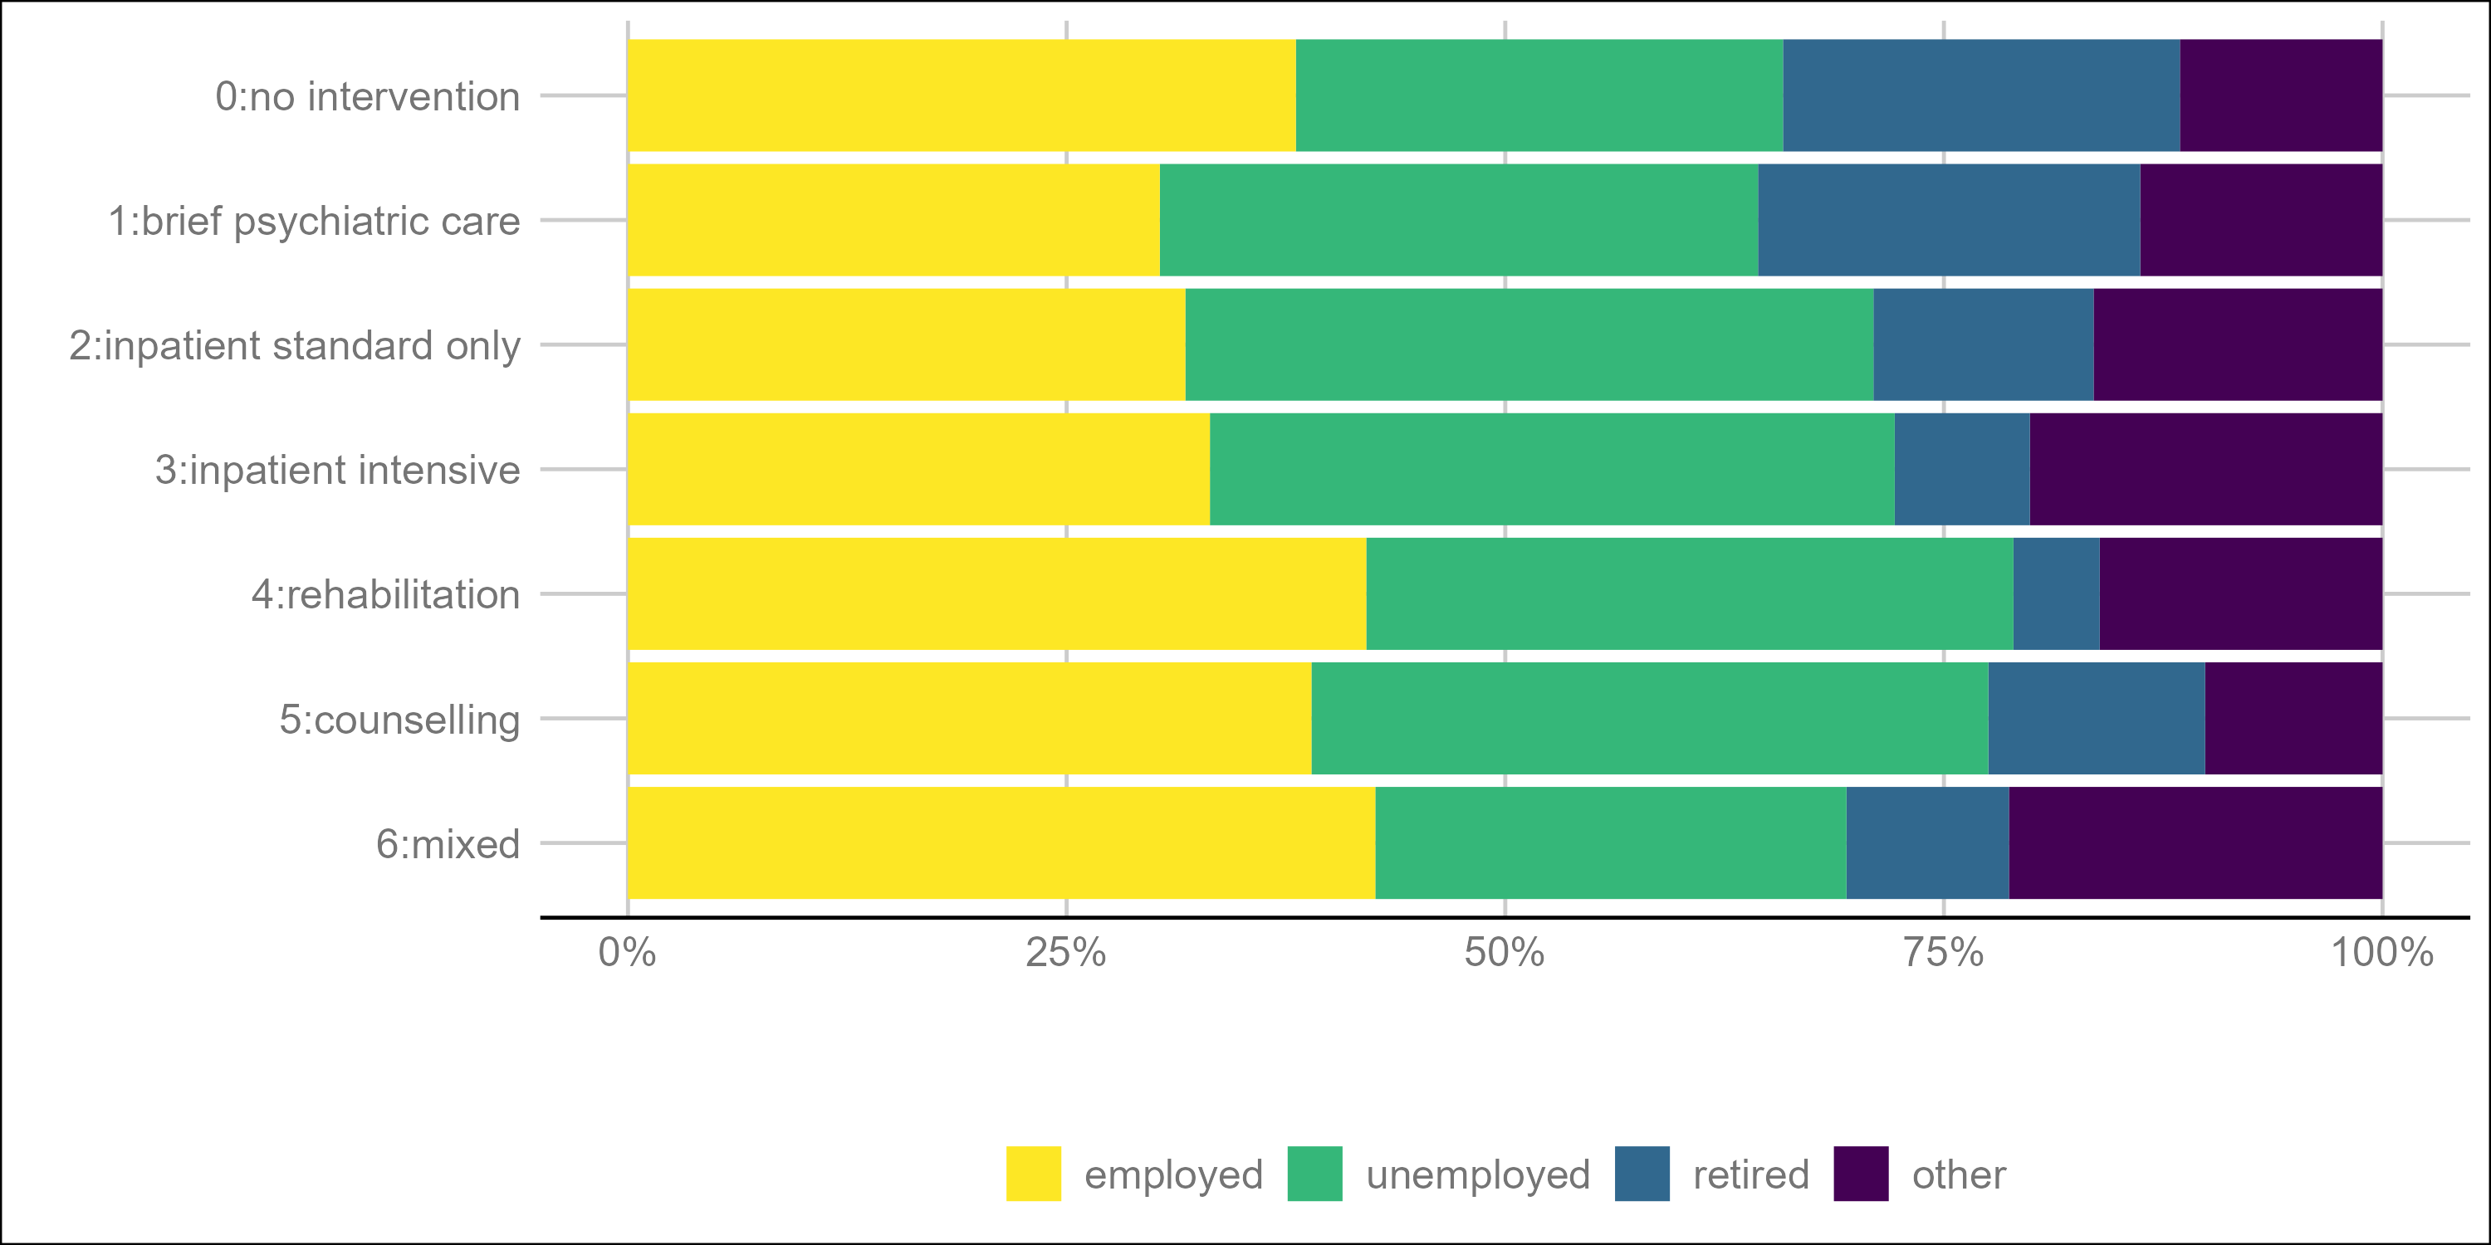
Supplementary Figure 5. Distribution of employment/retirement status within six treatment utilisation pattern (latent class) and among no-treatment seekers (class 0).
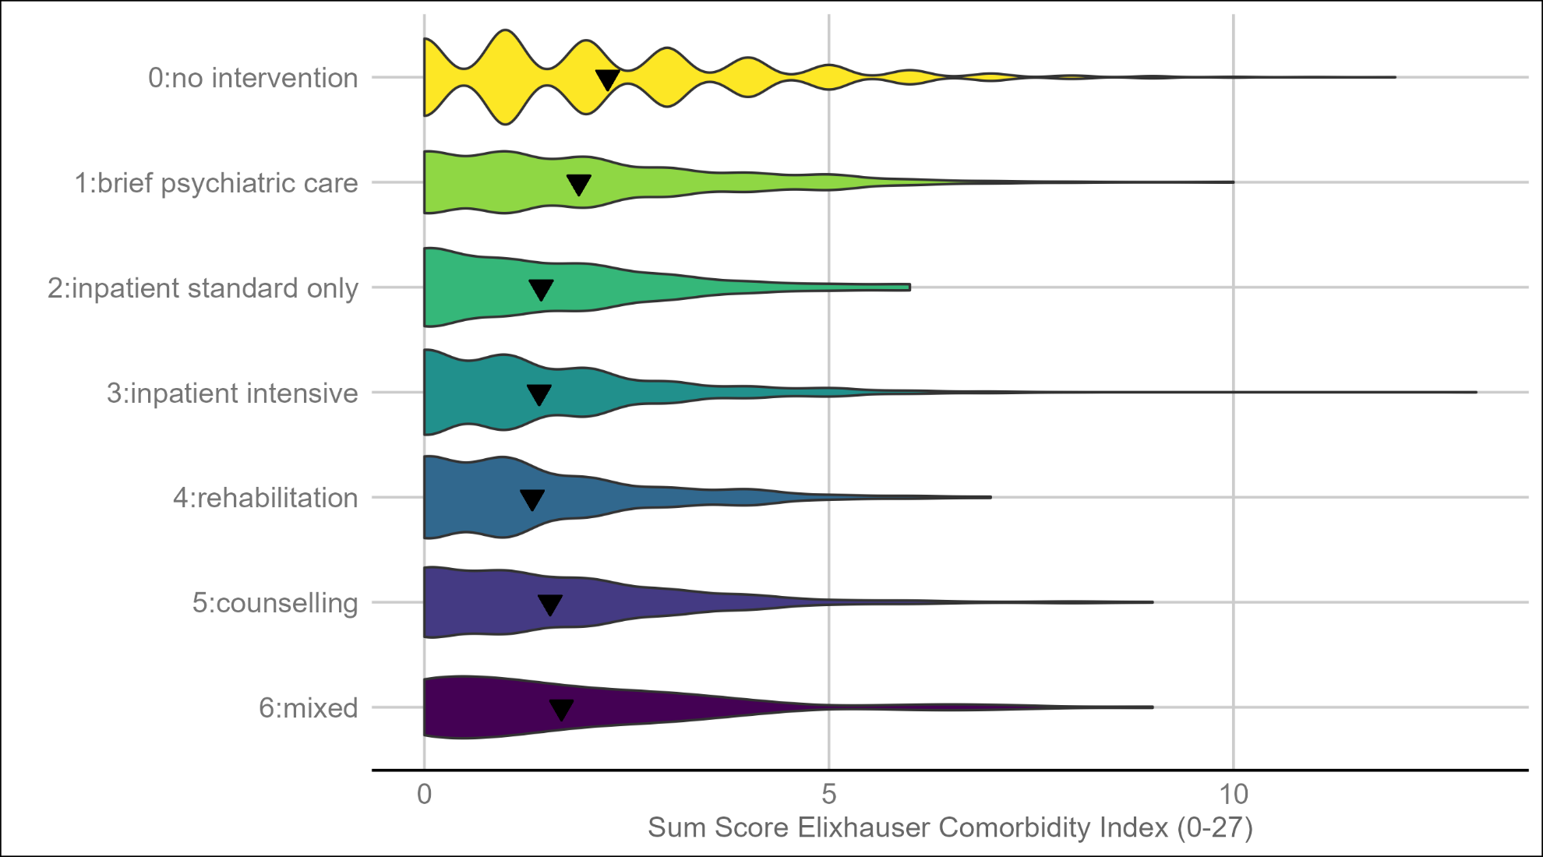
Supplementary Figure 6. Violin plots showing the distribution of the Elixhauser physical comorbidity index by treatment utilisation pattern (latent class). As the comorbidity index is an integer variable, a high distribution density occurs at integer values (resulting in bumps). The triangles indicate the arithmetic mean for each subgroup.

Supplementary Tables
Supplementary Table 1. Selected metrics and fit criteria for 6 latent class models with 2-7 classes.
Models | LL | Smallest Class (n) | Smallest Class (%) | Entropy | ALCPP min (%) | BIC
2 Class | -7510.867 | 1282 | 44.8 | 0.7961 | 93.1 | 15141.11
3 Class | -7370.406 | 181 | 6.3 | 0.8285 | 89.5 | 14923.86
4 Class | -7218.330 | 190 | 6.6 | 0.8684 | 89.8 | 14683.38
5 Class | -7141.064 | 181 | 6.3 | 0.8963 | 81.4 | 14592.51
6 Class | -7087.732 | 108 | 3.8 | 0.9209 | 81.6 | 14549.52
7 Class | -7065.815 | 21 | 0.7 | 0.9758 | 86.8 | 14569.35
Note. LL: log likelihood of each model; ALCPP min: minimum of the Average Latent Class Posterior Probabilities where the number of computed ALCPPs is the same as the number of classes within each model; BIC: Bayesian Information Criterion

Supplementary Table 2. Results of Multinomial Regression Model (dependent variable: class membership, reference category: no treatment)
Latent Class  (Ref: No Intervention) | Independent Variable | Intercept | Exp(Coefficient)¹
1: Brief Psychiatric Care | Employment (Ref: employed):
 | unemployed | 0.114 | 1.425 (1.223 to 1.660) **
 | retired | 0.114 | 1.703 (1.415 to 2.048) **
 | other | 0.114 | 1.447 (1.186 to 1.765) **
 | Age (Ref: 65+):
 | 55-64 | 0.114 | 2.073 (1.710 to 2.514) **
 | 35-54 | 0.114 | 2.685 (2.214 to 3.257) **
 | 18-34 | 0.114 | 1.872 (1.422 to 2.463) **
 | Sex (Ref: female): male | 0.114 | 0.592 (0.520 to 0.673) **
 | Nationality (Ref: German): Not German / Unknown | 0.114 | 0.736 (0.619 to 0.875) *
2: Inpatient Standard Treatment Only | Employment (Ref: employed):
 | unemployed | 0.0167 | 1.524 (1.126 to 2.062) *
 | retired | 0.0167 | 1.112 (0.707 to 1.747)
 | other | 0.0167 | 1.567 (1.067 to 2.300) *
 | Age (Ref: 65+):
 | 55-64 | 0.0167 | 1.724 (1.073 to 2.770) *
 | 35-54 | 0.0167 | 3.053 (1.947 to 4.788) **
 | 18-34 | 0.0167 | 4.393 (2.622 to 7.359) **
 | Sex (Ref: female): male | 0.0167 | 0.785 (0.595 to 1.036)
 | Nationality (Ref: German): Not German / Unknown | 0.0167 | 0.923 (0.671 to 1.269)
3: Inpatient Intensive | Employment (Ref: employed):
 | unemployed | 0.025 | 1.392 (1.138 to 1.702) **
 | retired | 0.025 | 0.725 (0.511 to 1.029)
 | other | 0.025 | 1.852 (1.452 to 2.364) **
 | Age (Ref: 65+):
 | 55-64 | 0.025 | 2.792 (1.932 to 4.037) **
 | 35-54 | 0.025 | 5.145 (3.608 to 7.337) **
 | 18-34 | 0.025 | 5.589 (3.731 to 8.372) **
 | Sex (Ref: female): male | 0.025 | 0.947 (0.780 to 1.150)
 | Nationality (Ref: German): Not German / Unknown | 0.025 | 0.615 (0.485 to 0.781) **
4: Rehabilitation | Employment (Ref: employed):
 | unemployed | 0.016 | 1.021 (0.802 to 1.300)
 | retired | 0.016 | 0.423 (0.253 to 0.709) **
 | other | 0.016 | 1.157 (0.844 to 1.584)
 | Age (Ref: 65+): | 0.016
 | 55-64 | 0.016 | 3.371 (1.943 to 5.849) **
 | 35-54 | 0.016 | 8.601 (5.096 to 14.519) **
 | 18-34 | 0.016 | 8.511 (4.780 to 15.154) **
 | Sex (Ref: female): male | 0.016 | 0.787 (0.621 to 0.996) *
 | Nationality (Ref: German): Not German / Unknown | 0.016 | 0.480 (0.348 to 0.661) **
5: counselling | Employment (Ref: employed):
 | unemployed | 0.008 | 1.143 (0.863 to 1.515)
 | retired | 0.008 | 1.140 (0.741 to 1.754)
 | other | 0.008 | 0.765 (0.495 to 1.180)
 | Age (Ref: 65+): | 0.008
 | 55-64 | 0.008 | 4.118 (2.344 to 7.235) **
 | 35-54 | 0.008 | 7.052 (4.055 to 12.267) **
 | 18-34 | 0.008 | 12.170 (6.656 to 22.249) **
 | Sex (Ref: female): male | 0.008 | 1.125 (0.838 to 1.510)
 | Nationality (Ref: German): Not German / Unknown | 0.008 | 0.487 (0.336 to 0.707) **
6: Mixed | Employment (Ref: employed):
 | unemployed | 0.008 | 0.758 (0.473 to 1.215)
 | retired | 0.008 | 0.666 (0.322 to 1.377)
 | other | 0.008 | 1.499 (0.900 to 2.498)
 | Age (Ref: 65+): | 0.008
 | 55-64 | 0.008 | 3.253 (1.487 to 7.118) *
 | 35-54 | 0.008 | 5.037 (2.353 to 10.781) **
 | 18-34 | 0.008 | 5.795 (2.426 to 13.841) **
 | Sex (Ref: female): male | 0.008 | 0.560 (0.376 to 0.833) *
 | Nationality (Ref: German): Not German / Unknown | 0.008 | 0.645 (0.374 to 1.110)
Note: *p<0.05; **p<0.001; ¹ exponentiated coefficient: Odds Ratio
Supplementary Table 3. Results of Zero-inflated Regression Model (dependent variable: Elixhauser physical comorbidity score)
Independent Variable |  | Exp(coefficient)¹
Count model coefficients
Intercept |  | 2.019 (1.92 to 2.127)**
Age (z-standardized) |  | 1.404 (1.38 to 1.433)**
Sex: male (ref: female) |  | 0.979 (0.95 to 1.013)
Employment/Retirement type (ref: employed)
unemployed |  | 1.012 (0.97 to 1.053)
retired |  | 1.176 (1.13 to 1.222)**
other |  | 1.006 (0.96 to 1.059)
Nationality: German (ref: not German/unknown²) |  | 1.056 (1.01 to 1.103)*
Class: treatment utilisation pattern (Ref: no treatment)
1: brief psychiatric care |  | 0.924 (0.88 to 0.967)**
2: inpatient standard only |  | 0.826 (0.74 to 0.922)**
3: inpatient intensive |  | 0.844 (0.78 to 0.909)**
4: rehabilitation |  | 0.834 (0.76 to 0.919)**
5: counselling |  | 0.945 (0.85 to 1.049)
6: mixed |  | 0.984 (0.84 to 1.149)
Zero-inflation model coefficients
Intercept |  | 0.044 (0.03 to 0.065)
Age (z-standardized) |  | 0.358 (0.31 to 0.407)
Sex: male (ref: female) |  | 2.137 (1.46 to 3.139)
Observations |  | 9,491
Log Likelihood |  | -1.6650.84
Note: *p<0.05; **p<0.001; ¹ exponentiated coefficient: Incident Rate Ratio in the count model component and Odds Ratio in the zero-inflated model component; ² n=18 with unknown information on nationality

