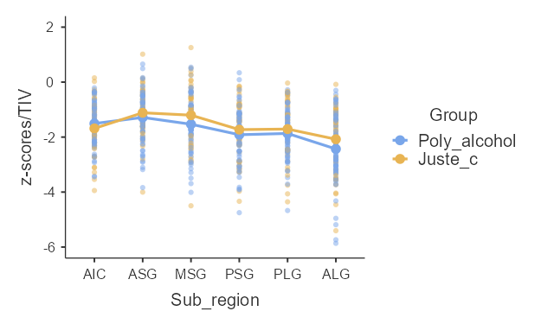**Supplementary Figure 1.** Effect plots of the grey matter volume deficits (z-scores) of insular subregions, in sCUD patients with (n=38) and without (n=23) a problematic alcohol use.

z-scores

PLG

ALG

PSG

MSG

ASG

AIC

sCUD

sCUD & problematic alcohol use

*Note.* AIC: Anterior Inferior Cortex; ALG: Anterior Long Gyrus; ASG: Anterior Short Gyrus; MSG: Middle Short Gyrus; PLG: Posterior Long Gyrus; PSG: Posterior Short Gyrus; sCUD: severe Crack/Cocaine Use Disorder.