**A Systematic Review and Meta-analysis of Music Interventions to Improve Sleep in Adults with Mental Health Problems**

**Supplementary material**

Nan Zhao1, Helle Nystrup Lund2, Kira Vibe Jespersen3

1Department of Psychology, University of Gothenburg, Gothenburg, Sweden

2Unit for Psychiatric Research, Aalborg University Hospital, Aalborg, Denmark

3Center for Music in the Brain, Department of Clinical Medicine, Aarhus University & The Royal Academy of Music Aarhus/Aalborg, Aarhus, Denmark

**Content:**

Supplementary Table S1 - Overview of database search results

Supplementary Figure S1 - Risk of bias overview plot

Supplementary Figure S2.1 - Sleep quality funnel plots

Supplementary Figure S2.2 - Depression funnel plots

Supplementary Figure S2.3 - Anxiety funnel plots

Supplementary Figure S3.1 - Sleep quality meta-analysis outlier analyses

Supplementary Figure S3.2 - Depression meta-analysis outlier analyses

Supplementary Figure S3.3 - Anxiety meta-analysis outlier analyses

Supplementary Figure S4.1 - Intervention duration and meta-analyses effect size comparison plot

Supplementary Figure S4.2 - Intervention duration and music group PSQI pre-post score change plot

Supplementary Figure S5 – Bayesian meta-analysis forest plot for sleep quality outcome (sensitivity analysis)

***Table S1 - Overview of database search results***

|  |  |  |  |
| --- | --- | --- | --- |
| **Search string for each database (*April, 2023*)** | | | |
| **Database** | **Filter** | **Search string** | **Results** |
| Pubmed | All fields | ("music*") AND ("sleep*" OR insomnia*) AND  (“schizo*” OR “delusion*” OR “psychot*” OR “catatonia” OR “bipolar” OR “cyclothymic” OR “anxiety” OR “anxious*” OR “depress*” OR “suici*” OR “selective mutism” OR “phobia” OR “panic” OR “obsessive” OR “compulsive” OR “OCD” OR “body dysmorphic” OR “reactive attachment” OR “disinhibited social engagement” OR “posttraumatic stress” OR “post-traumatic stress” OR “PTSD” OR “acute stress” OR “adjustment disorder*” OR “dissociative” OR “depersonalization” OR “derealization” OR “rumination disorder” OR “avoidant food intake disorder” OR “restrictive food intake disorder” OR “anorexia” OR “bulimia” OR “binge-eating” OR “binge eating” OR “oppositional defiant disorder” OR “ODD” OR “intermittent explosive disorder” OR “conduct disorder” OR “antisocial personality” OR “substance-related disorder*” OR “alcohol-related disorder” OR “alcohol related disorder” OR “caffeine-related disorder” OR “caffeine related disorder” OR “cannabis-related disorder” OR “cannabis related disorder” OR “hallucinogen-related disorder” OR “hallucinogen related disorder” OR “inhalant-related disorder” OR “inhalant related disorder” OR “opioid-related disorder” OR “opioid related disorder” OR “sedative-related disorder” OR “sedative related disorder” OR “hypnotic-related disorder” OR “hypnotic related disorder” OR “anxiolytic-related disorder” OR “anxiolytic related disorder” OR “stimulant-related disorder” OR “stimulant related disorder” OR “tobacco-related disorder” OR “tobacco related disorder” OR “gambling disorder” OR “neurocognitive disorder*” OR “delirium” OR “personality disorder*” OR “paranoid personality” OR “schizoid personality” OR “schizotypal personality” OR “borderline personality” OR “histrionic personality” OR “narcissistic personality” OR “avoidant personality” OR “dependent personality” OR “obsessive-compulsive personality” OR “obsessive compulsive personality” OR “mental disorder*” OR “psychopathol*” OR “psychiatric disorder*”) | 302 |
| Scopus | (Titles, Abstracts, Key words) | (TITLE-ABS-KEY("music*")) AND (TITLE-ABS-KEY ("sleep*" OR insomnia*)) AND  (TITLE-ABS-KEY(“schizo*” OR “delusion*” OR “psychot*” OR “catatonia” OR “bipolar” OR “cyclothymic” OR “anxiety” OR “anxious*” OR “depress*” OR “suici*” OR “selective mutism” OR “phobia” OR “panic” OR “obsessive” OR “compulsive” OR “OCD” OR “body dysmorphic” OR “reactive attachment” OR “disinhibited social engagement” OR “posttraumatic stress” OR “post-traumatic stress” OR “PTSD” OR “acute stress” OR “adjustment disorder*” OR “dissociative” OR “depersonalization” OR “derealization” OR “rumination disorder” OR “avoidant food intake disorder” OR “restrictive food intake disorder” OR “anorexia” OR “bulimia” OR “binge-eating” OR “binge eating” OR “oppositional defiant disorder” OR “ODD” OR “intermittent explosive disorder” OR “conduct disorder” OR “antisocial personality” OR “substance-related disorder*” OR “alcohol-related disorder” OR “alcohol related disorder” OR “caffeine-related disorder” OR “caffeine related disorder” OR “cannabis-related disorder” OR “cannabis related disorder” OR “hallucinogen-related disorder” OR “hallucinogen related disorder” OR “inhalant-related disorder” OR “inhalant related disorder” OR “opioid-related disorder” OR “opioid related disorder” OR “sedative-related disorder” OR “sedative related disorder” OR “hypnotic-related disorder” OR “hypnotic related disorder” OR “anxiolytic-related disorder” OR “anxiolytic related disorder” OR “stimulant-related disorder” OR “stimulant related disorder” OR “tobacco-related disorder” OR “tobacco related disorder” OR “gambling disorder” OR “neurocognitive disorder*” OR “delirium” OR “personality disorder*” OR “paranoid personality” OR “schizoid personality” OR “schizotypal personality” OR “borderline personality” OR “histrionic personality” OR “narcissistic personality” OR “avoidant personality” OR “dependent personality” OR “obsessive-compulsive personality” OR “obsessive compulsive personality” OR “mental disorder*” OR “psychopathol*” OR “psychiatric disorder*”)) | 636 |
| Embase | (Titles, Abstracts, Key words) | 'music*':ti,ab,kw AND ('sleep*':ti,ab,kw OR insomnia*:ti,ab,kw) AND ('schizo*':ti,ab,kw OR 'delusion*':ti,ab,kw OR 'psychot*':ti,ab,kw OR 'catatonia':ti,ab,kw OR 'bipolar':ti,ab,kw OR 'cyclothymic':ti,ab,kw OR 'anxiety':ti,ab,kw OR 'anxious*':ti,ab,kw OR 'depress*':ti,ab,kw OR 'suici*':ti,ab,kw OR 'selective mutism':ti,ab,kw OR 'phobia':ti,ab,kw OR 'panic':ti,ab,kw OR 'obsessive':ti,ab,kw OR 'compulsive':ti,ab,kw OR 'ocd':ti,ab,kw OR 'body dysmorphic':ti,ab,kw OR 'reactive attachment':ti,ab,kw OR 'disinhibited social engagement':ti,ab,kw OR 'posttraumatic stress':ti,ab,kw OR 'post-traumatic stress':ti,ab,kw OR 'ptsd':ti,ab,kw OR 'acute stress':ti,ab,kw OR 'adjustment disorder*':ti,ab,kw OR 'dissociative':ti,ab,kw OR 'depersonalization':ti,ab,kw OR 'derealization':ti,ab,kw OR 'rumination disorder':ti,ab,kw OR 'avoidant food intake disorder':ti,ab,kw OR 'restrictive food intake disorder':ti,ab,kw OR 'anorexia':ti,ab,kw OR 'bulimia':ti,ab,kw OR 'binge-eating':ti,ab,kw OR 'binge eating':ti,ab,kw OR 'oppositional defiant disorder':ti,ab,kw OR 'odd':ti,ab,kw OR 'intermittent explosive disorder':ti,ab,kw OR 'conduct disorder':ti,ab,kw OR 'antisocial personality':ti,ab,kw OR 'substance-related disorder*':ti,ab,kw OR 'alcohol-related disorder':ti,ab,kw OR 'alcohol related disorder':ti,ab,kw OR 'caffeine-related disorder':ti,ab,kw OR 'caffeine related disorder':ti,ab,kw OR 'cannabis-related disorder':ti,ab,kw OR 'cannabis related disorder':ti,ab,kw OR 'hallucinogen-related disorder':ti,ab,kw OR 'hallucinogen related disorder':ti,ab,kw OR 'inhalant-related disorder':ti,ab,kw OR 'inhalant related disorder':ti,ab,kw OR 'opioid-related disorder':ti,ab,kw OR 'opioid related disorder':ti,ab,kw OR 'sedative-related disorder':ti,ab,kw OR 'sedative related disorder':ti,ab,kw OR 'hypnotic-related disorder':ti,ab,kw OR 'hypnotic related disorder':ti,ab,kw OR 'anxiolytic-related disorder':ti,ab,kw OR 'anxiolytic related disorder':ti,ab,kw OR 'stimulant-related disorder':ti,ab,kw OR 'stimulant related disorder':ti,ab,kw OR 'tobacco-related disorder':ti,ab,kw OR 'tobacco related disorder':ti,ab,kw OR 'gambling disorder':ti,ab,kw OR 'neurocognitive disorder*':ti,ab,kw OR 'delirium':ti,ab,kw OR 'personality disorder*':ti,ab,kw OR 'paranoid personality':ti,ab,kw OR 'schizoid personality':ti,ab,kw OR 'schizotypal personality':ti,ab,kw OR 'borderline personality':ti,ab,kw OR 'histrionic personality':ti,ab,kw OR 'narcissistic personality':ti,ab,kw OR 'avoidant personality':ti,ab,kw OR 'dependent personality':ti,ab,kw OR 'obsessive-compulsive personality':ti,ab,kw OR 'obsessive compulsive personality':ti,ab,kw OR 'mental disorder*':ti,ab,kw OR 'psychopathol*':ti,ab,kw OR 'psychiatric disorder*':ti,ab,kw) | 393 |
| PsycINFO | (Not Full Text)  (Scholarly Journals OR Dissertations & Theses) | noft(("music*")) AND noft(("sleep*" OR insomnia*) ) AND noft((“schizo*” OR “delusion*” OR “psychot*” OR “catatonia” OR “bipolar” OR “cyclothymic” OR “anxiety” OR “anxious*” OR “depress*” OR “suici*” OR “selective mutism” OR “phobia” OR “panic” OR “obsessive” OR “compulsive” OR “OCD” OR “body dysmorphic” OR “reactive attachment” OR “disinhibited social engagement” OR “posttraumatic stress” OR “post-traumatic stress” OR “PTSD” OR “acute stress” OR “adjustment disorder*” OR “dissociative” OR “depersonalization” OR “derealization” OR “rumination disorder” OR “avoidant food intake disorder” OR “restrictive food intake disorder” OR “anorexia” OR “bulimia” OR “binge-eating” OR “binge eating” OR “oppositional defiant disorder” OR “ODD” OR “intermittent explosive disorder” OR “conduct disorder” OR “antisocial personality” OR “substance-related disorder*” OR “alcohol-related disorder” OR “alcohol related disorder” OR “caffeine-related disorder” OR “caffeine related disorder” OR “cannabis-related disorder” OR “cannabis related disorder” OR “hallucinogen-related disorder” OR “hallucinogen related disorder” OR “inhalant-related disorder” OR “inhalant related disorder” OR “opioid-related disorder” OR “opioid related disorder” OR “sedative-related disorder” OR “sedative related disorder” OR “hypnotic-related disorder” OR “hypnotic related disorder” OR “anxiolytic-related disorder” OR “anxiolytic related disorder” OR “stimulant-related disorder” OR “stimulant related disorder” OR “tobacco-related disorder” OR “tobacco related disorder” OR “gambling disorder” OR “neurocognitive disorder*” OR “delirium” OR “personality disorder*” OR “paranoid personality” OR “schizoid personality” OR “schizotypal personality” OR “borderline personality” OR “histrionic personality” OR “narcissistic personality” OR “avoidant personality” OR “dependent personality” OR “obsessive-compulsive personality” OR “obsessive compulsive personality” OR “mental disorder*” OR “psychopathol*” OR “psychiatric disorder*”)) | 184 |
| Cinahl | (None) | ("music*") AND ("sleep*" OR insomnia*) AND  (“schizo*” OR “delusion*” OR “psychot*” OR “catatonia” OR “bipolar” OR “cyclothymic” OR “anxiety” OR “anxious*” OR “depress*” OR “suici*” OR “selective mutism” OR “phobia” OR “panic” OR “obsessive” OR “compulsive” OR “OCD” OR “body dysmorphic” OR “reactive attachment” OR “disinhibited social engagement” OR “posttraumatic stress” OR “post-traumatic stress” OR “PTSD” OR “acute stress” OR “adjustment disorder*” OR “dissociative” OR “depersonalization” OR “derealization” OR “rumination disorder” OR “avoidant food intake disorder” OR “restrictive food intake disorder” OR “anorexia” OR “bulimia” OR “binge-eating” OR “binge eating” OR “oppositional defiant disorder” OR “ODD” OR “intermittent explosive disorder” OR “conduct disorder” OR “antisocial personality” OR “substance-related disorder*” OR “alcohol-related disorder” OR “alcohol related disorder” OR “caffeine-related disorder” OR “caffeine related disorder” OR “cannabis-related disorder” OR “cannabis related disorder” OR “hallucinogen-related disorder” OR “hallucinogen related disorder” OR “inhalant-related disorder” OR “inhalant related disorder” OR “opioid-related disorder” OR “opioid related disorder” OR “sedative-related disorder” OR “sedative related disorder” OR “hypnotic-related disorder” OR “hypnotic related disorder” OR “anxiolytic-related disorder” OR “anxiolytic related disorder” OR “stimulant-related disorder” OR “stimulant related disorder” OR “tobacco-related disorder” OR “tobacco related disorder” OR “gambling disorder” OR “neurocognitive disorder*” OR “delirium” OR “personality disorder*” OR “paranoid personality” OR “schizoid personality” OR “schizotypal personality” OR “borderline personality” OR “histrionic personality” OR “narcissistic personality” OR “avoidant personality” OR “dependent personality” OR “obsessive-compulsive personality” OR “obsessive compulsive personality” OR “mental disorder*” OR “psychopathol*” OR “psychiatric disorder*”) | 39 |
| RILM | (None) | ("music*") AND ("sleep*" OR insomnia*) AND  (“schizo*” OR “delusion*” OR “psychot*” OR “catatonia” OR “bipolar” OR “cyclothymic” OR “anxiety” OR “anxious*” OR “depress*” OR “suici*” OR “selective mutism” OR “phobia” OR “panic” OR “obsessive” OR “compulsive” OR “OCD” OR “body dysmorphic” OR “reactive attachment” OR “disinhibited social engagement” OR “posttraumatic stress” OR “post-traumatic stress” OR “PTSD” OR “acute stress” OR “adjustment disorder*” OR “dissociative” OR “depersonalization” OR “derealization” OR “rumination disorder” OR “avoidant food intake disorder” OR “restrictive food intake disorder” OR “anorexia” OR “bulimia” OR “binge-eating” OR “binge eating” OR “oppositional defiant disorder” OR “ODD” OR “intermittent explosive disorder” OR “conduct disorder” OR “antisocial personality” OR “substance-related disorder*” OR “alcohol-related disorder” OR “alcohol related disorder” OR “caffeine-related disorder” OR “caffeine related disorder” OR “cannabis-related disorder” OR “cannabis related disorder” OR “hallucinogen-related disorder” OR “hallucinogen related disorder” OR “inhalant-related disorder” OR “inhalant related disorder” OR “opioid-related disorder” OR “opioid related disorder” OR “sedative-related disorder” OR “sedative related disorder” OR “hypnotic-related disorder” OR “hypnotic related disorder” OR “anxiolytic-related disorder” OR “anxiolytic related disorder” OR “stimulant-related disorder” OR “stimulant related disorder” OR “tobacco-related disorder” OR “tobacco related disorder” OR “gambling disorder” OR “neurocognitive disorder*” OR “delirium” OR “personality disorder*” OR “paranoid personality” OR “schizoid personality” OR “schizotypal personality” OR “borderline personality” OR “histrionic personality” OR “narcissistic personality” OR “avoidant personality” OR “dependent personality” OR “obsessive-compulsive personality” OR “obsessive compulsive personality” OR “mental disorder*” OR “psychopathol*” OR “psychiatric disorder*”) | 74 |
| OSF | (Registrations) | ("music*") AND ("sleep*" OR insomnia*) AND  (“schizo*” OR “delusion*” OR “psychot*” OR “catatonia” OR “bipolar” OR “cyclothymic” OR “anxiety” OR “anxious*” OR “depress*” OR “suici*” OR “selective mutism” OR “phobia” OR “panic” OR “obsessive” OR “compulsive” OR “OCD” OR “body dysmorphic” OR “reactive attachment” OR “disinhibited social engagement” OR “posttraumatic stress” OR “post-traumatic stress” OR “PTSD” OR “acute stress” OR “adjustment disorder*” OR “dissociative” OR “depersonalization” OR “derealization” OR “rumination disorder” OR “avoidant food intake disorder” OR “restrictive food intake disorder” OR “anorexia” OR “bulimia” OR “binge-eating” OR “binge eating” OR “oppositional defiant disorder” OR “ODD” OR “intermittent explosive disorder” OR “conduct disorder” OR “antisocial personality” OR “substance-related disorder*” OR “alcohol-related disorder” OR “alcohol related disorder” OR “caffeine-related disorder” OR “caffeine related disorder” OR “cannabis-related disorder” OR “cannabis related disorder” OR “hallucinogen-related disorder” OR “hallucinogen related disorder” OR “inhalant-related disorder” OR “inhalant related disorder” OR “opioid-related disorder” OR “opioid related disorder” OR “sedative-related disorder” OR “sedative related disorder” OR “hypnotic-related disorder” OR “hypnotic related disorder” OR “anxiolytic-related disorder” OR “anxiolytic related disorder” OR “stimulant-related disorder” OR “stimulant related disorder” OR “tobacco-related disorder” OR “tobacco related disorder” OR “gambling disorder” OR “neurocognitive disorder*” OR “delirium” OR “personality disorder*” OR “paranoid personality” OR “schizoid personality” OR “schizotypal personality” OR “borderline personality” OR “histrionic personality” OR “narcissistic personality” OR “avoidant personality” OR “dependent personality” OR “obsessive-compulsive personality” OR “obsessive compulsive personality” OR “mental disorder*” OR “psychopathol*” OR “psychiatric disorder*”) | 14 |
| WHO Clinical Trails Database | (None) | ("music*") AND ("sleep*" OR insomnia*) AND  (“schizo*” OR “delusion*” OR “psychot*” OR “catatonia” OR “bipolar” OR “cyclothymic” OR “anxiety” OR “anxious*” OR “depress*” OR “suici*” OR “selective mutism” OR “phobia” OR “panic” OR “obsessive” OR “compulsive” OR “OCD” OR “body dysmorphic” OR “reactive attachment” OR “disinhibited social engagement” OR “posttraumatic stress” OR “post-traumatic stress” OR “PTSD” OR “acute stress” OR “adjustment disorder*” OR “dissociative” OR “depersonalization” OR “derealization” OR “rumination disorder” OR “avoidant food intake disorder” OR “restrictive food intake disorder” OR “anorexia” OR “bulimia” OR “binge-eating” OR “binge eating” OR “oppositional defiant disorder” OR “ODD” OR “intermittent explosive disorder” OR “conduct disorder” OR “antisocial personality” OR “substance-related disorder*” OR “alcohol-related disorder” OR “alcohol related disorder” OR “caffeine-related disorder” OR “caffeine related disorder” OR “cannabis-related disorder” OR “cannabis related disorder” OR “hallucinogen-related disorder” OR “hallucinogen related disorder” OR “inhalant-related disorder” OR “inhalant related disorder” OR “opioid-related disorder” OR “opioid related disorder” OR “sedative-related disorder” OR “sedative related disorder” OR “hypnotic-related disorder” OR “hypnotic related disorder” OR “anxiolytic-related disorder” OR “anxiolytic related disorder” OR “stimulant-related disorder” OR “stimulant related disorder” OR “tobacco-related disorder” OR “tobacco related disorder” OR “gambling disorder” OR “neurocognitive disorder*” OR “delirium” OR “personality disorder*” OR “paranoid personality” OR “schizoid personality” OR “schizotypal personality” OR “borderline personality” OR “histrionic personality” OR “narcissistic personality” OR “avoidant personality” OR “dependent personality” OR “obsessive-compulsive personality” OR “obsessive compulsive personality” OR “mental disorder*” OR “psychopathol*” OR “psychiatric disorder*”) | 44 |
| Cochrane Library | (Trails) | ("music*") in Title Abstract Keyword AND ("sleep*" OR insomnia*) in Title Abstract Keyword AND (“schizo*” OR “delusion*” OR “psychot*” OR “catatonia” OR “bipolar” OR “cyclothymic” OR “anxiety” OR “anxious*” OR “depress*” OR “suici*” OR “selective mutism” OR “phobia” OR “panic” OR “obsessive” OR “compulsive” OR “OCD” OR “body dysmorphic” OR “reactive attachment” OR “disinhibited social engagement” OR “posttraumatic stress” OR “post-traumatic stress” OR “PTSD” OR “acute stress” OR “adjustment disorder*” OR “dissociative” OR “depersonalization” OR “derealization” OR “rumination disorder” OR “avoidant food intake disorder” OR “restrictive food intake disorder” OR “anorexia” OR “bulimia” OR “binge-eating” OR “binge eating” OR “oppositional defiant disorder” OR “ODD” OR “intermittent explosive disorder” OR “conduct disorder” OR “antisocial personality” OR “substance-related disorder*” OR “alcohol-related disorder” OR “alcohol related disorder” OR “caffeine-related disorder” OR “caffeine related disorder” OR “cannabis-related disorder” OR “cannabis related disorder” OR “hallucinogen-related disorder” OR “hallucinogen related disorder” OR “inhalant-related disorder” OR “inhalant related disorder” OR “opioid-related disorder” OR “opioid related disorder” OR “sedative-related disorder” OR “sedative related disorder” OR “hypnotic-related disorder” OR “hypnotic related disorder” OR “anxiolytic-related disorder” OR “anxiolytic related disorder” OR “stimulant-related disorder” OR “stimulant related disorder” OR “tobacco-related disorder” OR “tobacco related disorder” OR “gambling disorder” OR “neurocognitive disorder*” OR “delirium” OR “personality disorder*” OR “paranoid personality” OR “schizoid personality” OR “schizotypal personality” OR “borderline personality” OR “histrionic personality” OR “narcissistic personality” OR “avoidant personality” OR “dependent personality” OR “obsessive-compulsive personality” OR “obsessive compulsive personality” OR “mental disorder*” OR “psychopathol*”) in Title Abstract Keyword - (Word variations have been searched) | 271 |
| ClincalTrials.gov | (Adults, older adults) | CONDITION OR DISEASE: sleep;  OTHER TERMS: music | 65 |
| CNKI | (Research paper) | 音乐 AND (睡眠+失眠) AND (心理+抑郁+焦虑)  *English translation:*  *Music AND (sleep + insomnia) AND (mental + depression + anxious)* | 316 |

***Figure S1 - Risk of bias overview plot***

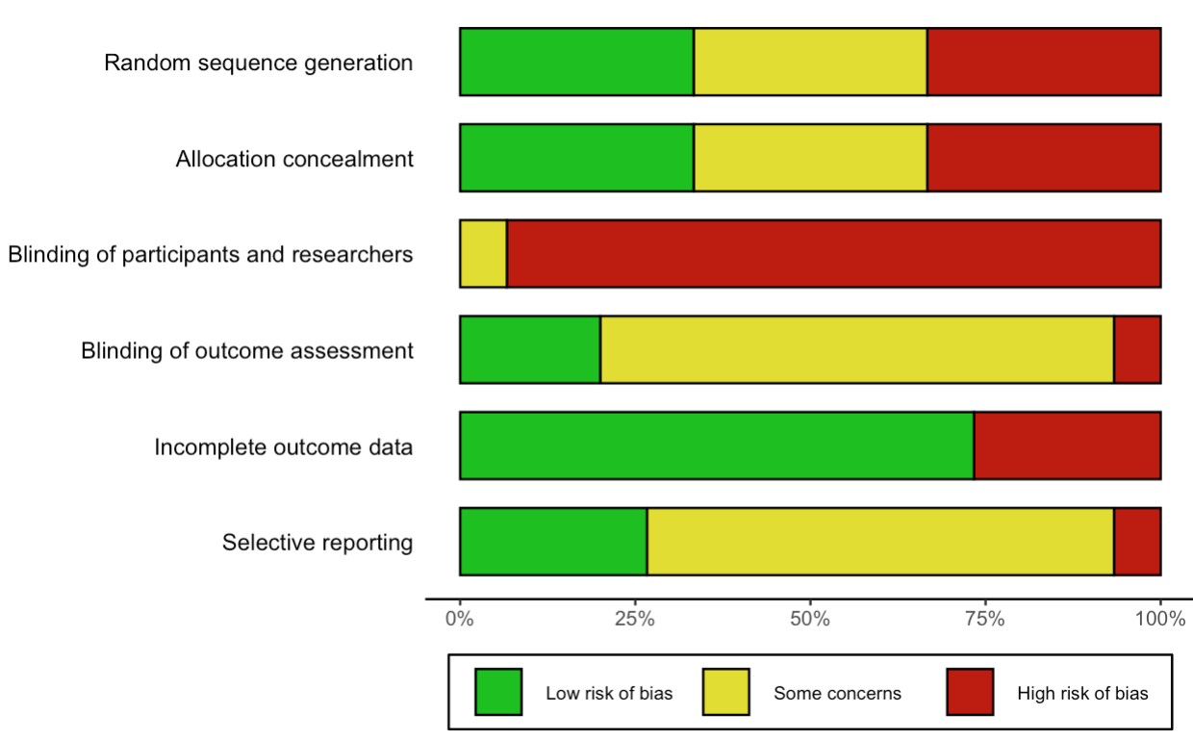

***Figure S2.1- Sleep quality funnel plots***

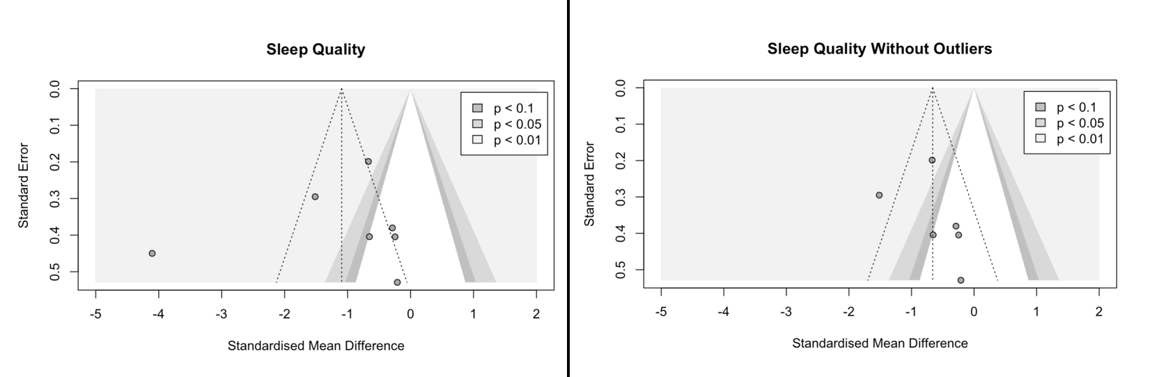

***Figure S2.2- Depression funnel plots***

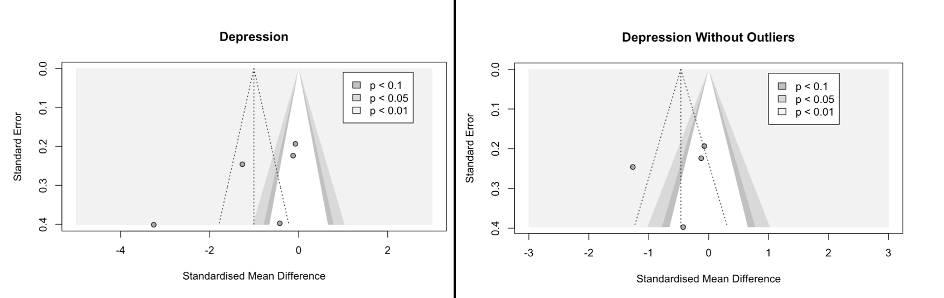

***Figure S2.3- Anxiety funnel plots***

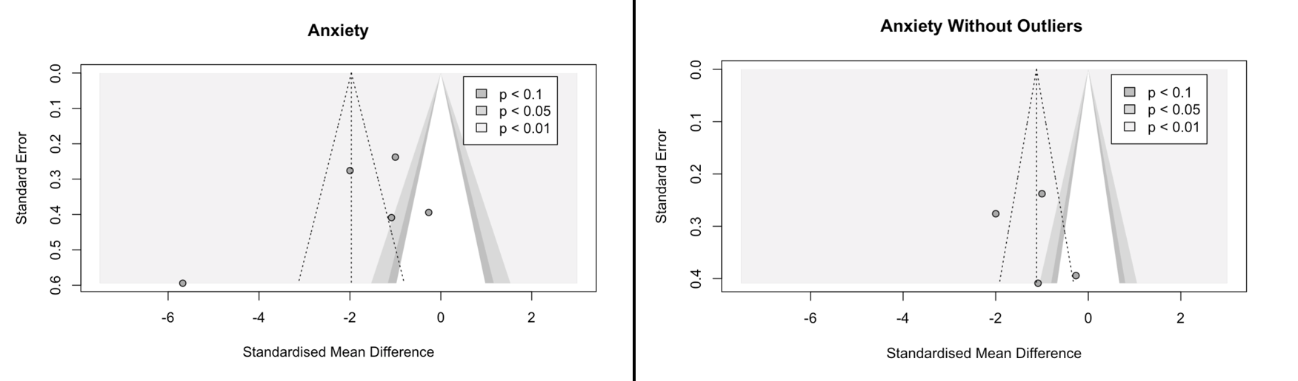

***Figure S3.1 - Sleep quality meta-analysis outlier analyses***

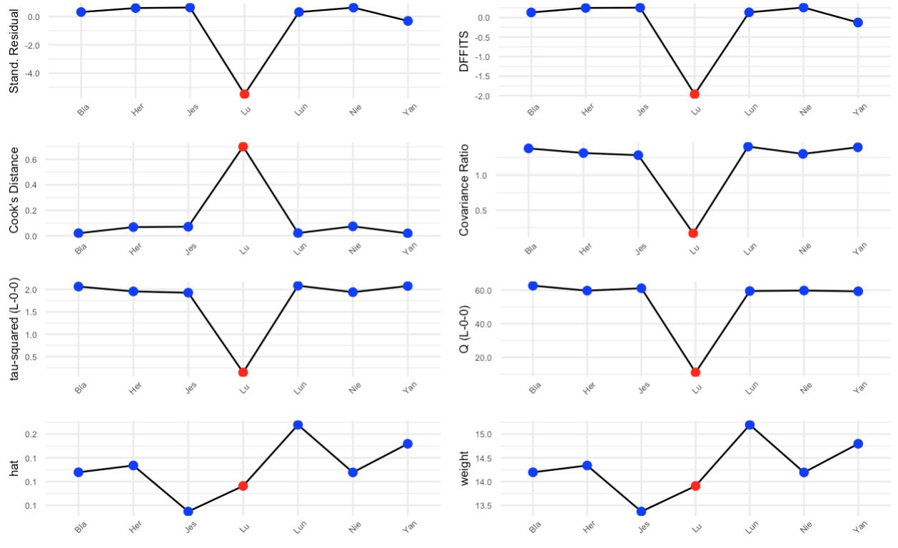

***Figure S3.2 - Depression meta-analysis outlier analyses***

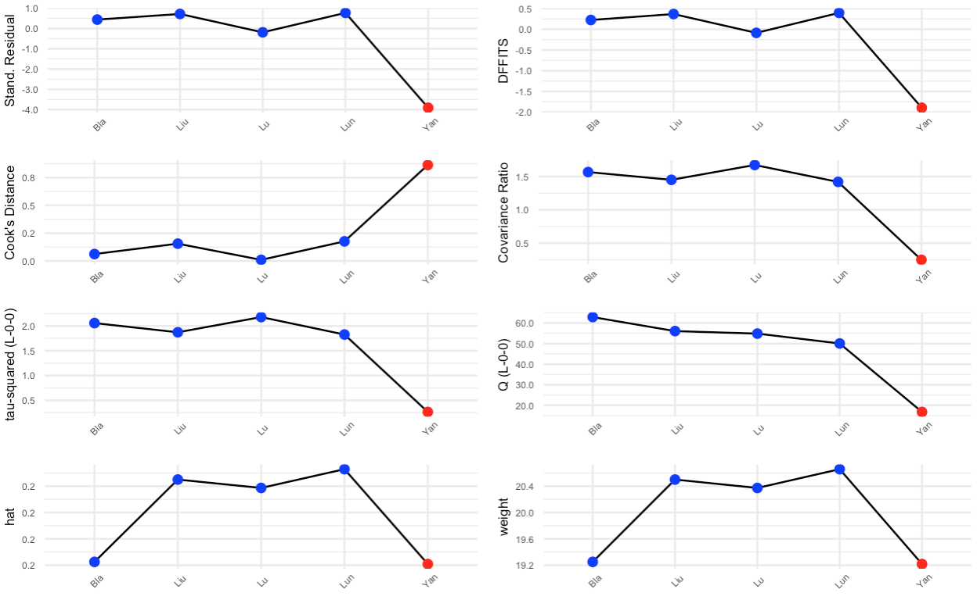

***Figure S3.3 - Anxiety meta-analysis outlier analyses***

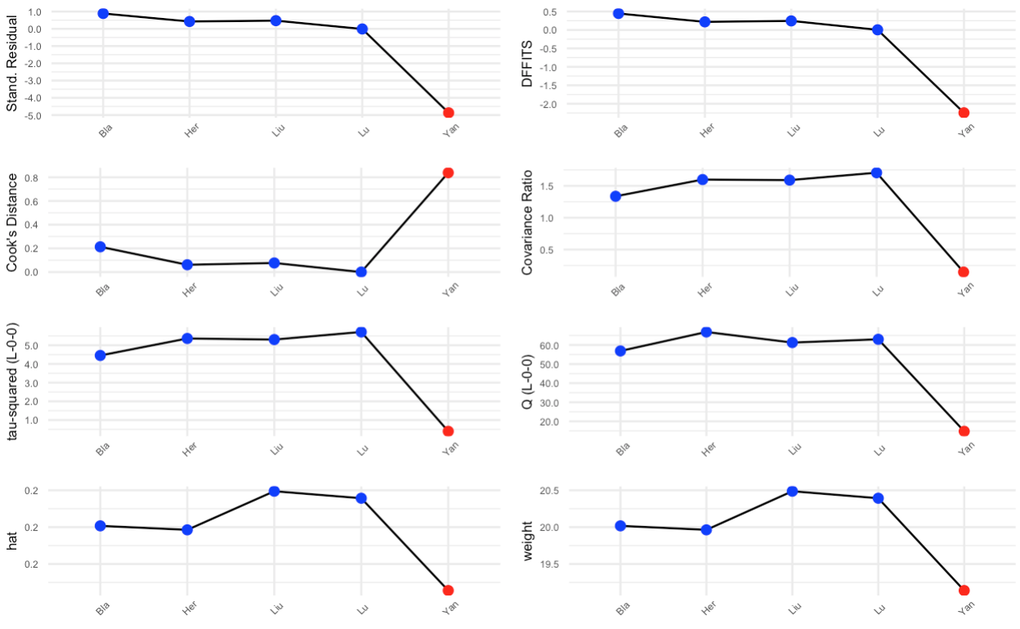

***Figure S4.1 - Intervention duration and meta-analyses effect size comparison plot***

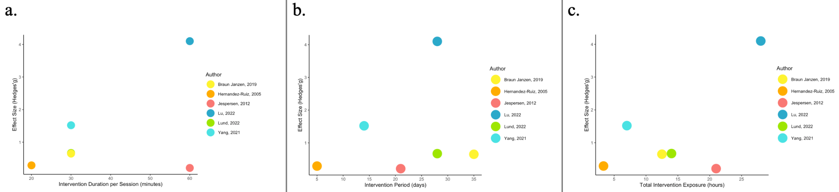

*Note. a.= music intervention duration per session (mins) vs. single study effect size; b.= intervention period vs. single effect size; c.= total intervention exposure (hours) (time per session x days) vs. single effect size. This graph only included studies that were in the sleep outcome meta-analysis*

***Figure S4.2 - Intervention duration and music group PSQI pre-post score change plot***

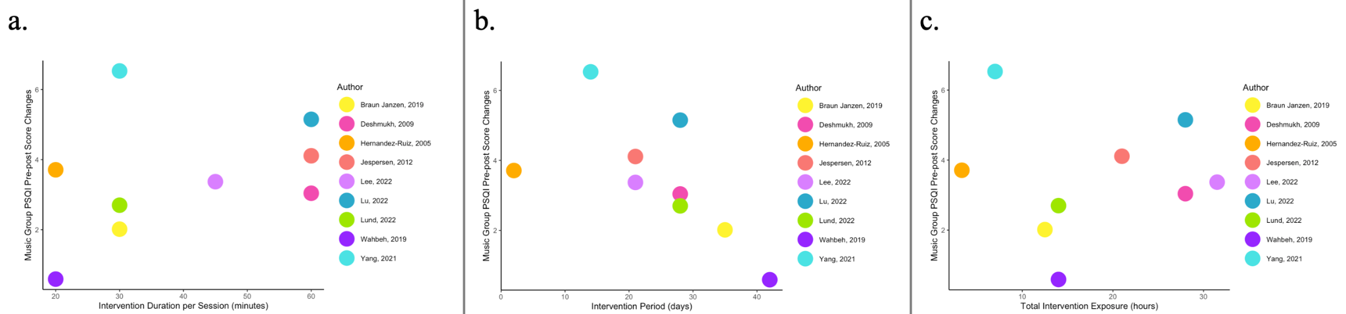

*Note. a.= music intervention duration per session (mins) vs. music group PSQI pre–post score changes; b.= intervention period vs. music group PSQI pre–post score changes; c.= total intervention exposure (hours) (time per session x days) vs. music group PSQI pre–post score changes. This graph included all studies that were in the systematic review using PSQI for sleep outcomes.*

***Figure S5 – Bayesian meta-analysis forest plot for sleep quality outcome (sensitivity analysis)***

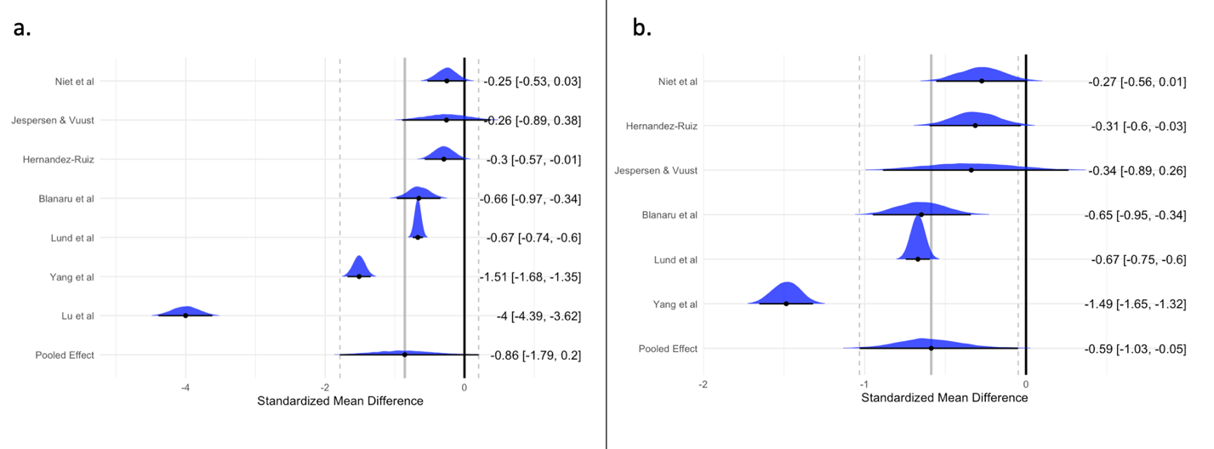

*Note. a. = results with the outlier (Lu), b. = results without the outlier; Weakly informative priors were used in this sensitivity analysis: with a normal distribution with a mean of 0 and a standard deviation of 1 for the overall effect size; with a Half- Cauchy distribution with a location parameter of 0 and a scale parameter of 0.5.*