Supplement to “Long-term benzodiazepine use and risk of labour market marginalization in Finland – A cohort study with five-year follow-up”, by Heidi Taipale, Antti Tanskanen, Terhi Kurko Tero Taiminen, Hanna Särkilä, Jari Tiihonen, Reijo Sund, Solja Niemelä, Leena Saastamoinen and Jarmo Hietala

Supplementary Table 1. Distribution of diagnosis for granted disability pensions for short-term and long-term benzodiazepine and related drug users.
ICD-10 | Description | Short-term users, N |  | Long-term users, N |  |  |  | chi-squared test p-value
A-B | Infectious and parasitic diseases | 7 |  | <5 |  |  |  |  | 0.322
C-D | Neoplasms and anaemias etc. | 133 |  | 77 |  |  |  |  | 0.001
E | Endocrine, nutritional and metabolic diseases | 28 |  | 21 |  |  |  |  | 0.700
F | Mental, Behavioural and Neurodevelopmental disorders | 1244 |  | 1246 |  |  |  |  | <0.001
G | Diseases of the nervous system | 186 |  | 188 |  |  |  |  | 0.070
H | Diseases of the eye and adnexa | 28 |  | 14 |  |  |  |  | 0.111
I | Diseases of the ear and mastoid process | 106 |  | 78 |  |  |  |  | 0.383
J | Diseases of the respiratory system | 35 |  | 27 |  |  |  |  | 0.746
K | Diseases of the digestive system | 37 |  | 18 |  |  |  |  | 0.055
L | Diseases of the skin and subcutaneous tissue | 11 |  | <5 |  |  |  |  | 0.069
M | Diseases of the musculoskeletal system and connective tissue | 738 |  | 449 |  |  |  |  | <0.001
N | Diseases of the genitourinary system | 7 |  | 7 |  |  |  |  | 0.741
Q | Congenital malformations, deformations and chromosomal abnormalities | 10 |  | <5 |  |  |  |  | 0.103
R | Symptoms, signs and abnormal clinical and laboratory findings, not elsewhere classified | 9 |  | 5 |  |  |  |  | 0.458
S | Injury, poisoning and certain other consequences of external causes | 97 |  | 101 |  |  |  |  | 0.126
T | Injury, poisoning and certain other consequences of external causes | 35 |  | 31 |  |  |  |  | 0.823
Z | Factors influencing health status and contact with health services | 5 |  | 6 |  |  |  |  | 0.551
NA | Not specified/ recorded | <5 |  | <5
Total |  | 2717 |  | 2277
Supplementary Table 2. Distribution of diagnosis for granted disability pensions for short-term and long-term benzodiazepine and related drug users in ICD-10 subcategory F, referring to ‘Mental, Behavioural and Neurodevelopmental disorders’.
ICD-10 subcategories |  |  | Short-term users, N |  | Long-term users, N |  | chi-squared test p-value
F0 Mental disorders due to known physiological conditions |  |  | 9 |  | 16 |  |  |  | 0.163
F1 Mental and behavioural disorders due to psychoactive substance use |  |  | 34 |  | 51 |  |  |  | 0.066
F2 Schizophrenia, schizotypal, delusional, and other non-mood psychotic disorders |  |  | 173 |  | 189 |  |  |  | 0.409
F3 Mood [affective] disorders |  |  | 885 |  | 840 |  |  |  | 0.264
F4 Anxiety, dissociative, stress-related, somatoform and other nonpsychotic mental disorders |  |  | 95 |  | 99 |  |  |  | 0.783
F5 Behavioural syndromes associated with physiological disturbances and physical factors |  |  | <5 |  | <5 |  |  |  | 0.707
F6 Disorders of adult personality and behaviour |  |  | 22 |  | 28 |  |  |  | 0.399
F7 Intellectual disabilities |  |  | 10 |  | 7 |  |  |  | 0.465
F8 Behavioural and emotional disorders with onset usually occurring in childhood and adolescence |  |  | 11 |  | 5 |  |  |  | 0.133
F9 Unspecified mental disorder |  |  | <5 |  | 7 |  |  |  | 0.096
Total |  |  | 1244 |  | 1246

Supplementary Figure 1. Cumulative incidence function curve for labour marker marginalization (A), disability pension (B), long-term sickness absence (C) and long-term unemployment (D) for long-term vs. short-term benzodiazepine and related drug users.

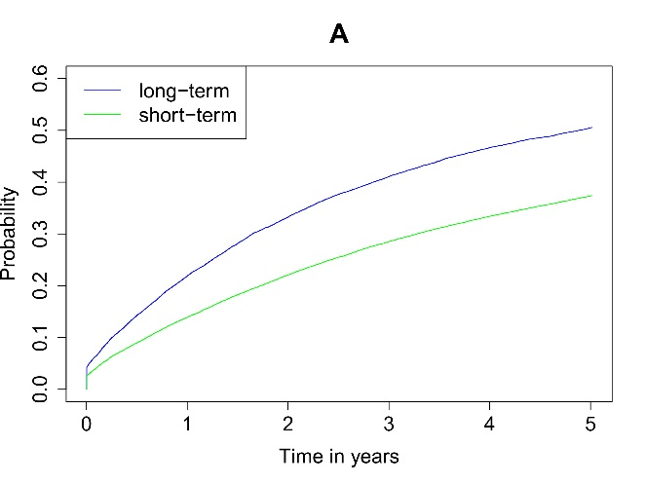 | 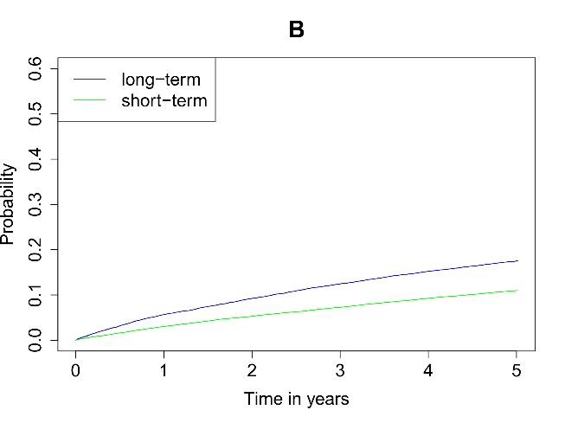
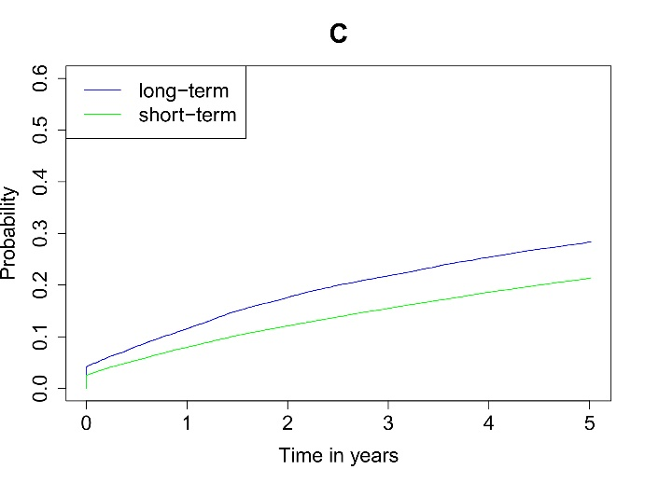 | 