Supplementary material

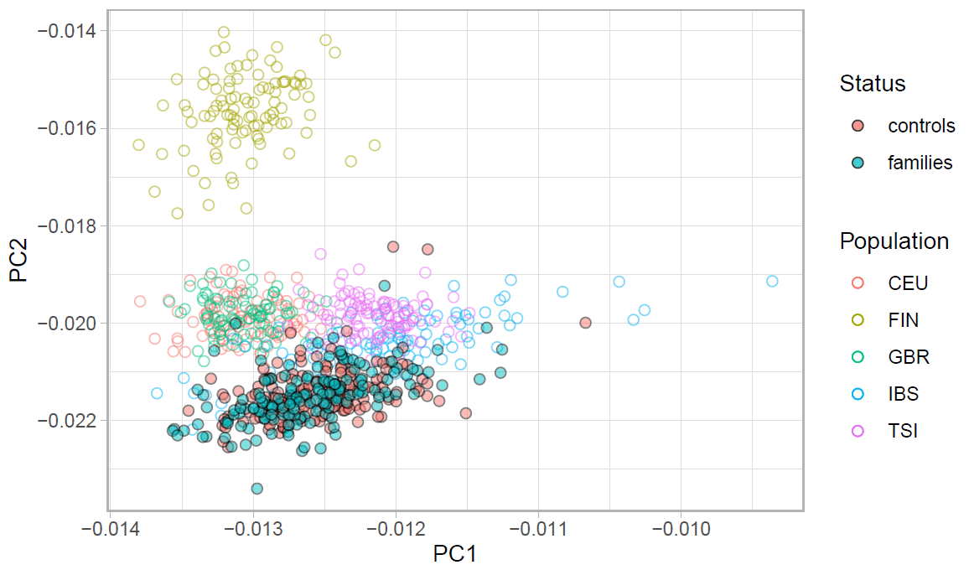
Figure 1. Scatter plot of the homogeneity of the participants based on ancestry principal components. The x-axis represents the first principal component (PC1), and the y-axis represents the second principal component (PC2). Based on 1000 Genomes Project European reference populations, the plot shows that our study participants (both families and controls) overlap with the Iberian population.

Notes on the estimation of deviation from family-IQ
Family-IQ was estimated in two different ways: 1) with all family members including patients (M= 109.25, SD= 9.32); 2) only unaffected relatives without patients (M= 105.13, SD= 8.90). Both measures are highly correlated (r= 0.83, p<0.001). Given the distribution of our sample, we performed the main analysis based on the family-IQ estimated on all participants.
The following Tables 1 and 2 show the results of the family-IQ as estimated on unaffected relatives only.
Table 1. The predictive effect of PGS-SCZ on IQ deviation from unaffected relatives using linear mixed models.
Fixed effects | Beta coefficient standardized (SE) | T | pFDR
PGS-SCZ | -0.17(0.05) | -3.42 | <0.001
Years of education | 0.18 (0.05) | 3.82 | <0.001
Age | 0.39 (0.05) | 7.78 | <0.001
Sex | 0.03 (0.05) | 0.69 | 0.487
Overall model: Wald= 106.77, p<0.001, R2= 0.24

Table 2. The predictive effect of PGS-IQ on IQ deviation from unaffected relatives using linear mixed models.
Fixed effects | Beta coefficient standardized (SE) | T | pFDR
PGS-IQ | 0.10 (0.05) | 2.12 | 0.045
Years of education | 0.19 (0.05) | 4.10 | <0.001
Age | 0.43 (0.05) | 8.90 | <0.001
Sex | 0.02 (0.05) | 0.500 | 0.617
Overall model: Wald= 97.73, p<0.001, R2= 0.22

