Supplementary Content
Figure S1. Study design and timelines
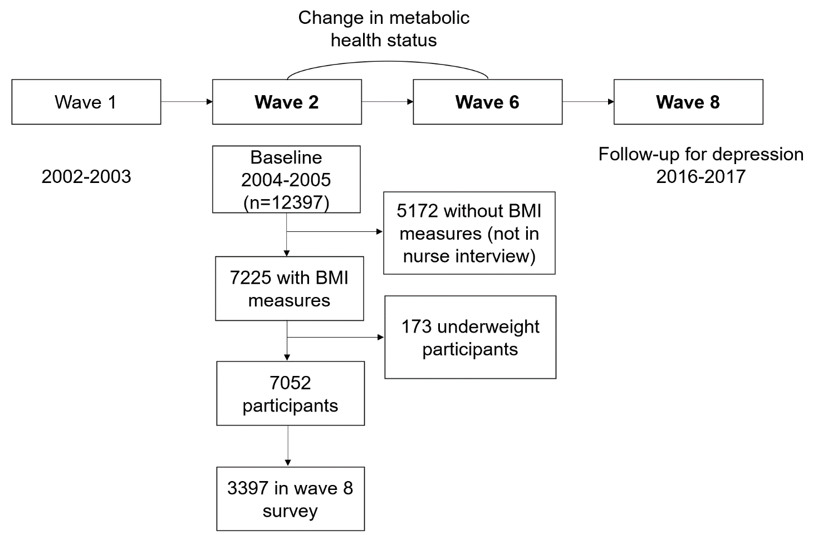
Table S1. Subgroup analyses on the association general obesity, metabolic health, and risk of depression
 | Non-obese |  | Obese |  | P value for interaction
 | Metabolically healthy | Metabolically unhealthy | Metabolically healthy | Metabolically unhealthy
Age |  |  |  |  | 0.39
<65 (n=2123)
OR, multivariate-adjusted† | 1 [Reference] | 1.24 (0.82-1.86) | 1.73 (1.11-2.68) | 1.73 (1.13-2.63)
≥65 (n=1274)
OR, multivariate-adjusted† | 1 [Reference] | 1.24 (0.83-1.87) | 0.94 (0.49-1.71) | 1.51 (0.95-2.40)
Sex |  |  |  |  | 0.49
Male (n=1463)
OR, multivariate-adjusted† | 1 [Reference] | 1.77 (1.06-2.97) | 1.78 (0.87-3.48) | 2.27 (1.26-4.07)
Female (n=1934)
OR, multivariate-adjusted† | 1 [Reference] | 1.11 (0.78-1.57) | 1.29 (0.85-1.95) | 1.44 (1.00-2.07)
Smoking |  |  |  |  | 0.99
Never (n=1384)
OR, multivariate-adjusted† | 1 [Reference] | 1.18 (0.74-1.85) | 1.56 (0.87-2.70) | 1.63 (0.98-2.70)
Ever (n=2013)
OR, multivariate-adjusted† | 1 [Reference] | 1.31 (0.90-1.90) | 1.40 (0.87-2.20) | 1.61 (1.08-2.39)
†Adjusted for age, sex, race/ethnicity, education level, smoking, alcohol consumption, physical activity, cardiovascular diseases, history of psychiatric disorders, CES-D score, and mutually for other metabolic risk factors at baseline.

Table S2. Sensitivity analyses on the association general obesity, metabolic health, and risk of depression
a, metabolic health at baseline
 | Non-obese |  | Obese
 | Metabolically healthy | Metabolically unhealthy | Metabolically healthy | Metabolically unhealthy
SA1: Excluding participants with diagnosed mental disorders at baseline (n=3186) | 1 [Reference] | 1.30 (0.96-1.75) | 1.38 (0.93-2.01) | 1.64 (1.18-2.28)
SA2: Further adjustment for other chronic diseases at baseline† | 1 [Reference] | 1.24 (0.91-1.68) | 1.39 (0.95-2.01) | 1.64 (1.17-2.30)
SA3: Further adjustment for central obesity# | 1 [Reference] | 1.24 (0.93-1.65) | 1.26 (0.84-1.88) | 1.43 (1.00-2.05)
SA4: Further adjustment for weight change between baseline at wave 2 and wave 6 | 1 [Reference] | 1.17 (0.86-1.60) | 1.34 (0.90-1.97) | 1.58 (1.12-2.21)
SA5: Using wave 9 data for the follow-up of depression (n=2950) | 1 [Reference] | 1.14 (0.84-1.53) | 1.14 (0.77-1.67) | 1.46 (1.04-2.03)
SA6: Excluding participants who were metabolically healthy obese at baseline but were not already obese at wave 0* (n=3288) | 1 [Reference] | 1.26 (0.95-1.68) | 1.57 (1.06-2.30) | 1.62 (1.18-2.20)
b, change in metabolic health between baseline and follow-up
 | Non-obese at baseline |  |  | Obese at baseline
 | Metabolically healthy at baseline |  | Metabolically unhealthy at baseline | Metabolically healthy at baseline |  | Metabolically unhealthy at baseline
 | Metabolically healthy at follow-up | Metabolically unhealthy at follow-up |  | Metabolically healthy at follow-up | Metabolically unhealthy at follow-up
SA1: Excluding participants with diagnosed mental disorders at baseline (n=3186) | 1 [Reference] | 1.38 (0.91-2.09) | 1.48 (1.04-2.12) | 1.64 (0.95 -2.76) | 1.52 (0.88-2.56) | 1.88 (1.29-2.76)
SA2: Further adjustment for other chronic diseases at baseline† | 1 [Reference] | 1.48 (1.00-2.18) | 1.48 (1.06-2.09) | 1.67 (0.99-2.74) | 1.69 (1.03-2.74) | 1.88 (1.32-2.70)
SA3: Further adjustment for central obesity# | 1 [Reference] | 1.46 (0.99-2.16) | 1.46 (1.04-2.05) | 1.48 (0.86-2.52) | 1.49 (0.88-2.49) | 1.69 (1.13-2.53)
SA4: Further adjustment for weight change between baseline at wave 2 and wave 6 | 1 [Reference] | 1.37 (0.90-2.08) | 1.34 (0.93-1.94) | 1.46 (0.80-2.56) | 1.58 (0.92-2.66) | 1.81 (1.23-2.67)
SA5: Using wave 9 data for the follow-up of depression (n=2950) | 1 [Reference] | 1.17 (0.78-1.74) | 1.21 (0.86-1.71) | 0.96 (0.52-1.70) | 1.45 (0.87-2.38) | 1.55 (1.07-2.25)
SA6: Excluding participants who were metabolically healthy obese at baseline but were not already obese at wave 0* (n=3288) | 1 [Reference] | 1.48 (1.00-2.18) | 1.49 (1.07-2.09) | 1.70 (0.95-2.94) | 2.00 (1.17-3.33) | 1.91 (1.34-2.73)
†Other chronic diseases included cardiovascular diseases, lung disease, asthma, arthritis, osteoporosis, cancer, Parkinson's disease, and dementia. Models were adjusted for age, sex, race/ethnicity, education level, smoking, alcohol consumption, physical activity, cardiovascular diseases, history of psychiatric disorders, CES-D score, and additionally for other covariates in sensitivity analyses.
#Central obesity as defined by waist circumference.
*73.5% of the metabolically healthy obese participants at baseline were in fact classified as obese already at wave 0.

