Supplementary material

Table S1. Baseline characteristics
Characteristic | Total
 | n= 111
Age (years)
Mean, SD | 43.2, 11.2
Min, max | 20, 65
Prior duration of PP1M (months)
Mean, SD | 33.6, 24.9
Min, max | 3, 85
 | n (%)
Sex
Female | 35 | (31.5)
Male | 76 | (68.5)
Ethnicity
Asian/ Asian British¹ | 7 | (6.3)
Black/ Black British | 72 | (64.9)
Mixed Background | 5 | (4.5)
Other | 8 | (7.2)
White | 19 | (17.1)
Care setting on initiation of PPLAI (1M)
Inpatient | 57 | (51.4)
Outpatient | 54 | (48.6)
Considered treatment-responsive
No | 34 | (30.6)
Yes | 77 | (69.4)
Polypharmacy for ≥1 month
No² | 97 | (87.4)
Yes | 14 | (12.6)
Oral aripiprazole | 5 | (4.5)
Oral olanzapine | 2 | (1.8)
Oral risperidone | 6 | (5.4)
Oral aripiprazole and oral risperidone | 1 | (0.9)
Prior PP1M dose
150mg | 39 | (35.1)
100mg | 44 | (39.6)
75mg | 18 | (16.2)
50mg | 10 | (9.0)
¹Asian refers to Indian-subcontinent as per NHS ethnicity classifications.
²One patient received one administration of flupentixol 100mg in error.

Table S2. PP3M characteristics
PP3M | Total
 | n= 111
Initial PP3M dose [n (%)]
525mg | 36 | (32.4)
350mg | 46 | (41.4)
263mg | 18 | (16.2)
175mg | 11 | (9.9)
Dose change [n (%)]
None | 87 | (85.3)
Increase [n (%)] | 4 | (3.9)
Worsening symptoms | 3 | (75.0)
Patient request | 1 | (25.0)
Decrease [n (%)] | 11 | (10.8)
Patient request | 5 | (45.5)
Adverse effects | 4 | (36.4)
Improved condition | 1 | (9.1)
Unclear | 1 | (9.1)

Table S3 Substance abuse
Substance abuse (SA) | Total
 | n=111
 | n | %
No history of SA or confirmed diagnosis | 40 | (36.0)
History of SA | 61 | (55.0)
Diagnosis of SA | 10 | (9.0)
F10 | 1 | (1)
F12 | 5 | (4.5)
F19 | 3 | (3)
F10 and F19 | 1 | (1)
Continuers | 62
No history of SA or confirmed diagnosis | 27 | (43.5)
History of SA | 33 | (53.2)
Diagnosis of SA | 2 | (3.2)
Discontinuers | 40
No history of SA or confirmed diagnosis | 11 | (27.5)
History of SA | 23 | (57.5)
Diagnosis of SA | 6 | (15.0)
Relative risk (RR) 95%CI
Discontinuation and SA | 1.28 | 0.961- 1.717

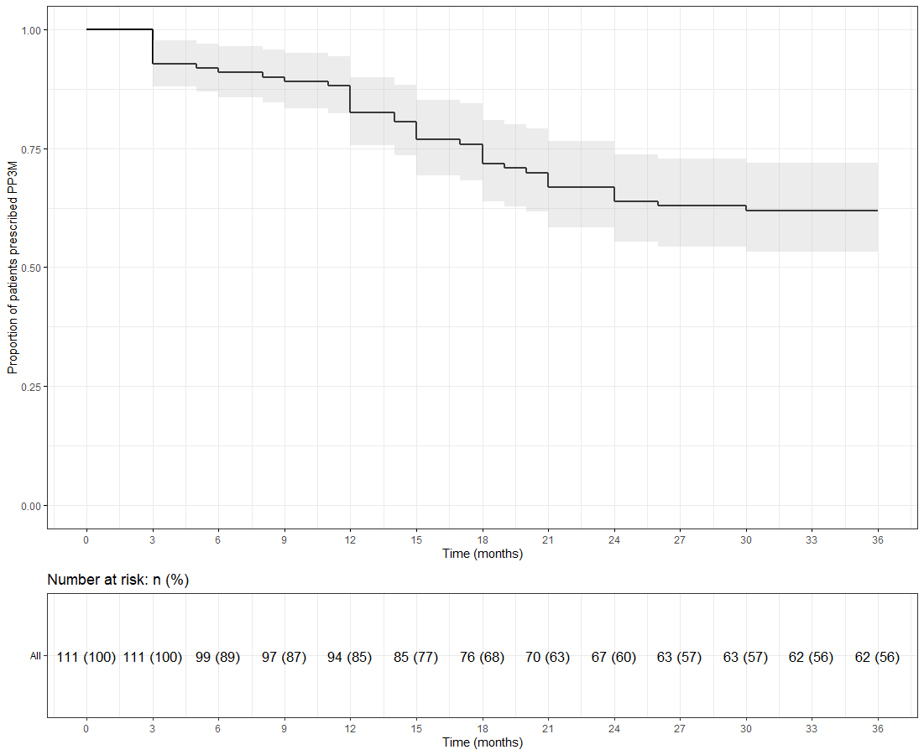
Figure S1: Kaplan-Meier plot showing the proportion of patients prescribed PP3M since initiation and at 36 months

Table S4. Discontinuation from PP3M
Clinical Outcome after three years (PP3M)
 | n= 111
Outcome three years after initiating PP3M [n (%)]
Continuation | 62 | (55.9)
Discontinuation | 40 | (36.0)
Attrition | 9 | (8.1)
 | n= 40
Reasons for discontinuation [n (%)]
Patient refusal | 12 | (30.0)
Perceived inefficacy | 9 | (22.5)
Adverse effects | 9 | (22.5)
Patient request | 5 | (12.5)
Independent health condition¹ | 3 | (7.5)
Need more flexible dose adjustment | 2 | (5.0)
Next medication (6 months after last depot) [n (%)]
PP1M | 19 | (47.5)
No medication* | 7 | (17.5)
Risperidone (oral) | 4 | (10.0)
Aripiprazole (oral) | 4 | (10.0)
Haloperidol (oral) | 2 | (5.0)
Quetiapine (oral) | 1 | (2.5)
Flupentixol (LAI) | 1 | (2.5)
Zuclopenthixol (LAI) | 1 | (2.5)
Lurasidone (oral) | 1 | (2.5)
 | n= 9
Reasons for attrition [n (%)]
Lost to follow-up² | 7 | (77.8)
Died³ | 2 | (22.2)
¹Independent health condition: cancer (n=2) and kidney problems.
²Lost to follow up: missing person (n=3), left country (n=2), changed trust (n=1), disengagement (n=1)
³Deaths classified using ePJS and not at a systems level: non-adherence to diabetes medication (n=1)
and unknown (n=1).
*All refused medication.

Table S5. Discontinuation from PPLAI (1M or 3M)
Clinical Outcome after three years (1M or 3M)
 | n= 111
Outcome three years after initiating PPLAIs (1M and 3M) [n (%)]
Continuation | 74 | (66.7)
Discontinuation | 26 | (23.4)
Attrition | 11 | (9.9)
 | n= 25
Reasons for discontinuation | [n (%)]
Patient refusal | 10 | (43.5)
Adverse effects | 5 | (21.7)
Perceived inefficacy | 3 | (13.0)
Patient request | 3 | (13.0)
Independent health condition | 2 | (8.7)
 | n= 11
Reasons for attrition [n (%)]
Lost to follow-up¹ | 9 | (81.8)
Died | 2 | (18.2)
¹ The two additional patients lost to follow-up were because of changing trust and being discharged to their GP.

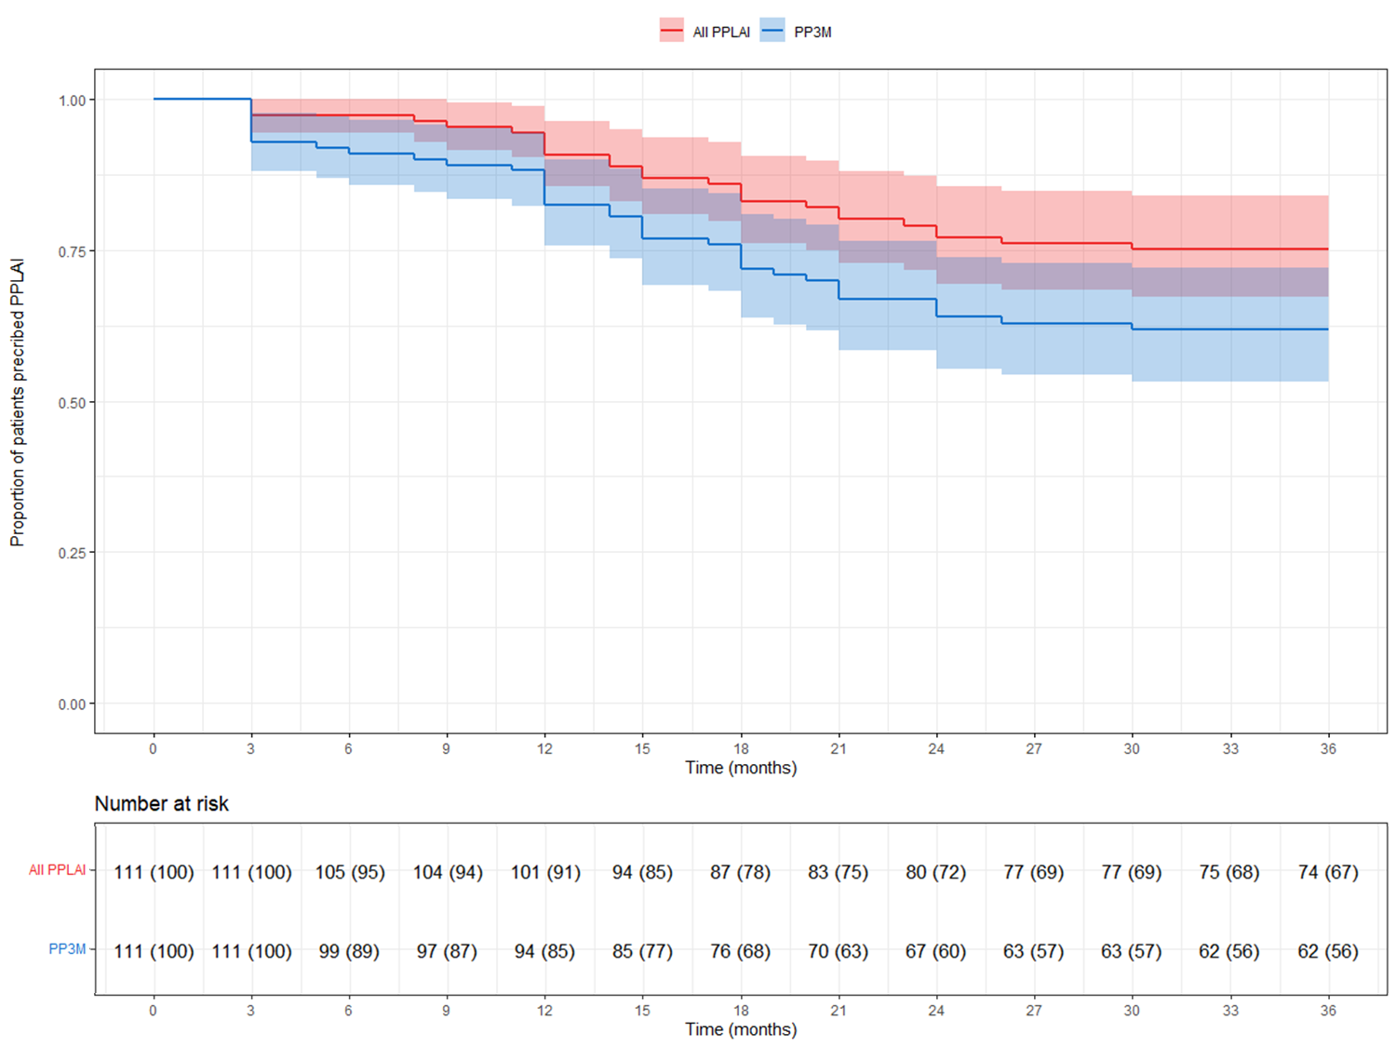
Figure S2- Kaplan-Meier plot showing the proportion of patients (with 95% confidence interval) prescribed PPLAI since PP3M initiation. All PPLAI (PP3M followed by PP1M and in some cases PP3M again) is shown in red and PP3M only is shown in blue.

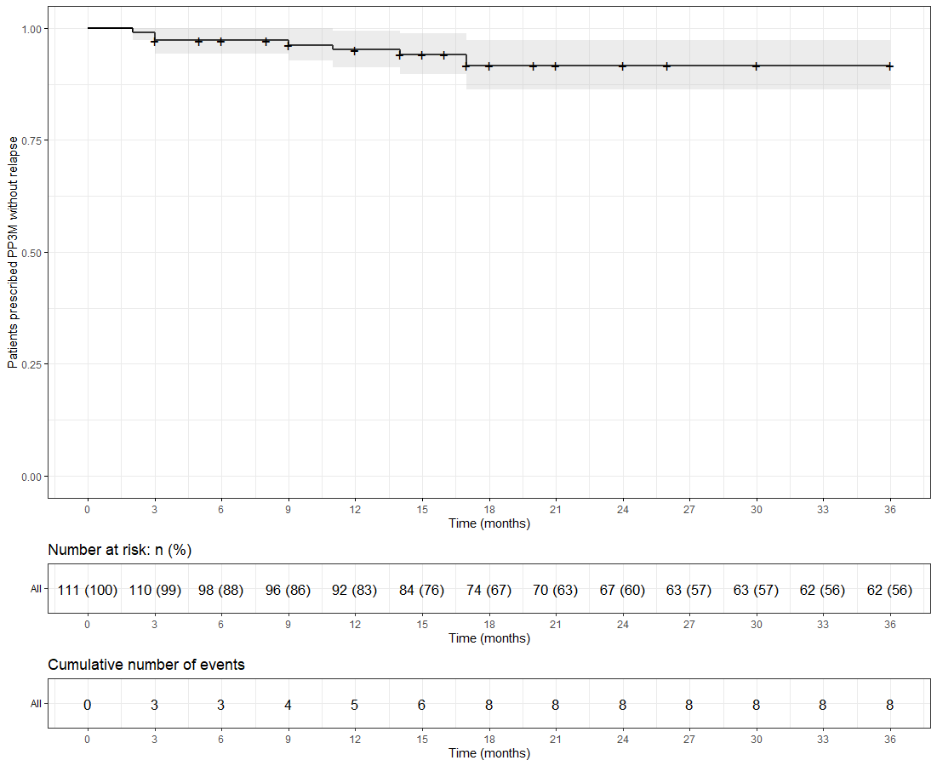
Figure S3- Kaplan-Meier plot showing the proportion of patients that relapsed (with 95% confidence interval) whilst being prescribed PP3M. Patients who discontinued were censored (shown as a dash on the plot).

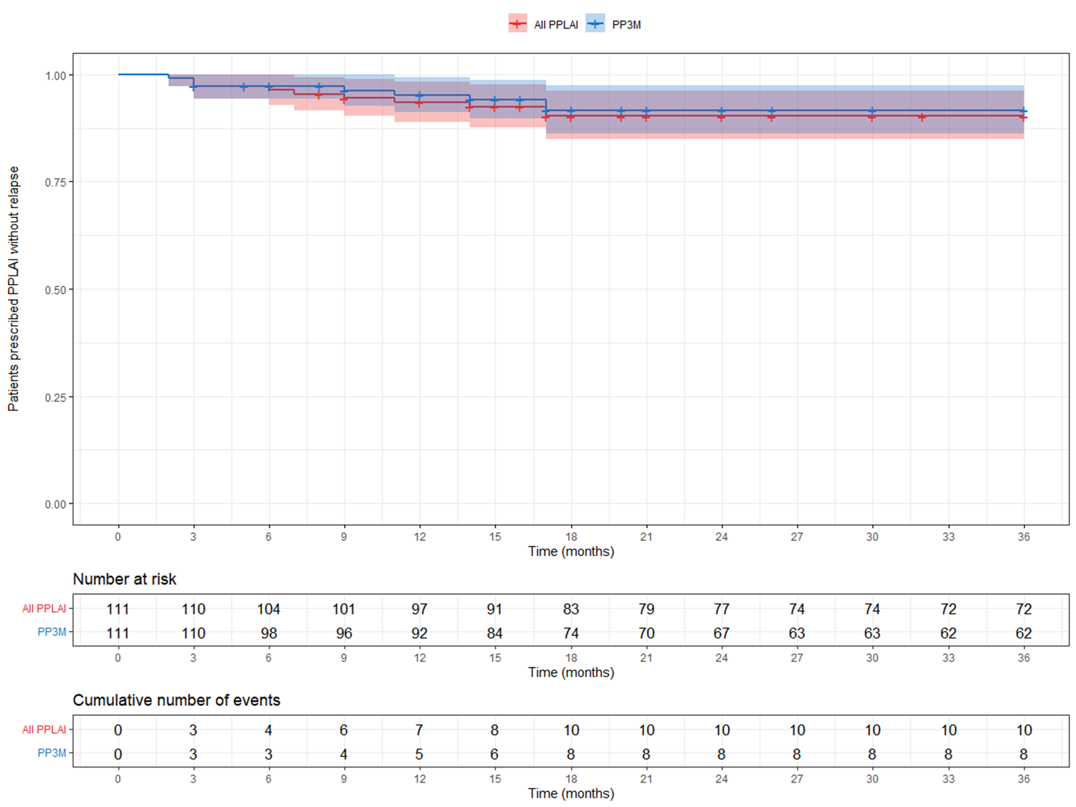
Figure S4- Kaplan-Meier plot showing the proportion of patients that relapsed (with 95% confidence interval) whilst being prescribed PPLAI. Patients who discontinued were censored (shown as a dash on the plot). All PPLAI (PP3M followed by PP1M and in some cases PP3M) is shown in red and PP3M only is shown in blue.

