SUPPLEMENTARY APPENDIX
1. Complete search strategy
1.1 MEDLINE (Ovid)
1 exp Antipsychotic Agents/
2 (Antipsychotic* or neuroleptic or acepromazine or acetophenazine or amisulpride or aripiprazole or asenapine or benperidol or brexpiprazole or bromperidol or butaperazine or cariprazine or chlorpromazine or chlorproethazine or chlorprothixene or clopenthixol or clotiapine or clozapine or cyamemazine or dixyrazine or droperidol or fluanisone or flupentixol or fluphenazine or fluspirilene or haloperidol or iloperidone or levomepromazine or levosulpiride or loxapine or lurasidone or melperone or mesoridazine or molindone or moperone or mosapramine or olanzapine or oxypertine or paliperidone or penfluridol or perazine or periciazine or perphenazine or pimavanserin or pimozide or pipamperone or pipotiazine or prochlorperazine or promazine or prothipendyl or quetiapine or remoxipride or risperidone or sertindole or sulpiride or sultopride or tiapride or thiopropazate or thioproperazine or thioridazine or tiotixene or trifluoperazine or trifluperidol or triflupromazine or veralipride or ziprasidone or zotepine or zuclopenthixol).ti,ab,kw,kf.
3 (("first episode" or "early onset") adj5 (psycho* or schizophre* or bipolar or manic or mania or schizoaffective)).ti,ab,kw,kf.
4 ("first episode" or "early onset").ti,ab,kw,kf. adj5 exp Psychotic Disorders/
5 Clinical trial.pt. or randomized.ab. or placebo.ab. or drug therapy.fs. or randomly.ab. or trial.ab. or groups.ab.
6 exp Withholding Treatment/
7 (Withholding or withdraw* or Maintenance or Continue or adjust or stop or reduction or discontinuation or Cessation or placebo or prophylactic or halt* or intermittent).ti,ab,kw,kf.
8 (1 or 2) and (3 or 4) and 5 and (6 or 7)

Supplemental Table 1. The Effect of Antipsychotic Discontinuation on Hospital Admission - Subgroup Analysis
Subgroup | Trials | Participants | I² | Risk ratio  IV, Random, 95% CI
Overall | 6 | 336 | 28% | 2.01 (0.96, 4.22)
Bias
- Low risk of bias | 0 | 0 | -
- Some concerns | 2 | 193 | 0% | 3.54 (1.28, 9.77)
- High risk of bias | 4 | 143 | 12% | 1.35 (0.62, 2.96)
Discontinuation method
- Abrupt discontinuation | 2 | 15 | - | 10.13 (0.64, 160.32)
- Gradual discontinuation | 5 | 321 | 24% | 1.75 (0.85, 3.58)
Remission duration
- < 12 months | 2 | 79 | 0% | 0.96 (0.47, 1.97)
- ≥ 12 months | 4 | 257 | 0% | 3.83 (1.61, 9.08)
Antipsychotics
- FGA | 1 | 15 | - | 10.13 (0.64, 160.32)
- SGA | 2 | 207 | 0% | 2.28 (0.89, 5.83)
- Mixed | 3 | 114 | 41% | 1.88 (0.53, 6.72)
DDDª
- < 0.9 | 3 | 114 | 41% | 1.88 (0.53, 6.72)
- [0.9, 1.1] | 2 | 207 | 0% | 2.28 (0.89, 5.83)
- > 1.1 | 0 | 0 | - | -
IV: inverse variance; CI: confidence intervals; FGA: First generation antipsychotics; SGA: Second generation antipsychotics; DDD: Defined Daily Dose.
ªMcCreadie et al. did not report any doses of antipsychotic used by participants.
Supplemental Figure 1. Funnel Diagram for the Hospital Admission Outcome
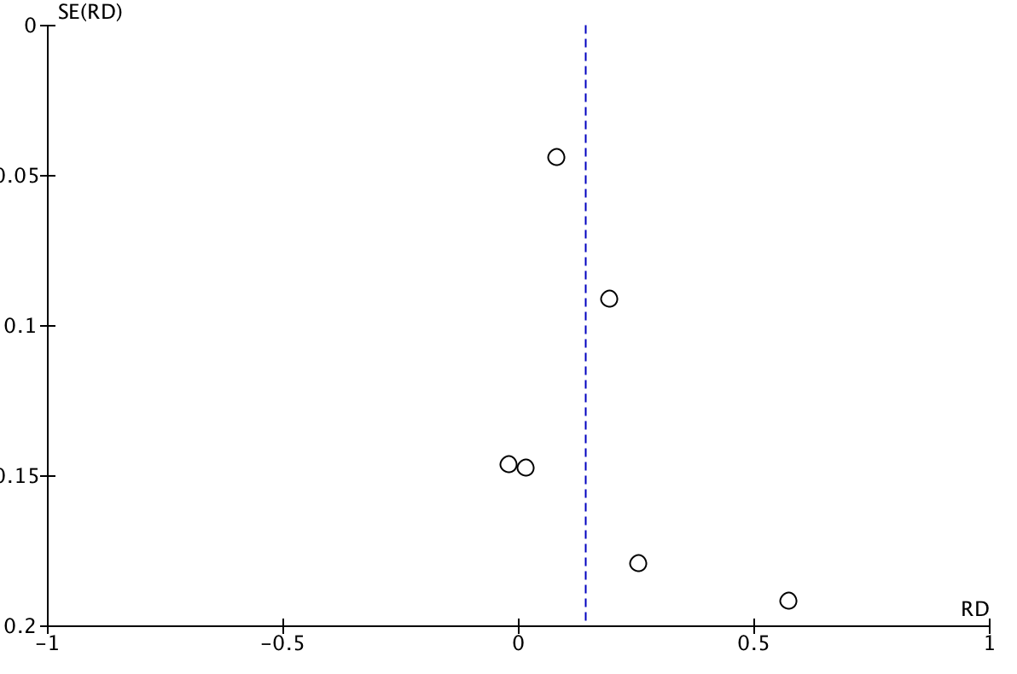

Supplemental Figure 2. The Effect of Antipsychotic Discontinuation on Positive Symptomsª

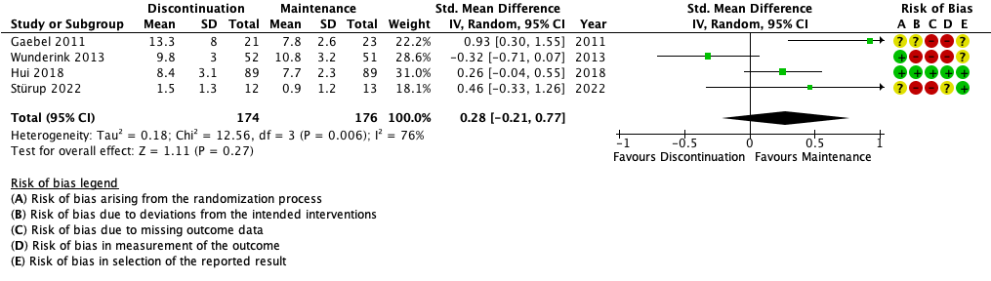
Std.: Standardized; IV: inverse variance; CI: confidence intervals.
ª The following scales were used for the meta-analysis: Positive And Negative Syndrome Scale – Positive subscale in Gaebel et al., Hui et al. and Wunderink et al. The Scales for the Assessment of Positive Symptoms was used in Stürup et al.

Supplemental Table 2. The Effect of Antipsychotic Discontinuation on Positive Symptomsª - Subgroup Analysis
Subgroup | Trials | Participants | I² | SMD^{b}  IV, Random, 95% CI
Overall | 4 | 350 | 76% | 0.28 (-0.21, 0.77)
Remission duration
- < 12 months | 2 | 128 | 67% | -0.01 (-0.76, 0.74)
- ≥ 12 months | 2 | 222 | 72% | 0.53 (-0.12, 1.18)
Antipsychotics
- FGA | 0 | - | - | -
- SGA | 2 | 203 | 0% | 0.28 (0.00, 0.56)
- Mixed | 2 | 172 | 83% | 0.45 (-0.41, 1.30)
DDD
- < 0.9 | 2 | 147 | 91% | 0.28 (-0.94, 1.50)
- [0.9, 1.1] | 2 | 203 | 0% | 0.28 (0.00, 0.56)
- > 1.1 | 0 | 0 | - | -
SMD: Standardized mean difference; IV: Inverse variance; CI: Confidence intervals; FGA: First generation antipsychotics; SGA: Second generation antipsychotics; DDD: Defined Daily Dose.
ª The following scales were used for the meta-analysis: Positive And Negative Syndrome Scale – Positive subscale in Gaebel et al., Hui et al. and Wunderink et al. The Scales for the Assessment of Positive Symptoms was used in Stürup et al.
^{b} Positive values favours antipsychotic maintenance.

Supplemental Figure 3. The Effect of Antipsychotic Discontinuation on Negative Symptomsª
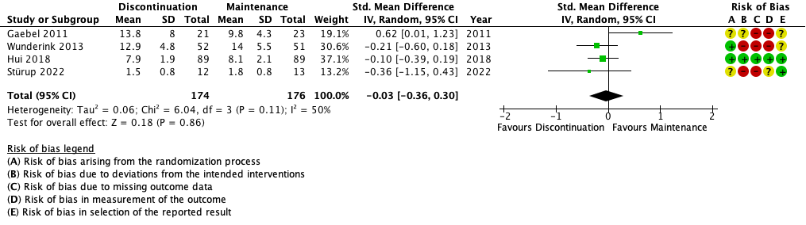
Std.: Standardized; IV: inverse variance; CI: confidence intervals.
ª The following scales were used for the meta-analysis: Positive And Negative Syndrome Scale – Negative subscale in Gaebel et al., Hui et al. and Wunderink et al. The Scales for the Assessment of Negative Symptoms was used in Stürup et al.

Supplemental Table 3. The Effect of Antipsychotic Discontinuation on Negative Symptomsª - Subgroup Analysis
Subgroup | Trials | Participants | I² | SMD^{b}  IV, Random, 95% CI
Overall | 4 | 350 | 50% | -0.03 [-0.36, 0.30]
Remission duration
- < 12 months | 2 | 128 | 0% | -0.24 [-0.59, 0.11]
- ≥ 12 months | 2 | 222 | 77% | 0.21 [-0.49, 0.91]
Antipsychotics
- FGA | 0 |  | - | -
- SGA | 2 | 203 | 0% | -0.13 [-0.41, 0.14]
- Mixed | 2 | 147 | 80% | 0.17 [-0.64, 0.98]
DDD
- < 0.9 | 2 | 147 | 80% | 0.17 (-0.64, 0.98)
- [0.9, 1.1] | 2 | 203 | 0% | -0.13 [-0.41, 0.14]
- > 1.1 | 0 | 0 | - | -

SMD: Standardized mean difference; IV: Inverse variance; CI: Confidence intervals; FGA: First generation antipsychotics; SGA: Second generation antipsychotics; DDD: Defined Daily Dose.
ª The following scales were used for the meta-analysis: Positive And Negative Syndrome Scale – Negative subscale in Gaebel et al., Hui et al. and Wunderink et al. The Scales for the Assessment of Negative Symptoms was used in Stürup et al.
^{b} Positive values favours antipsychotic maintenance.

Supplemental Figure 4. The Effect of Antipsychotic Discontinuation on Global Functioningª
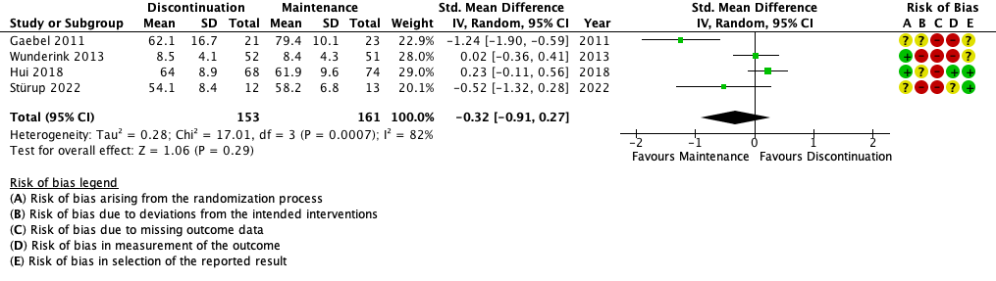
Std.: Standardized; IV: inverse variance; CI: confidence intervals.
ª The following scales were used for the meta-analysis: Global Assessment in Functioning (GAF) was used in Gaebel et al. and Stürup et al. Social and Occupational Functioning Assessment Scale (SOFAS) was used in Hui et al. and Groningen Social Disabilities Schedule (GSDS) was used in Wunderink et al.

Supplemental Table 4. The Effect of Antipsychotic Discontinuation on Global Functioningª - Subgroup Analysis
Subgroup | Trials | Participants | I² | SMD^{b}  IV, Random, 95% CI
Overall | 4 | 314 | 82% | -0.32 [-0.91, 0.27]
Remission duration
- < 12 months | 2 | 128 | 31% | -0.13 [-0.61, 0.35]
- ≥ 12 months | 2 | 186 | 94% | -0.48 [-1.92, 0.96]
Antipsychotics
- FGA | 0 | - | - | -
- SGA | 2 | 167 | 65% | -0.06 [-0.76, 0.65]
- Mixed | 2 | 147 | 91% | -0.58 [-1.82, 0.66]
DDD
- < 0.9 | 2 | 147 | 91% | -0.58 (-1.82, 0.66)
- [0.9, 1.1] | 2 | 167 | 65% | -0.06 [-0.76, 0.65]
- > 1.1 | 0 | 0 | - | -
SMD: Standardized mean difference; IV: Inverse variance; CI: Confidence intervals; FGA: First generation antipsychotics; SGA: Second generation antipsychotics; DDD: Defined Daily Dose.
ª The following scales were used for the meta-analysis: Global Assessment in Functioning (GAF) was used in Gaebel et al. and Stürup et al. Social and Occupational Functioning Assessment Scale (SOFAS) was used in Hui et al. and Groningen Social Disabilities Schedule (GSDS) was used in Wunderink et al.
^{b} Positive values favours antipsychotic maintenance.

Supplemental Figure 5. The Effect of Antipsychotic Discontinuation on Quality of Lifeª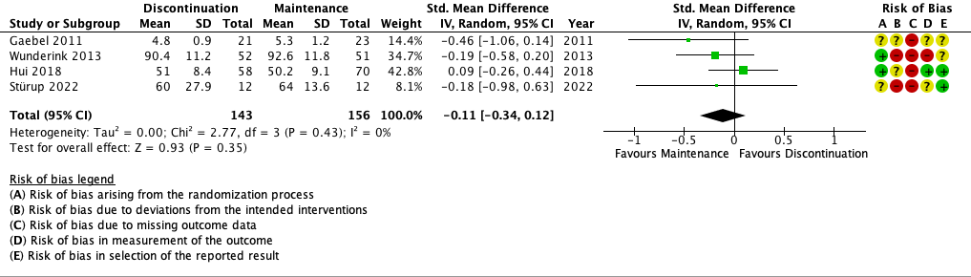
Std.: Standardized; IV: inverse variance; CI: confidence intervals.
ª The following scales were used for the meta-analysis: Lancashire Quality of Life Profile (LQLP) was used in Gaebel et al. Short-Form 36 item Health survey – mental component summary was used in Hui et al. World Health Organization - 5 wellbeing index was used and Stürup et al. World Health Organization Quality of Life scale was used in Wunderink et al.

Supplemental Table 5. The Effect of Antipsychotic Discontinuation on Quality of Lifeª - Subgroup Analysis
Subgroup | Trials | Participants | I² | SMD^{b}  IV, Random, 95% CI
Overall | 4 | 299 | 0% | -0.11 [-0.34, 0.12]
Remission duration
- < 12 months | 2 | 127 | 0% | -0.19 [-0.54, 0.16]
- ≥ 12 months | 2 | 172 | 59% | -0.13 [-0.66, 0.40]
Antipsychotics
- FGA | 0 | - | - | -
- SGA | 2 | 152 | 0% | 0.05 [-0.27, 0.37]
- Mixed | 2 | 147 | 0% | -0.27 [-0.59, 0.06]
DDD
- < 0.9 | 2 | 147 | 0% | -0.27 (-0.59, 0.06)
- [0.9, 1.1] | 2 | 152 | 0% | 0.05 [-0.27, 0.37]
- > 1.1 | 0 | 0 | - | -
SMD: Standardized mean difference; IV: Inverse variance; CI: Confidence intervals; FGA: First generation antipsychotics; SGA: Second generation antipsychotics; DDD: Defined Daily Dose.
ª The following scales were used for the meta-analysis: Lancashire Quality of Life Profile (LQLP) was used in Gaebel et al. Short-Form 36 item Health survey – mental component summary was used in Hui et al. World Health Organization - 5 wellbeing index was used and Stürup et al. World Health Organization Quality of Life scale was used in Wunderink et al.
^{b} Negative values favours antipsychotic maintenance.

Supplemental Figure 6. The Effect of Antipsychotic Discontinuation on employment

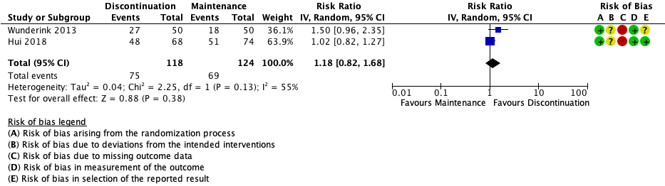
IV: inverse variance; CI: confidence intervals.

Supplemental Figure 7. Risk of bias for the adverse drug reaction outcome

 | 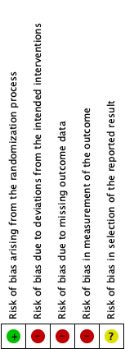
Kane 1982 | + | + | ? | - | ?
Wunderink 2007 | + | - | + | - | ?
Chen 2010 | + | + | + | + | +
Gaebel 2011 | ? | - | - | + | ?
Stürup 2022 | ? | - | - | - | +

+ : Low risk of bias; ? : Some concerns risk of bias; - : High risk of bias

Section and Topic | Item # | Checklist item | Location where item is reported
TITLE
Title | 1 | Identify the report as a systematic review. | p. 1
ABSTRACT
Abstract | 2 | See the PRISMA 2020 for Abstracts checklist. | p. 3, SM
INTRODUCTION
Rationale | 3 | Describe the rationale for the review in the context of existing knowledge. | p. 4
Objectives | 4 | Provide an explicit statement of the objective(s) or question(s) the review addresses. | p. 4
METHODS
Eligibility criteria | 5 | Specify the inclusion and exclusion criteria for the review and how studies were grouped for the syntheses. | p. 5,8
Information sources | 6 | Specify all databases, registers, websites, organisations, reference lists and other sources searched or consulted to identify studies. Specify the date when each source was last searched or consulted. | p. 6
Search strategy | 7 | Present the full search strategies for all databases, registers and websites, including any filters and limits used. | p. 6, S1
Selection process | 8 | Specify the methods used to decide whether a study met the inclusion criteria of the review, including how many reviewers screened each record and each report retrieved, whether they worked independently, and if applicable, details of automation tools used in the process. | p. 6
Data collection process | 9 | Specify the methods used to collect data from reports, including how many reviewers collected data from each report, whether they worked independently, any processes for obtaining or confirming data from study investigators, and if applicable, details of automation tools used in the process. | p. 6,7
Data items | 10a | List and define all outcomes for which data were sought. Specify whether all results that were compatible with each outcome domain in each study were sought (e.g. for all measures, time points, analyses), and if not, the methods used to decide which results to collect. | p. 6,7
 | 10b | List and define all other variables for which data were sought (e.g. participant and intervention characteristics, funding sources). Describe any assumptions made about any missing or unclear information. | p. 7,8
Study risk of bias assessment | 11 | Specify the methods used to assess risk of bias in the included studies, including details of the tool(s) used, how many reviewers assessed each study and whether they worked independently, and if applicable, details of automation tools used in the process. | p. 8
Effect measures | 12 | Specify for each outcome the effect measure(s) (e.g. risk ratio, mean difference) used in the synthesis or presentation of results. | p. 8
Synthesis methods | 13a | Describe the processes used to decide which studies were eligible for each synthesis (e.g. tabulating the study intervention characteristics and comparing against the planned groups for each synthesis (item #5)). | p. 8
 | 13b | Describe any methods required to prepare the data for presentation or synthesis, such as handling of missing summary statistics, or data conversions. | p.8, 9
 | 13c | Describe any methods used to tabulate or visually display results of individual studies and syntheses. | p. 8,9
 | 13d | Describe any methods used to synthesize results and provide a rationale for the choice(s). If meta-analysis was performed, describe the model(s), method(s) to identify the presence and extent of statistical heterogeneity, and software package(s) used. | p. 8,9
 | 13e | Describe any methods used to explore possible causes of heterogeneity among study results (e.g. subgroup analysis, meta-regression). | p. 8,9
 | 13f | Describe any sensitivity analyses conducted to assess robustness of the synthesized results. | -
Reporting bias assessment | 14 | Describe any methods used to assess risk of bias due to missing results in a synthesis (arising from reporting biases). | p. 8
Certainty assessment | 15 | Describe any methods used to assess certainty (or confidence) in the body of evidence for an outcome. | p. 9
RESULTS
Study selection | 16a | Describe the results of the search and selection process, from the number of records identified in the search to the number of studies included in the review, ideally using a flow diagram. | p. 9, F1
 | 16b | Cite studies that might appear to meet the inclusion criteria, but which were excluded, and explain why they were excluded. | p. 9
Study characteristics | 17 | Cite each included study and present its characteristics. | p. 9, T1
Risk of bias in studies | 18 | Present assessments of risk of bias for each included study. | p. 6, F2-3, SM
Results of individual studies | 19 | For all outcomes, present, for each study: (a) summary statistics for each group (where appropriate) and (b) an effect estimate and its precision (e.g. confidence/credible interval), ideally using structured tables or plots. | T1-2, F2-3, SM
Results of syntheses | 20a | For each synthesis, briefly summarise the characteristics and risk of bias among contributing studies. | p. 9-13
 | 20b | Present results of all statistical syntheses conducted. If meta-analysis was done, present for each the summary estimate and its precision (e.g. confidence/credible interval) and measures of statistical heterogeneity. If comparing groups, describe the direction of the effect. | p. 9-13, F1-2, T2, SM
 | 20c | Present results of all investigations of possible causes of heterogeneity among study results. | SM
 | 20d | Present results of all sensitivity analyses conducted to assess the robustness of the synthesized results. | -
Reporting biases | 21 | Present assessments of risk of bias due to missing results (arising from reporting biases) for each synthesis assessed. | SM
Certainty of evidence | 22 | Present assessments of certainty (or confidence) in the body of evidence for each outcome assessed. | T2
DISCUSSION
Discussion | 23a | Provide a general interpretation of the results in the context of other evidence. | p. 13
 | 23b | Discuss any limitations of the evidence included in the review. | p. 13-14
 | 23c | Discuss any limitations of the review processes used. | p. 15
 | 23d | Discuss implications of the results for practice, policy, and future research. | p. 15
OTHER INFORMATION
Registration and protocol | 24a | Provide registration information for the review, including register name and registration number, or state that the review was not registered. | 5
 | 24b | Indicate where the review protocol can be accessed, or state that a protocol was not prepared. | SM
 | 24c | Describe and explain any amendments to information provided at registration or in the protocol. | -
Support | 25 | Describe sources of financial or non-financial support for the review, and the role of the funders or sponsors in the review. | p. 2
Competing interests | 26 | Declare any competing interests of review authors. | p. 2
Availability of data, code and other materials | 27 | Report which of the following are publicly available and where they can be found: template data collection forms; data extracted from included studies; data used for all analyses; analytic code; any other materials used in the review. | -
From: Page MJ, McKenzie JE, Bossuyt PM, Boutron I, Hoffmann TC, Mulrow CD, et al. The PRISMA 2020 statement: an updated guideline for reporting systematic reviews. BMJ 2021;372:n71. doi: 10.1136/bmj.n71
For more information, visit: http://www.prisma-statement.org/

Section and Topic | Item # | Checklist item | Reported (Yes/No)
TITLE
Title | 1 | Identify the report as a systematic review. | Yes
BACKGROUND
Objectives | 2 | Provide an explicit statement of the main objective(s) or question(s) the review addresses. | Yes
METHODS
Eligibility criteria | 3 | Specify the inclusion and exclusion criteria for the review. | Yes
Information sources | 4 | Specify the information sources (e.g. databases, registers) used to identify studies and the date when each was last searched. | Yes
Risk of bias | 5 | Specify the methods used to assess risk of bias in the included studies. | Yes
Synthesis of results | 6 | Specify the methods used to present and synthesise results. | Yes
RESULTS
Included studies | 7 | Give the total number of included studies and participants and summarise relevant characteristics of studies. | Yes
Synthesis of results | 8 | Present results for main outcomes, preferably indicating the number of included studies and participants for each. If meta-analysis was done, report the summary estimate and confidence/credible interval. If comparing groups, indicate the direction of the effect (i.e. which group is favoured). | Yes
DISCUSSION
Limitations of evidence | 9 | Provide a brief summary of the limitations of the evidence included in the review (e.g. study risk of bias, inconsistency and imprecision). | Yes
Interpretation | 10 | Provide a general interpretation of the results and important implications. | Yes
OTHER
Funding | 11 | Specify the primary source of funding for the review. | p. ii
Registration | 12 | Provide the register name and registration number. | No

From: Page MJ, McKenzie JE, Bossuyt PM, Boutron I, Hoffmann TC, Mulrow CD, et al. The PRISMA 2020 statement: an updated guideline for reporting systematic reviews. BMJ 2021;372:n71. doi: 10.1136/bmj.n71

For more information, visit: http://www.prisma-statement.org/

