SUPPLEMENTARY MATERIAL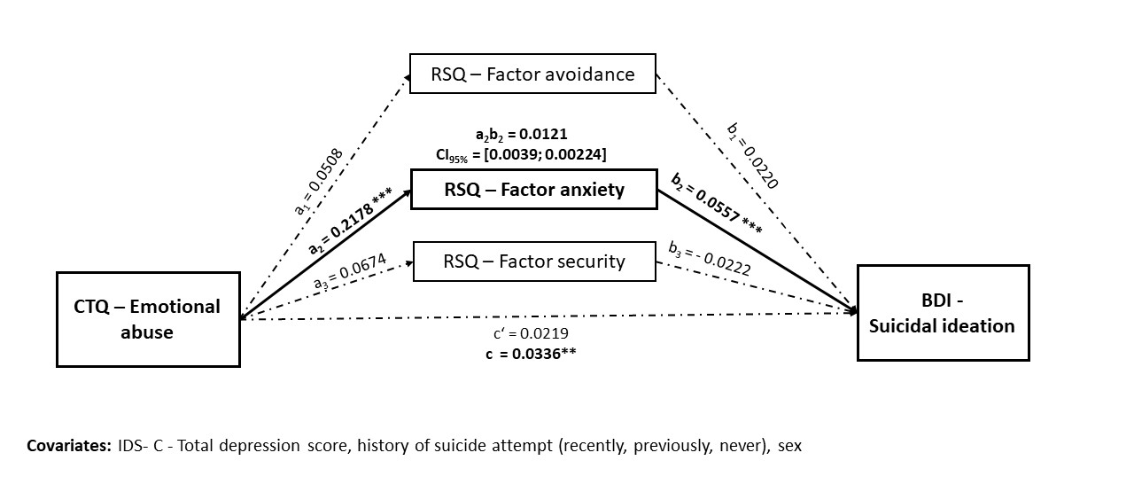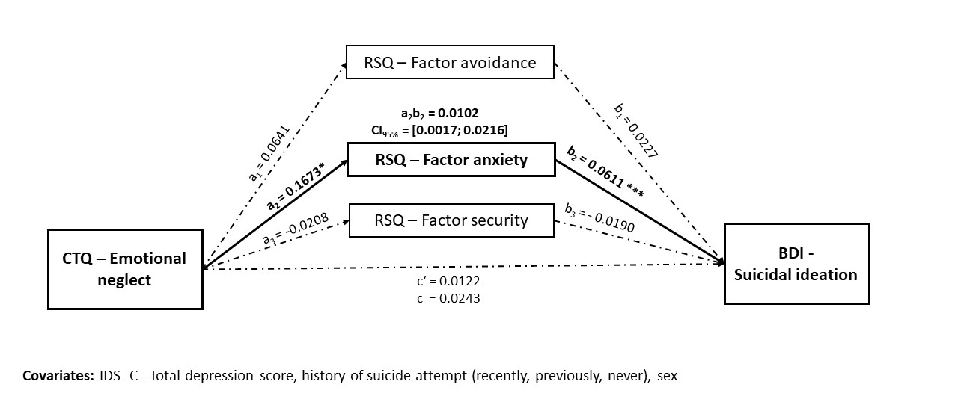
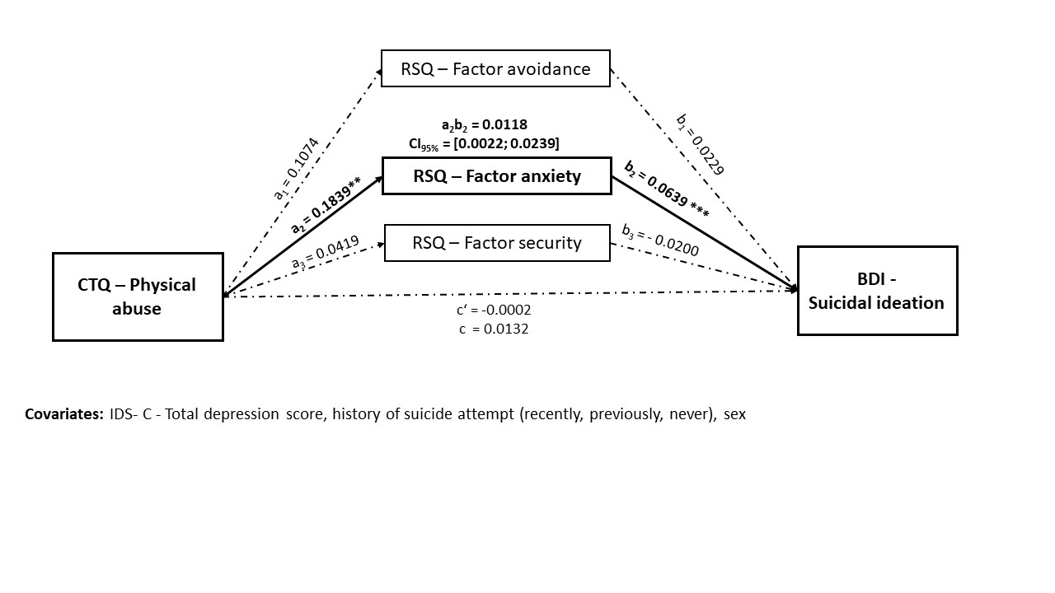
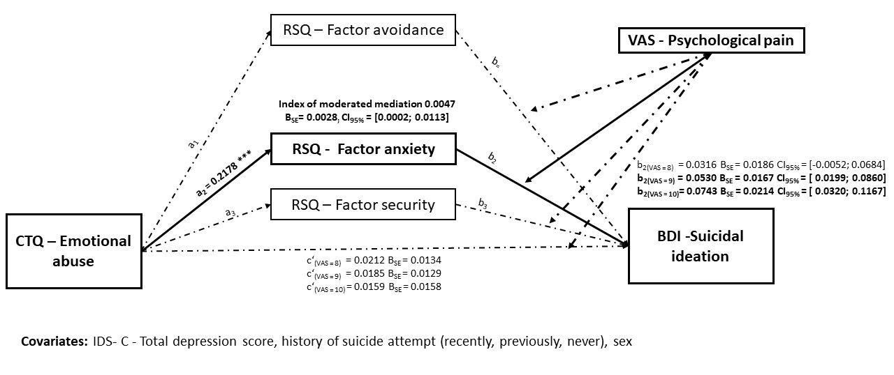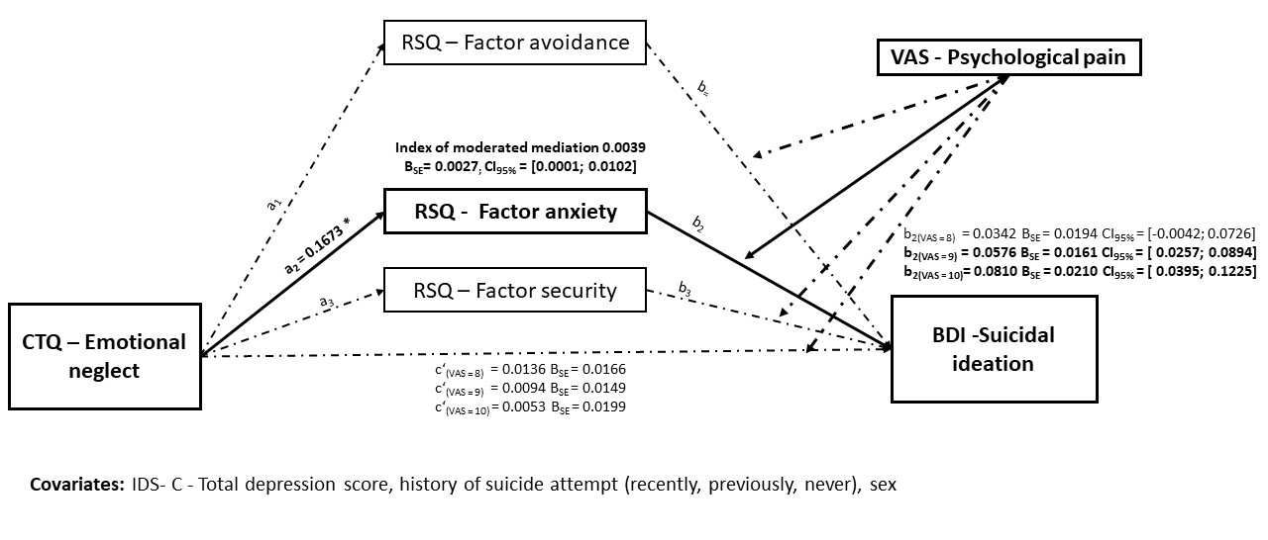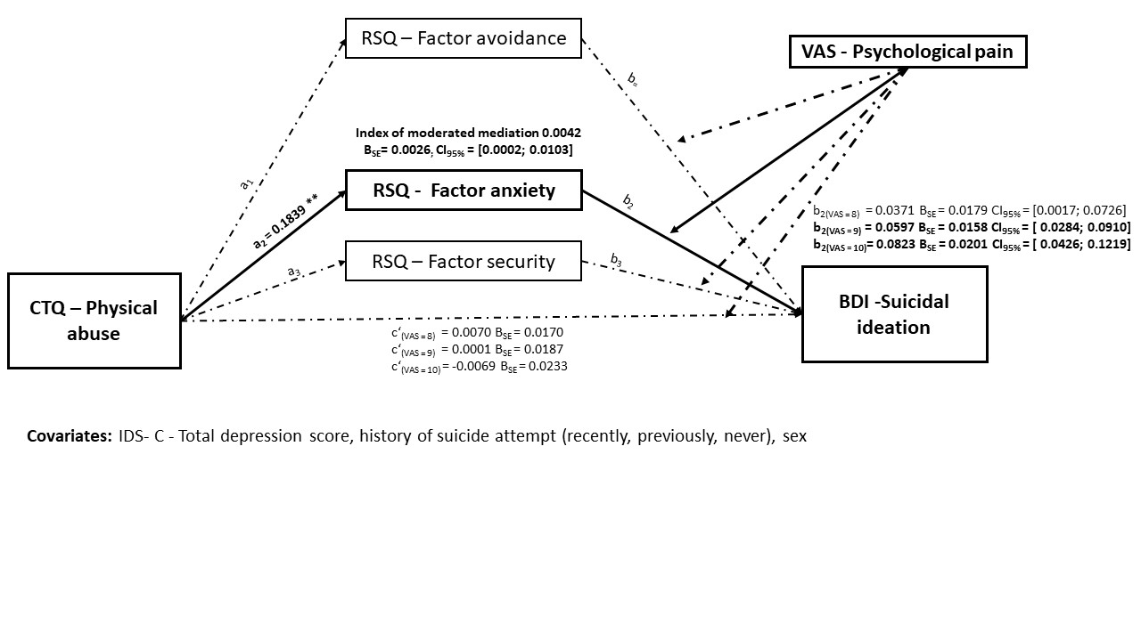

SUPPLEMENTARY MATERIAL BORDERLINE
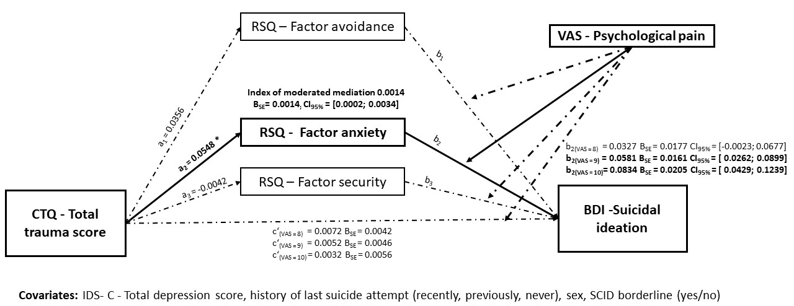
There was no indication of moderated mediation of social pain on the effect of CT over avoidance and security factor on suicidal ideation.
No moderated mediation effect of attachment on relationship between CT and suicidal ideation, with social pain as moderator. No effects were found when the total trauma score served as predictor, and the index of moderated mediation showed a tendency of significance = 0.0002, CI_{95%} = [0;0.0004]. Consecutively, we did not test for any trauma subtype.
Table SUPPLEMENTARY MATERIAL : Mean and SD of full cohort, patients with Borderline characteristic, and those without, and results of Mann-Whitney-U test comparing Borderline vs Non-Borderline
 | Cohort  N = 161 |  | Borderline  N = 38 |  | Non-Borderline  N = 123
 | M | SD | M | SD | M | SD | U | p
BDI - Item G - Suicidal ideation | 1.07 | 1.019 | 1.00 | 0.900 | 1.09 | 1.056 | 2296.50 | 0.864
CTQ – Physical abuse | 8.24 | 4.744 | 10.11 | 5.922 | 7.66 | 4.178 | 1704.50 | 0.007
CTQ – Emotional neglect | 13.58 | 5.210 | 15.08 | 5.509 | 13.11 | 5.048 | 1834.00 | 0.045
CTQ – Physical neglect | 8.19 | 3.613 | 9.74 | 3.881 | 7.71 | 3.401 | 1544.00 | 0.001
CTQ – Sexual abuse | 7.07 | 3.663 | 7.37 | 3.823 | 6.98 | 3.622 | 2179.00 | 0.468
CTQ – Rmotional abuse | 12.54 | 6.259 | 14.84 | 6.533 | 11.83 | 6.023 | 1715.50 | 0.013
CTQ – Total trauma score | 49.61 | 18.783 | 57.13 | 19.968 | 47.28 | 17.852 | 1650.00 | 0.006
VAS-PPP - Worst psychological pain | 8.75 | 1.750 | 9.16 | 1.053 | 8.63 | 1.901 | 2035.00 | 0.204
IDS – Total score depression | 38.53 | 8.696 | 38.87 | 9.715 | 38.43 | 8.396 | 2295.00 | 0.867
RSQ – Avoidance factor | 21.48 | 4.718 | 20.58 | 4.984 | 21.76 | 4.619 | 1994.50 | 0.172
RSQ – Anxiety factor | 15.39 | 4.561 | 16.26 | 4.385 | 15.11 | 4.597 | 1999.50 | 0.178
RSQ – Security factor | 17.08 | 3.875 | 18.53 | 3.674 | 16.63 | 3.840 | 1690.00 | 0.010
 | 37 |  | 123
NTS – Total Score social pain | 53.86 | 12.875 | 52.62 | 13.54 | 54.26 | 11.55 | 2068.00 | 0.401

