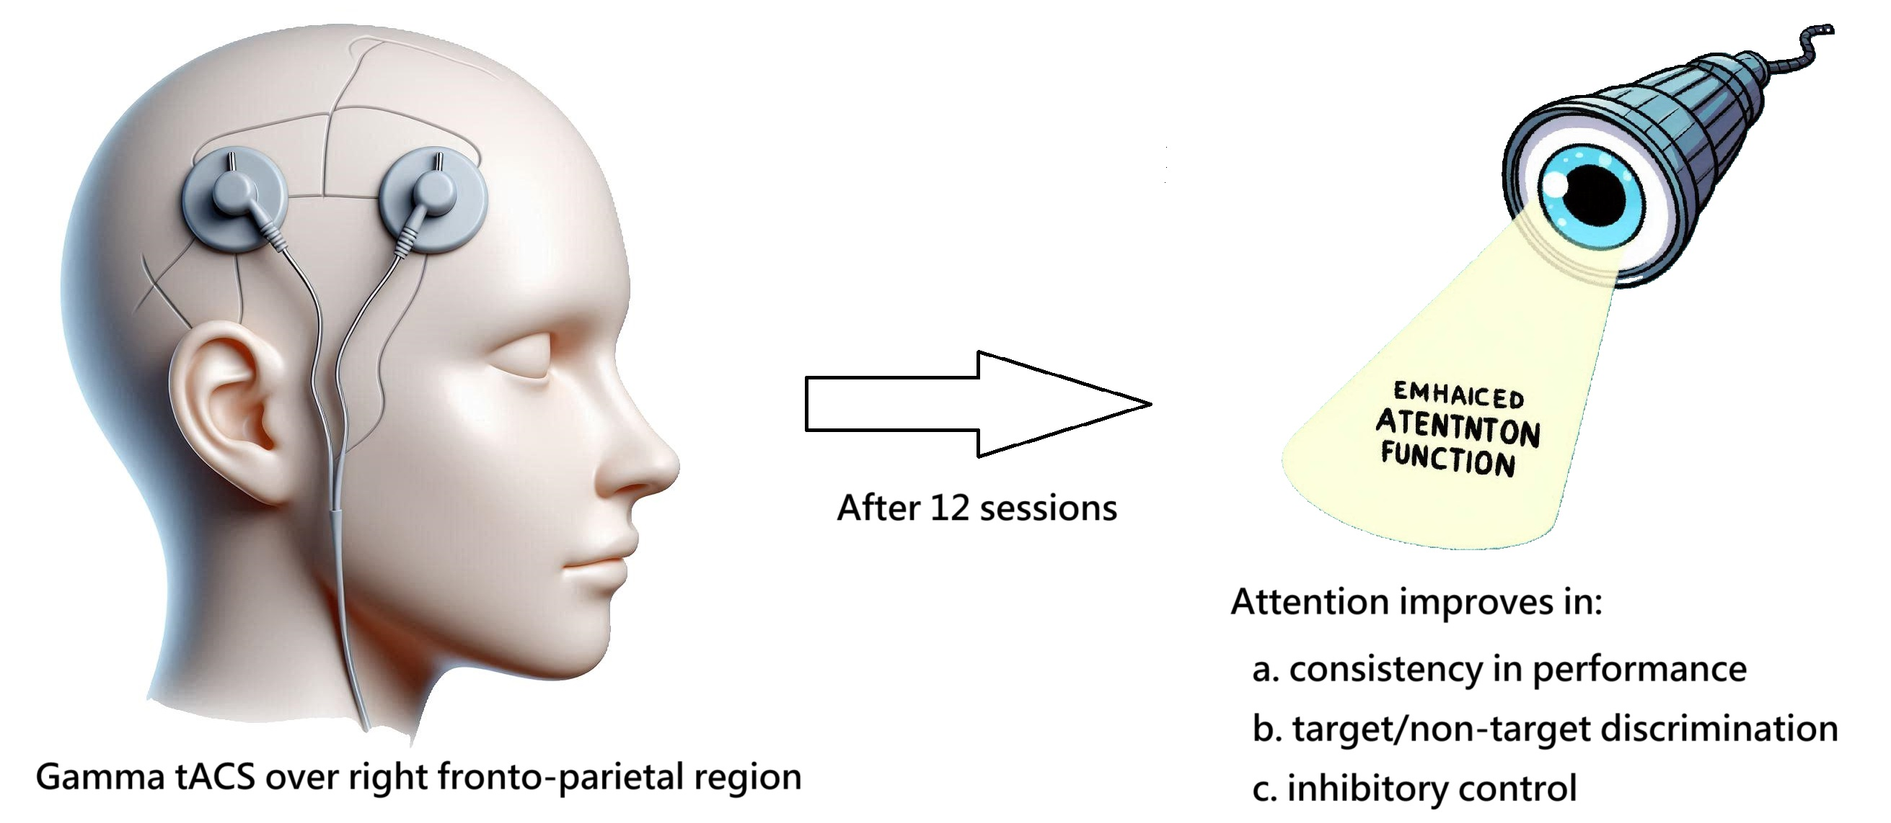Highlights

•Transcranial alternating current stimulation (tACS) at 40 Hz was applied to F4 and P4 EEG lead positions to enhance attention in diverse neuropsychiatric conditions.
•The tACS protocol involved 12 sessions, each lasting 20 minutes, with a current of 2 mA.
•Significant improvements were observed in attention consistency, target/non-target discrimination, and inhibitory control following the treatment.

