SUPPLEMENTARY MATERIAL
A meta-analysis of the prevalence of neuropsychiatric disorders and their association with disease onset in myotonic dystrophy
Acta Neuropsychiatrica

Index
Table S1. Baseline characteristics of the participants included in the studies.
Table S2. Studies excluded for justified reasons.
Table S3. Classification of participants by myotonic dystrophy onset.
Table S4. Diagnostic criteria or scales used.
Table S5. Estimates of the prevalence of neuropsychiatric disorders in the included studies.
Table S6. Risk of bias assessment.
Table S7. Quality of evidence assessment.
Table S8. Sensitivity analyses.
Table S9. Meta-regressions for the prevalence of neuropsychiatric disorders (in natural logarithm) and mean CTG repeats.
Figure S1. Meta-analysis of depression in DM1 and DM2 by onset.
Figure S2. Meta-analysis of anxiety in DM1 by onset.
Figure S3. Meta-analysis of ASD prevalence-onset association through prevalence ratio considering childhood and juvenile onset.
Figure S4. Meta-analysis of ADHD prevalence-onset association through prevalence ratio considering childhood and juvenile onset.
Figure S5. Funnel plots of primary outcomes.
Appendix S1: Search strategy.

Table S1. Baseline characteristics of the participants included in the studies.
Reference | Country | N_{T} | Inheritance |  | Onset |  |  | CTG | Age | Outcomes
 |  |  | N_{M} | N_{P} | N_{C} | N_{J} | N_{A} |  |  | ASD | ADHD | DEP | ANX
Myotonic dystrophy 1
Bungener C et al (1998) | France | 15 | - | - | - | - | 15 | 260 to 1000 | 36.8 ± 11.3 | - | - | ✓ | ✓
Caso F et al (2014) | Serbia | 51 | - | - | 0 | 17 | 34 | 750 ± 276 | 42.0 ±10.0 | - | - | ✓ | ✓
Colombo G et al (1992) | Italy | 40 | 12 | 24 | - | - | - | - | 39.9 | - | - | ✓ | ✓
Cuthill J et al (1988) | Canada | 13 | - | - | - | - | - | - | 32.4 (21.0 to 49.0) | - | - | ✓ | ✓
Di Costanzo A et al (2000) | Italy | 10 | - | - | 0 | 0 | 10 | - | 37.7 ± 13.5 | - | - | ✓ | -
Douniol M et al (2012) | France | 28 | 17 | 11 | 0 | 28 | 0 | 656 ± 326 | 17.0 ± 3.0 | ✓ | ✓ | ✓ | ✓
Echenne B et al (2008) | France  Canada | 32 | 28 | 4 | 17 | 15 | 0 | 1155 ± 676 | - | ✓ | ✓ | ✓ | ✓
Ekström AB et al (2008) | Sweeden | 57 | 45 | 10 | 37 | 18 | 2 | 550 to 1600 | C1: 9.2  C2: 13.2  J: 14.2  A: 16.4 | ✓ | ✓ | - | -
Ekström AB et al (2009) | Sweeden | 55 | 45 | 8 | 37 | 18 | 0 | 930 to 1600 | C1: 10.6  C2:11.9  J: 14.1 | ✓ | - | - | -
Fujino H et al (2018) | Japan | 60 | - | - | 0 | 21 | 39 | 1113 ± 1025 | 47.1 ± 10.8 | - | - | ✓ | -
Gallais B et al (2015) | France | 38 | - | - | 0 | 0 | 38 | 568 ± 341 | 36.0 ± 10.2 | - | - | ✓ | -
Geirdal AO et al (2015) | Norway | 13 | - | - | - | - | - | - | 40.9 ± 14.4 | - | - | ✓ | ✓
Jacobs D et al (2017) | Belgium | 27 | - | - | 0 | 27 | 0 | 1600 ± 775 | 19.5 ± 2.7 | ✓ | ✓ | ✓ | ✓
Johnson N et al (2016) | Canada  Sweden  US | 150 | 37 | 106 | 74 | 69 | 0 | 959.0 | 17.9 ± 10.2 | ✓ | ✓ | - | -
Kacem E et al (2021) | Tunisia | 20 | - | - | . | . | 20 | - | 40.0 (28 – 49) | - | - | ✓ | ✓
Kalkman JS et al (2007) | Netherlands | 79 | - | - | 0 | 0 | 79 | - | 41 ± 9.9 | - | - | ✓ | ✓
Kierkegaard M et al (2011) | Sweden | 70 | 24 | 33 | 0 | 12 | 58 | - | 45.0 ± 13.0 | - | - | ✓ | ✓
Krogias C et al (2015) – 1 | Germany | 17 | - | - | - | 7 | 10 | 700 (70 to 1000) | 39.0 ± 15.0 | - | - | ✓ | -
Lagrue E et al (2019) | France | 314 | - | - | 155 | 126 | 0 | 846 ± 473 | 11.0 (5.0 – 15.0) | ✓ | - | - | -
Meloa G et al (2003) – 1 | Italy | 21 | - | - | 0 | 13 | 8 | 500 to 700 | 44.1 ± 9.5 | - | - | ✓ | ✓
Miller JN et al (2021) | US | 39 | - | - | 0 | 0 | 39 | 146 (81 to 501) | 45.5 ± 9.0 | - | - | ✓ | -
Petra A et al (2023) | Norway | 20 | 10 | 5 | 5 | 15 | 0 | To 1600 | - | ✓ | - | - | -
Rakocevic Stojanovic V et al (2014) | Serbia | 66 | - | - | - | 22 | 44 | - | - | - | - | ✓ | ✓
Rakocevic Stojanovic V et al (2016) – 1 | Serbia | 42 | - | - | 0 | 0 | 42 | - | 47.3 ± 7.2 | - | - | ✓ | -
Rubinsztein JS et al (1998) | UK | 36 | 12 | 20 | 0 | 5 | 30 | 300 to 4600 | 42.3 ± 12.3 | - | - | ✓ | -
Schneider-Gold C et al (2015) – 1 | Germany | 12 | - | - | 0 | 3 | 9 | 470.4 ± 238.2 | 45.0 ± 13.0 | - | - | ✓ | -
Seijas-Gomez R et al (2015) | Spain | 27 | - | - | 0 | 0 | 27 | - | 38,6 ± 9,2 | - | ✓ | ✓ | ✓
Serra L et al (2015) | Italy | 10 | - | - | 1 | 1 | 8 | 534 ± 539 | 41.8 ± 9.6 | - | - | ✓ | ✓
Steyaert J et al (1997) | Netherlands | 16 | 12 | 4 | 2 | 14 | 0 | 2086 ± 743 | 13.0 ± 3.2 | ✓ | ✓ | ✓ | ✓
Stokes M et al (2019) | US | 74 | - | - | 52 | 22 | 0 | 143 to 2300 | - | ✓ | ✓ | - | -
Timman R et al (2010) | Netherlands | 69 | - | - | - | - | - | - | 45.6 | - | - | ✓ | ✓
Urata Y et al (2020) | Japan | 4 | - | - | - | - | - | - | 27.0 ± 3.7 | ✓ | - | - | -
Van Heugten C et al (2018) | Netherlands | 66 | - | - | 0 | 0 | 66 | - | 47.0 ± 12.7 | - | - | ✓ | ✓
Van Spaendonck KPM et al (1995) | Netherlands | 26 | 7 | 14 | 0 | - | - | - | 35.5 ± 10.3 | - | - | ✓ | -
Winblad S et al (2010) | Sweden | 31 | - | - | 0 | 0 | 31 | 578 ± 401 | 41.8 ± 9.5 | - | - | ✓ | -
Myotonic dystrophy 2
Krogias C et al (2015) – 2 | Germany | 14 | - | - | - | 1 | 13 | - | 37.0 ± 11.0 | - | - | ✓ | -
Meloa G et al (1999) | Italy  US | 20 | - | - | 0 | 9 | 10 | - | - | - | - | ✓ | -
Meloa G et al (2003) – 2 | Italy | 19 | - | - | 0 | 0 | 19 | - | 55.7 ± 6.4 | - | - | ✓ | ✓
Montagnese F et al (2020) | Germany | 66 | - | - | - | - | - | - | 54.8 ± 12.4 | - | - | ✓ | -
Rakocevic Stojanovic V et al (2016) – 2 | Serbia | 49 | - | - | 0 | 0 | 49 | - | 51.4 ± 10.8 | - | - | ✓ | -
Schneider-Gold C et al (2015) – 2 | Germany | 16 | - | - | - | - | 16 | - | 52.0 ± 7.0 | - | - | ✓ | -
Suokas KI et al (2012) | Finland | 93 | - | - | 0 | - | - | - | 53.0 (20 to 80) | - | - | ✓ | -
Abbreviations: N_{T}: Total sample size; N_{M}: Sample size with maternal inheritance; N_{P}: Sample size with paternal inheritance; N_{C}: Sample size with congenital onset; N_{J}: Sample size with juvenile onset; N_{A}: Sample size with adult onset; CTG: mean (or median if mean is not available) of CTG repeats

Table S2. Studies excluded for justified reasons.
Reference | Main reason
D’Alessandro R et al (2021) | Not outcome of interest
Gosar D et al (2021) | Not outcome of interest
Kim HJ et al (2019) | Not outcome of interest
Tanaka H et al (2012) | Not outcome of interest
Tuikka RA et al (1993) | Not outcome of interest
Woo J et al (2019) | Not outcome of interest
Zalonis I et al (2010) | Not population of interest

Supplementary references
D’alessandro, R., Ragusa, N., Vacchetti, M., Rolle, E., Rossi, F., Brusa, C., et al. (2021) Assessing cognitive function in neuromuscular diseases: A pilot study in a sample of children and adolescents, Journal of Clinical Medicine, 10 (20). DOI:10.3390/jcm10204777.
Gosar, D., Košmrlj, L., Musek, P. L., Meško, T., Stropnik, S., Krkoč, V., et al. (2021) Adaptive skills and mental health in children and adolescents with neuromuscular diseases., European Journal of Paediatric Neurology : EJPN : Official Journal of the European Paediatric Neurology Society, 30, pp. 134–143. DOI:10.1016/j.ejpn.2020.10.008.
Kim, H. J., Na, J.-H. and Lee, Y.-M. (2019) Genotype-phenotype correlations in pediatric patients with myotonic dystrophy type 1, Korean Journal of Pediatrics, 62 (2), pp. 55–61. DOI:10.3345/KJP.2018.06919.
Tanaka, H., Arai, M., Harada, M., Hozumi, A. and Hirata, K. (2012) Cognition and event-related potentials in adult-onset non-demented myotonic dystrophy type 1, Clinical Neurophysiology, 123 (2), pp. 261–269. DOI:10.1016/j.clinph.2011.06.012.
Tuikka, R. A., Laaksonen, R. K. and Somer, H. V (1993) Cognitive function in myotonic dystrophy: a follow-up study., European Neurology, 33 (6), pp. 436–441. DOI:10.1159/000116989.
Woo, J., Lee, H.-W. and Park, J.-S. (2019) Differences in the pattern of cognitive impairments between juvenile and adult onset myotonic dystrophy type 1., Journal of Clinical Neuroscience : Official Journal of the Neurosurgical Society of Australasia, 68, pp. 92–96. DOI:10.1016/j.jocn.2019.07.029.
Zalonis, I., Bonakis, A., Christidi, F., Vagiakis, E., Papageorgiou, S. G., Kalfakis, N., Manta, P. and Vassilopoulos, D. (2010) Toward understanding cognitive impairment in patients with myotonic dystrophy type 1, Archives of Clinical Neuropsychology, 25 (4), pp. 303–313. DOI:10.1093/arclin/acq016.

Table S3. Classification of participants by myotonic dystrophy onset.
Reference | MD form | Included onsets | Classification
Bungener C et al (1998) | DM1 | The patients had been diagnosed >17 years | Adult (Some cases of juvenile onset cannot be ruled out)
Caso F et al (2014) | DM1 | Childhood/Juvenile: <20 years  Adult: ≥20 years | Juvenile + Adult
Colombo G et al (1992) | DM1 | Not specified | Not specified
Cuthill J et al (1988) | DM1 | Not specified | Not specified
Di Costanzo A et al (2000) | DM1 | Adult: ranges of age not specified | Adult
Douniol M et al (2012) | DM1 | Onset between 1 and 10 years | Juvenile
Echenne B et al (2008) | DM1 | Congenital: at neonatal period  Juvenile: infantile + juvenile | Congenital + Juvenile
Ekström AB et al (2008) | DM1 | Congenital: at utero or birth  Childhood: 1-10 years  Classic: At or after adolescence | All
Ekström AB et al (2009) | DM1 | Congenital: at utero or birth  Childhood: 1-10 years | Congenital + Juvenile
Fujino H et al (2018) | DM1 | Infantile: 1 month to 10 years  Juvenile: 11–20 years  Adult: 21–40 years  Late onset: >40 years | Juvenile + Adult
Gallais B et al (2015) | DM1 | Adult or late-onset: the study included participants with 21 to 60 years | Adult
Geirdal AO et al (2015) | DM1 | Not specified | Not specified
Jacobs D et al (2017) | DM1 | Juvenile: <12 years, but not at birth | Juvenile
Johnson N et al (2016) | DM1 | Congenital: <1 year  Childhood: 1-10 years  Juvenile: 11-17 years | Congenital + Juvenile
Kacem E et al (2021) | DM1 | Adult onset: reported by authors | Adult
Kalkman JS et al (2007) | DM1 | Adult onset | Adult
Kierkegaard M et al (2011) | DM1 | Includes childhood and adult onsets, but does not specify the age ranges at the onset | Juvenile + Adult
Krogias C et al (2015) | DM1 and DM2 | Juvenile: ≤15 years  Adult: >15 years | Juvenile + Adult
Lagrue E et al (2019) | DM1 | Congenital: at birth or during the first month  Infantile: 1–10 years  Juvenile: 10–18 years  Adult  Late-onset | Congenital + Juvenile
Meloa G et al (1999) | DM2 | Not classified, but included participants have an onset from the second decade of life. | Juvenile + Adult
Meloa G et al (2003) – 1 | DM1 | Not classified, but included participants have an onset from the first decade of life. | Congenital + Juvenile
Meloa G et al (2003) – 2 | DM2 | Not classified, but included participants have an onset from the second decade of life. | Adult
Miller JN et al (2021) | DM1 | Adult: >18 years | Adult
Montagnese F et al (2020) | DM2 | Not specified, presumably adults | Adult
Petra A et al (2023) | DM1 | Congenital: < 1 month  Infantile: 1 month to 10 years  Juvenile: 10 to 20 years | Congenital + Juvenile
Rakocevic Stojanovic V et al (2014) | DM1 | Juvenile: <20 years (without congenital)  Adult: ≥20 years (without late-onset) | Juvenile + Adult
Rakocevic Stojanovic V et al (2016) | DM1 and DM2 | Adult (participants with DM1 are presumably those of Rakocevic Stojanovic V et al (2014)) | Adult
Rubinsztein JS et al (1998) | DM1 | Juvenile: 10 to 17 years  Adult: ≥18 years | Juvenile + Adult
Schneider-Gold C et al (2015) | DM1 and DM2 | Juvenile: 14 to 20 years  Adult: >20 years | Juvenile + Adult (DM1)  Adult (DM2)
Seijas-Gomez R et al (2015) | DM1 | Adult: Not specified age range | Adult
Serra L et al (2015) | DM1 | Congenital: Not specified age range  Childhood: Not specified age range  Adult: Not specified age range | All
Steyaert J et al (1997) | DM1 | Congenital: at birth  Juvenile: <10 years | Congenital + Juvenile
Stokes M et al (2019) | DM1 | Congenital: at birth  Infantile: <10 years  Juvenile: >10 years | Congenital + Juvenile
Suokas KI et al (2012) | DM2 | Onset from 6 to 69 years | All
Timman R et al (2010) | DM1 | Not specified | Not specified
Urata Y et al (2020) | DM1 | Not specified | Not specified
Van Heugten C et al (2018) | DM1 | Adult: >18 years | Adult
Van Spaendonck KPM et al (1995) | DM1 | Onset between 11 to 40 years | Juvenile + Adult
Winblad S et al (2010) | DM1 | Onset between 15 to 50 years | Adult

Table S4. Diagnostic criteria or scales used.
Reference | ASD | ADHD | Depression disorders | Anxiety disorders
Bungener C et al (1998) | - | - | DSM III-R | DSM III-R
Caso F et al (2014) | - | - | HDRS (score ≥17) | HARS (score ≥18)
Colombo G et al (1992) | - | - | RDC | RDC
Cuthill J et al (1988) | - | - | SDS, HDRS (score ≥18) | HARS (score ≥16)
Di Costanzo A et al (2000) | - | - | DSM-III-R, HDRS | -
Douniol M et al (2012) | DSM-IV, Autism Mental Status Examination, Autism Diagnostic Interview-Revised | DSM-IV, ADHD section of the Diagnostic Interview Schedule for Children IV, Adult ADHD Self-Report Scale | DSM-IV, Children’s Depression Inventory, BDI, HDRS | DSM-IV, STAI
Echenne B et al (2008) | DSM-IV | NS | NS | NS
Ekström AB et al (2008) | DSM-IV | DSM-IV | - | -
Ekström AB et al (2009) | DSM-IV | - | - | -
Fujino H et al (2017) | - | - | PHQ-9 | -
Gallais B et al (2015) | - | - | MINI | -
Geirdal AO et al (2015) | - | - | HADS (score >7) | HADS (score >7)
Jacobs D et al (2017) | DSM-IV | DSM-IV | DSM-IV | DSM-IV
Johnson N et al (2016) | Self-reported | Self-reported | - | -
Kacem E et al (2021) | - | - | HADS | HADS
Kalkman JS et al (2007) | - | - | DSM-IV, BDI, SCL-90, GFQ-12 | DSM-IV, SCL-90
Kierkegaard M et al (2011) | - | - | HADS (score >10) | HADS (score >10)
Krogias C et al (2015) | - | - | BDI-II (score ≥20) | -
Lagrue E et al (2019) | DSM-V | - | - | -
Meloa G et al (1999) | - | - | DSM-IV | -
Meloa G et al (2003) | - | - | DSM-IV | DSM-IV
Miller JN et al (2021) | - | - | BDI-II | -
Montagnese F et al (2020) | - | - | BDI-II (score ≥20) | -
Petra A et al (2023) | ICD-10 | - | - | -
Rakocevic Stojanovic V et al (2014) | - | - | HDRS (score ≥17) | HARS (score ≥18)
Rakocevic Stojanovic V et al (2016) | - | - | HDRS (score ≥17) | -
Rubinsztein JS et al (1998) | - | - | SADS-L | -
Schneider-Gold C et al (2015) | - | - | BDI-II (score ≥20) | -
Seijas-Gomez R et al (2015) | - | Conners’ Performance Test II | BDI-II, SCL-90 | HARS
Serra L et al (2015) | - | - | BDI (score ≥15) | HARS (score ≥18)
Steyaert J et al (1997) | CARS | DSM-III, ADIKA | CDS, BDI | NS
Stokes M et al (2019) | Medical records | Medical records | - | -
Suokas KI et al (2012) | - | - | RBDI | -
Timman R et al (2010) | - | - | HADS (score >7) | HADS (score >7)
Urata Y et al (2020) | Medical records | - | - | -
Van Heugten C et al (2018) | - | - | HADS (score >7) | HADS (score >7)
Van Spaendonck KPM et al (1995) | - | - | ZDS | -
Winblad S et al (2010) | - | - | BDI (score ≥10) | -

Table S5. Estimates of the prevalence of neuropsychiatric disorders in the included studies.
Reference | Prevalence
 | ASD | ADHD | DEP | ANX
Myotonic dystrophy 1
Bungener C et al (1998) | - | - | 0.07 (0.01, 0.30) | 0.00
Caso F et al (2014) | - | - | 0.20 (0.11, 0.32) | 0.14 (0.07, 0.26)
Colombo G et al (1992) | - | - | 0.20 (0.11, 0.32) | 0.08 (0.03, 0.20)
Cuthill J et al (1988) | - | - | 0.23 (0.08, 0.50) | 0.08 (0.01, 0.33)
Di Costanzo A et al (2000) | - | - | 0.10 (0.02, 0.40) | -
Douniol M et al (2012) | 0.00 | 0.29 (0.15, 0.47) | 0.21 (0.10, 0.40) | 0.43 (0.27, 0.61)
Echenne B et al (2008) | 0.03 (0.01, 0.16) | 0.34 (0.20, 0.52) | 0.03 (0.01, 0.16) | 0.09 (0.03, 0.24)
Ekström AB et al (2008) | 0.49 (0.37, 0.62) | 0.41 (0.22, 0.64) | - | -
Ekström AB et al (2009) | 0.49 (0.37, 0.62) | - | - | -
Fujino H et al (2018) | - | - | 0.23 (0.14, 0.35) | -
Gallais B et al (2015) | - | - | 0.24 (0.13, 0.39) | -
Geirdal AO et al (2015) | - | - | 0.15 (0.04, 0.42) | 0.31 (0.13, 0.58)
Jacobs D et al (2017) | 0.15 (0.06, 0.62) | 0.19 (0.08, 0.37) | 0.04 (0.01, 0.18) | 0.00
Johnson N et al (2016) | 0.22 (0.16, 0.29) | 0.18 (0.13, 0.25) | - | -
Kacem E et al (2021) | - | - | 0.25 (0.11, 0.47) | 0.25 (0.11, 0.47)
Kalkman JS et al (2007) | - | - | 0.22 (0.14, 0.32) | 0.16 (0.10, 0.26)
Kierkegaard M et al (2011) | - | - | 0.00 | 0.07 (0.03, 0.16)
Krogias C et al (2015) – 1 | - | - | 0.06 (0.01, 0.27) | -
Lagrue E et al (2019) | 0.05 (0.02, 0.11) | - | - | -
Meloa G et al (2003) – 1 | - | - | 0.00 | 0.00
Miller JN et al (2021) | - | - | 0.10 (0.04, 0.24) | -
Petra A et al (2023) | 0.15 (0.05, 0.36) | - | - | -
Rakocevic Stojanovic V et al (2014) | - | - | 0.15 (0.08, 0.26) | 0.11 (0.05, 0.20)
Rakocevic Stojanovic V et al (2016) – 1 | - | - | 0.24 (0.13, 0.39) | -
Rubinsztein JS et al (1998) | - | - | 0.06 (0.02, 0.18) | -
Schneider-Gold C et al (2015) – 1 | - | - | 0.08 (0.01, 0.35) | -
Seijas-Gomez R et al (2015) | - | 0.04 (0.01, 0.18) | 0.19 (0.08, 0.37) | 0.00
Serra L et al (2015) | - | - | 0.00 | 0.00
Steyaert J et al (1997) | 0.06 (0.01, 0.28) | 0.31 (0.14, 0.56) | 0.13 (0.03, 0.36) | 0.19 (0.07, 0.43)
Stokes M et al (2019) | 0.05 (0.02, 0.13) | 0.38 (0.27, 0.49) | - | -
Timman R et al (2010) | - | - | 0.14 (0.08, 0.25) | 0.16 (0.09, 0.26)
Urata Y et al (2020) | 0.25 (0.05, 0.70) | - | - | -
Van Heugten C et al (2018) | - | - | 0.18 (0.11, 0.29) | 0.30 (0.21, 0.42)
Van Spaendonck KPM et al (1995) | - | - | 0.00 | -
Winblad S et al (2010) | - | - | 0.32 (0.19, 0.50) | -
Myotonic dystrophy 2
Krogias C et al (2015) – 2 | - | - | 0.21 (0.08, 0.48) | -
Meloa G et al (1999) | - | - | 0.10 (0.03, 0.30) | -
Meloa G et al (2003) – 2 | - | - | 0.00 | 0.00
Montagnese F et al (2020) | - | - | 0.21 (0.13, 0.33) | -
Rakocevic Stojanovic V et al (2016) – 2 | - | - | 0.08 (0.03, 0.19) | -
Schneider-Gold C et al (2015) – 2 | - | - | 0.25 (0.10, 0.49) | -
Suokas KI et al (2012) | - | - | 0.18 (0.12, 0.27) | -

Table S6. Risk of bias assessment.
Reference | 1 | 2 | 3 | 4 | 5 | 6 | 7 | 8 | 9 | 10 | 11 | 12 | 13 | 14 | 15
Bungener C et al (1998)
Caso F et al (2014)
Colombo G et al (1992)
Cuthill J et al (1988)
Di Costanzo A et al (2000)
Douniol M et al (2012)
Echenne B et al (2008)
Ekström AB et al (2008)
Ekström AB et al (2009)
Fujino H et al (2018)
Gallais B et al (2015)
Geirdal AO et al (2015)
Jacobs D et al (2017)
Johnson N et al (2016)
Kacem E et al (2021)
Kalkman JS et al (2007)
Kierkegaard M et al (2011)
Krogias C et al (2015)
Lagrue E et al (2019)
Meloa G et al (1999)
Meloa G et al (2003)
Miller JN et al (2021)
Montagnese F et al (2020)
Petra A et al (2023)
Rakocevic Stojanovic V et al (2014)
Rakocevic Stojanovic V et al (2016)
Rubinsztein JS et al (1998)
Schneider-Gold C et al (2015)
Seijas-Gomez R et al (2015)
Serra L et al (2015)
Steyaert J et al (1997)
Stokes M et al (2019)
Suokas KI et al (2012)
Timman R et al (2010)
Urata Y et al (2020)
Van Heugten C et al (2018)
Van Spaendonck KPM et al (1995)
Winblad S et al (2010)
Assessment of risk of bias for observational studies with 'Study Quality Assessment Tools'. Green: good/low risk; Red: poor/high risk; Yellow: fair/some concerns/not available/not applicable
Items for Study Quality Assessment Tools:
1. Was the research question or objective in this paper clearly stated?
2. Was the study population clearly specified and defined?
3. Was the participation rate of eligible persons at least 50%?
4. Were all the subjects selected or recruited from the same or similar populations (including the same time period)? Were inclusion and exclusion criteria for being in the study prespecified and applied uniformly to all participants?
5. Was a sample size justification, power description, or variance and effect estimates provided?
6. For the analyses in this paper, were the exposure(s) of interest measured prior to the outcome(s) being measured?
7. Was the timeframe sufficient so that one could reasonably expect to see an association between exposure and outcome if it existed?
8. For exposures that can vary in amount or level, did the study examine different levels of the exposure as related to the outcome (e.g., categories of exposure, or exposure measured as continuous variable)?
9. Were the exposure measures (independent variables) clearly defined, valid, reliable, and implemented consistently across all study participants?
10. Was the exposure(s) assessed more than once over time?
11. Were the outcome measures (dependent variables) clearly defined, valid, reliable, and implemented consistently across all study participants?
12. Were the outcome assessors blinded to the exposure status of participants?
13. Was loss to follow-up after baseline 20% or less?
14. Were key potential confounding variables measured and adjusted statistically for their impact on the relationship between exposure(s) and outcome(s)?
15. Overall bias: good, fair, or poor. If poor, it need a justification.

Table S7. Quality of evidence assessment.
Certainty assessment |  |  |  |  |  |  | Effect Size | Certainty
№ of studies | Study design | Risk of bias | Inconsistency | Indirectness | Imprecision | Other considerations
- ASD – Congenital vs. Juvenile
5 | Observational studies | Not serious | Not serious | Not serious | Not serious | Large effect | PR = 1.79 (1.12, 2.87) | Moderate
- ADHD – Congenital vs Juvenile
5 | Observational studies | Not serious | Serious | Not serious | Not serious | None | PR = 0.66 (0.43, 1.03) | Very low
- ASD – Congenital vs. Childhood
5 | Observational studies | Not serious | Not serious | Not serious | Serious | None | PR = 1.98 (0.66, 5.94) | Very low
- ASD – Childhood vs. Juvenile (without Childhood)
3 | Observational studies | Not serious | Serious | Not serious | Serious | None | PR = 2.04 (0.16, 25.36) | Very low
- ADHD – Congenital vs. Childhood
5 | Observational studies | Not serious | Serious | Not serious | Not serious | None | PR = 0.69 (0.44, 1.07) | Very low
- ADHD – Childhood vs. Juvenile (without Childhood)
2 | Observational studies | Not serious | Serious | Not serious | Not serious | None | PR = 1.44 (0.44, 4.75) | Very low

Table S8. Sensitivity analyses.
- Autism spectrum disorders
Study omitted | Estimate | 95% Confidence interval
1 | -2.0393078 | -2.6801271, -1.3984884
2 | -1.9351264 | -2.5825708, -1.2876821
3 | -2.2577462 | -2.8410206, -1.674472
4 | -2.06493 | -2.7673483, -1.3625119
5 | -2.1855605 | -3.1019111, -1.26921
6 | -1.8679143 | -2.4908066, -1.2450221
7 | -2.0636997 | -2.7594121, -1.3679873
8 | -1.9861959 | -2.6477346, -1.3246572
9 | -1.9036084 | -2.5482461, -1.2589706
Combined | -2.0393078 | -2.6801271, -1.3984884

- Attention deficit hyperactivity disorder
Study omitted | Estimate | 95% Confidence interval
1 | -1.5355623 | -1.9703227, -1.1008018
2 | -1.5735401 | -2.0112276, -1.1358527
3 | -1.3458239 | -1.6816951, -1.0099525
4 | -1.4639229 | -1.8754354, -1.0524104
5 | -1.4374459 | -1.8567942, -1.0180974
6 | -1.4132715 | -1.7713248, -1.0552183
7 | -1.5362777 | -1.957039, -1.1155163
8 | -1.5874553 | -1.9874219, -1.1874887
Combined | -1.4815742 | -1.8574767, -1.1056717

- Depression
Study omitted | Estimate | 95% Confidence interval
Myotonic dystrophy 1
1 | -1.6842948 | -1.8576325, -1.5109571
2 | -1.6991044 | -1.8845631, -1.5136456
3 | -1.707101 | -1.8883747, -1.5258273
4 | -1.6922839 | -1.8697481, -1.5148195
5 | -1.7099042 | -1.8941734, -1.525635
6 | -1.6631293 | -1.822665, -1.5035936
7 | -1.724934 | -1.9106188, -1.5392493
8 | -1.7187197 | -1.9024341, -1.5350053
9 | -1.6969925 | -1.8774601, -1.5165249
10 | -1.6687375 | -1.832186, -1.5052891
11 | -1.7130605 | -1.8940398, -1.5320814
12 | -1.722474 | -1.91312, -1.5318279
13 | -1.6936167 | -1.8670224, -1.5202112
14 | -1.6814114 | -1.8530601, -1.5097625
15 | -1.6936167 | -1.8670224, -1.5202112
16 | -1.6700374 | -1.842643, -1.4974319
17 | -1.6828506 | -1.8672476, -1.4984536
18 | -1.6594683 | -1.8206835, -1.4982531
19 | -1.6889365 | -1.8647907, -1.5130823
20 | -1.7022489 | -1.886242, -1.5182557
21 | -1.6936167 | -1.8670224, -1.5202112
22 | -1.6913779 | -1.870146, -1.5126096
Combined | -1.6936168 | -1.8670223, -1.5202112
Myotonic dystrophy 2
1 | -1.7234367 | -2.0309012, -1.4159721
2 | -1.6723242 | -1.9439124, -1.400736
3 | -1.7723911 | -2.1039257, -1.4408566
4 | -1.6277061 | -1.9050337, -1.3503783
5 | -1.734743 | -2.0199914, -1.4494945
6 | -1.724615 | -2.111686, -1.337544
Combined | -1.698117 | -1.9640899, -1.4321441

- Anxiety
Study omitted | Estimate | 95% Confidence interval
Myotonic dystrophy 1
1 | -1.8018398 | -2.173867, -1.4298128
2 | -1.7433599 | -2.118777, -1.3679428
3 | -1.7783674 | -2.1573472, -1.3993876
4 | -1.9030588 | -2.2483649, -1.5577527
5 | -1.7620654 | -2.145226, -1.3789048
6 | -1.865039 | -2.2635572, -1.4665208
7 | -1.8018398 | -2.173867, -1.4298128
8 | -1.7760715 | -2.1601326, -1.3920105
9 | -1.8158474 | -2.2346413, -1.3970534
10 | -1.7130085 | -2.0770733, -1.3489438
11 | -1.8018398 | -2.173867, -1.4298128
12 | -1.7532958 | -2.1396766, -1.3669149
Combined | -1.8018399 | -2.173867, -1.4298127

Table S9. Meta-regressions for the prevalence of neuropsychiatric disorders (in natural logarithm) and mean CTG repeats.
Outcome | Slope (95% CI) | p-value
Autism spectrum disorders | -0.0002 (-0.0023, 0.0019) | 0.830
Attention deficit hyperactivity disorder | 0.0000 (-0.0009, 0.0011) | 0.894
Depression | -0.0003 (-0.0014, 0.0007) | 0.521
Anxiety | -0.0005 (-0.0124, 0.0114) | 0.696

Figure S1. Meta-analysis of depression in DM1 and DM2 by onset.
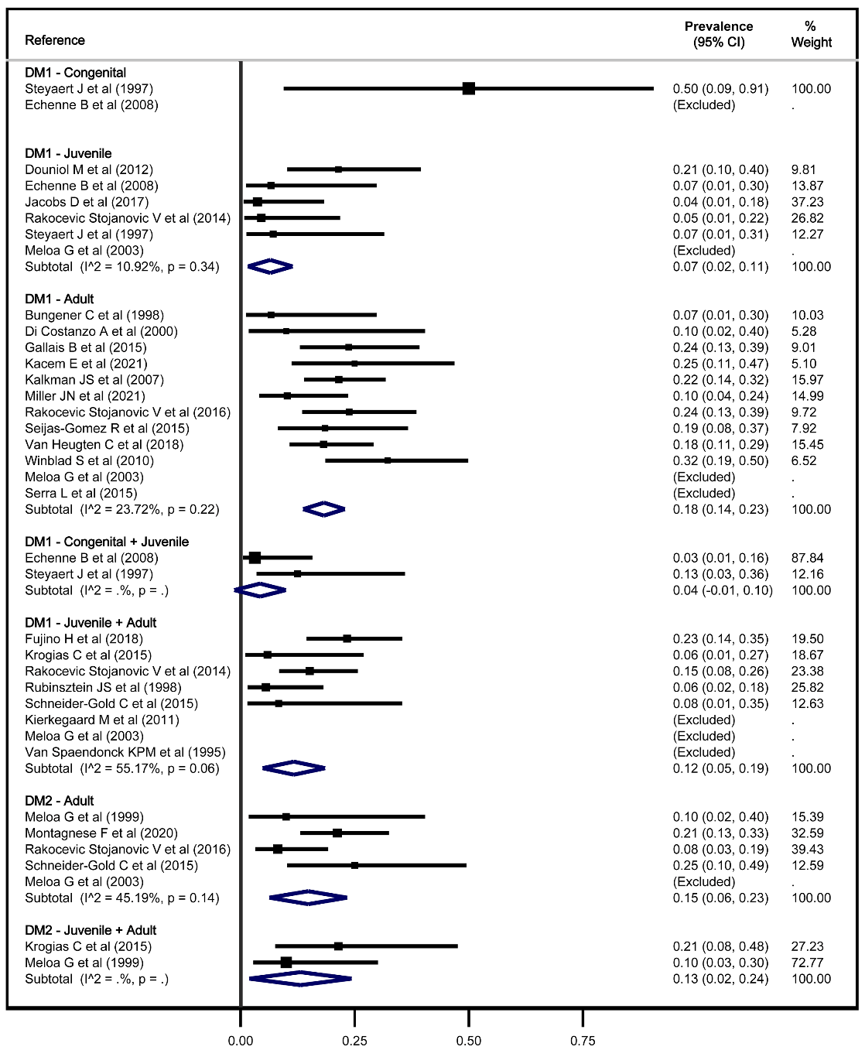

Figure S2. Meta-analysis of anxiety in DM1 by onset.
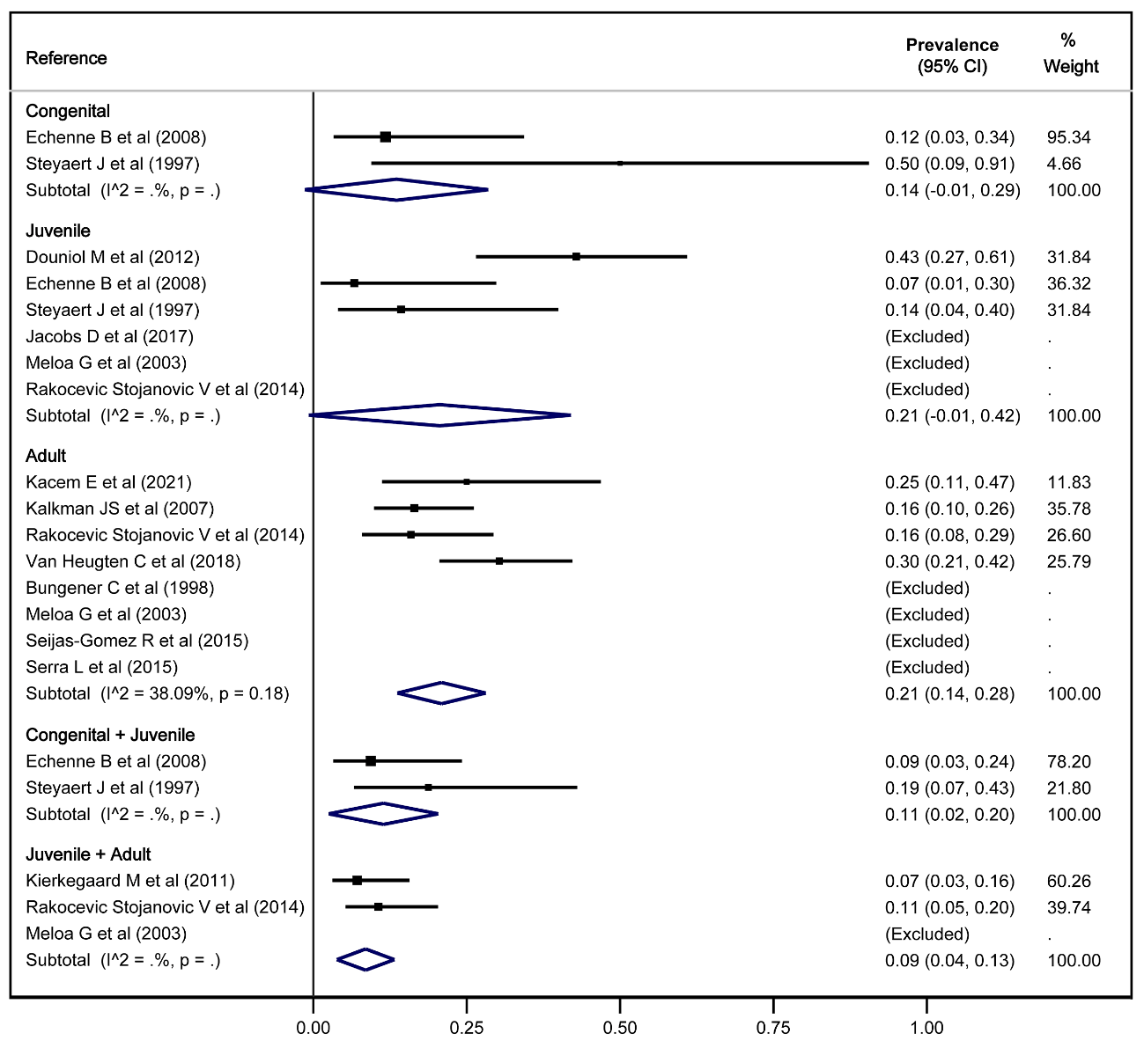

Figure S3. Meta-analysis of ASD prevalence-onset association through prevalence ratio considering childhood and juvenile onset.
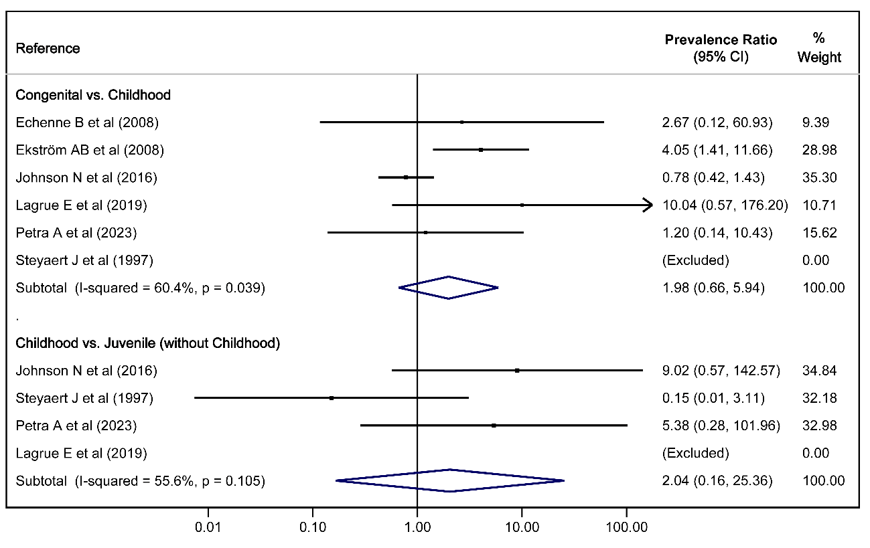

Figure S4. Meta-analysis of ADHD prevalence-onset association through prevalence ratio considering childhood and juvenile onset.
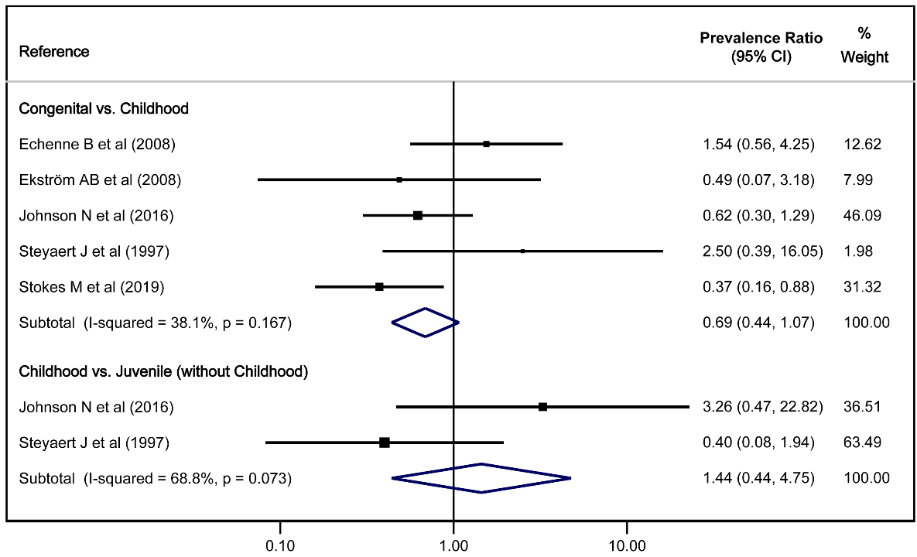

Figure S5. Funnel plots of primary outcomes.
- Funnel plot of ASDs.
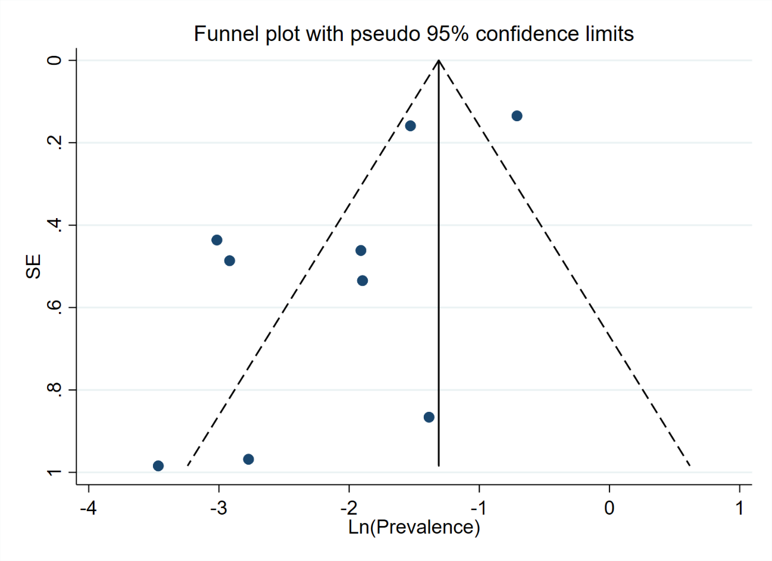
- Funnel plot of ADHD.
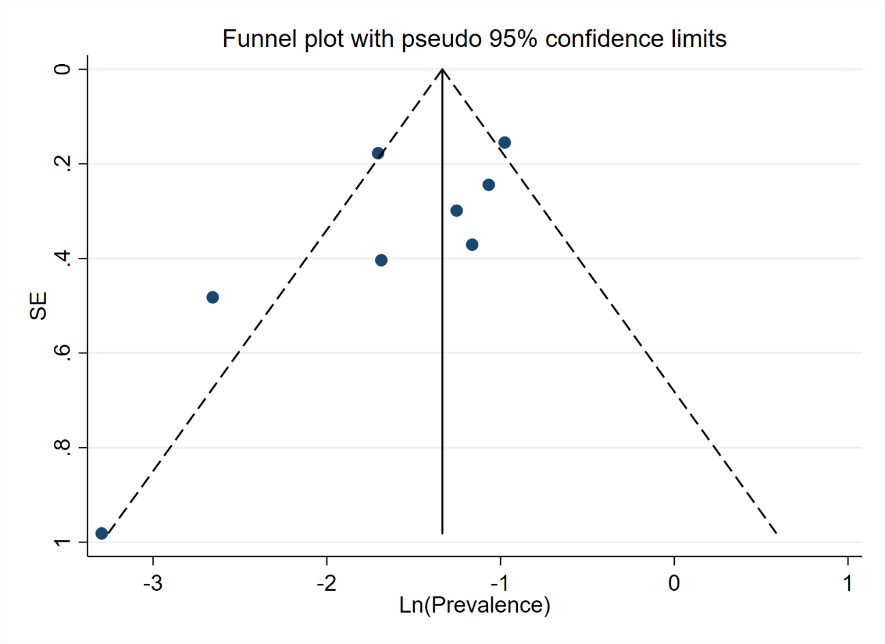
- Funnel plot of depression in DM1.
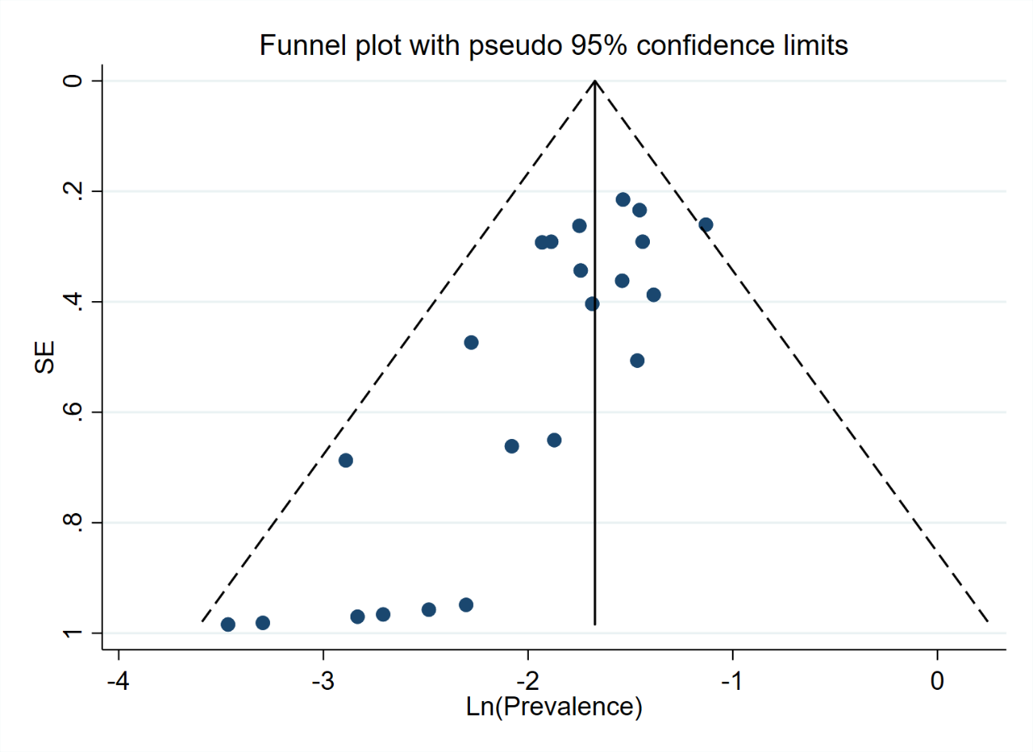
- Funnel plot of depression in DM2.
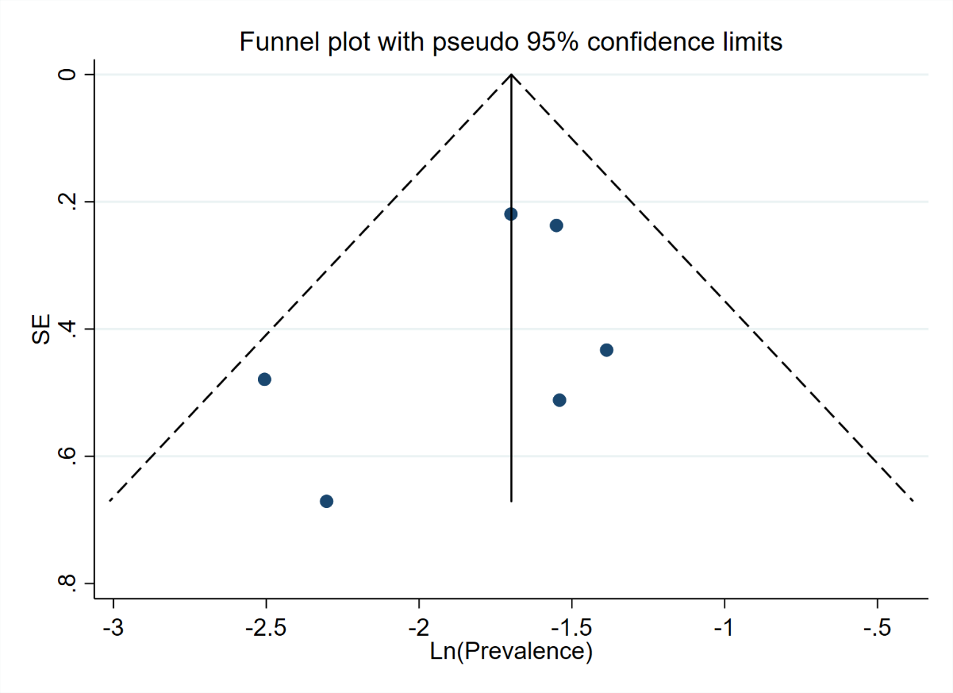

- Funnel plot of anxiety in DM1.
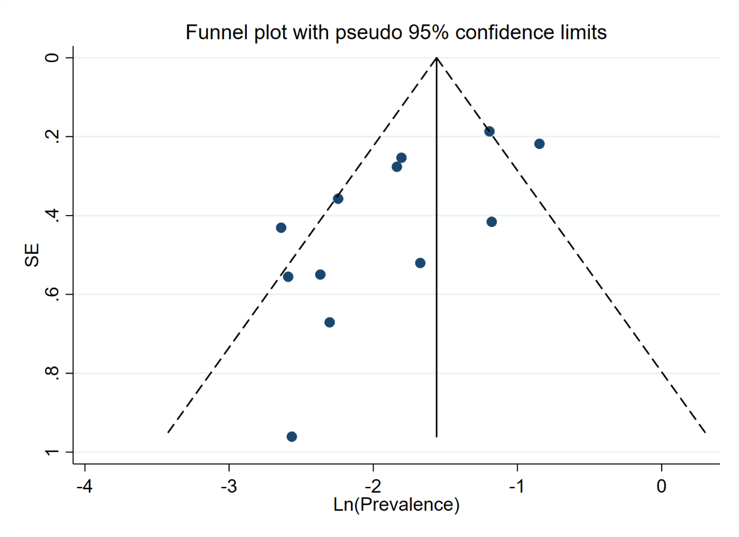

Appendix S1: Search strategy.
- Medline, Scopus, Web of Science, Cochrane Library
("myotonic dystrophy" OR "Steinert myotonic dystrophy" OR “myotonic dystrophy type 1” OR “type 1 myotonic dystrophy” OR “myotonic dystrophy type 2” OR “type 2 myotonic dystrophy”) AND (“cognitive profile” OR “cognitive function” OR “psychological profile” OR “mental disorders” OR “mental health” OR “neurodevelopmental” OR “developmental” OR “psychiatric” OR “autism” OR "attention deficit hyperactivity disorder" OR “adhd” OR “depression” OR “anxiety”)
- Grey literature
Not specified.

