Supplementary Table 1. The cortical structures showing significant correlations accounting for sex between performance of divergent thinking and cortical thickness or surface areas in patients with bipolar disorder and controls.
 | ATTA | Max | Cluster size (mm^{^2}) | TalX | TalY | TalZ | Corrected P value | Structure
Cortical thickness
BD
 | Fluency | -3.80 | 1530.0 | 29.4 | -86.0 | 4.4 | 0.000 | R. lateraloccipital
HC
 | Originality | 4.66 | 1188.9 | 36.4 | 30.2 | -2.2 | 0.004 | R. parstriangularis
 |  | 3.30 | 1757.6 | -26.2 | 10.4 | -14.0 | 0.000 | L. insula
Surface area
BD
 | Total score | 4.99 | 1322.7 | 14.2 | 41.0 | 13.9 | 0.023 | R. superiorfrontal
 | Flexibility | 3.23 | 2192.6 | 12.4 | 63.4 | -2.8 | 0.000 | R. superiorfrontal
 |  | 4.10 | 1634.1 | 12.2 | 42.7 | 15.9 | 0.005 | R. superiorfrontal
HC
 | Total score | -3.44 | 1699.1 | -41.1 | 31.8 | -13.2 | 0.003 | L. parsorbitalis
 |  | -3.37 | 1507.4 | -9.3 | -18.3 | 46.8 | 0.010 | L. paracentral
 | Originality | -3.07 | 1194.4 | -7.0 | -68.7 | 18.8 | 0.042 | L. cuneus

Max = Maximum voxel-wise significance in cluster; Size = Surface area of cluster; TalX, TalY, TalZ = Talairach coordinate of maximum;

Supplementary Figure 1. A detailed description of participants enrollment process in this study.
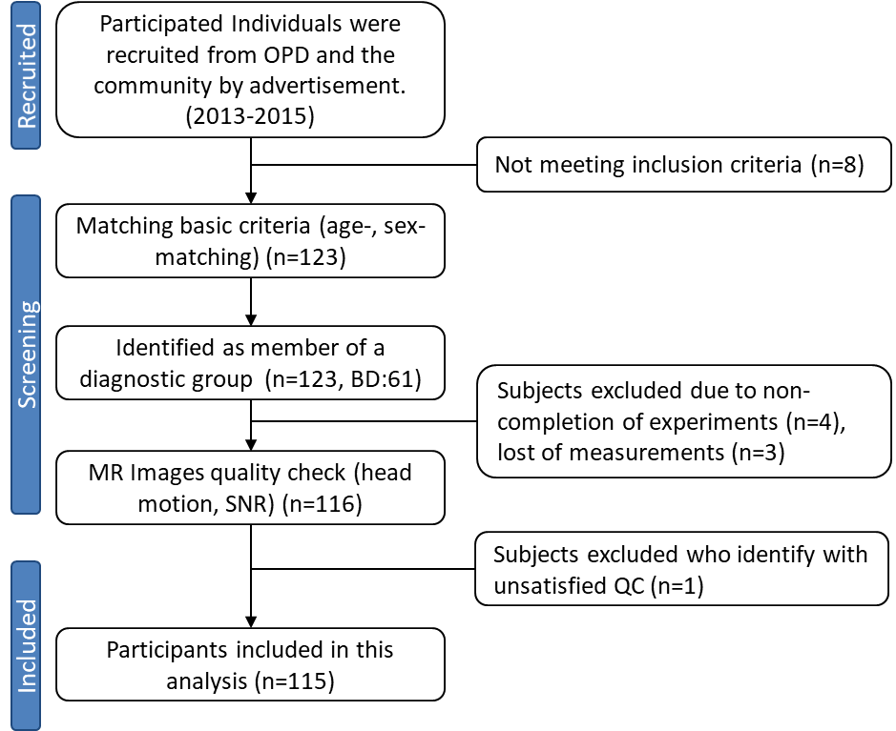

Supplementary Figure 2. The patients with BD showed a significantly cortical thinning in left inferior temporal gyrus compared to HCs in this study.
