**Supplementary material**

**Title: Do far ultraviolet-C light technologies increase ozone concentrations in healthcare facility patient rooms?**

**Authors**: Samir Memic BS1,2, Claire Kaple BS3, Jennifer L. Cadnum BS2, and Curtis J. Donskey MD4,5

**Figure 1. Outdoor ozone concentrations in Cleveland, Ohio during the study period. Data acquired from iqair.com (**[**https://www.iqair.com/us/usa/ohio/cleveland**](https://www.iqair.com/us/usa/ohio/cleveland)**).**

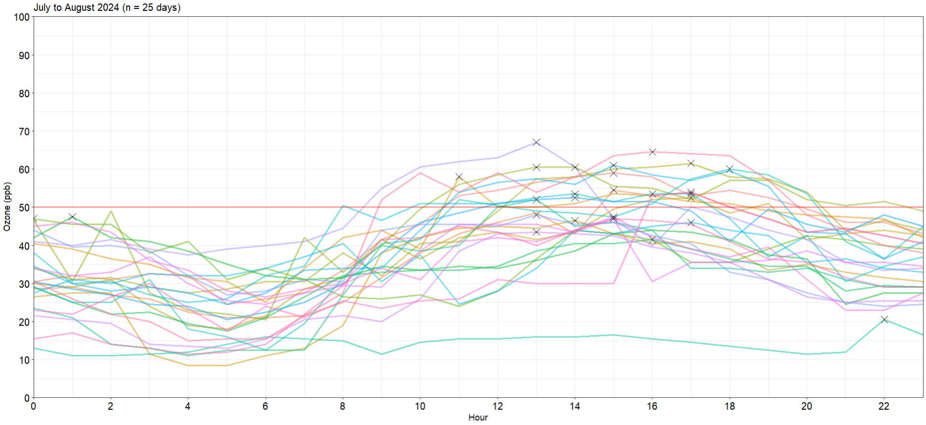

**Figure 2. Comparison of outdoor ozone concentrations acquired from iqair.com (**[**https://www.iqair.com/us/usa/ohio/cleveland**](https://www.iqair.com/us/usa/ohio/cleveland)**) versus measured using a 2B Tech Personal Ozone Monitor on 2 days in Cleveland, Ohio.**

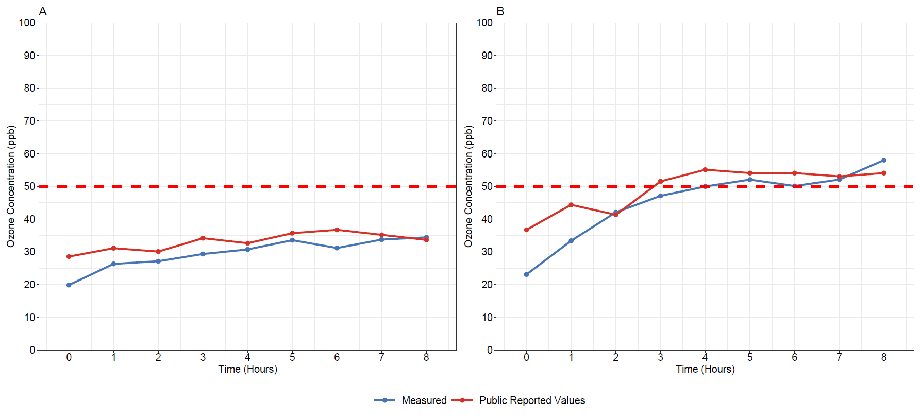

**Figure 3. Outdoor ozone concentrations acquired from iqair.com (https://www.iqair.com/us/usa/ohio/cleveland) and concurrent patient room concentrations measured using a 2B Tech Personal Ozone Monitor.**

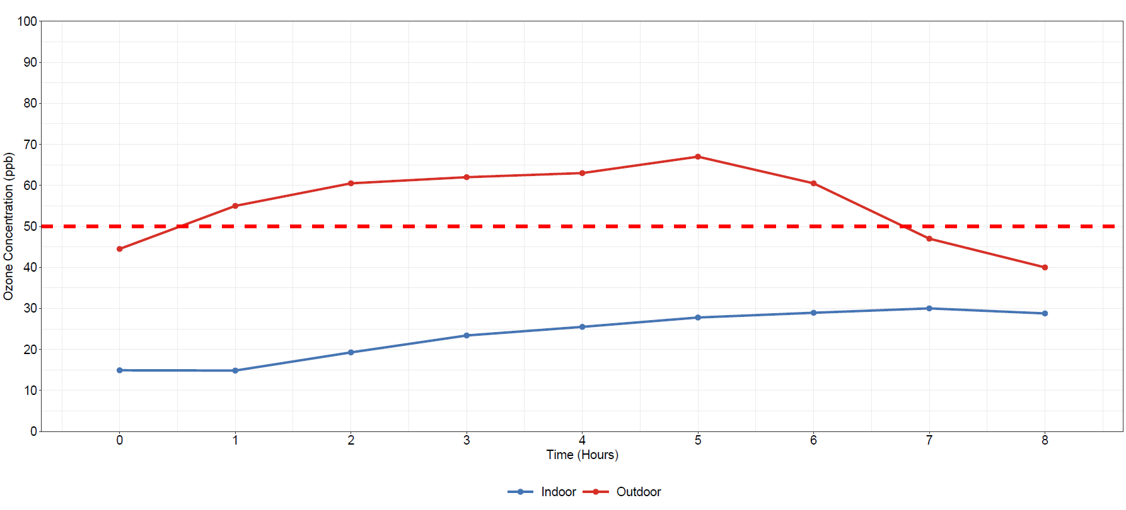

**Figure 4. Ozone concentrations (parts per billion) in a single-patient room over 8 hours when a far ultraviolet-C technology was operated versus when no technology was used (control). The dashed red line indicates 50 parts per billion which is a recommended threshold limit value.2 Outdoor ozone concentrations were acquired from iqair.com (https://www.iqair.com/us/usa/ohio/cleveland) and concurrent patient room concentrations were measured using a 2B Tech Personal Ozone Monitor.**

