Supplementary Table 1. Difference in differences estimates for an alternative treatment group (VRE+VSE), derived from the interaction term (time x treatment) from the weighted restricted cubic spline model, which represent the impact of PCR introduction for diagnosis of enterococci (VRE+VSE) on 30-day mortality risk. 95% confidence intervals were calculated using a bootstrap analysis of 1000 resamples.

 |  |  | 95% CI
Days from intervention | 30-day mortality risk difference |  | Lower | Upper
-180 | 0.049 |  | -0.09 | 0.21
-120 | 0.039 |  | -0.06 | 0.18
-60 | 0.021 |  | -0.03 | 0.10
0 | - (Ref) |  | - | -
60 | -0.018 |  | -0.09 | 0.02
120 | -0.030 |  | -0.15 | 0.03
180 | -0.036 |  | -0.18 | 0.05

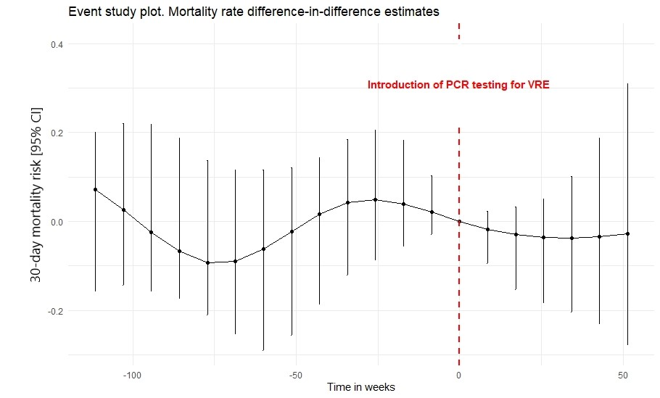

Supp Figure 1. Event Study Plot.
Event study coefficients along with their 95% confidence intervals for an alternative treatment group (VRE+VSE). Coefficients represent the impact of PCR introduction for diagnosis of enterococci (VRE+VSE) on mortality risk, and before the intervention (weeks <0) deviations from parallel pre-trends. Error bars depict 95% confidence intervals calculated using the 2.5th and 97.5th percentiles from 1000 bootstrap resamples.

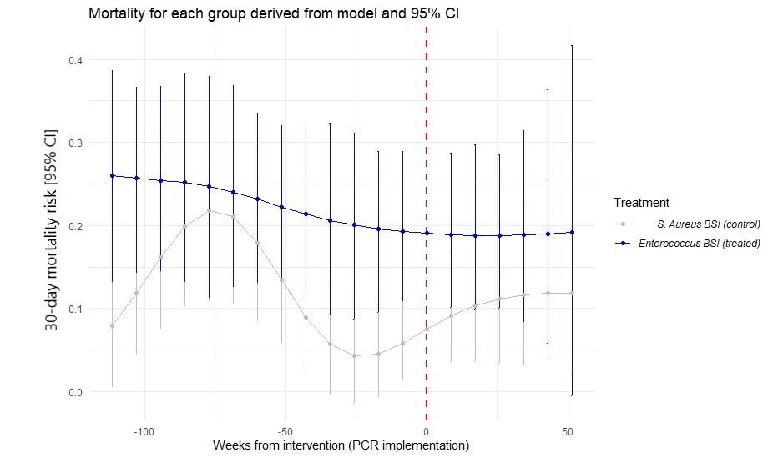
Supp Figure 2. Weighted mortality risk along with their 95% confidence intervals for enterococci (VRE+VSE) BSI (treated) and S. aureus (MSSA+MRSA) as control, groups derived from linear regression with time modeled as cubic restricted splines (DF=5). Study 95% confidence intervals represented as error bars calculated using a bootstrap analysis of 1000 resamples.

Supplementary Table 2. Difference in differences estimates for an alternative treatment group (VR E. faecium only), derived from the interaction term (time x treatment) from the weighted restricted cubic spline model, which represent the impact of PCR introduction for diagnosis of enterococci (VRE+VSE) on 30-day mortality risk. 95% confidence intervals were calculated using a bootstrap analysis of 1000 resamples.

 |  |  | 95% CI
Days from intervention | 30-day mortality risk difference |  | Lower | Upper
-180 | 0.104 |  | -0.0785 | 0.212
-120 | 0.0948 |  | -0.0524 | 0.167
-60 | 0.0552 |  | -0.0288 | 0.913
0 | - (Ref) |  | - | -
60 | -0.056 |  | -0.0938 | 0.0286
120 | -0.101 |  | -0.176 | 0.0523
180 | -0.130 |  | -0.243 | 0.0658

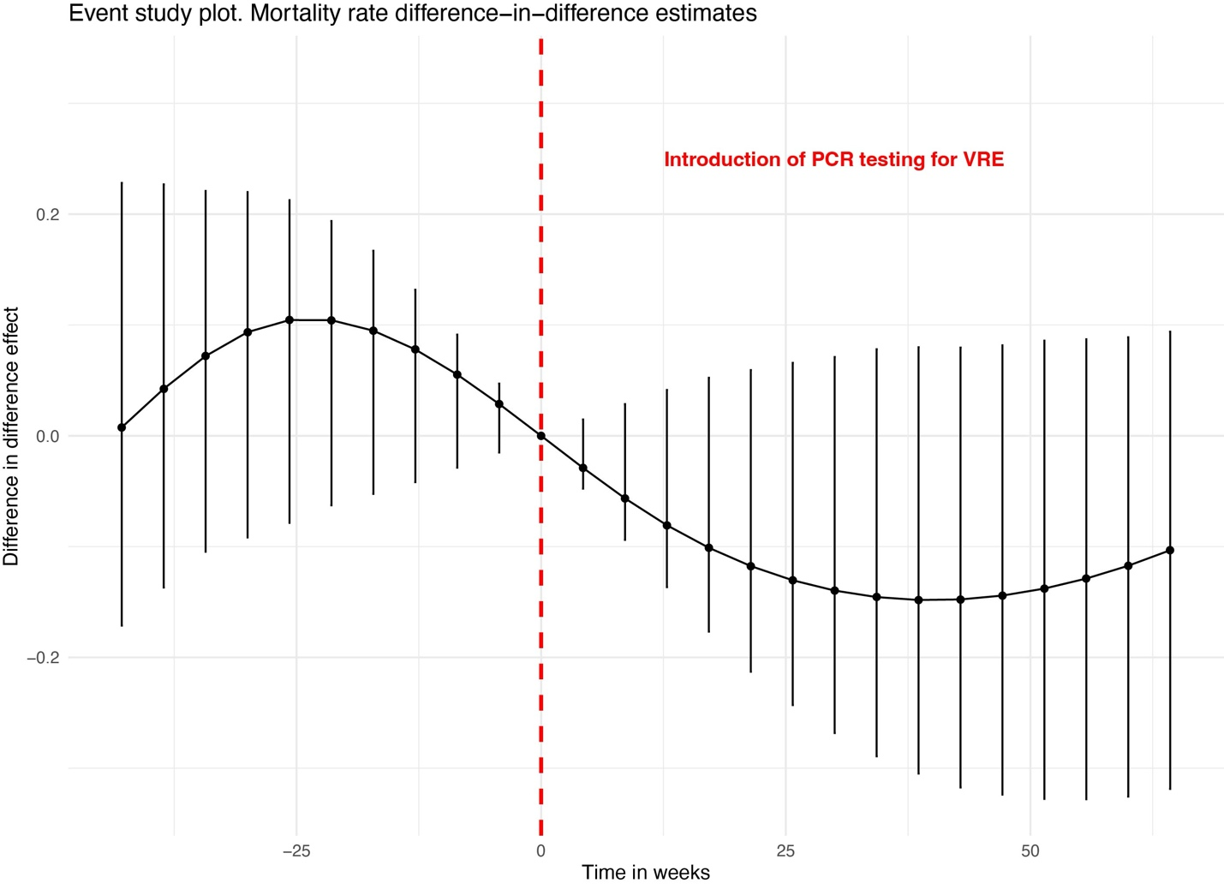
Supp. Figure 3. Event Study Plot.
Event study coefficients along with their 95% confidence intervals for an alternative treatment group (VR E. faecium only). Coefficients represent the impact of PCR introduction for diagnosis of VR E. faecium on mortality risk, and before the intervention (weeks <0) deviations from parallel pre-trends. Error bars depict 95% confidence intervals calculated using the 2.5th and 97.5th percentiles from 1000 bootstrap resamples.

Supp. Table 3 Regression coefficients to calculate the inverse probability of treatment weights (IPTW) and range of weights estimated

Term | Estimate | SE | Statistic | P-value
(Intercept) | -3.1004125 | 0.5532044 | -5.6044609 | 2.089E-08***
Age (years) | 0.00073277 | 0.00725204 | 0.10104297 | 0.91951635
Charlson Score | 0.00829178 | 0.03153839 | 0.26291064 | 0.79261946
Previous antibiotic use (yes) | 2.6100436 | 0.34321448 | 7.6047012 | 2.8556E-14***

Range of weights for the observations:
Minimum | Q1 | median | mean | Q3 | maximum
0.04582456 | 0.04825823 | 0.65134229 | 0.48444231 | 1 | 1

